SAR-LULC Monitor
Sentinel-1 SAR Semantic Segmentation and Twelve-Month Land-Cover Monitoring: A Proof-of-Concept Study
October 2026

Abstract
This project investigates the feasibility of a compact, Sentinel-1-only workflow for land-use and land-cover (LULC) segmentation and monthly monitoring. A three-level U-Net was trained using dual-polarization VV/VH SAR imagery and eight-class reference labels from the DFC2020 collection. The training experiment was deliberately limited to 50 epochs, with the best model selected by validation mean Intersection over Union (mIoU). The selected checkpoint achieved 49.35% validation mIoU and 79.44% validation overall accuracy (OA). On a separately held-out set of 986 image patches, performance decreased to 34.16% mIoU and 58.88% OA, with substantial variation between classes: Water reached 96.91% IoU, while Grassland and Wetlands remained below 1% IoU. A working Streamlit application integrates Google Earth Engine (GEE) acquisition, monthly median compositing, CPU segmentation, GeoTIFF export, visualization and change statistics. A recorded case study for the Heidelberg area retrieved 12 consecutive months (March 2024–February 2025) over a 6.5536 km² common valid area. The application demonstrates technical feasibility, but classification errors, domain shift and SAR acquisition variability prevent treating the observed month-to-month differences as verified land-cover changes. The contribution is an implemented and evaluated end-to-end proof of concept, not a state-of-the-art accuracy claim.
Keywords: Synthetic Aperture Radar; Sentinel-1; land cover; semantic segmentation; U-Net; Google Earth Engine; temporal monitoring.

1. Introduction
Land-cover maps are useful for studying urban growth, water distribution, agriculture and environmental change. Optical satellite imagery provides visually intuitive land-cover information, but cloud cover and lighting constrain reliable acquisition. Synthetic Aperture Radar (SAR) is an active sensing modality capable of collecting observations independently of daylight and through most cloud conditions. SAR backscatter nevertheless depends on viewing geometry, surface moisture, roughness and the physical scattering structure. Consequently, a change in a SAR-derived predicted class does not, by itself, demonstrate an actual change in land use.
The objective of SAR-LULC Monitor is to test whether a relatively small segmentation network can be combined with a practical, reproducible satellite-data retrieval and visualization workflow. Specifically, the study asks whether (i) VV/VH SAR alone can support eight-class pixel-wise prediction, (ii) the model can be executed locally without a GPU, and (iii) a user-specified location and start month can drive an automated twelve-month monitoring prototype. The experiment does not aim to establish a new DFC2020 leaderboard result or an operationally validated change-detection system.
The delivered system includes three executed Jupyter notebooks, a PyTorch model checkpoint, Python modules for preprocessing and evaluation, a GEE download layer, a Streamlit interface, exported CSV statistics, and a three-minute demonstration recording.

2. Related Work and Baseline Rationale
The 2020 IEEE GRSS Data Fusion Contest (DFC2020) studied global land-cover prediction with weak supervision, drawing on the SEN12MS collection of paired Sentinel-1, Sentinel-2 and coarse land-cover products [1, 2]. Its contest setting involves multimodal data and particular evaluation tracks. This project restricts its inputs to Sentinel-1 VV/VH and uses project-specific reallocated data partitions; its metrics must therefore not be compared directly to official contest rankings or the multimodal competition winners.
U-Net, proposed by Ronneberger, Fischer and Brox [3], is a standard encoder-decoder segmentation architecture combining multiscale context with skip-connected spatial detail. It provides a comprehensible and computationally economical architectural reference for a course-scale experiment. Here it is implemented with three downsampling/upsampling levels rather than a large pretrained backbone. Two SAR channels enter the network; the output contains eight per-pixel class logits.
Baseline/comparison limitation. The implemented experiment evaluates one lightweight U-Net configuration, rather than reproducing a published top-performing DFC2020 model under an identical protocol. Hence, no measured improvement over the best published model can be claimed. Architectural compactness and a working SAR-only deployment workflow constitute engineering choices, not an established quantitative performance advance. A rigorous future comparison would require a reproduced SAR-only baseline evaluated on the identical held-out patches, preprocessing, class ontology and metrics.

3. Dataset and Exploratory Analysis

3.1 Source data and project split
The supplied DFC2020 files contain paired Sentinel-1 SAR and high-resolution LULC label GeoTIFFs. The notebooks verified 5,128 paired tiles in the directory named ROIs0000_test and 986 paired tiles in ROIs0000_validation, with no unmatched filenames. Each input has shape 2 × 256 × 256 and the reference class raster has shape 256 × 256.
This project intentionally repurposes the original DFC2020 partitions. The original ROIs0000_test subset is randomly divided, with seed 42, into 4,102 training and 1,026 validation patches (approximately 80/20). The original ROIs0000_validation subset is reserved for independent final testing (986 patches). No test patches were used for checkpoint selection. The internal training-validation split is random by patch, not spatially grouped, and does not constitute a geographically independent validation design.
Only the SAR images and the DFC label rasters are used for model fitting. Sentinel-2 imagery and coarse MODIS-derived labels are not inputs to the model.

3.2 Class definition
Encoded class | DFC raw ID | Land-cover class
0 | 1 | Forest
1 | 2 | Shrubland
2 | 4 | Grassland
3 | 5 | Wetlands
4 | 6 | Croplands
5 | 7 | Urban/Built-up
6 | 9 | Barren
7 | 10 | Water
Other or invalid labels are mapped to 255, excluded from supervised loss and quantitative metrics. A substantial class imbalance is visible in the dataset. For example, in the independent test subset, Water accounts for approximately 35.01% of labeled pixels, whereas Barren accounts for approximately 2.92%. Such differences make classwise IoU and confusion analysis more informative than OA alone.
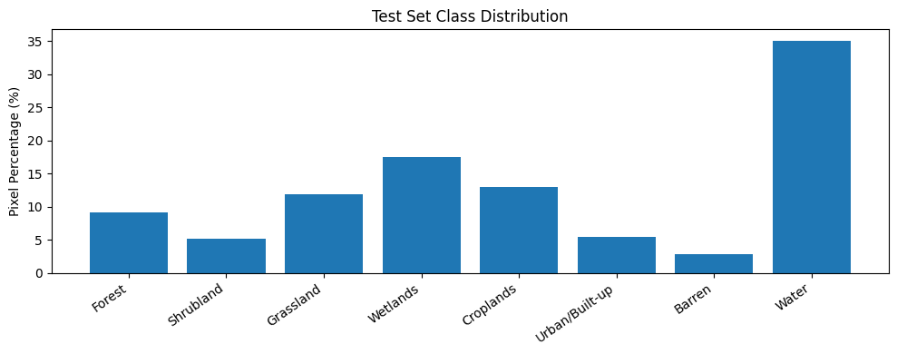
Exploratory distribution of raw land-cover classes in the held-out dataset.
Figure 1. Held-out test subset class distribution reproduced from the executed evaluation notebook.

3.3 Preprocessing and augmentation
VV/VH backscatter values are interpreted in the decibel domain. The implementation clips each band to [−25, 0] dB and transforms the clipped values to the interval [0, 1]:
$$x_{norm}=\frac{min\left(0,max\left(−25,x\right)\right)+25}{25}.$$
During training, synchronized random horizontal/vertical flips and rotations in multiples of 90° are applied to each input/label pair. These are online transformations, not a permanently enlarged dataset. Validation and final test inputs are not augmented.

4. Model Architecture and Training

4.1 Architecture
The model consists of three encoder downsampling stages with 3 × 3 convolutions, batch normalization and ReLU activations, followed by a bottleneck and a symmetric decoder. Bilinear upsampling and encoder-decoder skip concatenations restore spatial features. A 1 × 1 output convolution produces eight logits per pixel. The full model uses base_channels=32 and contains 1,948,232 trainable parameters. A single input tensor has size (1, 2, 256, 256); the output is (1, 8, 256, 256).
The standard supervised objective is pixelwise cross-entropy with ignored label 255:
LCE=−1Vp∈V​logexpzp,ypc=07expzp,c,
where $V$ denotes valid reference pixels, $y_{p}$ the reference class, and $z_{p,c}$ the class logit. The model contains no explicit temporal modeling: every monthly image is classified independently.

4.2 Experimental settings
Item | Implemented setting
Input | Sentinel-1 VV/VH, 256 × 256
Classes | 8 (+ ignore index 255)
Training / validation samples | 4,102 / 1,026
Batch size | 8
Optimizer | AdamW
Learning rate | 0.001
Weight decay | 0.0001
Loss | Cross-entropy
Training budget | 50 epochs
Early-stop patience | 10 (not triggered before budget ended)
Model selection | Highest validation mIoU
Random seed | 42
Training device | CUDA GPU
Total recorded training time | 1,306.8 seconds (~21.8 minutes)
Training was deliberately stopped after the 50-epoch budget, rather than after demonstrated convergence. The training loss was still decreasing at epoch 50, ending at approximately 0.6431. Validation performance varied by epoch; the best checkpoint was epoch 49, with mIoU = 0.4935 and OA = 0.7944. The best checkpoint was reloaded and re-evaluated on the validation set before final testing. Further training might help, but reducing training loss does not guarantee better independent-test IoU.
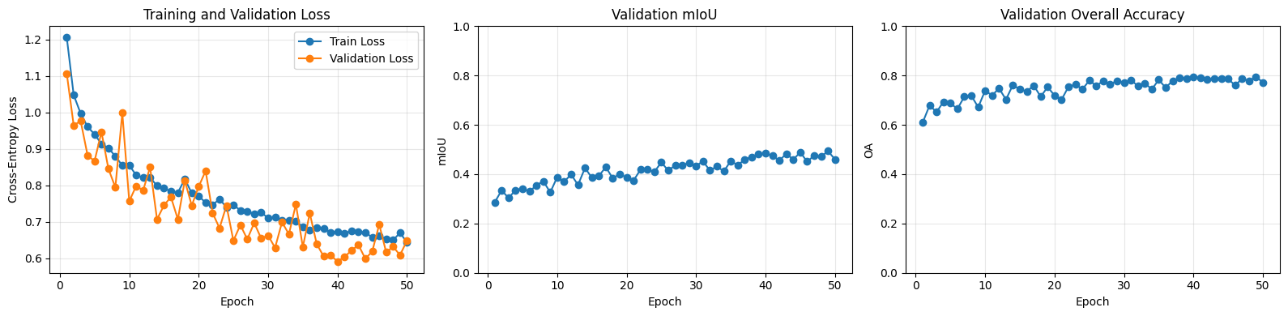
Loss, validation mean IoU and overall accuracy across 50 epochs.
Figure 2. Training and validation learning curves from the executed notebook. Fluctuations in validation metrics persist through the final epochs.

5. Independent Evaluation

5.1 Metrics
The executed third notebook evaluates the best validation checkpoint once on all 986 held-out patches without gradient updates. Overall accuracy measures the proportion of correct valid pixels. For class $c$, IoU is $TP_{c}/\left(TP_{c}+FP_{c}+FN_{c}\right)$, and F1 is $2TP_{c}/\left(2TP_{c}+FP_{c}+FN_{c}\right)$. Mean IoU is the mean over evaluable classes. The metrics are accumulated across all tested pixels using a confusion matrix.

5.2 Results
Aggregate measure | Independent test result
Overall accuracy (OA) | 58.88%
Mean Intersection over Union (mIoU) | 34.16%

Class | IoU (%) | F1 (%)
Forest | 52.21 | 68.60
Shrubland | 12.88 | 22.82
Grassland | 0.42 | 0.84
Wetlands | 0.29 | 0.59
Croplands | 28.95 | 44.90
Urban/Built-up | 59.50 | 74.61
Barren | 22.11 | 36.22
Water | 96.91 | 98.43
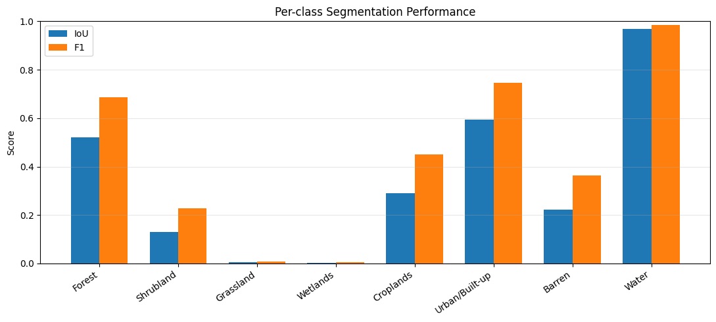
Per-class IoU and F1 from the independent test evaluation.
Figure 3. Severe classwise imbalance in predictive performance; Water is strong, whereas Grassland and Wetlands are rarely identified successfully.
The confusion matrix indicates that 69.04% of reference Wetlands pixels were predicted as Croplands, and 71.82% of reference Grassland pixels were predicted as Croplands. Such failures matter more for ecological interpretation than the OA metric alone suggests. The distinction between the best validation result (49.35% mIoU) and independent test result (34.16%) points to a meaningful generalization limitation. Differences in geographical content and class prevalence between these reallocated partitions may contribute; the available experiment does not isolate a single causal explanation.
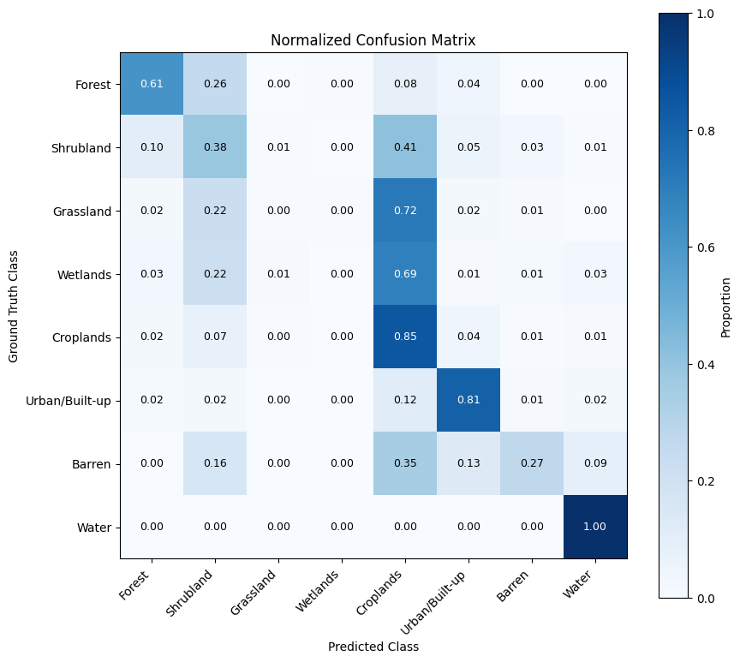
Normalized independent-test confusion matrix.
Figure 4. Row-normalized confusion matrix from the executed evaluation notebook.
Qualitative inspection of the notebook’s lowest-accuracy examples reinforces the limitations: in some patches, the model collapses much of the scene to a single predicted class despite heterogeneous reference labels. Therefore the checkpoint demonstrates feasibility of prediction and some classes, not reliable eight-class segmentation across all environments.

6. Twelve-Month Monitoring Prototype

6.1 Processing pipeline
The Streamlit interface accepts latitude, longitude, starting year and starting month as numerical values. For each of 12 months, the GEE module queries COPERNICUS/S1_GRD using acquisition mode IW, pass direction ASCENDING, and both VV and VH polarizations. The monthly observations are reduced with a per-pixel temporal median in dB. This produces one two-band composite per month; the implementation does not require each month to contain exactly one acquisition.
For a fixed location, a local UTM projection and affine transform define the same 256 × 256 grid at 10 m pixel spacing for all dates. The nominal footprint is 2.56 × 2.56 km, or 6.5536 km². GEE exports georeferenced GeoTIFF imagery, which is normalized in the same way as training inputs. The model runs inference on the local CPU; the class prediction is exported as a one-band GeoTIFF (class IDs 0–7, NoData 255) and a color-coded PNG. Downloaded valid SAR images are reused from the local cache.
The analysis.py module intersects valid-pixel masks across available months, then counts the fraction of pixels assigned to each class within the same comparison area. For class $c$ and month $t$:
$$P_{c,t}=100\frac{\#\{p∈V:{\hat{y}}_{p,t}=c\}}{\left|V\right|}, Δ_{c,t}=P_{c,t}−P_{c,t−1},$$
where $V$ is the common valid area and $Δ$ is expressed in percentage points (pp). First-to-last change is $P_{c,12}−P_{c,1}$. A missing month remains missing rather than being replaced with zeros; no adjacent-month difference is computed across an absent month. The application presents 12 maps, time-series charts, data tables and downloadable CSV exports.
An IPv4-only socket.getaddrinfo() compatibility workaround is used in this project’s Streamlit startup because the development network had nonfunctional IPv6 connectivity. This is an environment workaround, not a component of the segmentation method.

6.2 Recorded Heidelberg-area case study
The included docs/demo/demo.mp4 records a 185-second demonstration of the Streamlit workflow. The selected coordinates visible in the recording are approximately 49.4100°N, 8.6600°E, near Heidelberg, Germany. The requested period is March 2024 through February 2025. The application reports a successful 12-month analysis, 12/12 available months, 65,536 common valid pixels, and 6.55 km² of valid area. Exported monthly_coverage.csv, monthly_change_pp.csv, and first_to_last_change.csv are included in docs/demo/.
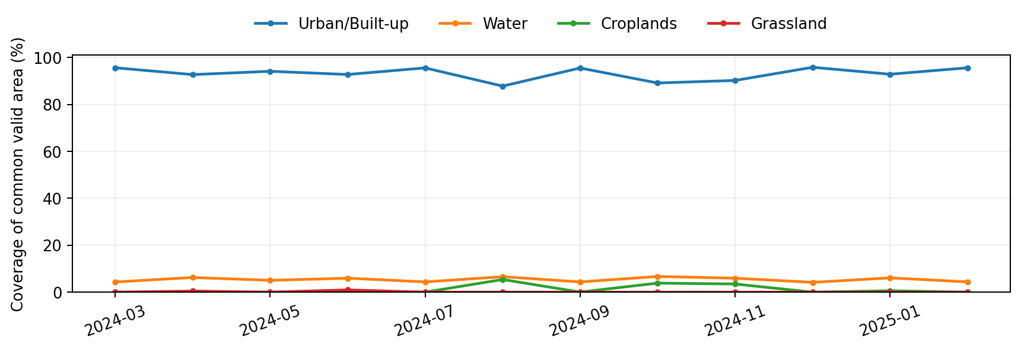
Selected class coverage across the recorded twelve-month case study, reconstructed from the exported CSV.
Figure 5. Predicted monthly class coverage derived from the uploaded demo CSV. The dominance of the Urban/Built-up class is a model output, not independently verified reference land cover.
Predicted class | March 2024 (%) | February 2025 (%) | Net change (pp)
Urban/Built-up | 95.5963 | 95.5826 | −0.0137
Water | 4.3442 | 4.3839 | +0.0397
Croplands | 0.0137 | 0.0107 | −0.0031
Barren | 0.0183 | 0.0229 | +0.0046
Across the twelve-month period, predicted Urban/Built-up ranged from approximately 87.79% to 95.80% and Water from 4.18% to 6.69%. The March-to-February net changes were small, but individual adjacent-month fluctuations were much larger. For example, Urban/Built-up fell by approximately 7.75 pp from July to August 2024, followed by a rise of approximately 7.70 pp from August to September. Such rapid reversals in a fixed geographical area are more consistent with classification/acquisition variability than with a confidently established physical land-cover conversion. Without independent contemporaneous ground truth, the report cannot determine the real change rate.

6.3 Operational behavior verified
The available source code and recording support the following completed functions: selection of location and year/month; twelve GEE composite requests; a 12-month progress display; local model inference; generation of geospatial and preview predictions; common-area coverage statistics; month-to-month and first-to-last tables; and CSV download. The video and exported tables corroborate successful end-to-end execution. They do not establish the accuracy of the case-study labels.

7. Critical Discussion and Limitations
Incomplete optimization. The 50-epoch constraint was a deliberate project-scope decision. The training loss was still decreasing; tuning longer schedules, learning-rate decay, loss reweighting or alternative samplers may help, but additional experiments are required to demonstrate any improvement.
Class imbalance and ambiguity. Land-cover categories differ in prevalence and radar scattering characteristics. Some classes, notably Wetlands and Grassland, are almost never predicted correctly in the held-out set. SAR-only VV/VH input omits spectral evidence that can help distinguish vegetation types. The reported system is therefore especially unsuitable for fine-grained ecological change claims.
Split and domain shift. The internal validation split is random by image patch, not geographic group. The held-out subset has a markedly different class composition, including a much greater prevalence of Wetlands and Water than in the training-pool directory. More importantly, the inference images come from GEE monthly composites rather than the DFC2020 tile acquisition and preprocessing chain. Matching dB range and spatial dimensions does not eliminate differences in incidence angle, season, location, speckle, composite statistics or label ontology.
Temporal false change. The U-Net classifies each monthly composite independently. The pipeline does not constrain stable land-cover classes over time. The fixed ASCENDING pass filter improves comparability, but acquisition geometry can still vary with relative orbit and local incidence angle; the implemented query does not constrain a single relative orbit. Per-month median compositing may alter backscatter statistics compared with an individual acquisition. The current change tables are best understood as changes in predicted class proportions.
No external reference validation. No quantitative ESA WorldCover or field-reference comparison is included in the submitted material. Such a check would need to align date, map resolution, geographic grid and differing land-cover ontologies. It must not be described as performed. Likewise, the study does not report a replicated state-of-the-art model comparison, statistical uncertainty bounds or an operational accuracy guarantee.
Scope of area estimates. On the aligned 10 m UTM grid, each valid pixel corresponds to a nominal 100 m², and the 65,536-pixel case study covers 6.5536 km². The implementation calculates class percentages rather than confident hectare-scale real-world transitions. No object tracking or change-event verification is carried out.

8. Conclusion and Future Work
SAR-LULC Monitor meets its proof-of-concept engineering objective: it demonstrates that a compact Sentinel-1 VV/VH U-Net can be trained and independently evaluated, integrated with on-demand GEE retrieval, and deployed in a local CPU-based application to produce twelve aligned monthly classification maps and interpretable coverage tables. The submitted notebooks and demo video make the process inspectable and repeatable.
The test-set mIoU of 34.16%, classwise failure modes and pronounced monthly fluctuations limit the scientific interpretation of its maps. The defensible result is successful end-to-end technical integration, not accurate long-term LULC change detection. Future work should prioritize: stronger SAR-only reference baselines on exactly the same split; targeted class balancing; longer but monitored training; geographic validation; fixed relative-orbit and incidence-angle controls; temporal smoothing or uncertainty estimation; and comparison with independent, appropriately dated land-cover maps.

References
[1] IEEE Geoscience and Remote Sensing Society. “2020 IEEE GRSS Data Fusion Contest: Global Land Cover Mapping with Weak Supervision.” https://www.grss-ieee.org/community/technical-committees/2020-ieee-grss-data-fusion-contest/ (accessed October 2026).
[2] M. Schmitt, L. H. Hughes, C. Qiu, and X. X. Zhu. “SEN12MS—A Curated Dataset of Georeferenced Multi-Spectral Sentinel-1/2 Imagery for Deep Learning and Data Fusion.” ISPRS Annals of the Photogrammetry, Remote Sensing and Spatial Information Sciences, IV-2/W7, 153–160, 2019. As referenced by [1].
[3] O. Ronneberger, P. Fischer, and T. Brox. “U-Net: Convolutional Networks for Biomedical Image Segmentation.” MICCAI, 2015. https://arxiv.org/abs/1505.04597.
[4] Google Earth Engine Data Catalog. “Sentinel-1 SAR GRD: C-band Synthetic Aperture Radar Ground Range Detected, log scaling (COPERNICUS/S1_GRD).” https://developers.google.com/earth-engine/datasets/catalog/COPERNICUS_S1_GRD (accessed October 2026).

Appendix: Reproducibility and Submitted Artifacts
The repository uses Python 3.12+ and uv. Install dependencies with uv sync; authenticate with uv run earthengine authenticate; set the applicable Google Cloud project ID in app.py; and start the interface with uv run streamlit run app.py. The three executed notebooks are 01_data_exploration.ipynb, 02_model_training.ipynb, and 03_model_evaluation.ipynb. The checkpoint path expected by the application is models/unet_full_best.pth, with the matching training configuration at outputs/training/unet_full_config.json. The downloadable source archive intentionally omits raw imagery, checkpoints and generated output directories, so those files must be supplied separately where necessary. The recorded case-study video and CSV tables appear under docs/demo/.
Source modules include preprocessing.py, dataset.py, augmentation.py, model.py, training.py, metrics.py, gee.py, inference.py, analysis.py and network.py. Additional demonstration artefacts are available in the submitted project package. All numerical experimental results reported here come from the executed notebooks or the included March 2024–February 2025 demonstration CSV files.

