Finite Element Reproduction and Refinement of the ASTM E1820 SE(B) Geometry Factor
Mingze Hong
Report DOI 10.5281/zenodo.24141562 | Software DOI 10.5281/zenodo.24141558

Abstract
The single-edge bend [SE(B)] geometry factor in ASTM E1820-01 was evaluated with the author’s TENSORA v1.2.2 finite element solver. A symmetry half-model represented a sharp through-thickness crack. Fourteen crack lengths over 0.15 ≤ a/W ≤ 0.80 were used to fit the geometry factors, and four additional lengths were reserved for validation. Domain integration provided the two-dimensional and interior three-dimensional factors. Crack opening displacement (COD) over a prescribed distance from the tip provided an equivalent factor at the free surface.
The two-dimensional results agreed closely with the ASTM reference. At a/W = 0.50, the fitted factors at quarter thickness and mid-thickness exceeded the reference by 3.81% and 5.10%, respectively. The surface equivalent was more sensitive to the COD sampling window than to mesh refinement. The resulting fits describe the specimen and boundary conditions analyzed here.
Keywords: single-edge bend specimen, stress intensity factor, domain integral, crack-front corner, Chebyshev approximation

1 ASTM reference and normalization
ASTM E1820-01 Annex A1 [1] gives the Mode I stress intensity factor for the SE(B) specimen. Here a is crack length, W is specimen depth, B is thickness, P is the total load, and S is the full support span. For a specimen without side grooves, the net thickness equals B and Eq. (A1.2) reduces to Eq. (1).
$$λ = \frac{a}{W} K_{I} = \frac{PS}{BW^{3/2}} f(λ) (1)$$
$$f(λ) = \frac{3\sqrt{λ}[1.99 - λ(1-λ)(2.15 - 3.93λ + 2.7λ^{2})]}{2(1+2λ){(1-λ)}^{3/2}} (2)$$
Equation (2) is the geometry function in ASTM Eq. (A1.3). Srawley [2] gives a wide-range calibration for the same specimen type. The model uses S/W = 4 and B/W = 0.50. The reference is evaluated over the study interval for comparison with the elastic simulations. That interval describes the numerical study and does not specify the qualification range for a fracture toughness test.
Table 1. Specimen dimensions and analysis parameters.
Parameter | Value | Description
W / B | 40 / 20 mm | No side grooves, B/W = 0.50
S / 2L | 160 / 180 mm | Support span / overall length
E / ν | 210 GPa / 0.30 | Isotropic linear elasticity
P / a | 1,000 N / λW | Downward load, crack along +y
Section z | 0 / 5 / 10 mm | Free surface to midplane

2 Specimen geometry and boundary conditions
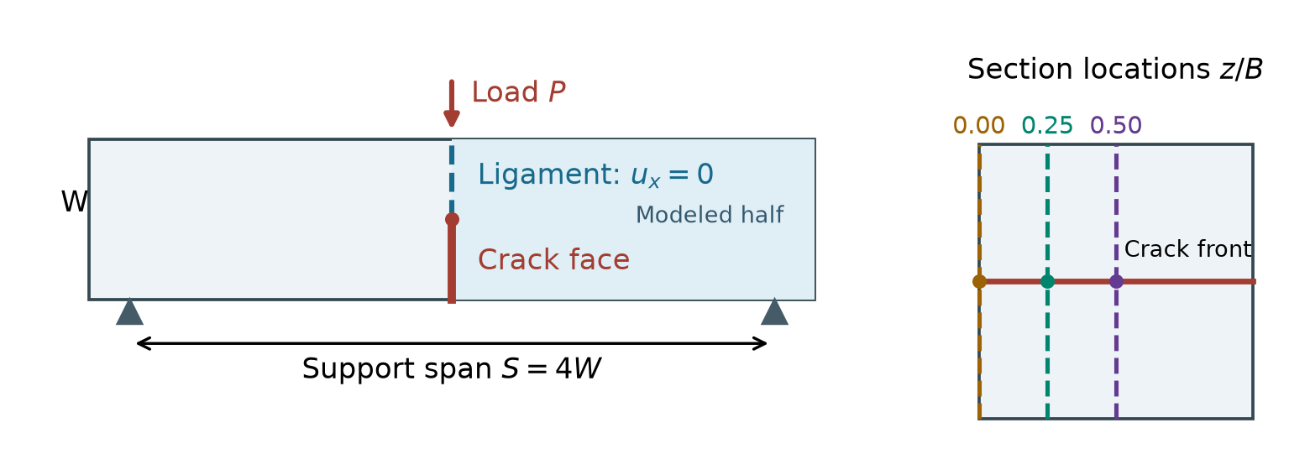
Figure 1. SE(B) specimen and modeled half. The right panel locates the crack front and the three sections on the x = 0 plane.

2.1 Sharp crack representation
The x axis follows the beam, y runs from the tensile edge to the loaded edge, and z measures distance through the thickness. On the symmetry plane x = 0, the segment 0 ≤ y < a is traction-free. The remaining ligament a ≤ y ≤ W is constrained in uₓ. The two-dimensional crack tip is at (0, a); the three-dimensional front spans the full thickness. Reflection across x = 0 gives a total opening of 2uₓ and maintains continuity across the ligament.
This representation introduces neither a finite notch width nor a tip radius. The change in boundary condition at y = a defines the sharp crack on the half-model.

2.2 Loading and support
The two-dimensional model carries a downward load of P/2 at (0, W), equivalent to 25,000 N/m per unit thickness. At (S/2, 0), only uᵧ is fixed. The three-dimensional half-model applies the uniform line load −P/(2B) at (0, W, z) with consistent nodal forces totaling −500 N. The support line (S/2, 0, z) fixes uᵧ. Fixing uz at its z = 0 endpoint removes rigid translation through the thickness. The thickness faces are traction-free.
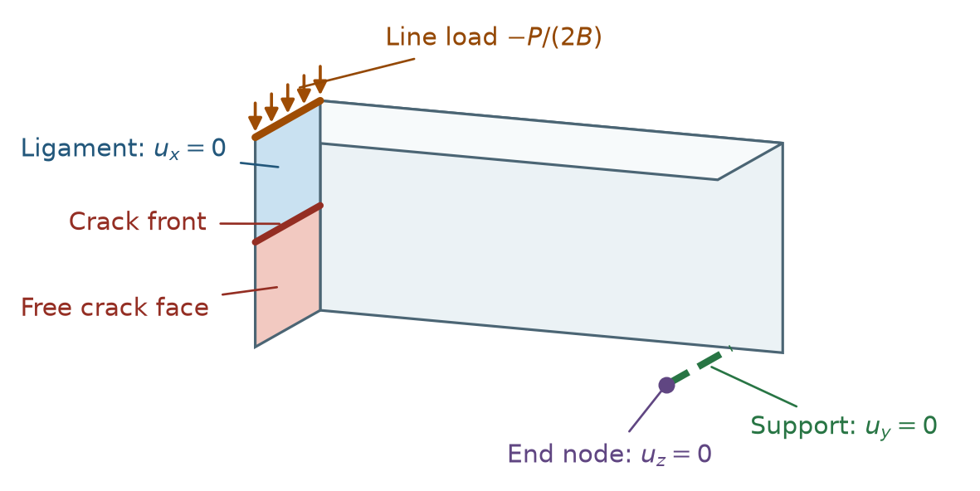
Figure 2. Line load, support, constrained ligament, and traction-free crack face in the three-dimensional half-model.

3 Finite element meshes and solution
Gmsh was used to construct a two-dimensional section bounded by six edges, with the symmetry boundary split at the crack tip. The section was extruded through the thickness for the three-dimensional model. Unstructured conforming meshes were refined by distance to the tip in 2D and to the crack front in 3D, placing the tip and front on element boundaries.
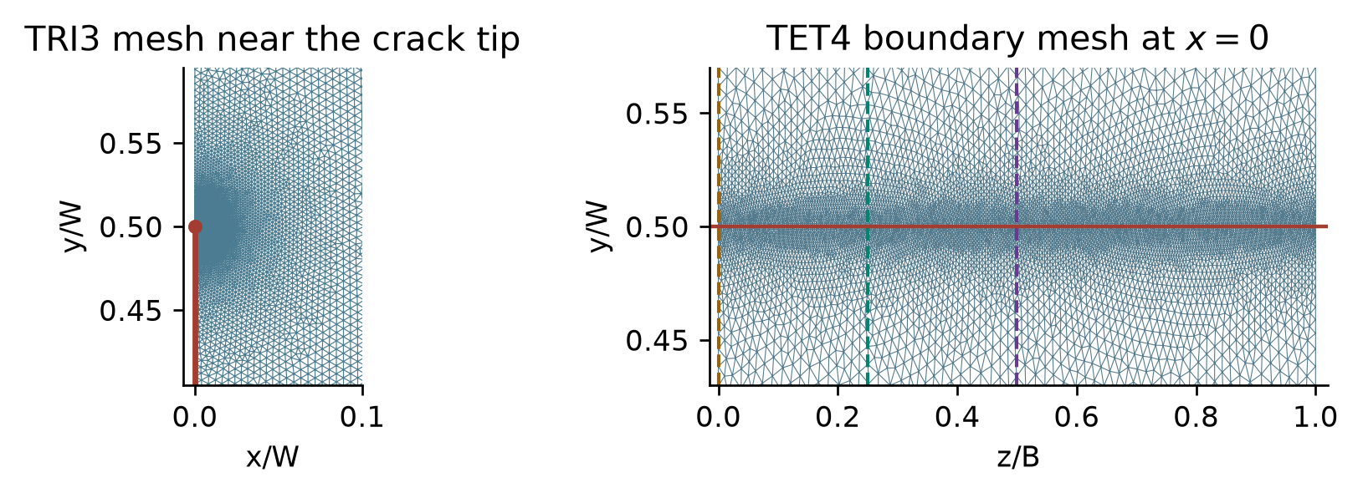
Figure 3. Meshes at a/W = 0.50. The horizontal line marks the front on the TET4 boundary mesh. The vertical lines mark the extraction sections.
Table 2. Mesh sizes and element counts for the modeled half.
Element | Level | Far field h (mm) | Front h₀ (mm) | Elements | Use
TRI3 | L0 | 0.3920 | 0.0300 | 55,892–56,076 | Check
TRI3 | L1 | 0.2760 | 0.0200 | 112,622–113,077 | Check
TRI3 | L2 | 0.1960 | 0.0136 | 223,211–224,050 | Main
TET4 | L0 | 1.2800 | 0.1320 | 201,505 | Check
TET4 | L1 | 1.0200 | 0.0920 | 410,761–412,212 | Check
TET4 | L2 | 0.8320 | 0.0680 | 780,197–781,981 | Main
TET4 | L3 | 0.8080 | 0.0540 | 1,090,890 | Check
The TRI3 and TET4 elements use linear displacement interpolation and constant strain. Each node has two displacement degrees of freedom in 2D and three in 3D. The TENSORA C++ solver uses Eigen’s sparse LDLᵀ factorization for plane stress and plane strain. The solid3d module assembles the TET4 stiffness matrix and solves it with a double-precision preconditioned conjugate-gradient method parallelized with OpenMP. All finite element cases were reproduced with TENSORA v1.2.2 on the archived meshes.
Table 2 lists the elements actually solved. All mesh levels use the same geometry and boundary conditions. The crack-tip region uses standard linear elements.

4 Extraction of geometry factors

4.1 Domain integral for 2D and interior 3D sections
For virtual crack extension along +y, the element displacement gradient gives stress σ and strain energy density U. Let Ωₕ denote the integration domain of the half-model, q the virtual-extension weight, and ξ the front-length normalization. The domain integral [3,4] is
$$J = \frac{2}{ξ} \int_{Ωₕ}{ (σ_{ij} u_{i,y} - U δ_{jy}) q_{,j} dΩ} (3)$$
The factor of two accounts for both halves. The radial weight is one for r ≤ R/4 and zero for r ≥ R, with a cubic transition. In 2D, ξ = 1. In 3D, the radial weight is multiplied by a symmetric triangular window along z, and ξ is its discrete integral along the crack front. The derivative of q with respect to z is retained. The elementwise linear interpolation of q gives a constant gradient for integration.
Five radii were tested: R/W = 0.035, 0.055, 0.075, 0.100, and 0.125. Each was scaled by min(1, λ/0.25, (1−λ)/0.25) to keep the domain clear of the external boundaries at short and long cracks. The reported factor averages the middle three radii. For interior 3D sections, normalized J was regressed against squared window width using half-widths of 0.10B, 0.15B, and 0.20B. The intercept estimates J at zero window width.
$$K_{I} = \sqrt{E'J}, E' = E (plane stress) or \frac{E}{1-ν^{2}} (plane strain and interior front) (4)$$

4.2 Free-surface COD equivalent
At z = 0 the crack front meets the free surface. The corner field generally differs from the classical inverse-square-root crack-front field [5]. A displacement-based equivalent was calculated by fitting the full opening Δ = 2uₓ to √r through the origin, where r = a−y. The fit used 61 interpolated points over 0.020 ≤ r/W ≤ 0.040.
$$K_{surf,app} = \frac{E\sqrt{2π}}{8} \frac{∑\sqrt{r_{k}}Δ_{k}}{∑r_{k}}, f_{surf,app} = \frac{BW^{3/2}}{PS} K_{surf,app} (5)$$
Equation (5) uses the classical plane-stress opening relation to scale the fitted slope [6]. The window is a reporting choice, spanning 0.8–1.6 mm, with four or five actual crack-face nodes in the main meshes. Its sensitivity is assessed in Section 9. This factor represents the opening over that interval.
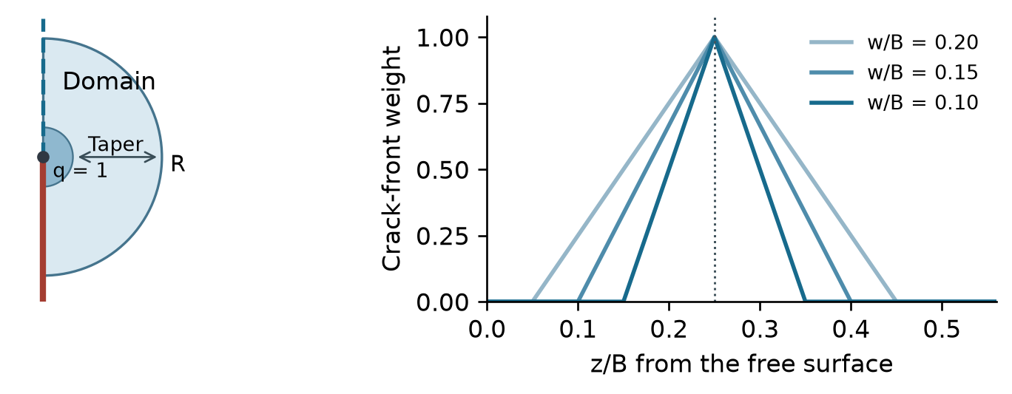
Figure 4. Radial domain and three crack-front weight functions centered at quarter thickness.

5 Two-dimensional fields and compliance check
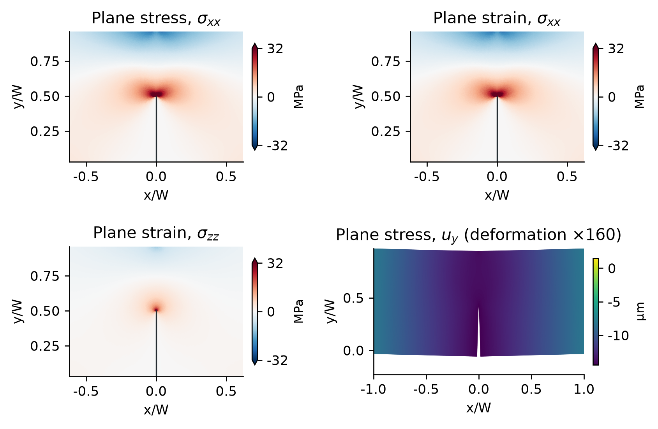
Figure 5. Two-dimensional fields at a/W = 0.50. The left half is reflected from the computed right half. The stress panels use the same clipped color scale.
The opening stress fields in plane stress and plane strain nearly coincide. The largest difference in f over the 18 crack lengths is 0.002%. The constitutive choice chiefly affects displacement and through-thickness stress: plane stress gives σzz = 0, while plane strain generally gives nonzero σzz. Each factor uses its corresponding E′. The deformation plot is magnified to show bending and opening.

5.1 Independent load-line compliance check
$$C = \frac{-u_{y}}{P} , J = \frac{P^{2}}{2B} \frac{dC}{da} (6)$$
The derivative of load-line compliance was estimated by central difference from λ = 0.495 and 0.505. At λ = 0.50, the compliance factors are 2.64076 for plane stress and 2.64150 for plane strain. They are 0.060% and 0.033% below the corresponding domain-integral values.
Across the 18 crack lengths, the plane-stress values deviate from ASTM by −1.82% to +0.35%. Mesh refinement and the compliance calculation quantify numerical sensitivity. The effects of the reference approximation, idealized support, and specimen details cannot be isolated with these simulations.

6 Three-dimensional stress fields
(a) σxx, Surface · z/B = 0.00  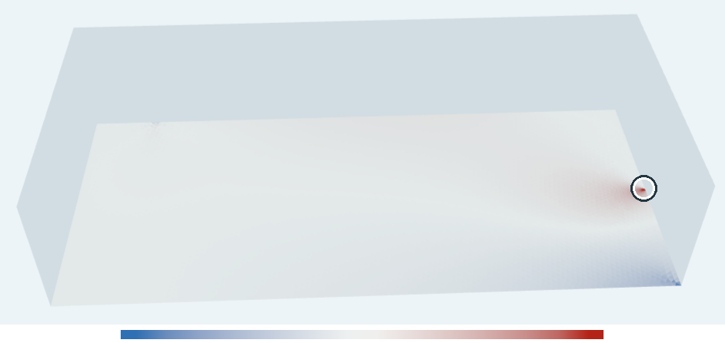  −40 to 40 MPa | (b) σxx, Quarter · z/B = 0.25  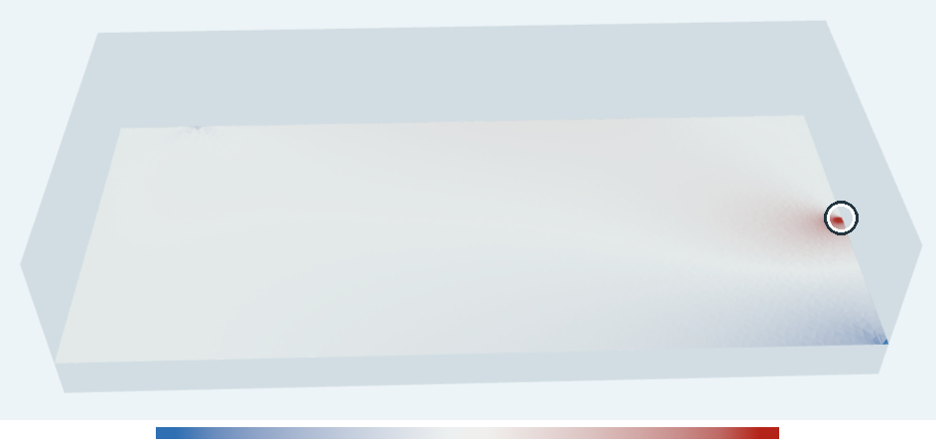  −40 to 40 MPa | (c) σxx, Midplane · z/B = 0.50  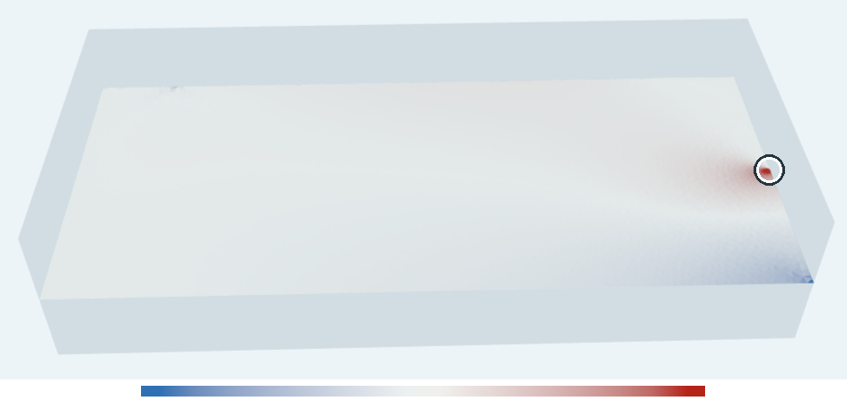  −40 to 40 MPa
(d) von Mises, Surface · z/B = 0.00  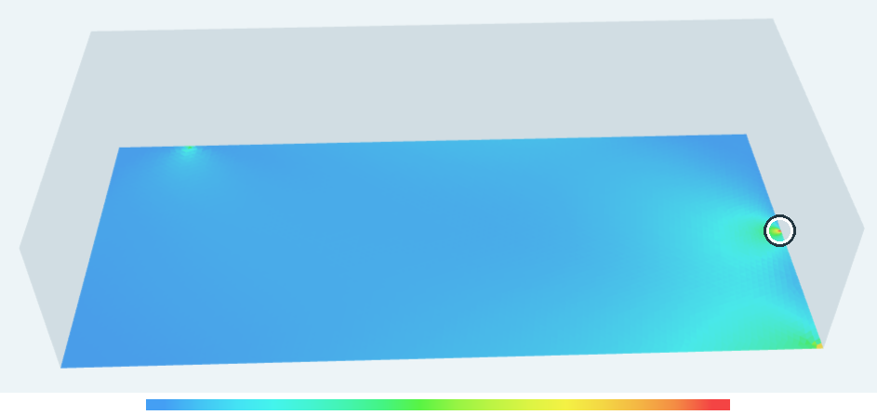  0 to 60 MPa | (e) von Mises, Quarter · z/B = 0.25  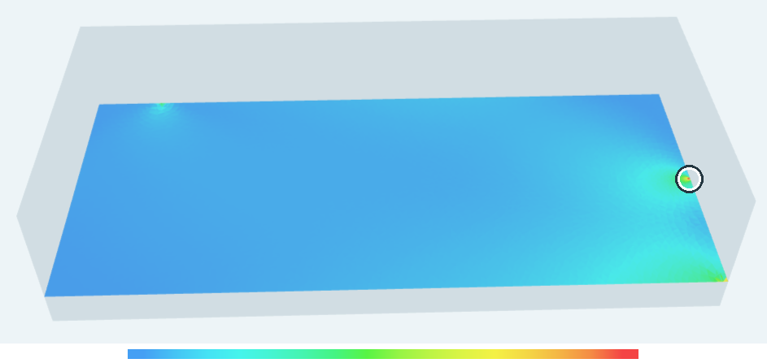  0 to 60 MPa | (f) von Mises, Midplane · z/B = 0.50  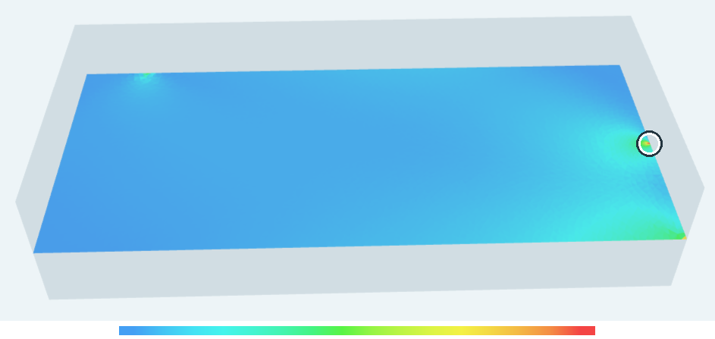  0 to 60 MPa
Figure 6. TENSORA stress sections and transparent specimen shell at a/W = 0.50.
The upper row shows opening stress σxx, and the lower row shows von Mises stress. The three XY sections lie 0, 5, and 10 mm from the same free surface. Circles mark the crack tip. Each stress measure has a shared color scale across the sections, with values outside its limits shown in the end colors.
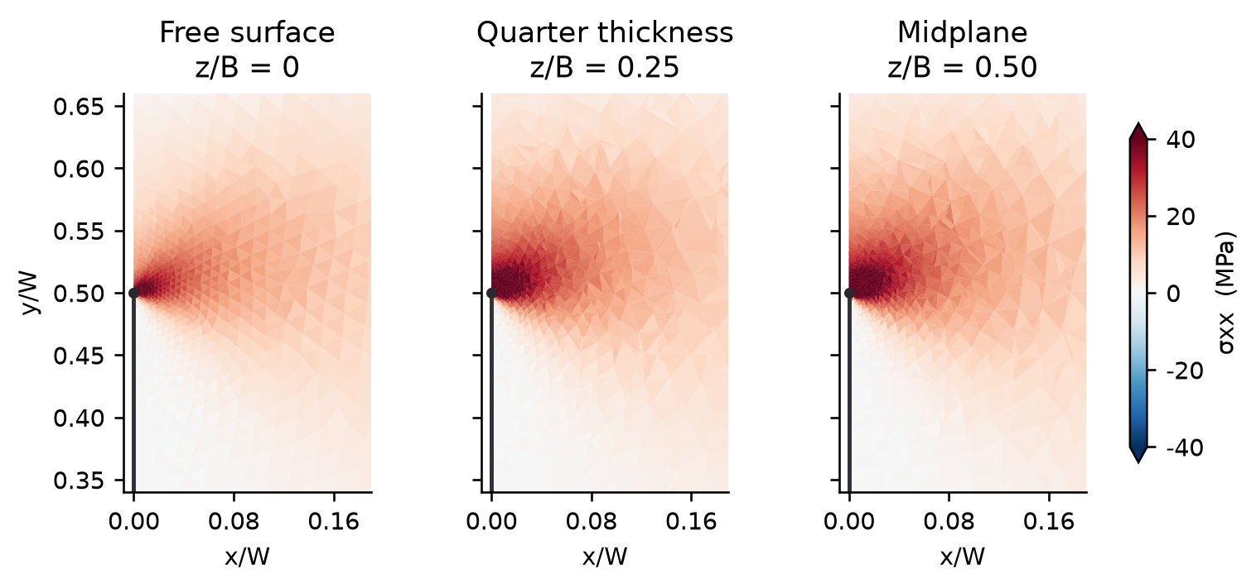
Figure 7. Opening stress near the crack tip at the three thickness positions.
The section planes intersect the tetrahedral mesh, and each intersected element contributes its constant stress. The same coordinate limits and color scale are used in each panel. The tensile concentration at the crack tip is visible in red. Its displayed intensity is bounded by the color scale, while the point stress in the ideal sharp-crack model increases with refinement.

7 Finite element geometry factors
Table 3. Geometry factors for the 14 crack lengths used in fitting.
λ | ASTM | Plane stress | Plane strain | Surface COD | Quarter thickness | Midplane
0.150 | 1.0169 | 0.9984 | 0.9984 | 0.9284 | 1.0399 | 1.0452
0.200 | 1.1749 | 1.1616 | 1.1616 | 1.0837 | 1.2150 | 1.2236
0.250 | 1.3390 | 1.3295 | 1.3295 | 1.2416 | 1.3932 | 1.4055
0.300 | 1.5212 | 1.5133 | 1.5133 | 1.4120 | 1.5873 | 1.6028
0.350 | 1.7318 | 1.7231 | 1.7231 | 1.6086 | 1.8064 | 1.8262
0.400 | 1.9818 | 1.9703 | 1.9703 | 1.8363 | 2.0647 | 2.0879
0.450 | 2.2855 | 2.2699 | 2.2699 | 2.1123 | 2.3775 | 2.4066
0.500 | 2.6625 | 2.6423 | 2.6424 | 2.4566 | 2.7638 | 2.7980
0.550 | 3.1424 | 3.1185 | 3.1185 | 2.8944 | 3.2559 | 3.2977
0.600 | 3.7716 | 3.7462 | 3.7463 | 3.4684 | 3.9022 | 3.9551
0.650 | 4.6279 | 4.6052 | 4.6052 | 4.2590 | 4.7829 | 4.8487
0.700 | 5.8504 | 5.8369 | 5.8370 | 5.3958 | 6.0331 | 6.1170
0.750 | 7.7101 | 7.7157 | 7.7159 | 7.1468 | 7.9342 | 8.0415
0.800 | 10.8032 | 10.8414 | 10.8417 | 10.1167 | 11.0665 | 11.1979
Table 4. Geometry factors for the four holdout crack lengths.
λ | ASTM | Plane stress | Plane strain | Surface COD | Quarter thickness | Midplane
0.175 | 1.0960 | 1.0802 | 1.0802 | 1.0077 | 1.1275 | 1.1350
0.375 | 1.8511 | 1.8412 | 1.8412 | 1.7163 | 1.9302 | 1.9511
0.625 | 4.1647 | 4.1400 | 4.1400 | 3.8303 | 4.3056 | 4.3636
0.775 | 9.0414 | 9.0614 | 9.0615 | 8.4198 | 9.2966 | 9.4038
The main two-dimensional meshes contain 223,211–224,050 triangles, and the three-dimensional meshes contain 780,197–781,981 tetrahedra. Under the selected dimensions and load, f equals the numerical value of Kᵢ in MPa√m.
Midplane f exceeds the quarter-thickness value by 0.51% to 1.39% at the calculated crack lengths. The surface column is the COD equivalent defined by Eq. (5).

8 Fitted corrections and applicability
The common factor √λ/(1−λ)³ᐟ² was taken out before fitting the remaining function with Chebyshev polynomials by least squares. Degrees two through seven were assessed by leave-one-out validation, selecting the lowest degree close to the minimum relative error. The four lengths in Table 4 were reserved for the holdout test.
$$t = \frac{λ-0.475}{0.325}, f(λ) = \frac{\sqrt{λ}}{{(1-λ)}^{3/2}} ∑_{k=0…n} c_{k} T_{k}(t) (7)$$
The polynomials satisfy T₀ = 1, T₁ = t, and Tₖ₊₁ = 2tTₖ − Tₖ₋₁. Table 5 lists coefficients by ascending degree. The fits cover 0.15 ≤ λ ≤ 0.80 at S/W = 4 for the geometry, boundary conditions, and extraction methods described here.
Table 5. Chebyshev coefficients for the five fitted curves.
Coeff. | Plane stress | Plane strain | Surface COD | Quarter thickness | Midplane
c0 | 1.44587390 | 1.44588708 | 1.34518262 | 1.50532007 | 1.52063570
c1 | -0.44450674 | -0.44449879 | -0.41711190 | -0.47588318 | -0.47497678
c2 | 0.10097079 | 0.10097482 | 0.09465938 | 0.09636075 | 0.09370521
c3 | -0.02225387 | -0.02225232 | -0.01627803 | -0.02226673 | -0.02187668
c4 | 0.00503040 | 0.00503073 | 0.00516289 | 0.00373608 | 0.00301190
c5 | -0.00115537 | -0.00115358 | — | -0.00059901 | -0.00067070
c6 | 0.00024484 | 0.00024271 | — | — | —
c7 | -0.00006044 | -0.00006102 | — | — | —
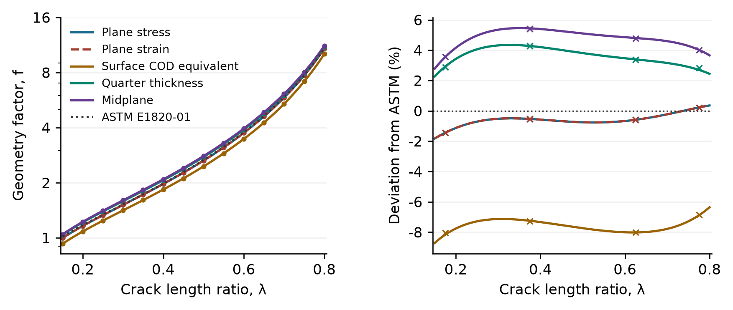
Figure 8. Fits and ASTM reference on a logarithmic vertical scale (left), and relative deviations from ASTM (right). Markers are finite element results: circles show the fitting lengths and crosses show the holdout lengths.
The largest holdout error relative to the corresponding finite element value was 0.120%.

8.1 Expanded fitting formulas
Equation (8) gives the ASTM reference with its bracket expanded in powers of λ. Equations (9)–(13) are the fitted alternatives, converted from Eq. (7) to the same form so they can be evaluated directly at λ = a/W.
$$f_{ASTM}(λ) = \frac{3\sqrt{λ}}{2(1+2λ){(1-λ)}^{3/2}} \left[1.99-2.15λ+6.08λ^{2}-6.63λ^{3}+2.70λ^{4}\right] (8)$$
Two-dimensional plane stress
$$f_{PS}(λ) = \frac{3\sqrt{λ}}{2(1+2λ){(1-λ)}^{3/2}} \left[\begin{aligned}1.880236933-1.394801578λ+4.072620378λ^{2} \\ -2.172008636λ^{3}-14.800419352λ^{4}+47.462897263λ^{5} \\ -66.558765297λ^{6}+46.907846065λ^{7}-13.466596378λ^{8}\end{aligned}\right] (9)$$
Two-dimensional plane strain
$$f_{PE}(λ) = \frac{3\sqrt{λ}}{2(1+2λ){(1-λ)}^{3/2}} \left[\begin{aligned}1.880124279-1.393529103λ+4.070590297λ^{2} \\ -2.188958279λ^{3}-14.736846504λ^{4}+47.438722097λ^{5} \\ -66.740582906λ^{6}+47.195380680λ^{7}-13.595570641λ^{8}\end{aligned}\right] (10)$$
Free-surface COD equivalent (z/B = 0)
$$f_{surf}(λ) = \frac{3\sqrt{λ}}{2(1+2λ){(1-λ)}^{3/2}} \left[\begin{aligned}1.667903157-0.221089052λ-1.036496865λ^{2} \\ +6.200745151λ^{3}-9.439612828λ^{4}+4.936144691λ^{5}\end{aligned}\right] (11)$$
Quarter thickness (z/B = 0.25)
$$f_{1/4}(λ) = \frac{3\sqrt{λ}}{2(1+2λ){(1-λ)}^{3/2}} \left[\begin{aligned}1.869165061-0.310798660λ-0.630866356λ^{2} \\ +6.068439105λ^{3}-11.761543226λ^{4}+10.180121520λ^{5} \\ -3.524330565λ^{6}\end{aligned}\right] (12)$$
Midplane (z/B = 0.50)
$$f_{mid}(λ) = \frac{3\sqrt{λ}}{2(1+2λ){(1-λ)}^{3/2}} \left[\begin{aligned}1.863201047-0.192811620λ-0.693481864λ^{2} \\ +5.663623853λ^{3}-11.126710940λ^{4}+10.278590246λ^{5} \\ -3.946113975λ^{6}\end{aligned}\right] (13)$$
Full-precision fitted coefficients were used for the conversion. The printed coefficients are rounded to nine decimal places. The 3D fits use B/W = 0.50 and ν = 0.30.

8.2 Comparison with ASTM E1820-01
Let Q be the polynomial in brackets after factoring out the common multiplier in Eqs. (8)–(13). The relative correction to the ASTM reference can be computed directly from Q.
$$ΔQ = Q - Q_{ASTM}, \frac{Δf}{f_{ASTM}} = \frac{ΔQ}{Q_{ASTM}} (14)$$
Table 6 shows the correction at λ = 0.50 and its range over the fitted interval. The extrema include stationary points in the interval and both endpoints.
Table 6. Fitted corrections relative to ASTM E1820-01.
Result | Q(0.50) | ΔQ(0.50) | f(0.50) | Δf/f at 0.50 | Deviation over interval
ASTM reference | 1.775000 | 0.000000 | 2.662500 | 0.000% | 0.000%
Plane stress | 1.761562 | -0.013438 | 2.642344 | -0.757% | -1.825% to +0.354%
Plane strain | 1.761579 | -0.013421 | 2.642369 | -0.756% | -1.825% to +0.356%
Surface COD | 1.637606 | -0.137394 | 2.456409 | -7.740% | -8.711% to -6.360%
Quarter thickness | 1.842569 | +0.067569 | 2.763853 | +3.807% | +2.261% to +4.344%
Midplane | 1.865506 | +0.090506 | 2.798259 | +5.099% | +2.782% to +5.453%
The plane-stress and plane-strain fits cross the reference near λ = 0.738. Both interior 3D curves stay above ASTM throughout the interval, with the midplane consistently higher than the quarter-thickness section.
At all 18 calculated crack lengths, the COD equivalent stays below the ASTM reference and both interior values for each of the three tested windows. The magnitude of the difference depends on the window.
The fitted corrections describe the elastic model and extraction conventions used in this study.

9 Mesh refinement and extraction sensitivity
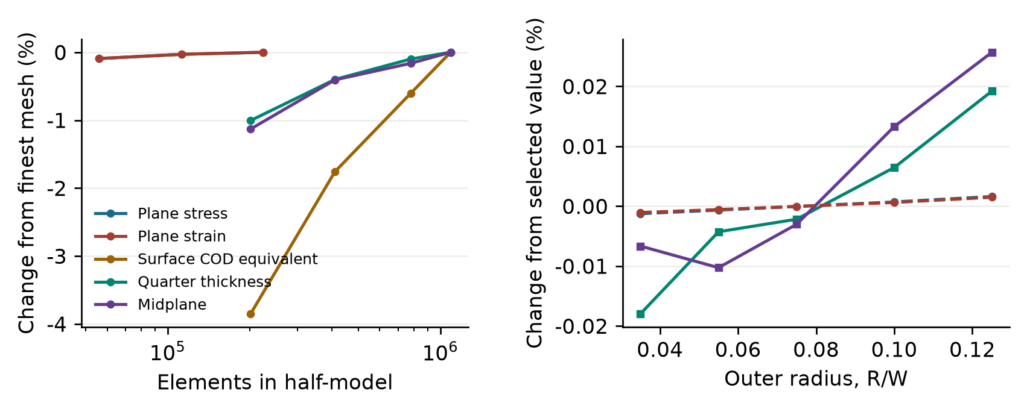
Figure 9. Mesh refinement and sensitivity to the outer radius of the domain integral at λ = 0.50.
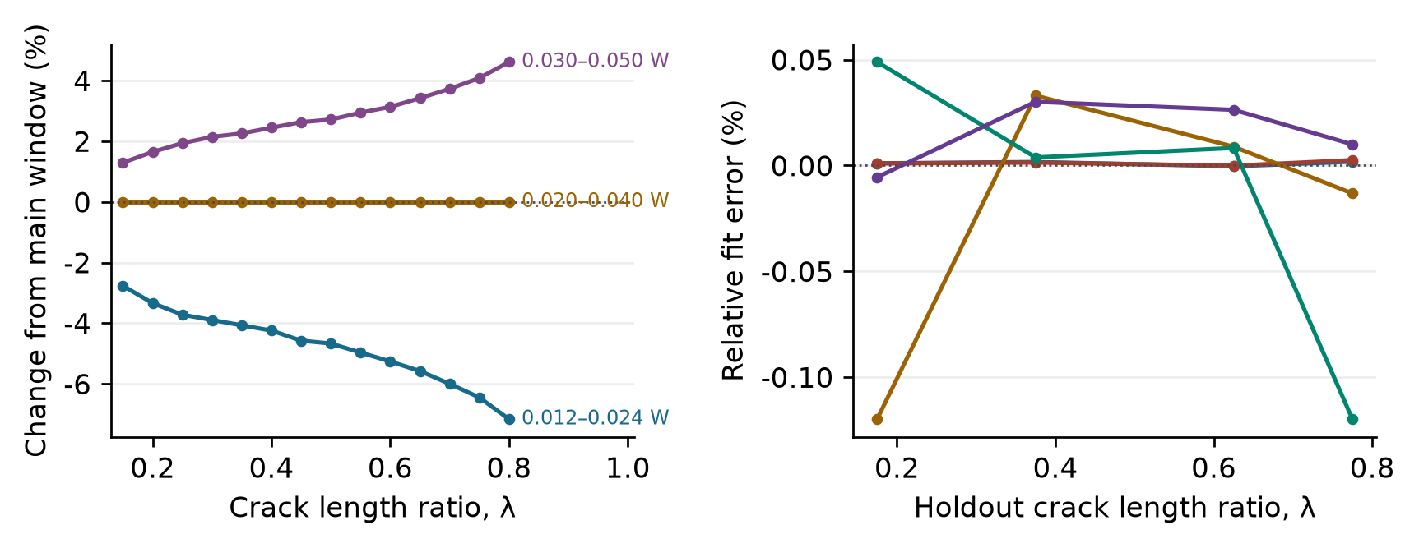
Figure 10. Surface COD window sensitivity and fit errors at the four holdout crack lengths.
Table 7. Relative fitting and holdout errors against finite element results.
Error metric | Plane stress | Plane strain | Surface COD | Quarter thickness | Midplane
Fit RMS | 0.0004% | 0.0003% | 0.0295% | 0.0162% | 0.0209%
Fit maximum | 0.0010% | 0.0008% | 0.0720% | 0.0303% | 0.0439%
Holdout maximum | 0.0018% | 0.0026% | 0.1198% | 0.1199% | 0.0301%
The spread in f across the middle three radii is at most 0.003% in 2D and 0.042% at the interior 3D sections. Across the three COD windows, (maximum − minimum)/main-window value ranges from 4.06% to 11.78%. At λ = 0.50, the three factors are 2.34184, 2.45659, and 2.52327. Their spread is 7.39% on the main mesh and 7.07% after refinement. The holdout errors characterize fitting at a fixed window.

10 Numerical accuracy and conclusions
Table 8. Three-dimensional mesh refinement at λ = 0.50.
Level | Tetrahedra | Surface COD | Quarter thickness | Midplane
L0 | 201,505 | 2.37627 | 2.73877 | 2.77090
L1 | 410,909 | 2.42803 | 2.75552 | 2.79118
L2 | 780,197 | 2.45659 | 2.76384 | 2.79802
L3 | 1,090,890 | 2.47146 | 2.76658 | 2.80257
The relative residual for the main 3D runs was at most 1.04 × 10⁻⁹. The total support reaction differed from 500 N by at most 7.66 × 10⁻⁷ N. At λ = 0.50, refinement from L2 to L3 increased the surface, quarter-thickness, and midplane values by 0.606%, 0.099%, and 0.162%, respectively.
The simulations reproduce the ASTM reference closely in 2D and resolve differences along the three-dimensional crack front. The fitted formulas provide local estimates for the modeled specimen and loading. The free-surface estimate should be reported with its COD window. Changes to thickness ratio, Poisson’s ratio, support contact, side grooves, or front shape call for a new analysis.

References
[1] ASTM International. ASTM E1820-01, Standard Test Method for Measurement of Fracture Toughness. Annex A1, Eqs. (A1.2)–(A1.3), 2001.
[2] Srawley J E. Wide range stress intensity factor expressions for ASTM E 399 standard fracture toughness specimens. International Journal of Fracture, 1976, 12: 475–476.
[3] Parks D M. A stiffness derivative finite element technique for determination of crack tip stress intensity factors. Engineering Fracture Mechanics, 1974, 6: 217–224.
[4] Shih C F, Moran B, Nakamura T. Energy release rate along a three-dimensional crack front in a thermally stressed body. International Journal of Fracture, 1986, 30: 79–102. DOI: 10.1007/BF00034019.
[5] Benthem J P. State of stress at the vertex of a quarter-infinite crack in a half-space. International Journal of Solids and Structures, 1977, 13: 479–492. DOI: 10.1016/0020-7683(77)90042-7.
[6] J. P. Gyekenyesi, A. Mendelson, and J. Kring, Three-Dimensional Elastic Stress and Displacement Analysis of Finite Circular Geometry Solids Containing Cracks, NASA TN D-7266, 1973, Eqs. (31)–(32).

