Question:

We define an employee's total earnings to be their monthly salary * months worked, and the maximum total earnings to be the maximum total earnings for any employee in the Employee table. Write a query to find the maximum total earnings for all employees as well as the total number of employees who have maximum total earnings. Then print these values as space-separated integers.

Input Format

The Employee table containing employee data for a company is described as follows:

Answer:

select max(salary*months),count(*)

from employee

where (salary*months)=(select max(salary*months) from employee) ;

Question:

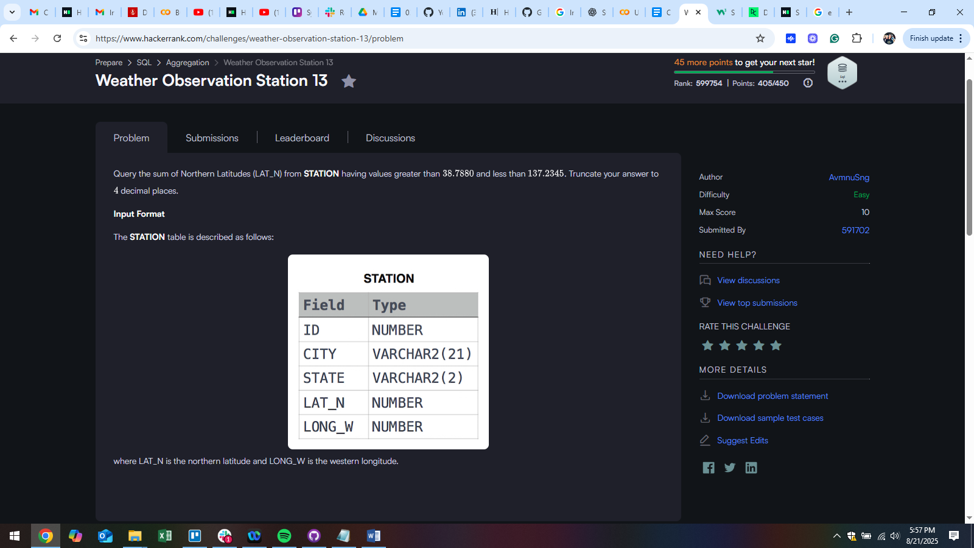

Answer:

SELECT TRUNCATE(SUM(LAT_N), 4)

FROM STATION

WHERE LAT_N > 38.7880 AND LAT_N < 137.2345