## Problem Alignment

### Objective

To create a ride-sharing platform that enables strangers to share rides efficiently, reducing transportation costs and environmental impact while maximizing vehicle utilization.

### Why does this matter to our customers and business?

* Provides an affordable transportation alternative for urban commuters
* Reduces individual transportation costs
* Decreases traffic congestion and carbon emissions
* Creates a new revenue stream through ride-matching technology
* Offers economic opportunities for drivers and riders alike

### Evidence or insights to support this

* Rising urban transportation costs
* Increasing environmental consciousness among millennials and Gen Z
* Growing acceptance of shared economy models
* Potential for significant cost savings compared to traditional transportation methods

## High-Level Approach

1. Develop a mobile application with smart matching algorithms
2. Implement robust user verification and safety protocols
3. Create flexible routing options that optimize ride sharing
4. Build a transparent pricing and payment system
5. Integrate real-time tracking and communication features

## Who Is This For

* Core Customers:
  + Urban commuters
  + Cost-conscious travelers
  + Environmentally aware individuals
* Partners:
  + Local drivers
  + Transportation networks
  + Corporate commuter groups
* Internal Teams:
  + Product development
  + Safety and compliance
  + Customer support
  + Data analytics

## Goals

1. Develop a user-friendly ride-sharing platform with seamless matching capabilities
2. Achieve 50,000 active users within first six months
3. Maintain a high user safety rating (4.5/5 or above)
4. Reduce individual transportation costs by 30-40%

### Success Metrics:

* User acquisition rate
* Average rides per user
* Cost savings compared to traditional transportation
* User safety incidents
* Customer satisfaction ratings
* Environmental impact (CO2 emissions reduced)

## Solution Alignment

### Key Features

#### Today:

1. Peer-to-peer ride-sharing platform connecting passengers with similar routes
2. Real-time matching algorithm for ride coordination
3. Transparent pricing and cost-sharing mechanism
4. User verification and safety profile system
5. In-app communication between potential ride sharers

#### Future:

1. Expand to multiple cities and urban regions
2. Introduce advanced route optimization algorithms
3. Implement reputation and rating system for users
4. Add multi-modal transportation integration

### Key Flows

#### 1. User Registration and Profile Creation

##### Step 1: App Download and Registration

* User downloads the app
* Creates profile with verified phone number
* Uploads necessary identification documents
* Links payment methods

##### Step 2: Route and Ride Preferences Setup

* Set home and work locations
* Define preferred travel times
* Specify vehicle preferences
* Set maximum detour time tolerance

#### 2. Ride Sharing Request Flow

##### Step 1: Ride Request Initiation

* User enters destination
* App suggests potential shared ride options
* Display estimated cost and time savings

##### Step 2: Matching Process

* Algorithm matches users with similar routes
* Sends ride share proposals
* Allows users to accept or decline matches

##### Step 3: Ride Confirmation

* Matched riders confirm ride details
* Payment split and route finalized
* Safety verification completed

#### 3. In-Ride Experience

* Real-time GPS tracking
* Rider communication channel
* Emergency support button
* Route progress updates

### Key Logic

#### Scenarios:

* Commuters traveling to similar locations
* Work/university routes with predictable patterns
* Weekend leisure travel

#### Edge Cases:

* No matching riders found
* Sudden route changes
* Rider cancellations
* Safety concerns during matching

#### Fallback Plan:

* Default to traditional ride-hailing if no match
* Flexible cancellation policies
* Automated refund mechanisms

### Key Considerations

#### Assumptions:

* Users willing to share rides with strangers
* Sufficient urban population density
* Smartphone and digital payment accessibility

#### Constraints:

* Regional transportation regulations
* Limited to specific geographic areas
* Vehicle capacity limitations

### Risks & Challenges

* Ensuring user safety during ride sharing
* Building trust in the platform
* Managing complex matching algorithms
* Handling potential conflicts between riders
* Compliance with local transportation laws

### Key Stakeholders

* **Product Team:** Design user experience and feature roadmap
* **Engineering:** Develop matching algorithms and platform
* **Legal Compliance:** Navigate transportation regulations
* **Safety Team:** Implement user verification and safety protocols
* **Marketing:** Build user trust and platform awareness
* **Customer Support:** Manage user interactions and resolve issues

## Launch Plan

### Phases:

1. **Internal Prototype Testing**
   * Develop core ride-sharing matching algorithm
   * Test initial platform functionality internally
   * Validate core technical infrastructure
2. **Limited City Pilot**
   * Select 2-3 metropolitan areas with high population density
   * Invite initial set of 50-100 drivers and riders
   * Validate real-world ride-matching capabilities
3. **Beta Testing**
   * Expand to 500 active users
   * Implement initial safety and verification features
   * Gather comprehensive user feedback
4. **Controlled Market Rollout**
   * Gradual expansion to multiple cities
   * Implement full platform features
   * Establish robust safety and rating mechanisms

## Key Milestones

| Target Date | Milestone | Description And Target |
| --- | --- | --- |
| YYYY-MM-15 | Internal Prototype | Validate core ride-sharing technology |
| YYYY-MM-30 | City Pilot Launch | Test platform in 2-3 initial cities |
| YYYY-M+2-15 | Beta Expansion | Reach 500 active platform users |
| YYYY-M+4-01 | Full Market Rollout | Launch in 5-10 metropolitan areas |

## Data Requirements

* **Core Tracking Metrics:**
  + Ride match rates
  + Average wait times
  + User satisfaction scores
  + Safety incident reports
  + Platform utilization percentages
* **User Experience Dashboards:**
  + Real-time ride matching performance
  + Driver and rider rating systems
  + Geographic coverage analysis

## Operational Checklist

### Sales

* Develop partner acquisition strategy for drivers
* Create incentive programs for early platform adopters
* Design commission and revenue-sharing models

### Marketing

* Create awareness campaigns highlighting cost-sharing benefits
* Develop referral programs
* Design targeted digital marketing for potential users

### Customer Support

* Build comprehensive support documentation
* Train support team on platform-specific scenarios
* Develop robust user verification protocols

### Go-to-Market Strategy

* Price competitively compared to existing ride-share platforms
* Offer introductory discounts
* Create clear value proposition for cost savings

### Partner Engagement

* Recruit initial driver network
* Establish partnership with local transportation authorities
* Develop driver onboarding and verification process

### Legal & Compliance

* Develop terms of service for ride sharing
* Obtain necessary transportation permits
* Create comprehensive user liability frameworks
* Ensure compliance with local transportation regulations

### Safety Protocols

* Implement user verification systems
* Develop real-time safety tracking
* Create emergency response mechanisms
* Establish transparent reporting systems

## Appendix

### FAQ:

**Q: What is the primary goal of this ride-sharing platform?**

A: The platform aims to create an efficient ride-sharing solution that reduces transportation costs, decreases environmental impact, and maximizes vehicle utilization by connecting strangers with similar travel routes.

**Q: How does this ride-sharing service benefit users?**

A: Users can expect significant cost savings (30-40% reduction in transportation expenses), reduced carbon emissions, and a convenient way to share rides with verified individuals traveling in similar directions.

**Q: What safety measures are in place for riders?**

A: The platform includes comprehensive user verification, a safety profile system, real-time tracking, in-app communication, and an emergency support button to ensure user safety during shared rides.

**Q: How will the ride-matching process work?**

A: Our smart matching algorithm connects users with similar routes, allowing them to view potential ride-share options, compare estimated costs and time savings, and confirm or decline matches before finalizing the ride.

**Q: What is the launch plan for this ride-sharing platform?**

A: The platform will launch in phases, starting with internal prototype testing, followed by a limited city pilot in 2-3 metropolitan areas, then a beta test with 500 active users, and finally a controlled market rollout across multiple cities.

**Q: What if no matching riders are found for my route?**

A: If no ride-share match is available, the platform will default to traditional ride-hailing options, ensuring you always have a transportation solution with flexible cancellation policies.

## High Level Design

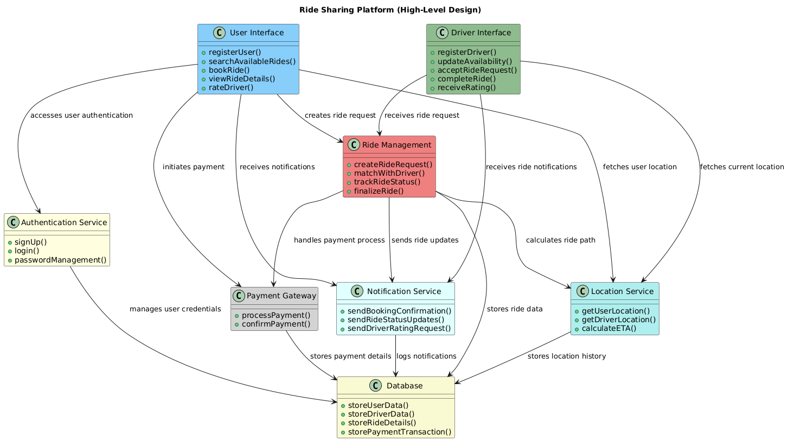

### User Interface

The **User Interface** component is designed to allow users to interact with the ride sharing platform. Users can perform actions such as registering, booking rides, and rating drivers.

**Methods:** - registerUser(): Facilitates new users to sign up for the platform. - searchAvailableRides(): Allows users to find available rides based on current location and destination. - bookRide(): Enables users to book a selected ride. - viewRideDetails(): Provides users with details about their booked rides such as driver information and expected arrival time. - rateDriver(): Allows users to provide feedback for the driver after a completed ride.

**Relationships:** - **AuthenticationService**: It accesses this service for user registrations and logins. - **Ride Management**: Interacts to create and manage ride requests. - **PaymentGateway**: Initiates the payment process for booked rides. - **NotificationService**: Receives notifications regarding booking confirmation and ride updates. - **LocationService**: Fetches the user’s current location to facilitate ride matching.

### Driver Interface

The **Driver Interface** component is created for drivers to manage their availability, accept ride requests, and receive ratings from users.

**Methods:** - registerDriver(): Allows drivers to register on the platform. - updateAvailability(): Lets drivers update their ride availability status. - acceptRideRequest(): Enables drivers to accept ride requests from users. - completeRide(): Marks the ride as completed once the destination is reached. - receiveRating(): Allows drivers to view ratings and feedback given by users.

**Relationships:** - **Ride Management**: Integrates to receive ride requests and update ride status. - **LocationService**: Utilizes this service to fetch current driver locations. - **NotificationService**: Receives updates and notifications about ride requests or changes.

### Authentication Service

The **Authentication Service** is responsible for managing user credentials and providing secure access to the platform.

**Methods:** - signUp(): Offers functionality for new user registrations. - login(): Handles validating and authenticating user login attempts. - passwordManagement(): Provides services for password resets and updates.

**Relationships:** - **Database**: Accesses the database to manage and store user credentials securely.

### Ride Management

The **Ride Management** component manages the lifecycle of ride requests including creation, matching with drivers, tracking, and finalization.

**Methods:** - createRideRequest(): Initiates a ride request for users. - matchWithDriver(): Matches ride requests with available drivers based on location and availability. - trackRideStatus(): Monitors and updates the current status of rides in progress. - finalizeRide(): Completes ride transactions after successful completion.

**Relationships:** - **Database**: Stores ride details and statuses. - **NotificationService**: Sends updates on ride status to users and drivers. - **PaymentGateway**: Interacts for processing payments after ride completions. - **LocationService**: Fetches paths and estimated arrival times.

### Payment Gateway

The **Payment Gateway** component handles all financial transactions between users and the platform, ensuring secure and reliable payment processing.

**Methods:** - processPayment(): Processes the payment transactions initiated by users after ride completion. - confirmPayment(): Confirms successful payments and notifications of payment success.

**Relationships:** - **Database**: Logs payment transactions for record-keeping and auditing.

### Notification Service

The **Notification Service** provides feedback and updates to users and drivers about various events and statuses within the system.

**Methods:** - sendBookingConfirmation(): Sends confirmation notifications for booked rides. - sendRideStatusUpdates(): Notifies users and drivers of any status changes regarding current rides. - sendDriverRatingRequest(): Sends notifications requesting users to rate their ride experience.

**Relationships:** - **Database**: Stores records of sent notifications for tracking and future references.

### Database

The **Database** component securely stores and manages data across the platform concerning users, drivers, rides, and payments.

**Methods:** - storeUserData(): Saves user-related data including personal information and ride history. - storeDriverData(): Maintains driver details and availability status. - storeRideDetails(): Logs information about ride requests, assignments, and completions. - storePaymentTransaction(): Documents all payment transactions conducted on the platform.

### Location Service

The **Location Service** provides geographical data crucial for matching drivers to ride requests, optimizing routes, and calculating estimated times of arrival (ETAs).

**Methods:** - getUserLocation(): Acquires the current geographical location of users. - getDriverLocation(): Retrieves real-time location data of drivers for matching purposes. - calculateETA(): Computes estimated durations for rides from start to completion.

**Relationships:** - **Database**: Maintains histories of location data for analytical and service improvement purposes.