**IoT based Intelligent Parking System**:

PAVANAJ R DHANUSH ATHRAYAA K

Electronics and Communication Engineering Electronics and Communication Engineering

Vellore Institute of Technology Vellore Institute of Technology,

Vellore Vellore

PRAGADEESH S.P SAKKTHI PRAANEESH S.M

Electronics and Communication Engineering Electronics and Communication Engineering

Vellore Institute of Technology Vellore Institute of Technology, Vellore Vellore

Dr. K.C.SRIHARIPRIYA

Associate Professor,

School of Electronics Engineering,

Vellore Institute of Technology,

Vellore.

***Abstract*—Drivers typically waste time and energy looking for parking spaces and wind up parking their cars on the street, which further congests the parking lot. In the worst situation, people are unable to find a parking space, particularly during busy times during the holiday season. Our idea intends to address the difficulties drivers encounter when parking their cars.**

**In this project, we made a cloud-integrated smart parking system that is IoT based. The suggested system entails the deployment of an IoT module on-site, which is utilised to track and signalise the availability of each individual parking place. Additionally, a smartphone application is offered that enables users to look for parking availability.**

**An intelligent IOT-based parking system that uses low-cost sensors, real-time data, and applications to enable users to monitor available and unavailable parking spots at the entrance before entering the parking lot and sends an alert about which slot is open to park the car in is what is anticipated to be the end result.**

***Keywords*- IoT, Arduino, Wi-Fi module, Blynk application, infrared sensor.**

# I.INTRODUCTION

The goal of the smart parking system project is to manage all available parking spaces for a user. An ordinary middle-class person can now afford a car thanks to recent economic expansion and the availability of inexpensive vehicles on the market, which is positive. However, this comes at the cost of severe traffic jams, pollution, and a lack of accessible roads and parking spaces. The issue of parking those automobiles is one of the crucial considerations that must be made in accounting.

Even if there is room to park, it takes a lot of time to find the right spot, which increases fuel consumption and is not environmentally beneficial. "IoT based clever Car Parking System Using Arduino, NodeMCU and Blynk Application" is a fantastic answer to this issue. It is a comprehensive system for managing parking spaces for autos. A smart car parking system uses sensors to detect the presence or absence of a vehicle and assists users in finding open spaces.

# II. LITERATURE SURVEY

In the last decade, the sensing technologies are known advancement in different aspects: connectivity, portability and power management. The sensors are characterized by tiny size. These devices integrate different connectivity technologies (WiFi, Bluetooth, etc.)

Yao-HueiHuang et al In[1],proposed an intelligent decision-support system proposed for directing open parking spaces along roadsides in urban regions. The numerical experiments confirmed that the proposed algorithms embedded in the system are also efficient and effective compared with the current commercial solvers.

Rajeswari S.R.et al [2] proposed an algorithm which allows the user to find the nearest available parking slot which is free. It helps saving the time of the driver,and also fuel.

Ali Aliedani et al [3] proposed a System called Cooperative Car Parking (CoPark), based on decentralized car parking approach for vast car park areas based on cooperation among vehicles through vehicle-to-vehicle communication, results show that it leads to reduced search times for car park spaces and reduced walking distances from where cars are parked to a destination building. For many public sharing services, the blockchain concept has been recognized as a reliable security foundation.

Muhammad Ibrahim et al [4] produced a blockchain architecture with a novel data verification and role-based access control technique. Using meantime testing (MTT), transaction sending rate (TPS), and average response time, several experiments are carried out using the sawtooth blockchain tool (ART).

IN [5] Aekarat Saeliw et al proposed a car parking system using RFID and IOT[19], management of parking lots also minimises the drawbacks of the traditional approach, which required users to open a web application and was unable to notify users automatically when a parking space's status changed.

In [6]Andrew Mackey et al proposed a system based on Bluetooth Low energy Beacons and particle filtering. Through extensive experimentation in both indoor and outdoor parking spaces, the system was able to correctly predict which spot the user has parked in, as well as estimate the distance of the user from the beacon.

In [7] Zhanlin Ji et al proposed a cloud-based intelligent car parking system for usage in an university campus is together with specifics of its design, implementation, and operation to show how car parking services can be provided based on the suggested middleware.

In [8] Mahmood, Zahid et al proposed a fully automated car parking system, The proposed technique entails installing a camera at the parking lot's entrance and exit. The camera continuously captures frames. If a face is found, it is recorded in the database. To confirm an individual's identity, a second face photograph is taken of the motorist as they exit the parking lot and compared with the database. The problem of lost tickets and auto theft may be mitigated by this automation.

In[9] BurakKizilkaya et al. proposed a Binary search tree based hierarchical placement algorithm,, it has a hierarchy of two levels, the algorithm simply searches for the closest parking lot at the first level. At the second level, the algorithm concentrates on the closest parking lot and looks up the closest parking space there. The search for an open area becomes more time-effective when using this hierarchical method. According to simulation results, hierarchical approach with BST is superior in terms of search time and energy efficiency.

In [10] Chulhoon Jang et al. proposed an automated parking system that is re-plannable and has a standalone around-view monitor. In order to increase parking precision and prevent crashes, the suggested system may continuously reflect various perception, positioning, and control mistakes and dangers that may occur in practical settings.

In [11] Stéphane CédricKoumetio Tekouabou et al. suggests a new system that combines the IoT with a predictive model based on ensemble techniques to improve the forecast of parking space availability in smart parking.

In [12] P.Kanakaraja et al. Proposed a Iot based car parking with Wifi module, microcontroller and a mobile app is used by the client to monitor the rate of occupancy on weekdays.

A Smart Parking system (SPS) with Raspberry Pi and camera which reduces the time in finding the parking areas [13][25].

In [14] Adel Mounir Said et al. Proposed the use of game theory to model the reservation system,This model proposes also to use GPS navigation to guide the drivers to the parking areas.

In [15] Janak Parnar et al. used the agent-based modelling technique to assess the impact of parking reservation system (PRS) on parking behaviour. They have considered two vehicle categories broadly–the intelligent vehicles having facility of PRS and the regular ones that can search vacant space manually.

In [16] A.V.Prabu et al. Suggested the system used Raspberry Pi processor and high resolution cameras. This proposed technology is helpful in maintaining parking efficiently. In addition, the usage of Open CV technology detects the presence of cars and its location sectors.

In [17] Kianpisheh et al. used Smart Parking System (SPS) where the ultrasonic sensor will detect the car occupancy or improper car parking with ultrasound. It indicates with different types of LED’s.

In [18] Pennacchio et al. suggested reverse parking of car through genetic algorithm. This paper presents a new automatic control system for the determination of a set of necessary maneuvers for reverse parking of a car.

In this paper [20] R Aswatha et al proposed a system where users can reserve a parking spot in advance with the help of a smartphone application

In this paper [21] M. M. Rashid et al. proposed a system Based on vehicle number plate identification, this article examined automatic parking systems and computerised parking charge collection. The purpose of this study is to create and install an automated parking system to improve the public parking lot's comfort and security, as well as avoiding the inconveniences of utilising a magnetic card when collecting parking fees. The auto parking system will be able to engage with cars less frequently.Humans don't use magnetic cards or their related equipment. And additionally, It has a parking advice system that may display and provide guidance user in direction of a parking spot. The programme utilised images processing of number-plate recognition for use in system for parking and paying. The systems generally function using pre-programmed controller to minimise human intervention participation in the parking system.

In this paper [22] Pampa Sadhukhan Proposed to design an automated smart parking management system that will not only assist a driver in finding a suitable parking place for his/her car, but will also cut fuel consumption and air pollution. It has been shown that vehicles spend over 15 minutes looking for a suitable parking place, which increases fuel consumption, traffic congestion, and air pollution.

In this paper [23] Sanam Kazi et al. proposed a programme 'Parking Panda' gives parking spots to venues such as stadiums and sports leagues

In this paper [24] Y.Aggarwal et al. proposed a Smart Parking System using IOT Technology, which will allow the users to find a vacant parking slot in a given area. It also avoids needless traveling through already filled parking lots. In this paper, the authors present a novel parking system with IoT over Wi-Fi and RFID.

# II. PROPOSED WORK

We propose a smart car parking system using Arduino, Nodemcu and Blynk app[fig 1]. In this system we have used 5 IR sensors out of which 3 are connected to the parking slots,while the other 2 are used at the entry and exit gates.

The entry and exit gates are controlled by servo motors, all of this is connected to the Arduino, then we connected the Arduino to the Nodemcu and the nodemcu is connected to the Blynk iot application through Wi-Fi.

When a car enters the parking lot the IR sensor at the entry gate sends this information to the Arduino which in turn moves the servo motor resulting in the opening of the gate.Then the driver can go and park in any of the three slots whichever slot he parks his car the led corresponding to that slot glows in the application indicating slot 1 is full.

Now when the next car enters the parking lot the driver gets a notification on the application that slot 1 is full and asks him to park the car in slot 2 as seen in fig 3. once the car is parked the led turns on in the application indicating the slot1&2 are full.

When the next car enters the parking lot the driver gets notification on the Blynk app that the slot 1 &2 are full and he has to park the car in slot 3.Now as all the slots are full, so now no more cars are allowed to enter the parking lot till a car exits the parking lot.

III.SYSTEM ARCHITECTURE

There are two main components to "IoT Based Car Parking System Using Arduino and Blynk Application." Arduino and an IR sensor make up the first portion. When a car enters a parking space, an IR sensor recognises the vehicle's presence, sets its output to high, and communicates that information to an Arduino board. The WiFi module and Blynk app, which are used to acknowledge the existence of free parking spaces, are included in the second part. This application allows users to confirm the availability of parking spaces from a distance.

A. HARDWARE

**Arduino: I**n this system we used Arduio Uno to connect the IR sensors and power the servo motors at the entry and exit gates. We also transferred the data collected by Arduino by serial communication to Nodemcu.

**NODE MCU:** In this system we used Nodemcu to transfer data to the Blynk application through its inbuilt wifi-module. The data which it received serially from Arduino was sent to the Blynk App through it.

B. SOFTWARE

**Arduino IDE:** We used this software to write the program for both Arduino and NodeMcu boards and uploaded them to the respective boards

**BLYNK** : It is an online application which provides GUI to user. The user gets the information about parking through this application.

**BLOCK DIAGRAM:**

Fig 1: Block diagram

# 

# **V. RESULTS**

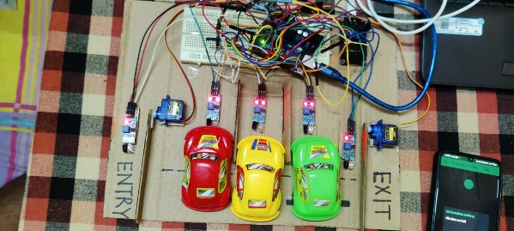

Fig 2:Overview of the hardware

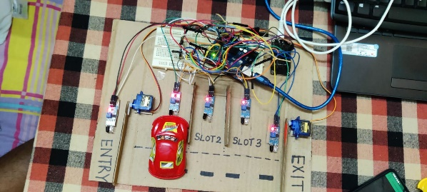

Fig 3: Case I( when only one car is parked)

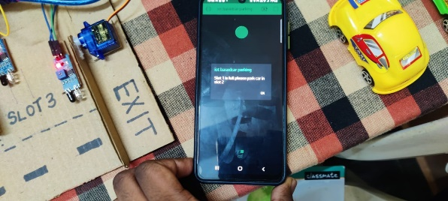

Fig 4. Notification in the BLYNK app

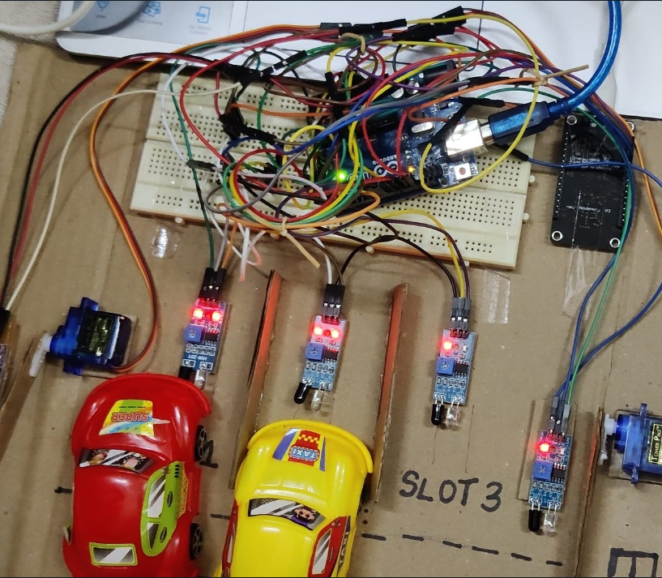

Fig 5.CASE II

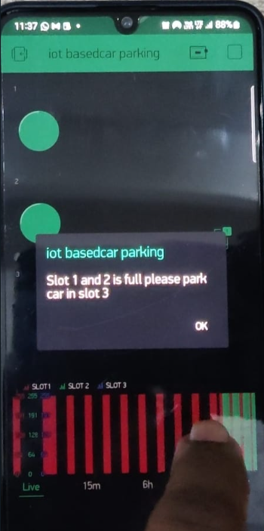

Fig 6. Notification in blynk app

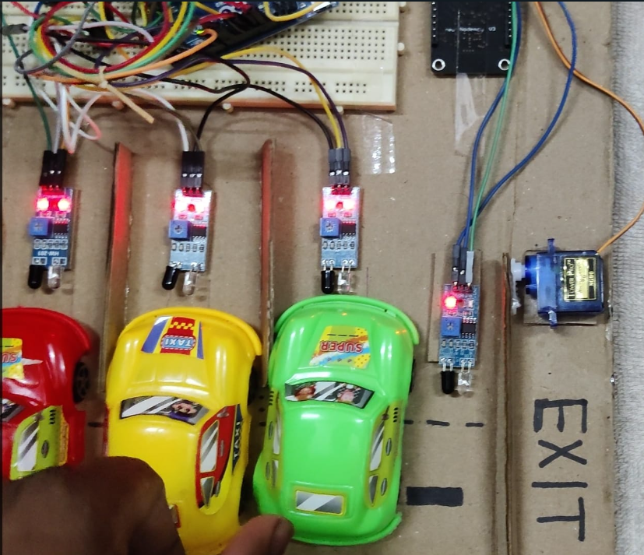

Fig7. Case III



Fig8.Notification in Blynk app

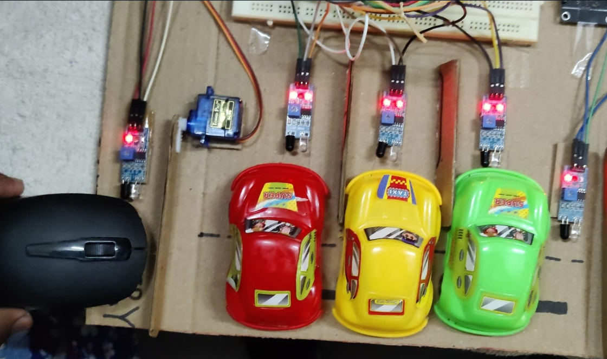

Fig 9.when fourth car tries to enter

When a car is parked in the Slot 1 as seen in (fig 3)The user gets updated with the same information on the Blynk app ,a LED glows in front of slot 1 in the Blynk application indicating that slot 1 is full and it also notifies to the user by sending a notification to park the car in slot 2 (free slot),as seen in (fig 4).

Now moving to the next scenario where two cars are parked in the parkin lot as seen in fig 5. So now the Led corresponding to Slot1 and 2 both would be glowing in the Blynk app stating that there are vehicles already parked in those slots. So the user gets notification on the Blynk app saying to park the car in slot 3(free slot).[fig 6].

Now when all the slots are full as seen in fig7 the user gets notification about the same on the Blynk app and all the three LED corresponding to the 3 slots would glow as seen in fig 8,now if another vehicle tries to enter the parking lot the entry gate would not open as already all the slots are full.as seen in fig[9]

# **VI. CONCLUSION**

From our project we conclude that our **IoT based Intelligent Parking System** is better alternative to searching for free parking slots by the driver in the busy metropolitan area where we face a hectic traffic. In our project we used BLYNK application, which collects real time data of the parking slot and gives the prior information to the driver, before arriving to the parking lot, which we adopted from our base papers. so that the driver spends lesser timer in parking his car in the busy area. Also, we replaced BLE beacons which is already used in the existing work ,with IR sensor for better accuracy. Our future upgradations which can be done in our project will be

1. Parking hours for the allotted slot are monitored in a smart way
2. Driver will be notified about the parking fee through smart mode(SMS or through any IOT app)
3. Exact timing of parking is calculated and reasonable charges only will be charged for the parked vehicle. Once the parking fee is paid the driver is allowed to move the vehicle out of the parking lot. This will be most suit for elevated parking systems in the metropolitan cities.

**VII. COMPARISION**

As taking the final experiment of IOT based smart car parking we have used cloud, Arduino, node MCU and blink to get the information where else in [6] they proposed BLE beacons which transmit low power and implement special interest and these are plotted at parking location where to avoid physical tampering Where we use IR sensor to detect the object in front of it at particular range which allot the free slots and give messages through blink. which is efficient than BLE.

In urban areas the front-end system [1] is used for parking where it is used webcam to capture the photos and send them to database server then it identify the free slot using detection algorithm. Where our project is little similar to this, but we used IR sensor which take less time to detect compare to webcam which verifies with data base.

To collect the data and to control there are many ways where as in [12] they used RFID sensor which is also used in many places but here we get the value from node MCU to blink app which make it more sufficient for the user..

**REFERENCES:**

[1]. Yao-Huei Huang, Cheng-Hung Hsieh,A decision support system for available parking slots on the roadsides in urban areas,Expert Systems with Applications,Volume 205,2022,117668,ISSN

0957-4174

2.Rajeswari, S.R. (57197121260); Guha, Rohit Kumar (57210209497); Gautam, Shubham (57210214044); Rahman, Adwitiya (57210208476); Pavani, T.V.R. (57210204045),IoT based car parking mechanism and control system(2019) International Journal of Recent Technology and Engineering, 8 (1 Special Issue4), pp. 371 - 373

3. Ali Aliedani, Seng W. Loke,Cooperative car parking using vehicle-to-vehicle communication: An agent-based analysis,Computers, Environment and Urban Systems,Volume 77,2019,101256

4. Muhammad Ibrahim, YunJung Lee, Hyun-Kook Kahng, Suyeon Kim, Do-Hyeun Kim,Blockchain-based parking sharing service for smart city development,Computers and Electrical EngineeringVolume 103,2022,108267,ISSN 0045-7906,

5. Saeliw, A., Hualkasin, W., Puttinaovarat, S., & Khaimook, K. (2019). Smart Car Parking Mobile Application based on RFID and IoT. International Journal of Interactive Mobile Technologies (iJIM), 13(05), pp. 4–14.

6. A. Mackey, P. Spachos and K. N. Plataniotis, "Smart Parking System Based on Bluetooth Low Energy Beacons With Particle Filtering," in IEEE Systems Journal, vol. 14, no. 3, pp. 3371-3382, Sept. 2020

7. Ji, Zhanlin, Ivan Ganchev, Máirtín O'Droma, Li Zhao, and Xueji Zhang. 2014. "A Cloud-Based Car Parking Middleware for IoT-Based Smart Cities: Design and Implementation" Sensors 14, no. 12: 22372-22393. https://doi.org/10.3390/s141222372

8. Mahmood Z., Haneef O., Muhammad N., Khattak S. AUTHOR FULL NAMES: Mahmood, Zahid (57190868120); Haneef, Ossama (57205725750); Muhammad, Nazeer (55803518500); Khattak, Shahid (57211811227)57190868120; 57205725750; 55803518500; 57211811227;Towards a fully automated car parking system(2019) IET Intelligent Transport Systems, 13 (2), pp. 252 - 259, Cited 19 times.DOI: 10.1049/iet-its.2018.5021

9. Burak Kizilkaya, Mehmet Caglar, Fadi Al-Turjman, Enver Ever,Binary search tree based hierarchical placement algorithm for IoT based smart parking applications,Internet of Things,Volume 5,2019,Pages 71-83,ISSN 2542-6605,https://doi.org/10.1016/j.iot.2018.12.001.

10. C. Jang, C. Kim, S. Lee, S. Kim, S. Lee and M. Sunwoo, "Re-Plannable Automated Parking System With a Standalone Around View Monitor for Narrow Parking Lots," in IEEE Transactions on Intelligent Transportation Systems, vol. 21, no. 2, pp. 777-790, Feb. 2020, doi: 10.1109/TITS.2019.2891665.

11. Stéphane Cédric Koumetio Tekouabou, El Arbi Abdellaoui Alaoui, Walid Cherif, Hassan Silkan,Improving parking availability prediction in smart cities with IoT and ensemble-based model,Journal of King Saud University - Computer and Information Sciences,Volume 34, Issue 3,2022,Pages 687-697,ISSN 1319-1578,

https://doi.org/10.1016/j.jksuci.2020.01.008.

12. P. Kanakaraja, L.S.P. Sairam Nadipalli, S.V. Aswin Kumer, K. Sarat Kumar, K. Ch. Sri Kavya,An implementation of advanced IoT in the car parking system,Materials Today: Proceedings,Volume 37, Part 2,2021,Pages 3143-3147ISSN 2214-7853,https://doi.org/10.1016/j.matpr.2020.09.042.

13. T. Arun Prasath, S. Selvaperumal, M. Paul Jeyaraj, M. Senthilkumar, R. Nagarajan,Smart parking system with real time scheduling using intelligent controller (https://www.sciencedirect.com/science/article/pii/S2214785321024081)

14. Adel Mounir Said, Ahmed E. Kamal, Hossam Afifi,An intelligent parking sharing system for green and smart cities based IoT,Computer Communications,Volume 172,2021,Pages 10-18,ISSN 0140-3664,https://doi.org/10.1016/j.comcom.2021.02.017.

15. Janak Parmar, Pritikana Das, Sanjaykumar M. Dave,Study on demand and characteristics of parking system in urban areas: A review,Journal of Traffic and Transportation Engineering (English Edition),Volume 7, Issue 1,2020,Pages 111-124,ISSN 2095-7564,https://doi.org/10.1016/j.jtte.2019.09.003.

16. A.V. Prabu, Apparao Tolada, Jyotirmaya Mishra, S. Rajasoundaran, Tharun Deepak,Automatic vehicle parking space booking system using IoT,Materials Today: Proceedings,2021,ISSN 2214-7853,https://doi.org/10.1016/j.matpr.2020.11.365.

17. Kianpisheh A., Mustaffa N., Limtrairut P., Keikhosrokiani P.AUTHOR FULL NAMES: Kianpisheh, Amin (41761820200); Mustaffa, Norlia (36608754600); Limtrairut, Pakapan (55316989400); Keikhosrokiani, Pantea (54420191700) 41761820200; 36608754600; 55316989400; 54420191700 Smart Parking System (SPS) architecture using ultrasonic detector (2012) International Journal of Software Engineering and its Applications, 6 (3), pp. 51 - 58, Cited 111 times. https://www.scopus.com/inward/record.uri?eid=2-s2.084866952271&partnerID=40&md5=25e5ebc06481b54f543ff5f9c81fdb61

18. Pennacchio S., Bellafiore E., Fontana F., Nevoloso O.,Pennacchio, Salvatore (8623690000); Bellafiore, Emanuele (8620001500); Fontana, Francesco (35960396900); Nevoloso, Orazio (8620001700)8623690000; 8620001500; 35960396900; 8620001700 A new algorithm for reverse car parking problem(2005) WSEAS Transactions on Circuits and Systems, 4 (4), pp. 374 - 378,

19V. Bharti, V. Sharma, K. Sureka and R. Agarwal, "A Novel Smart Parking System Using IoT," 2022 International Conference on Machine Learning, Big Data, Cloud and Parallel Computing (COM-IT-CON), 2022, pp. 806-810, doi: 10.1109/COM-IT-CON54601.2022.9850508.

20 R Aswatha, N Deepalakshmi, A Dinesh, R Arun Kumar and R Gokulram Published under licence by IOP Publishing Ltd, Volume 1916, 2021 International Conference on Computing, Communication, Electrical and Biomedical Systems (ICCCEBS) 2021 25-26 March 2021, Coimbatore, India

21M. M. Rashid, A. Musa, M. Ataur Rahman, and N. Farahana, A. Farhana, “Automatic Parking Management System and Parking Fee Collection Based on Number Plate Recognition.”, International Journal of Machine Learning and Computing, Vol. 2, No. 2, April 2012,Published 2014.

22. S. Kazi, S. Khan, U. Ansari and D. Mane, "Smart Parking based System for smarter cities," 2018 International Conference on Smart City and Emerging Technology (ICSCET), 2018, pp. 1-5, doi: 10.1109/ICSCET.2018.8537281.

23. P. Sadhukhan, "An IoT-based E-parking system for smart cities," 2017 International Conference on Advances in Computing, Communications and Informatics (ICACCI), 2017, pp. 1062-1066, doi: 10.1109/ICACCI.2017.8125982.

24. Y. Agarwal, P. Ratnani, U. Shah and P. Jain, "IoT based Smart Parking System," 2021 5th International Conference on Intelligent Computing and Control Systems (ICICCS), 2021, pp. 464-470, doi: 10.1109/ICICCS51141.2021.9432196.

25. V. Bharathi, M. Karpagam, S. Jeeva, L.K. Kiran,Smart parking guidance system using RASPBERRY-PI,Materials Today: Proceedings,2020,ISSN 2214-7853,https://doi.org/10.1016/j.matpr.2020.10.629.