# Word Documents Template

# Main heading:

Use the Heading 1 style for primary headings so that screen readers can identify them as such.

If not already, manually change your heading 1 style to be:

- sans serif (e.g. Arial, Verdana, Trebuchet or Calibri),

- 16 pt, and

- Bold

Then set this formatting as your default for this style.

Sub Headings:

Use Heading 2 style for sub headings.

If not already, manually change your heading 2 style to be:

- sans serif (e.g. Arial, Verdana, Trebuchet or Calibri),

- 14 pt, and

- Bold

Then set this formatting as your default for this style.

### Sub Sub Headings:

Use Heading 3 for sub sub-headings.

If not already, manually change your heading 2 style to be:

- sans serif (e.g. Arial, Verdana, Trebuchet or Calibri),

- 12 pt, and

- Bold

Then set this formatting as your default for this style.

**Paragraph**

Paragraphs should not be styled as headings. Paragraphs should be ‘normal’ style.

They should be:

* Sans serif font, 12 point
* 1.5 spacing (except for lists of bullet points)
* Left aligned instead of justified

Then set this formatting as your default for this style.

**Your document should also:**

* Leave sufficient white space at either side of the page
* Avoid using block capitals or italics. Use bold to make text stand out instead.

## To amend default styles:

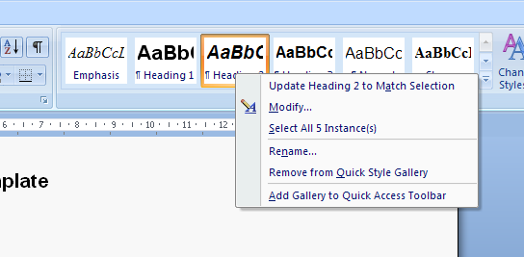

Amend the style in line with the above guidelines then right click the style in question under the home tab. Choose ‘modify’ from the drop down list. This will open a box.

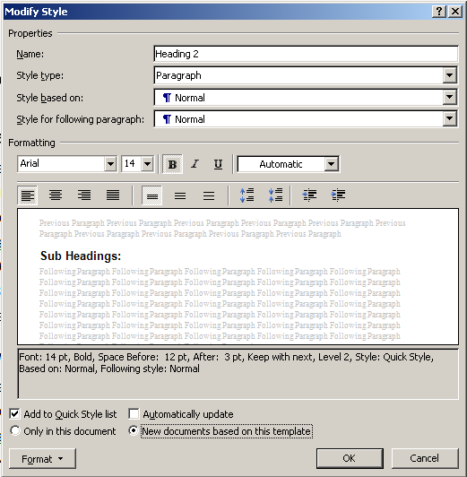

Within the box, ensure that the style is formatted to your preferences. For example, if ‘italics’ is checked, uncheck it.

Choose the radio button that states: ‘New documents based on this template’, and click ‘okay’.

## Image of the 'paragraphy' dislogue box.

## To amend paragraph defaulting:

Left click ‘paragraph’ under the home tab.

Ensure your alignment is set to ‘left’ and line spacing is set to ‘1.5 lines’.

Once your settings are correct click ‘default’.

Click ‘yes’ on the resulting ‘Are your sure’ message.

## To test your new settings

Open a new document and test each heading and paragraph style to ensure all settings have been saved.

## Table Usage

Construct tables to read logically from left to right, top to bottom order.

Tables with column headings in the top row must have the top row formatted as a header row. To set a table header row:

* Highlight the top row of the table
* Right click to display editing options
* Select “**Table Properties**” from the list.

The Table Properties window will be displayed; click on the “**Row**” tab

Check the option “**Repeat as header at the top of each page**”

|  | Col 1 | Col 2 | Col 3 | Col 4 |
| --- | --- | --- | --- | --- |
| Row 1 |  |  | Row 1, Cell 3 |  |

## Images

Alternative or Alt text is required for all images in a document (excluding purely decorative images without meaningful content).

* **Right-click** on the image;
* Select **Format Picture**.
* The **Format Picture** dialog box will appear. Select the **Web** tab.
* In the **Alternative text** box, type in the description of the image.
* Click “**OK**”.

Rationale for following Clear Print Guidelines

Example A:

Example A is Times New Roman, size ten, with single spacing. Example B is Arial, size twelve with 1.5 spacing. As you can see, smaller font sizes, single spacing and serif fonts are harder to read. Additionally, it is easier to keep one’s place on a page with left aligned text, as in example B, as left alignment gives the body of the text a specific shape and gives uniformity between words. Example A, which is justified, has no natural shape. Furthermore, bold print stands out**,** and does *not distort the shape of text as italics* and underlining do. FINALLY, BLOCK CAPITALS CAN BE DIFFICULT TO FOLLOW AS BLOCK CAPITALS REMOVE THE NATURAL SHAPE OF WORDS, TURNING THEM INTO BLOCKS. Clear layout allows one to focus on the content of visual materials rather than the format.

Example B:

Example A is Times New Roman, size ten, with single spacing. Example B is Arial, size twelve with 1.5 spacing. As you can see, smaller font sizes, single spacing and serif fonts are harder to read. Additionally, it is easier to keep one’s place on a page with left aligned text, as in example B, as left alignment gives the body of the text a specific shape and gives uniformity between words. Example A, which is justified, has no natural shape. Furthermore, **bold print stands out,** and does not distort the shape of text as italics and underlining do. Finally, block capitals can be difficult to follow as block capitals remove the natural shape of words, turning them into blocks. Clear layout allows one to focus on the content of visual materials rather than the format.

## Furthermore

If you use headings it makes the creation and upkeep of tables of contents easier (For automatic creation and updating go to: Insert – Reference – Index and Tables – Table of contents).