

**MS Word**

**Exercise**

1.

Locate Microsoft Word and open a new document.

2.

Type the following text:

He was an old man who fished alone in a skiff in the Gulf

Stream and he had gone eighty

-

four days now without taking

a fish.

Ernest Hemingway: The Old Man and the Sea (1952)

3.

Italicize the text.

4.

Underline the title of the story.

5.

Bold the author’s name.

6.

Increase the font size to 14.

7.

Change the font style to (your choice!).

8.

Adjust the line spacing to 2.0 (double space).

9.

Spellcheck your work.

10.

Use Save As to save your document to

the M Drive. Name the document

The

Old Man and the Sea.

11.

Inse

rt a picture onto your document (find an image from the internet,

save it to the M drive).

12.

Add a numbered list with your top three favourite authors (or movie

stars, etc.).

13.

Save your work.

*He was an old man who fished alone in a skiff in the Gulf Stream and he had gone eighty-four days now without taking a fish.* ***Ernest Hemingway****: The Old Man and the Sea (1952)*

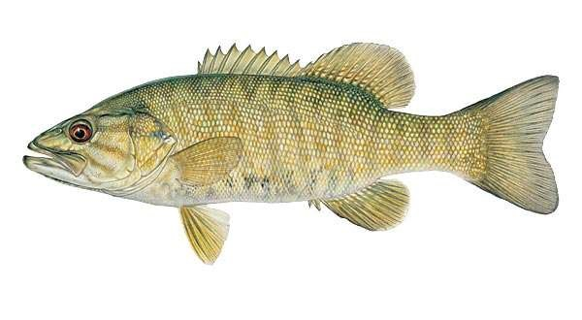

1. Ernest Hemingway
2. Margaret Atwood
3. Joseph Boyden