**Create an Instance in US East(N.Virginia) with an Ubuntu OS and install Nginx for making them web servers**

**Step-1:** Go to Amazon console at <https://aws.amazon.com/console/> , and in EC2 service in the navigation bar at the top of the screen, select US East (N.Virginia). From the Amazon EC2 console dashboard, choose Launch instance.

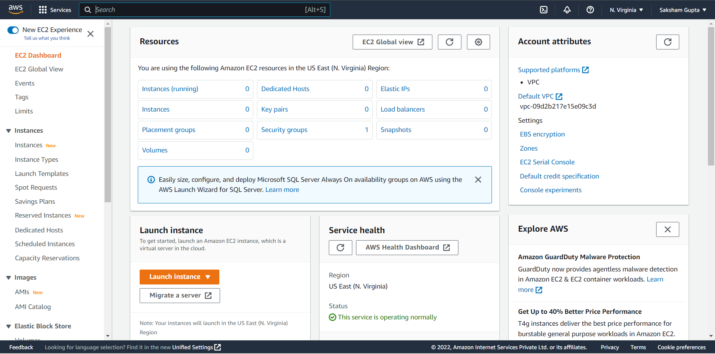

**Step-2:** Enter a descriptive name for the instance

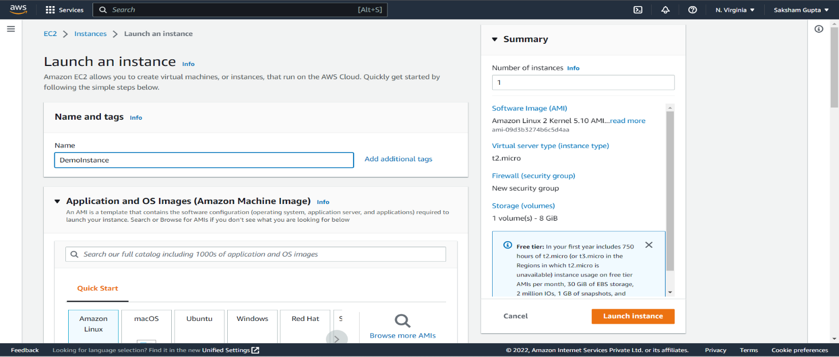

**Step-3:** Under Application and OS Images (Amazon Machine Image), choose Quick Start, and then choose the Ubuntu server 22.04 LTS (HVM), SSD Volume Type for your instance

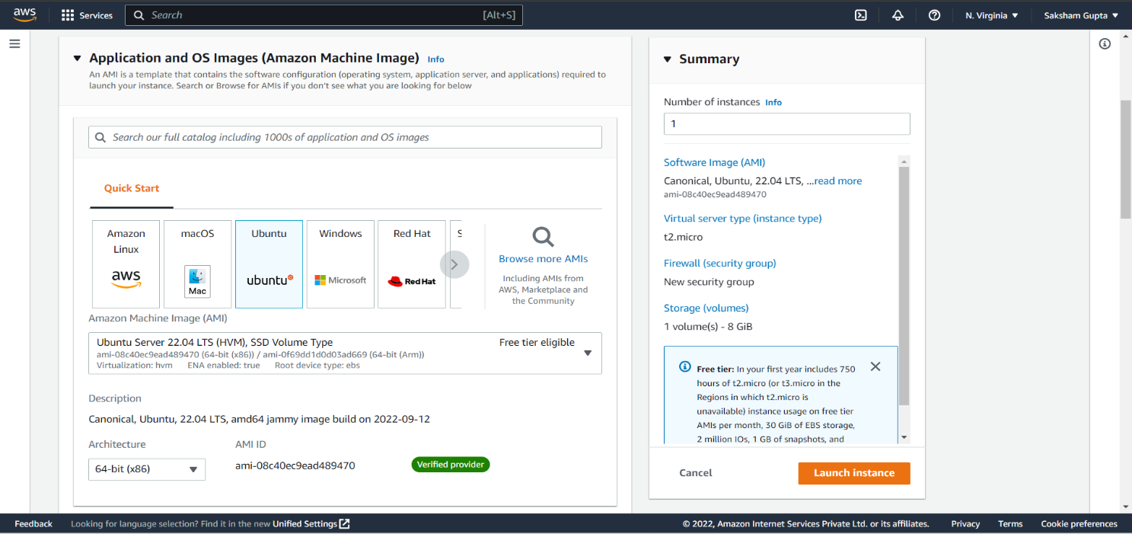

**Step-4:** For Instance type select free tire Instance type for the Instance & For key pair choose an existing key pair. Launch the Instance.

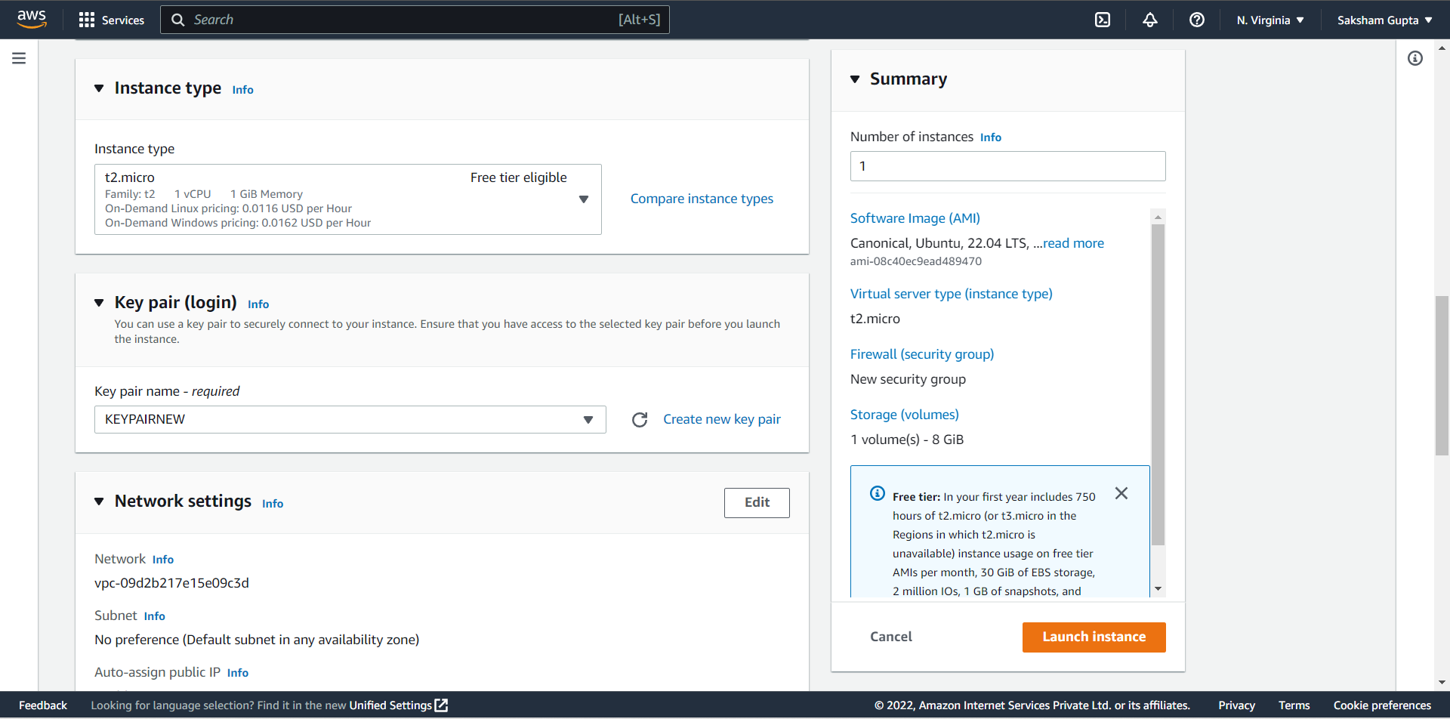

**Step-5:** When the Instance is launched, on the dashboard select that instance click on the connect on the top of the dashboard bar; U will be redirected to a Ubuntu page of AWS. Give first command ‘clear’ and then press enter. After that give command ‘sudo apt-get update’ and then ‘sudo apt-get install nginx -y’.

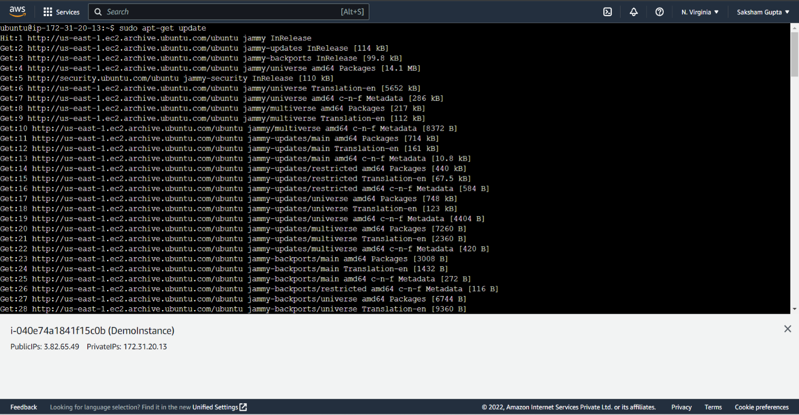

After sudo apt-get install nginx -y:

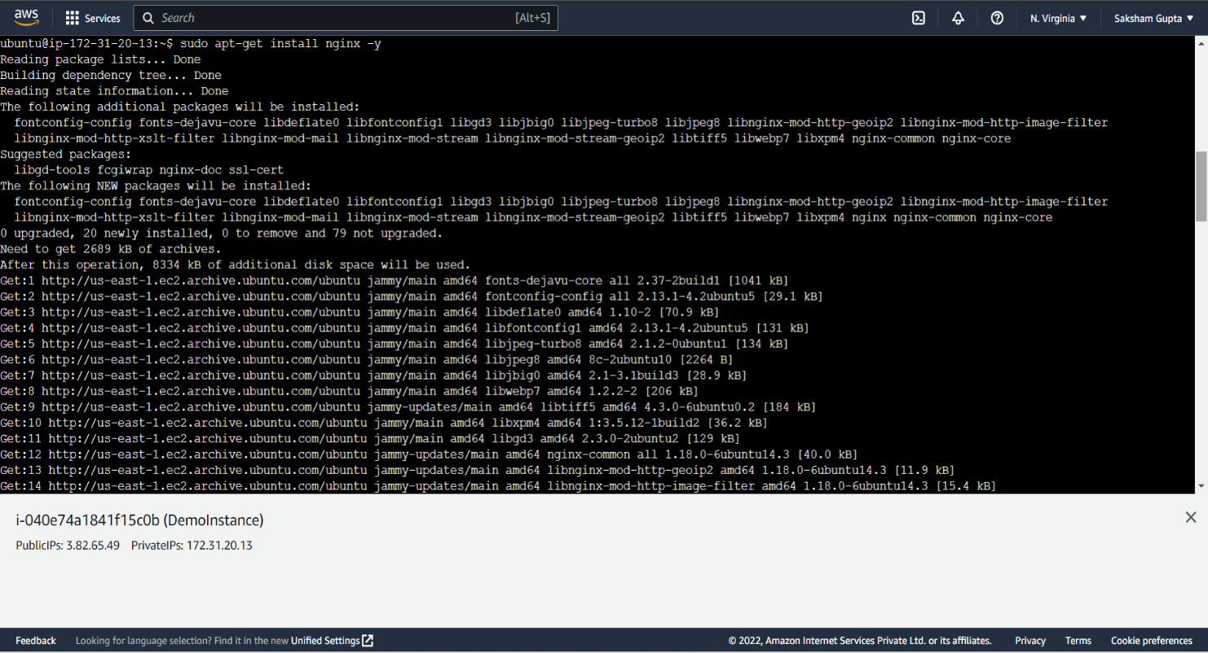

**Step-6:** Now copy the public IP written downside and paste it into a new chrome tab

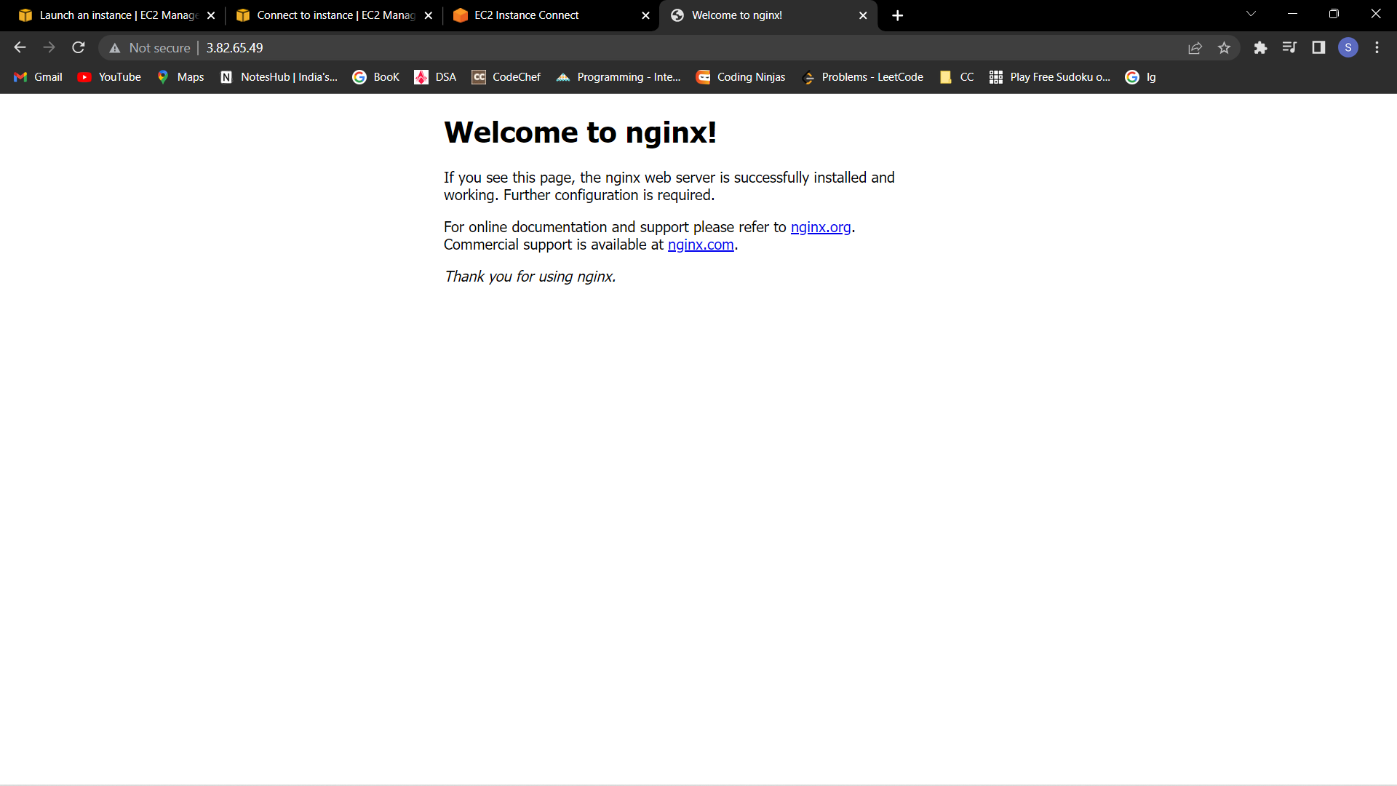

**Change the Default Website with a hello page**

**Step-7:** For 2nd question, enter command ‘clear’ then enter commands:

1. cd /var/www/html
2. ls
3. sudo rm index.nginx-debian.html
4. sudo nano index.html

Enter these commands

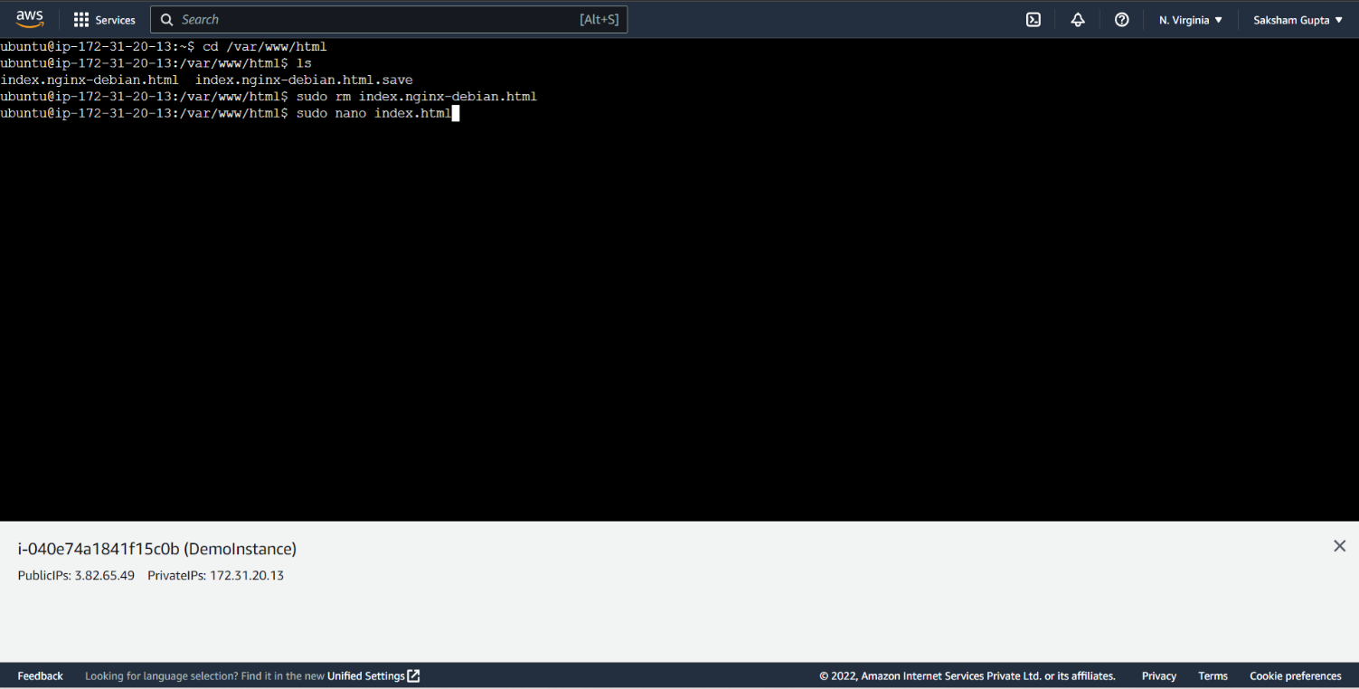

**Step-8:** Enter ‘Hello World’

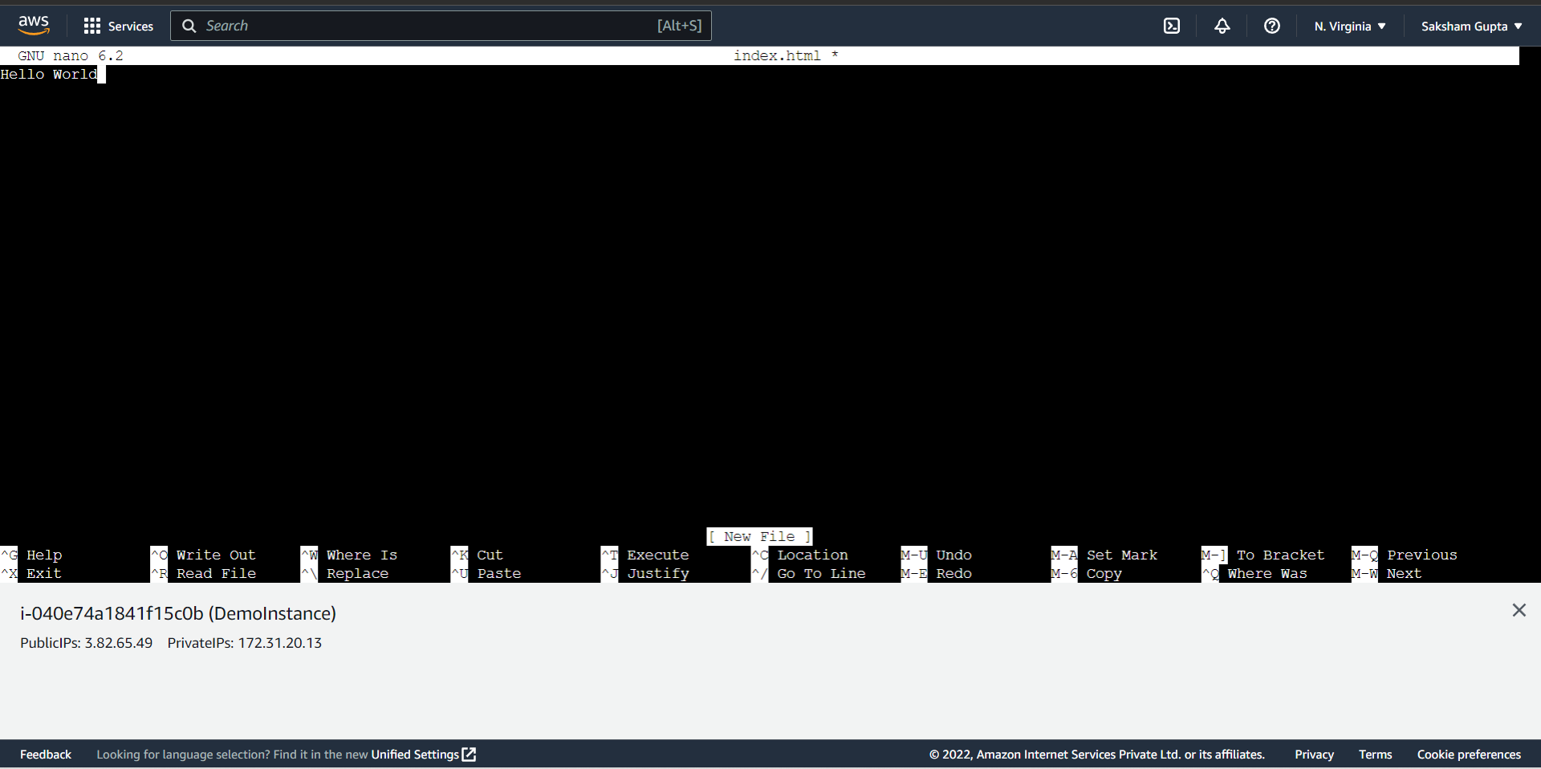

**Step-9:** Copy the public IP and paste in a new chrome tab

