1. Write a PL/SQL program to arrange the number of two variable in such

a way that the small number will store in num_small variable and large

number will store in num_large variable.

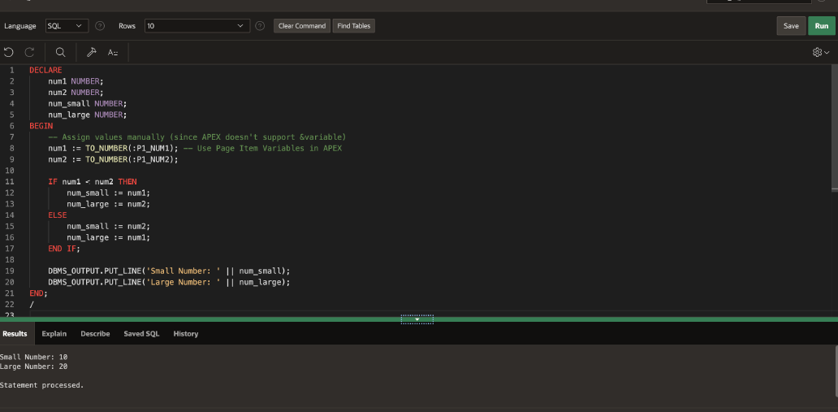

2. Write a PL/SQL program to check whether a number is even or odd.

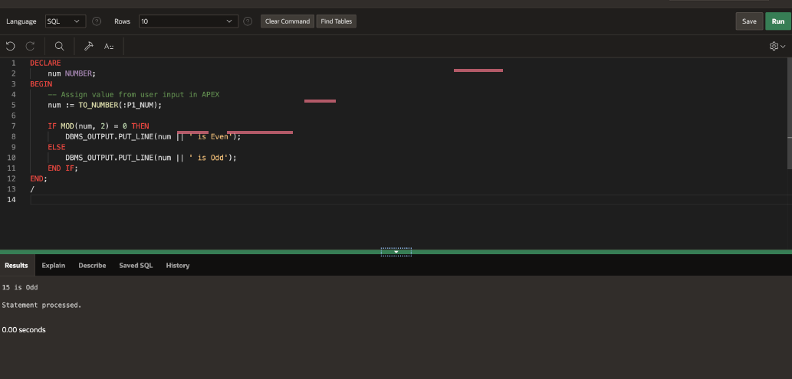

3. Write a PL/SQL program to display the description against a grade.

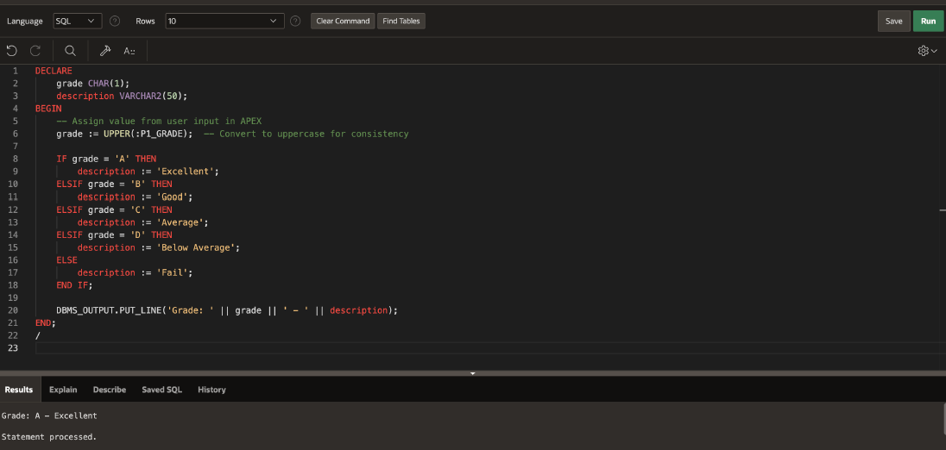

4.Write a PL/SQL program to display the description against a grade using

CASE statement

