Dbms_lab_assignment_4

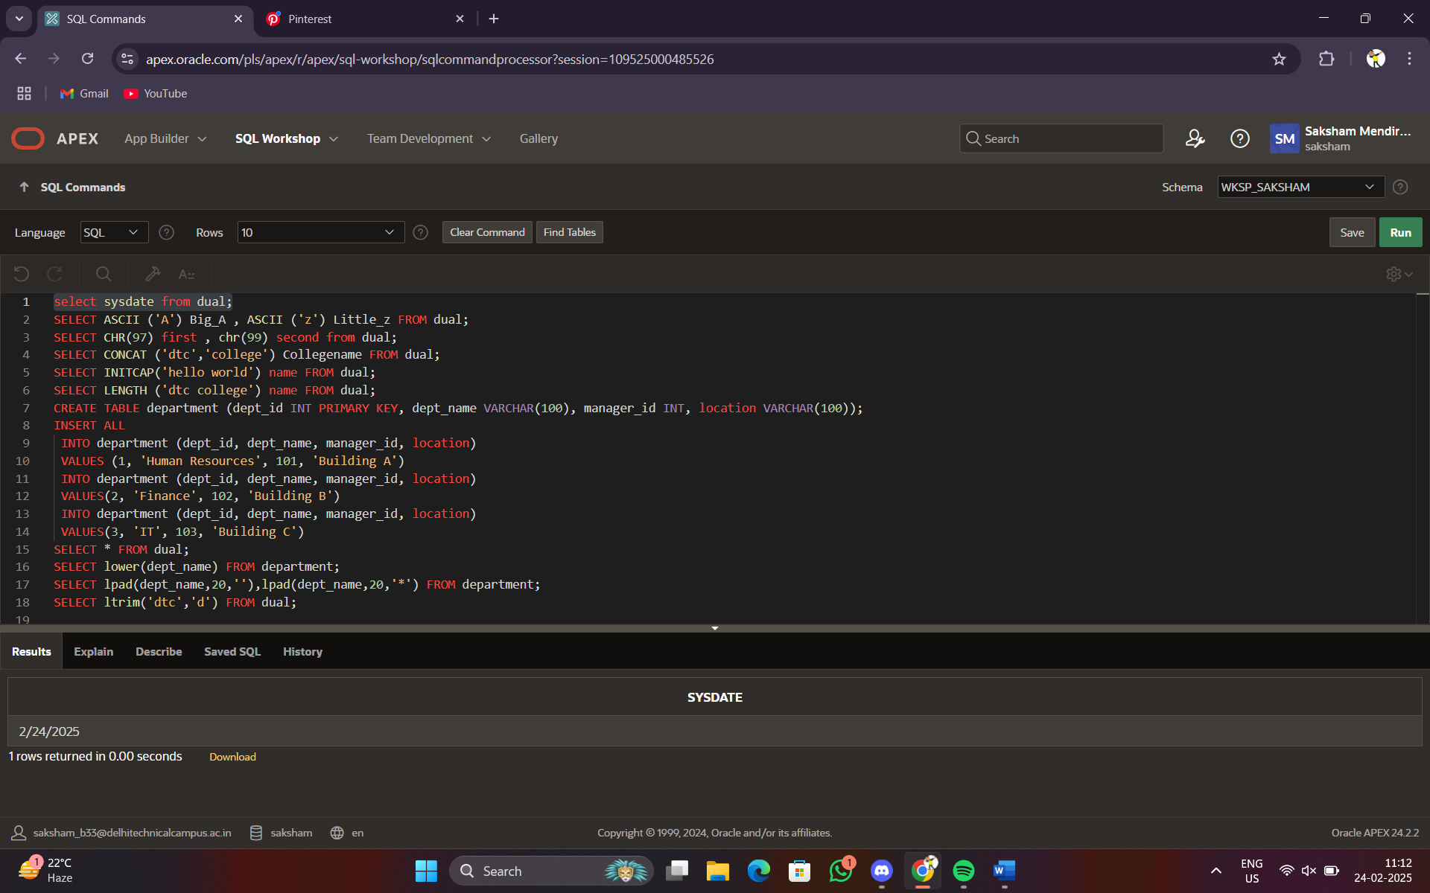

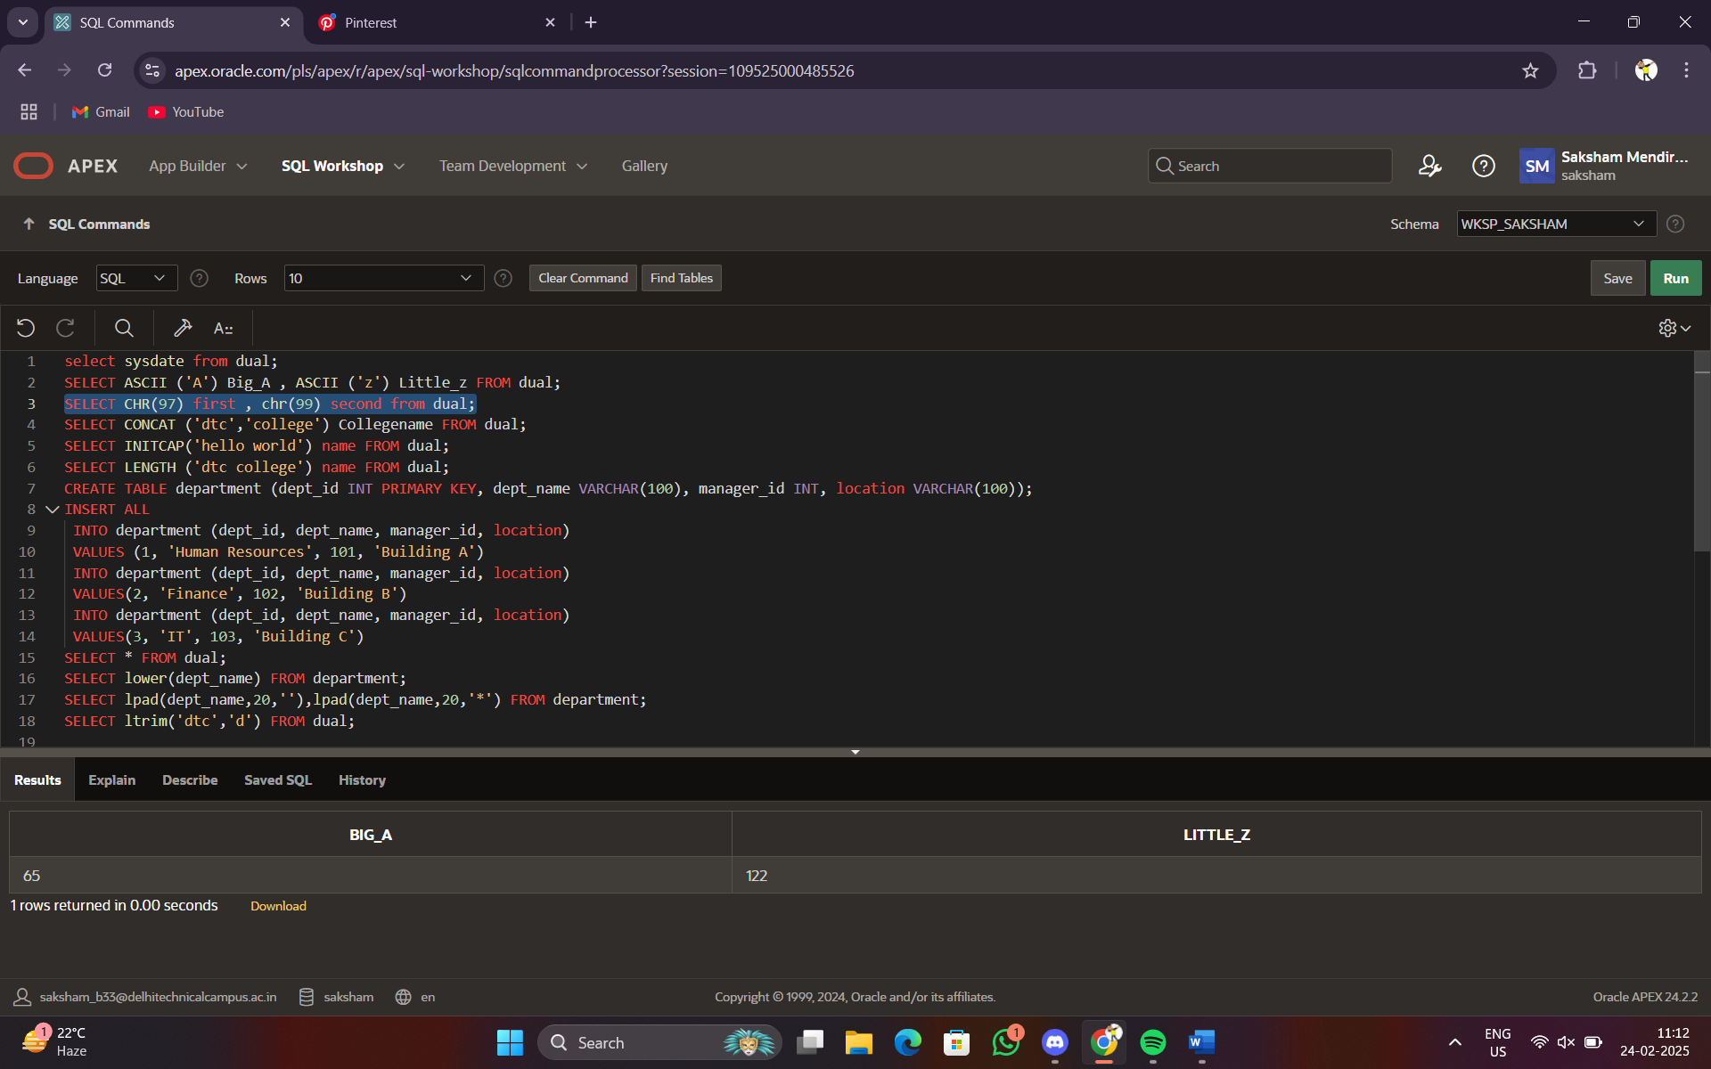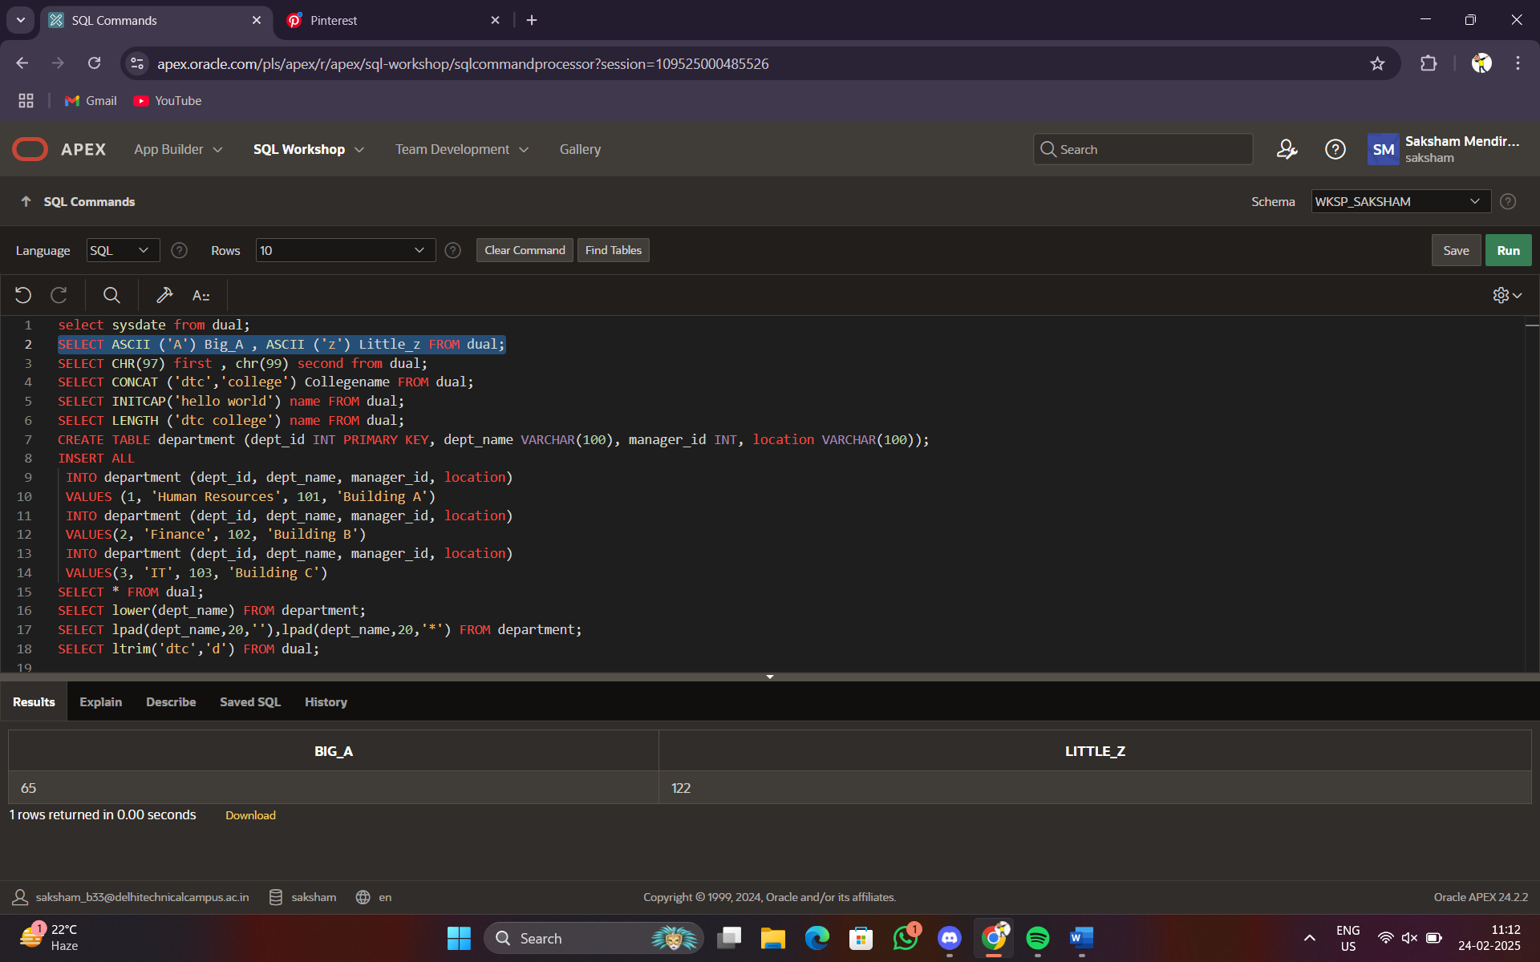

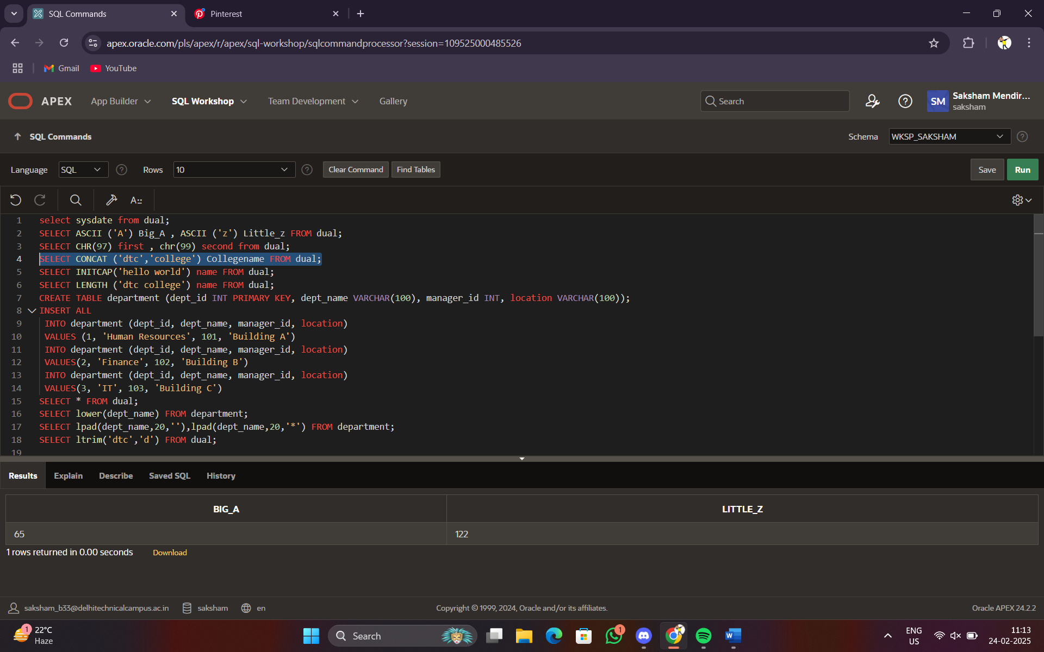

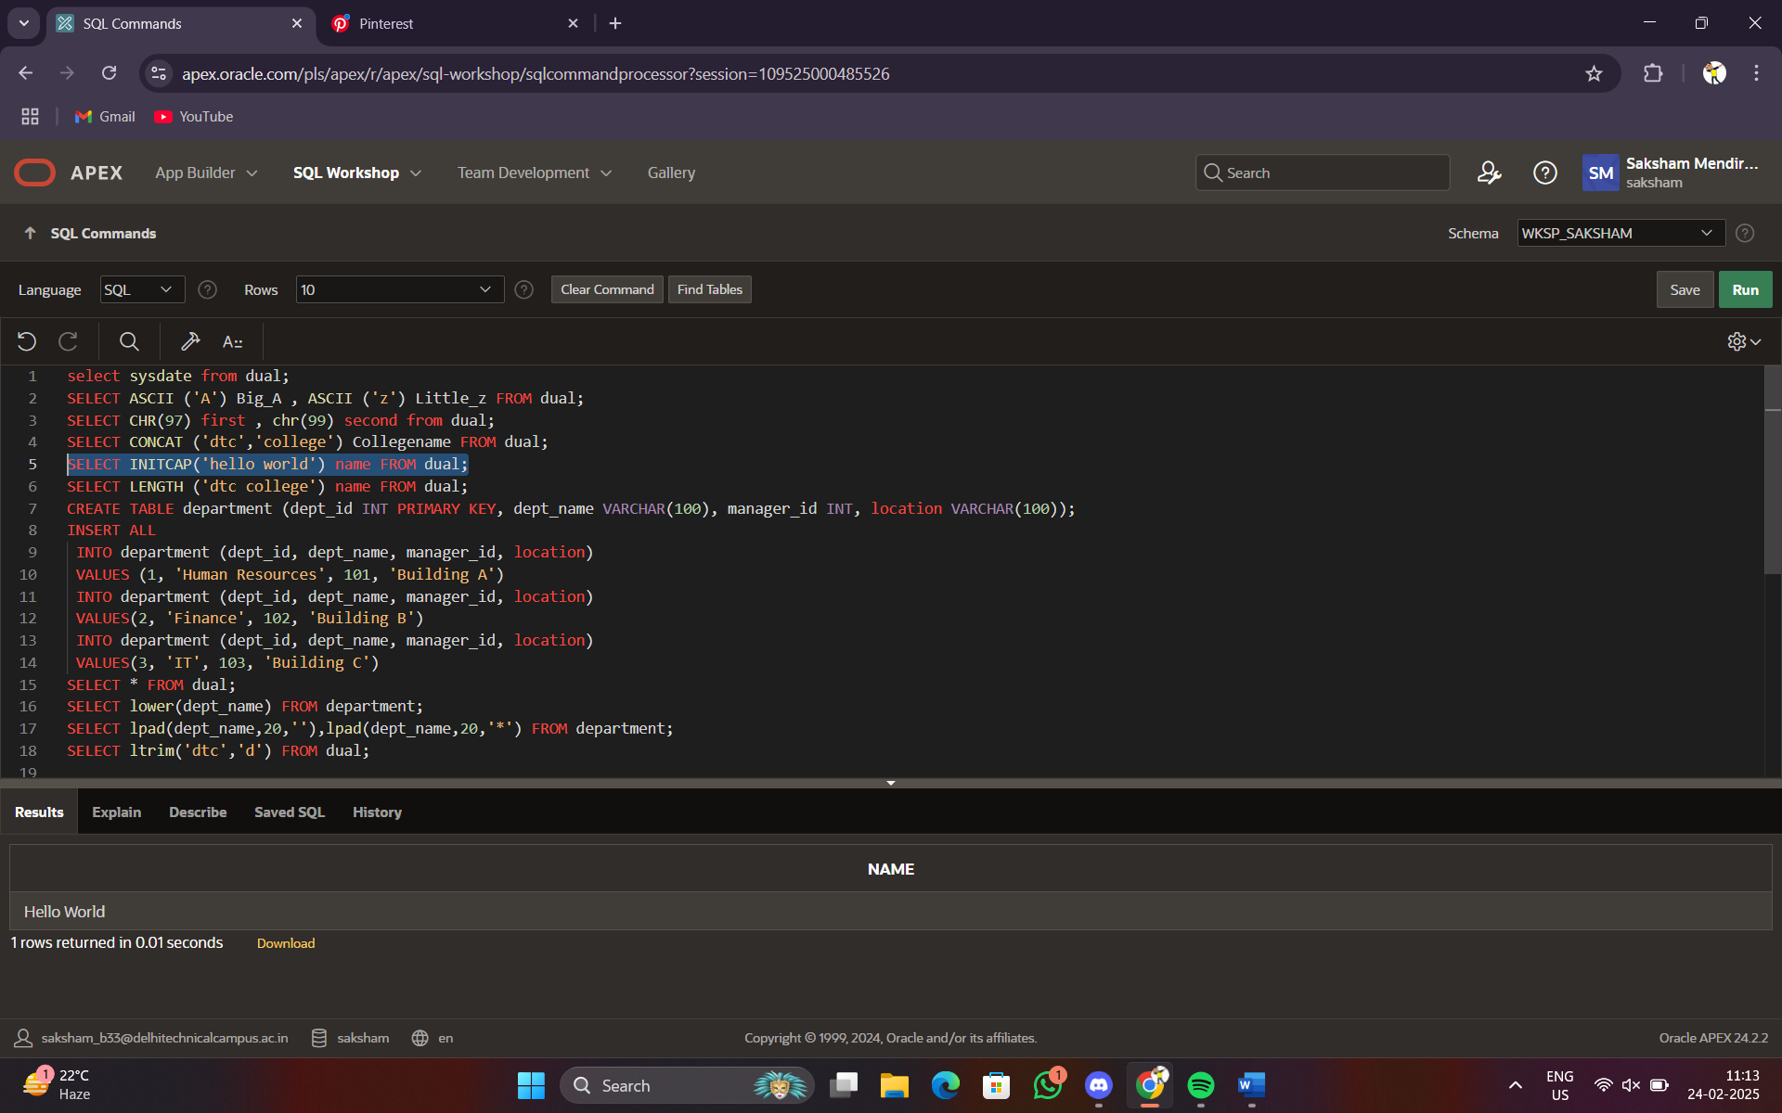

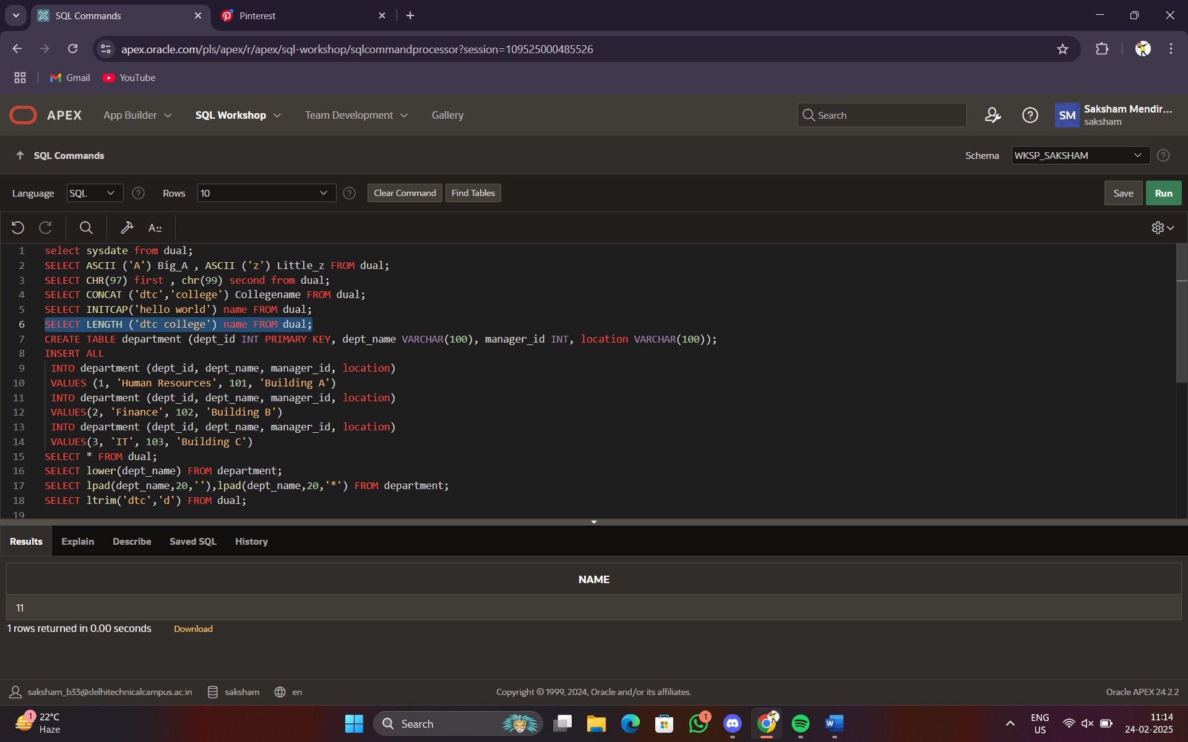



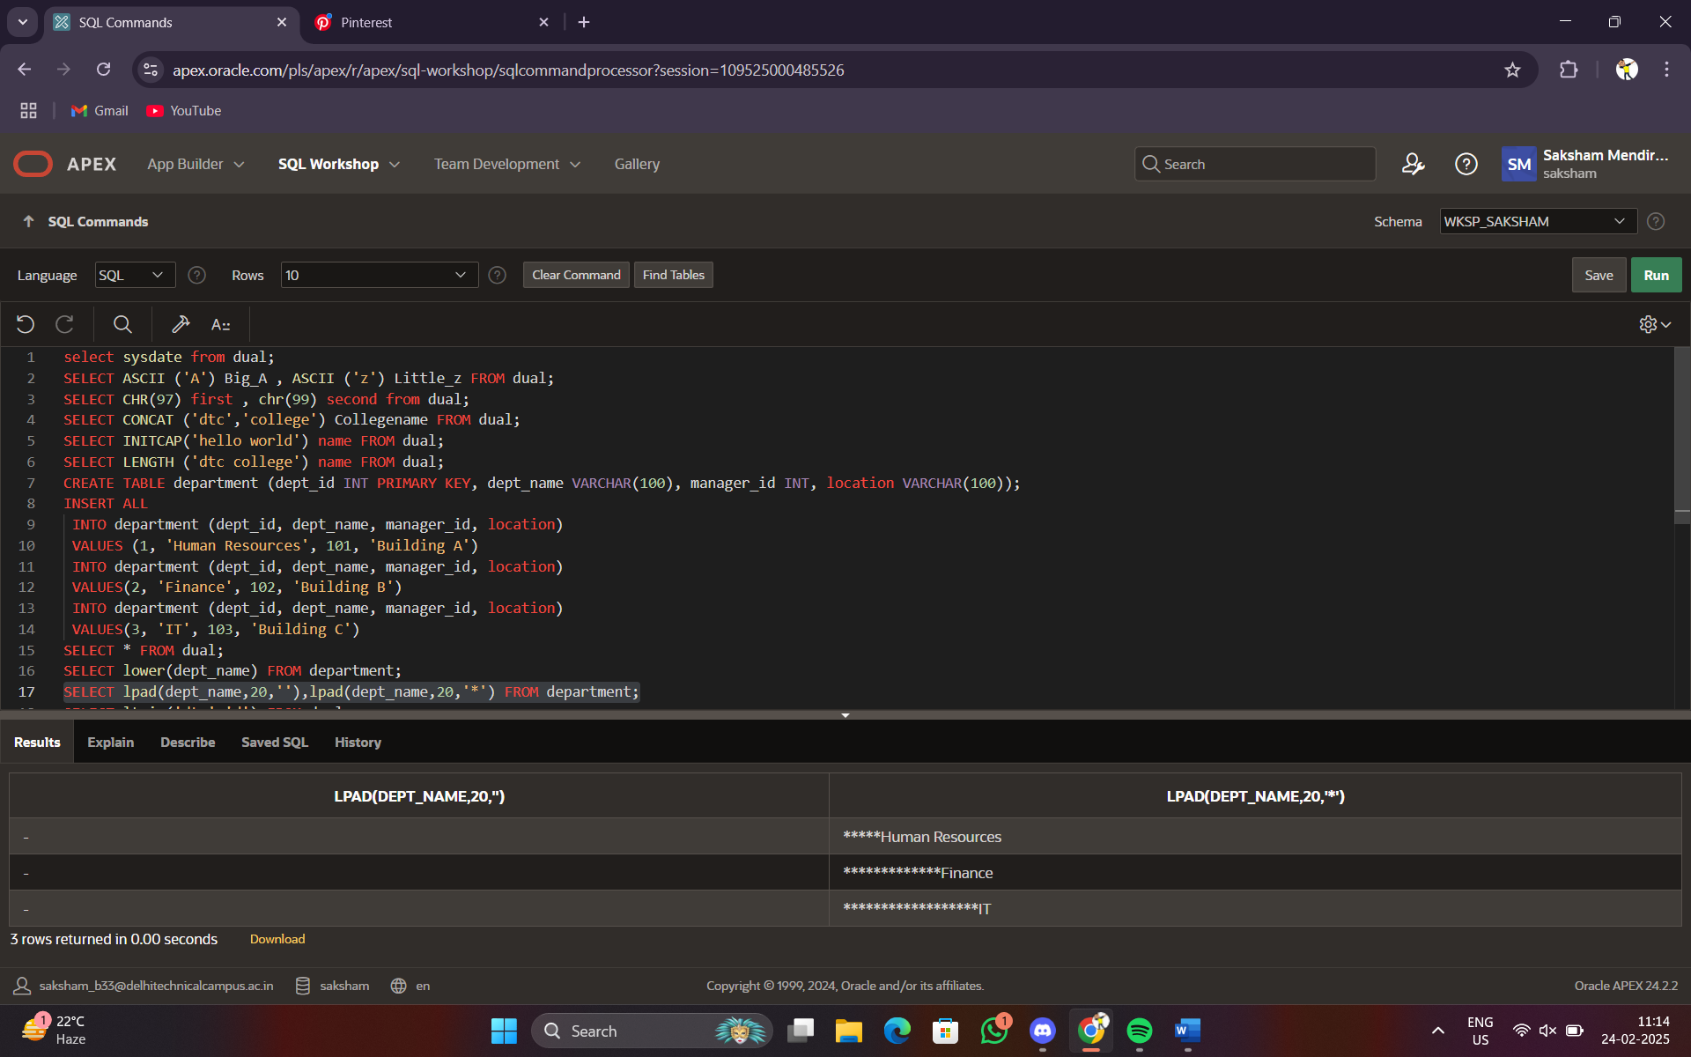

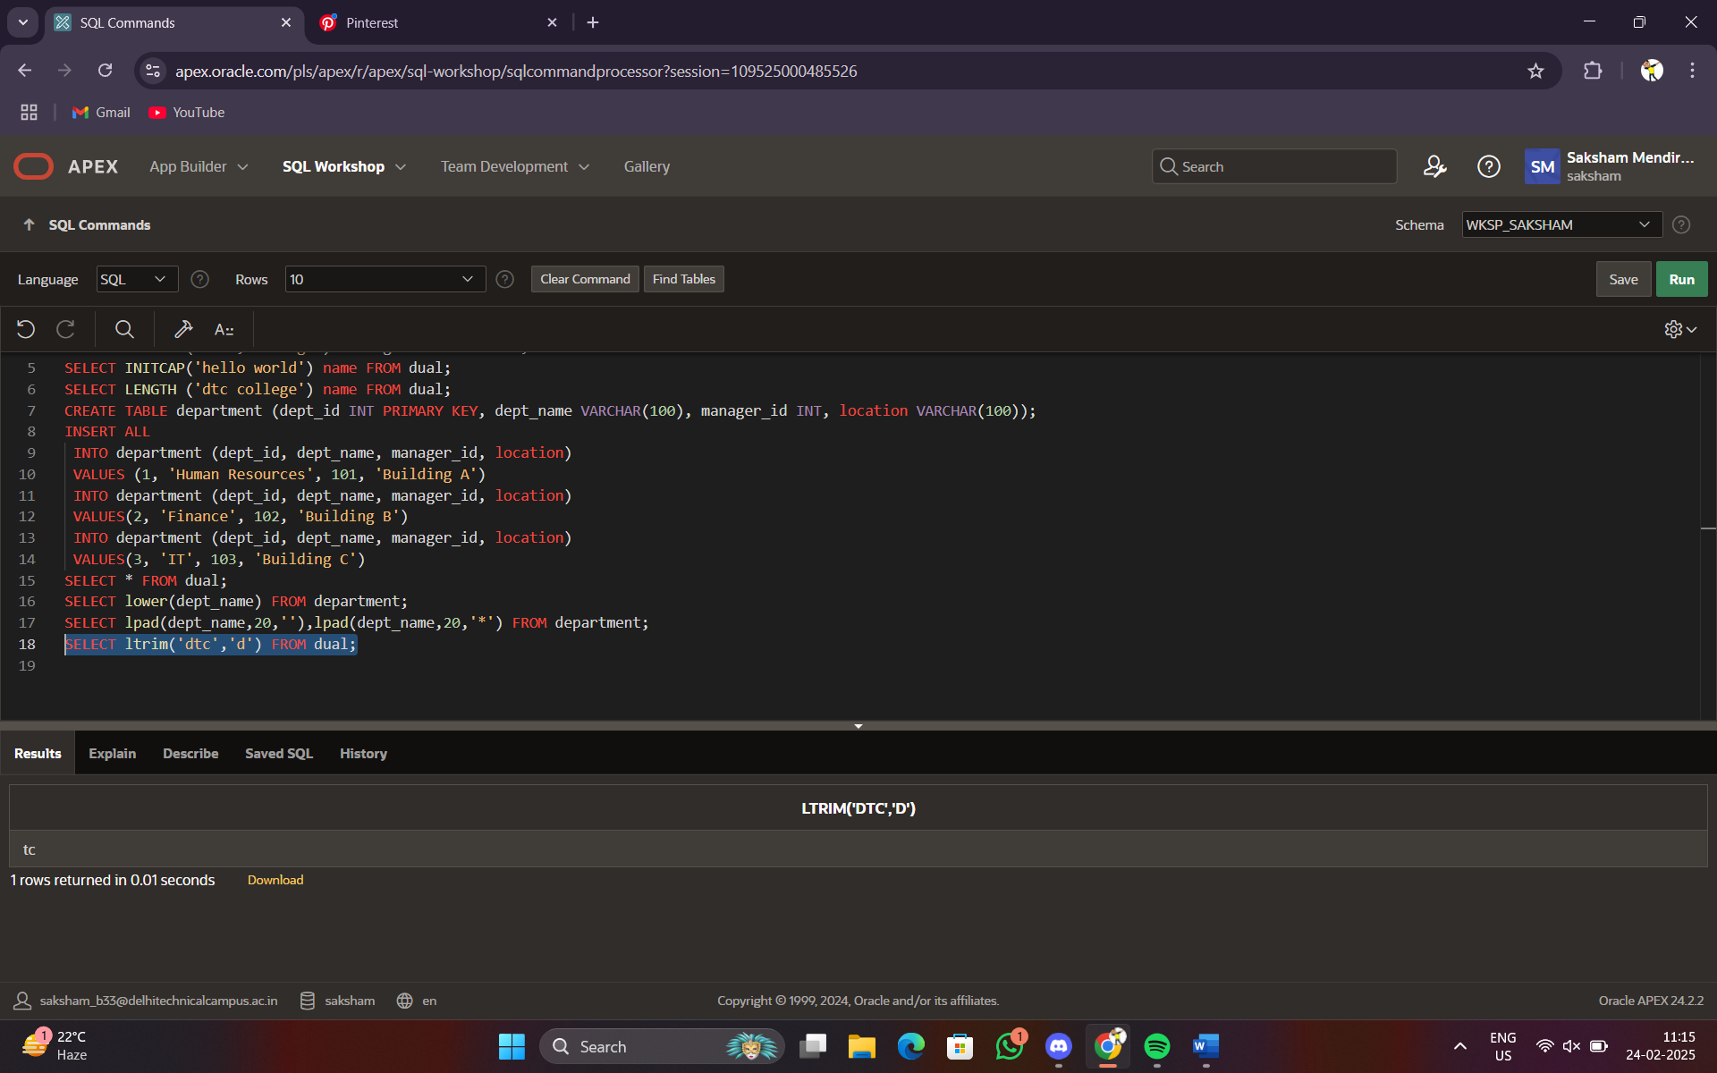

FUNCTIONS USED-

ASCII(<cl>)

CHR(x)

CONCAT(<cl1>,<cl2>)

INITCAP(<cl>)

LENGTH(<c>)

LOWER(<c>)

LPAD(<c1>,<i>,k[<c2>])

LTRIM(<c1>,<c2>)

RTRIM(<C1>,<C2>)

REPLACE

SUBSTR

TRANSLATE

TRIM

UPPER