

**Sub queries**

1. 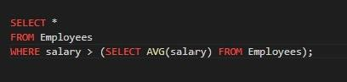Find employees earning more than the company’s average salary.

Output-



1. Get the second highest salary in the company.

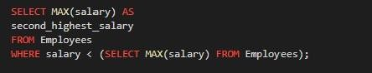

Output-



1. Find departments that have no employees.



Output-



1. List customers who have placed at least one order.

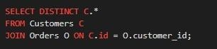

Output-



1. Find the employees who joined most recently.



Output-



1. Find products that have been ordered at least once.

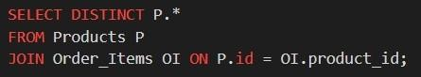

Output-

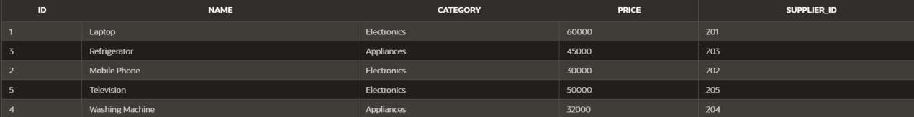

1. Retrieve employees whose salary is higher than their department’s average salary.

Output-



1. Get the department with the highest number of employees.



Output-



1. Find customers who have never placed an order.



1. Find products that are more expensive than the most expensive product in the category ‘Electronics’.
2. Find the order(s) with the highest total amount.



Output-



1. List suppliers who supply at least one product with a price greater than

$500.

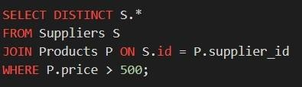

Output-

