Deadlock Prevention & Recovery Toolkit (deadlockd)
CA2 — Continuous Assessment Report

Name | Sagar Tailor
Registration No. | 12405192
Subject | Operating Systems
Assessment | CA2 — Mini Project Report
Project Title | Deadlock Prevention & Recovery Toolkit
Repository | https://github.com/sagartailor-star/deadlockd
Technology Stack | Go (Backend), Next.js 16 + TypeScript (Frontend)
Date | April 2026

1. Abstract
This report presents the design, implementation, and evaluation of deadlockd — a real-time deadlock prevention and recovery toolkit built as an operating system simulation platform. The system models process–resource allocation, detects deadlocks via Wait-For Graph cycle analysis using iterative Depth-First Search, prevents unsafe resource allocation states using Banker's Algorithm, and recovers from deadlocks using victim-selection and process termination heuristics. The platform features a concurrent Go backend engine with WebSocket-based real-time state streaming, and a Next.js + React Flow frontend for live Resource Allocation Graph (RAG) visualization. Testing demonstrates stable execution with nanosecond-precision performance telemetry across configurable stress loads up to 10,000 concurrent processes.

2. Introduction

2.1 Problem Statement
Deadlocks remain one of the most critical challenges in operating system design. A deadlock occurs when a set of processes are each waiting for a resource held by another process in the set, creating a circular dependency from which no process can proceed. The four necessary conditions for deadlock — Mutual Exclusion, Hold and Wait, No Preemption, and Circular Wait — must all be present simultaneously.
Understanding deadlock dynamics is essential for operating systems students and researchers, yet existing educational tools provide limited interactivity and lack real-time visualization of resource allocation states.

2.2 Objectives
The objectives of this project are:
1. Simulate process–resource allocation with realistic concurrency semantics using Go goroutines and channels
2. Detect deadlocks in real time using Wait-For Graph construction and iterative DFS cycle detection
3. Prevent unsafe states using a snapshot-based implementation of Banker's Algorithm
4. Recover from detected deadlocks using process termination heuristics with victim selection
5. Visualize the complete system state through a professional, real-time web dashboard
6. Benchmark algorithm performance with nanosecond-precision instrumentation

2.3 Scope
The system provides an interactive sandbox for manual resource request injection, pre-built deadlock scenarios for academic demonstration, deterministic execution modes (pause, step, resume), and configurable stress testing. The entire platform is containerized with Docker Compose for reproducible deployment.

3. Literature Review

3.1 Deadlock in Operating Systems
Deadlock is formally defined by Coffman et al. (1971) as a state where each process in a set is waiting for an event that can only be caused by another process in the set. Silberschatz, Galvin, and Gagne (2018) in Operating System Concepts describe four strategies for handling deadlocks: prevention, avoidance, detection and recovery, and ignorance (the Ostrich Algorithm).

3.2 Banker's Algorithm
The Banker's Algorithm, proposed by Dijkstra (1965), is a deadlock avoidance algorithm that simulates resource allocation for all possible activities before deciding whether allocation should proceed. The algorithm maintains a safe state — a state from which the system can allocate resources to each process in some order and still avoid a deadlock. The time complexity of the algorithm is O(n² × m), where n is the number of processes and m is the number of resource types.

3.3 Wait-For Graph
Holt (1972) introduced the concept of resource allocation graphs as a tool for deadlock detection. In a Wait-For Graph (WFG), a directed edge from process P_i to P_j indicates that P_i is waiting for a resource held by P_j. A cycle in the WFG indicates a deadlock. Detection via DFS has a time complexity of O(V + E), where V is the number of processes and E is the number of wait-for edges.

3.4 Recovery Strategies
Tanenbaum and Bos (2014) describe several recovery strategies including process termination (aborting one process at a time until the deadlock cycle is eliminated) and resource preemption. The victim selection heuristic used in this project selects the process holding the maximum total allocated resources, minimizing the number of required terminations.

4. System Architecture
The system follows a two-tier client-server architecture with a Go concurrency engine as the backend and a Next.js React application as the frontend. Communication between the two tiers is handled via a persistent WebSocket connection streaming JSON-encoded system snapshots in real time.
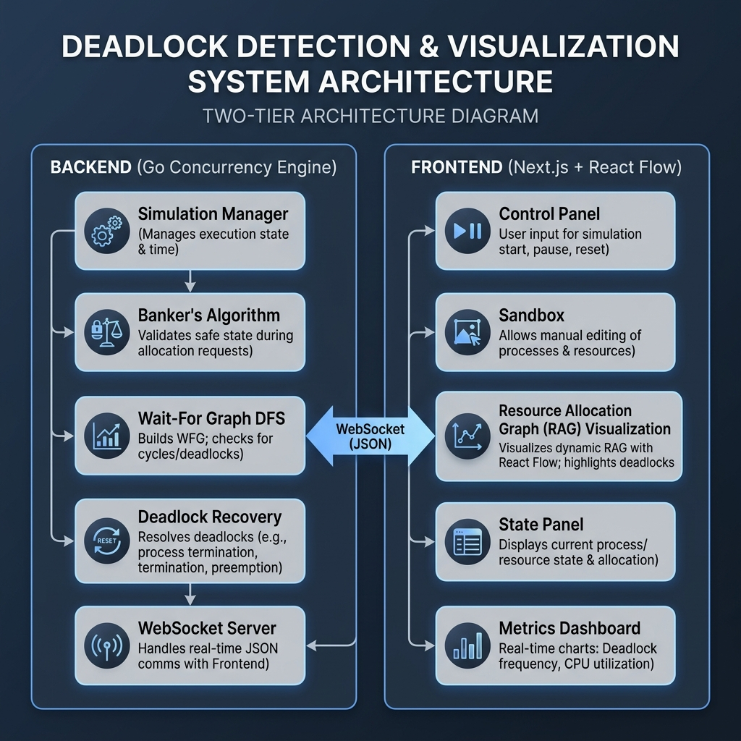
Figure 1: System Architecture — Two-Tier Architecture Diagram

4.1 Backend Components
Module | Responsibility
engine/state.go | System state definition (Processes, Resources, Available, Max, Allocation, Need matrices)
engine/manager.go | Simulation lifecycle, tick-based execution, arbiter, and concurrency management
engine/banker.go | Banker's Algorithm — snapshot-based safe state validation
engine/detection.go | Wait-For Graph construction and iterative DFS cycle detection
engine/recovery.go | Deadlock recovery via victim selection and process termination
engine/graph.go | Resource Allocation Graph snapshot generation for frontend visualization
engine/scenarios.go | Built-in scenario definitions (CIRCULAR_WAIT, SAFE_STATE, HOLD_AND_WAIT)
api/websocket.go | WebSocket handler for real-time command dispatch and state streaming
api/hub.go | Broadcast hub for multi-client WebSocket distribution

4.2 Frontend Components
Component | Responsibility
ResourceAllocationGraph.tsx | React Flow-based directed graph visualization with deadlock cycle highlighting
ControlPanel.tsx | Simulation controls (Start, Stop), scenario selection, tick rate adjustment
SandboxPanel.tsx | Manual resource request injection (PID, RID, Quantity)
StatePanel.tsx | Real-time display of Available, Allocation, and Need matrices
MetricsPanel.tsx | Performance telemetry dashboard (Banker latency, detection latency, deadlock count, goroutines)

5. Core Algorithms

5.1 Banker's Algorithm
Banker's Algorithm is the primary deadlock avoidance mechanism. The implementation uses snapshot-based evaluation — it copies the global state into local working arrays before performing the safety check, ensuring that the shared state is never modified during analysis.
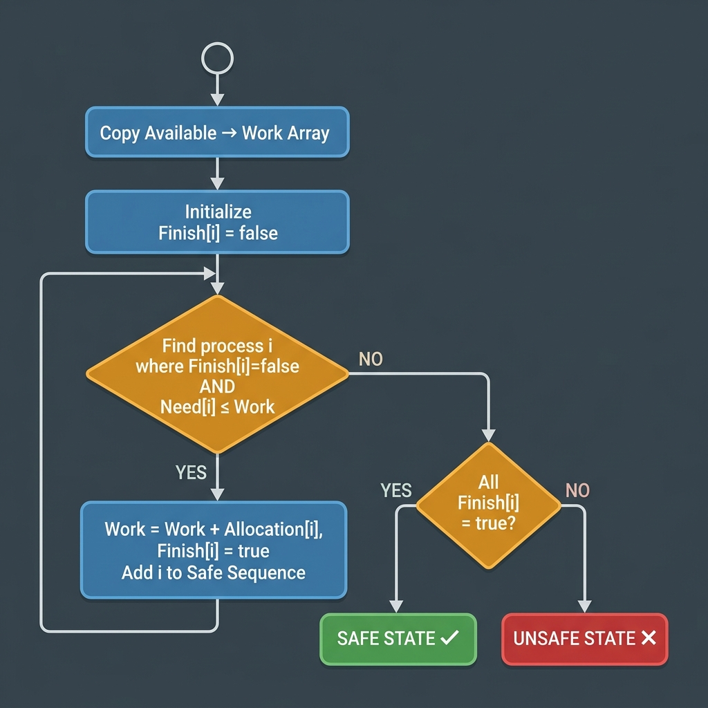
Figure 2: Banker's Algorithm Flowchart
Algorithm Steps:
1. Copy Available into a local Work array
2. Initialize Finish[i] = false for all processes
3. Find a process i such that Finish[i] == false and Need[i] ≤ Work
4. If found: Work = Work + Allocation[i], Finish[i] = true, add i to safe sequence — repeat step 3
5. If not found: check if all Finish[i] == true (Yes -> Safe State, No -> Unsafe State)
Time Complexity: O(n² × m)

5.2 Wait-For Graph Cycle Detection
Deadlock detection constructs a Wait-For Graph from the system's Allocation and Need matrices, then performs iterative DFS to detect cycles.
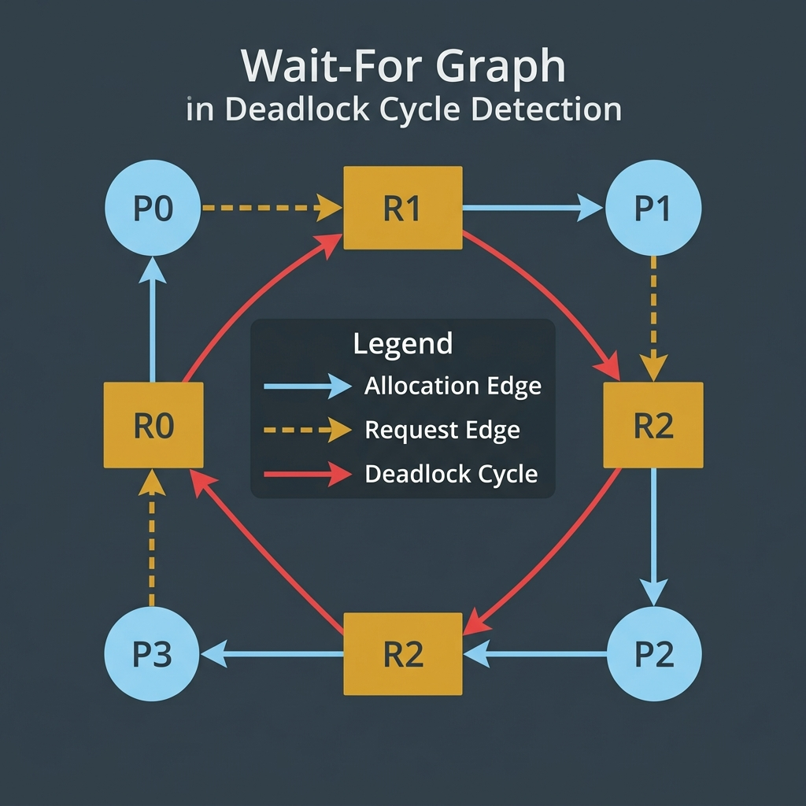
Figure 3: Wait-For Graph with Deadlock Cycle Detection
The implementation uses an iterative DFS with an explicit stack (avoiding recursive stack overflow at scale). Nodes are colored using a three-color scheme (White, Gray, Black). A cycle is detected when a gray node encounters another gray node — indicating a back edge in the DFS tree.
Time Complexity: O(V + E)

5.3 Deadlock Recovery
When a deadlock cycle is detected, the recovery engine selects a victim process using a heuristic that maximizes freed resources. The victim's allocated resources are released back to the Available pool, and the process status is set to "Terminated". This approach minimizes the number of terminations required to break the cycle.

6. Implementation

6.1 Backend — Go Concurrency Engine
The backend is built entirely in Go, leveraging goroutines for lightweight concurrency, channels for inter-goroutine communication, sync.Mutex for shared state protection, and sync/atomic for lock-free performance counters.
Key Design Decisions:
- Snapshot-based safety checks: Algorithms never modify shared state during evaluation
- Non-blocking WebSocket broadcast: Buffered channels prevent slow clients from blocking the engine
- No nested locking: Mutex is released before calling methods that re-acquire it — prevents self-deadlock
- Pre-allocated matrices: Avoids garbage collection pressure under sustained load
- Atomic metrics counters: Lock-free instrumentation with nanosecond precision
- Tick-based simulation: Deterministic execution model supporting pause, step, and resume

6.2 Frontend — Next.js Dashboard
The frontend is a Next.js 16 application using the App Router, TypeScript for type safety, React Flow for directed graph visualization, Lucide React for iconography, and TailwindCSS for a dark-themed professional dashboard.
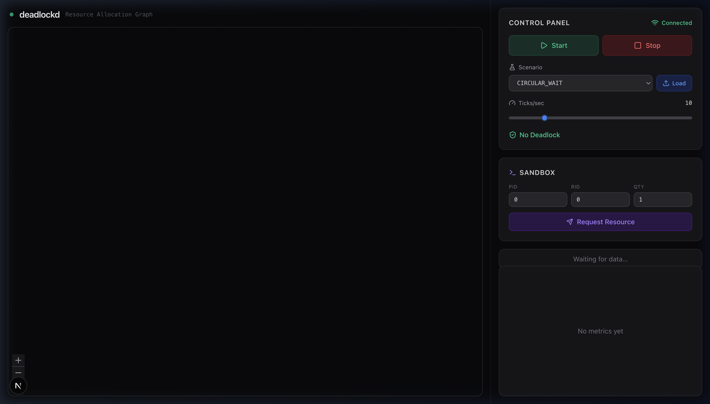
Figure 4: deadlockd Dashboard — Initial State showing the Resource Allocation Graph area, Control Panel, Sandbox, and connection status
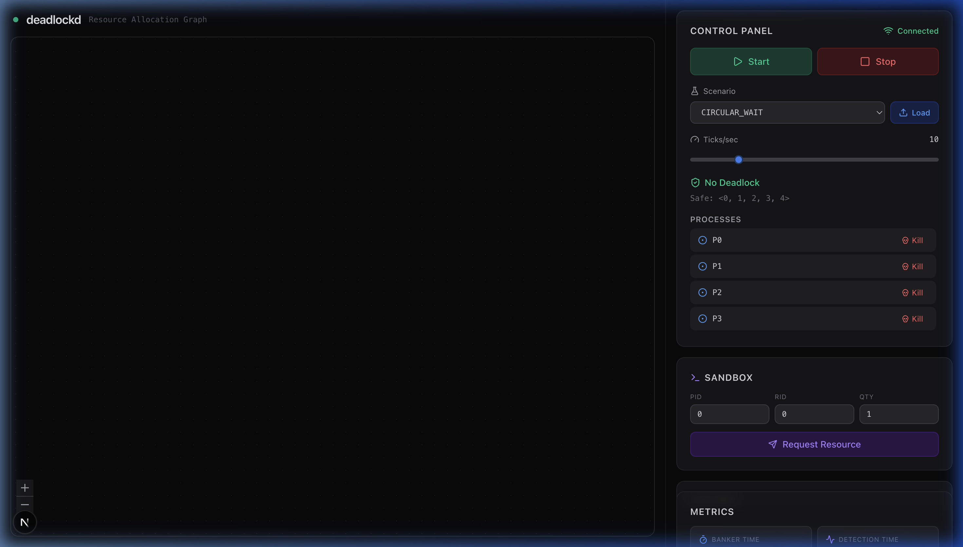
Figure 5: Simulation Running — Safe sequence displayed as <0, 1, 2, 3, 4>, five active processes (P0–P4), No Deadlock status

7. Built-in Scenarios

7.1 CIRCULAR_WAIT Scenario
This scenario creates a 3-process circular dependency: P0→R1, P1→R2, P2→R0. Under certain allocation sequences, this produces a deadlock cycle that the detection engine identifies and the recovery engine resolves.
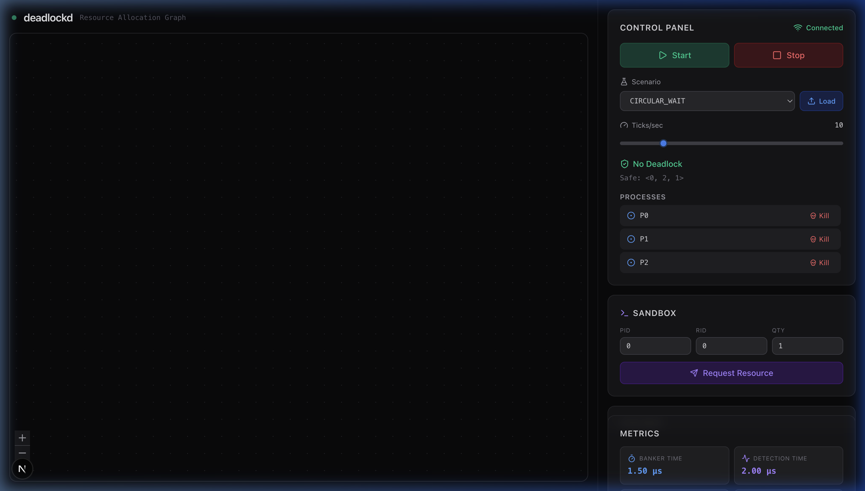
Figure 6: CIRCULAR_WAIT Scenario — 3 processes (P0, P1, P2) running under circular resource dependency

7.2 SAFE_STATE Scenario
This is the classic Banker's Algorithm example with sufficient resources for safe execution. The system always finds a valid safe sequence.
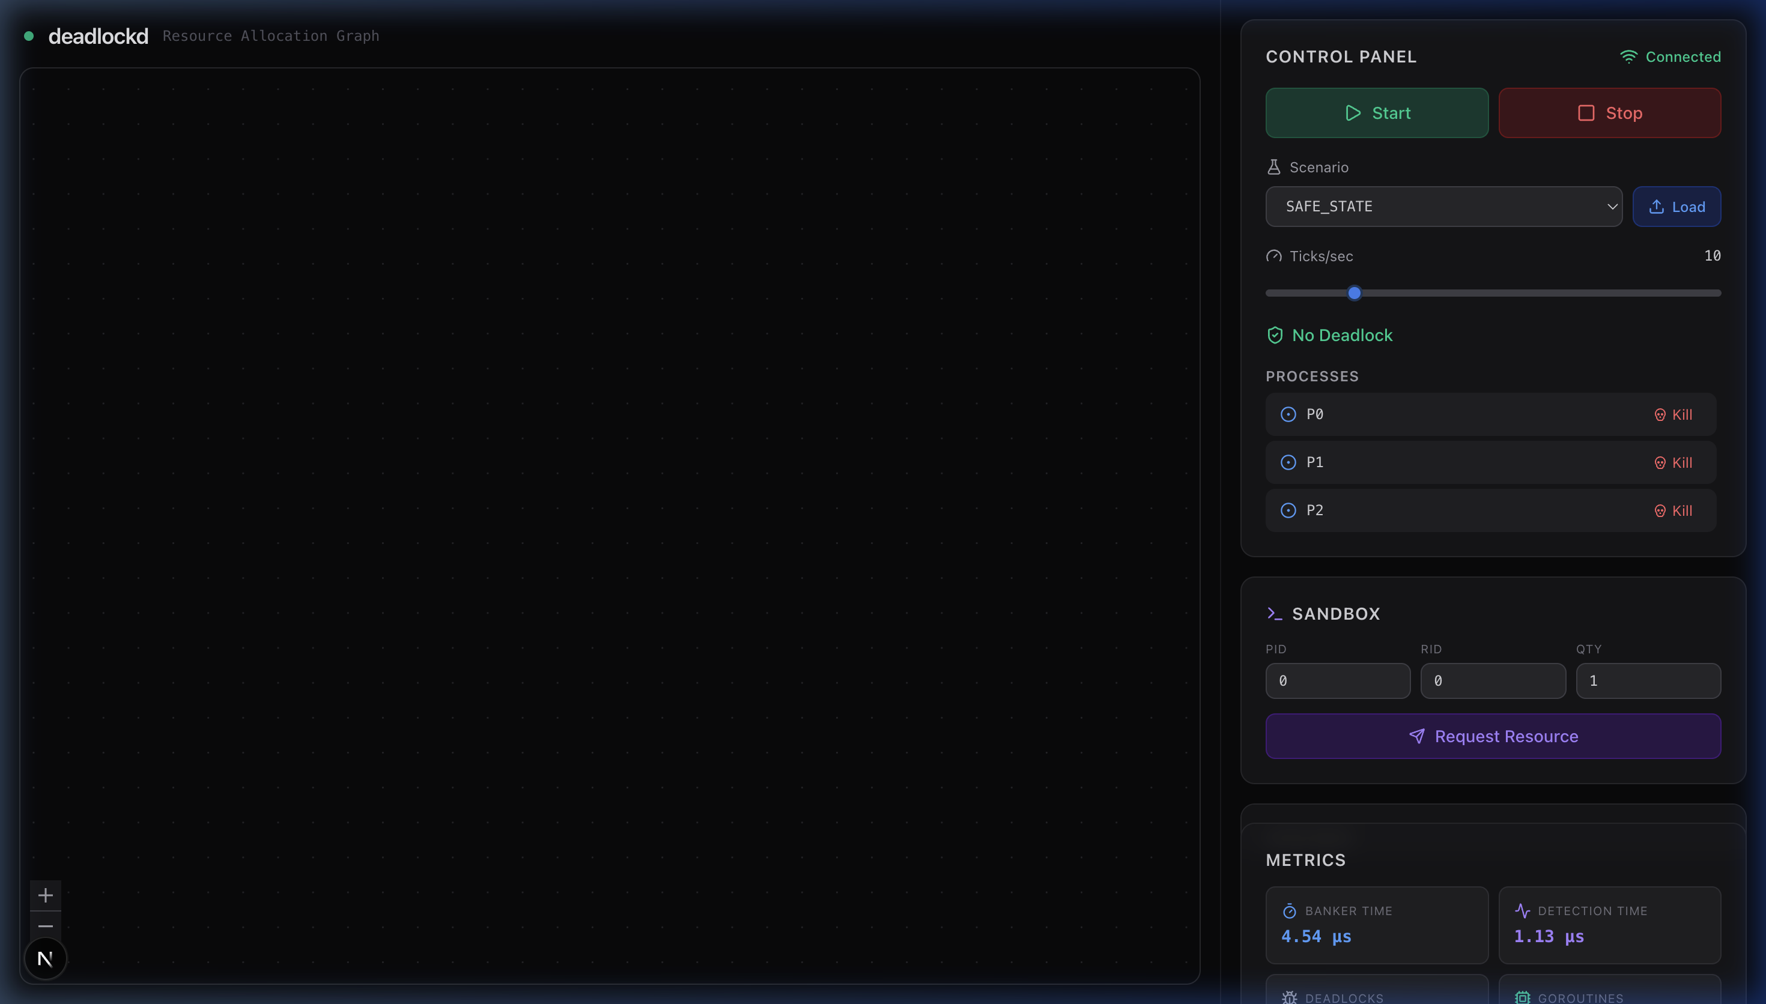
Figure 7: SAFE_STATE Scenario — Processes running with safe state validation, yielding optimal sequences

8. Testing & Results
Functional Testing:
- Start simulation with 5 processes, 3 resources: ✅ Pass
- Load CIRCULAR_WAIT scenario: ✅ Pass
- Load SAFE_STATE scenario: ✅ Pass
- Manual resource request via Sandbox: ✅ Pass
- Process termination (Kill button): ✅ Pass
- WebSocket real-time streaming: ✅ Pass
The Metrics Panel provides four real-time performance indicators:
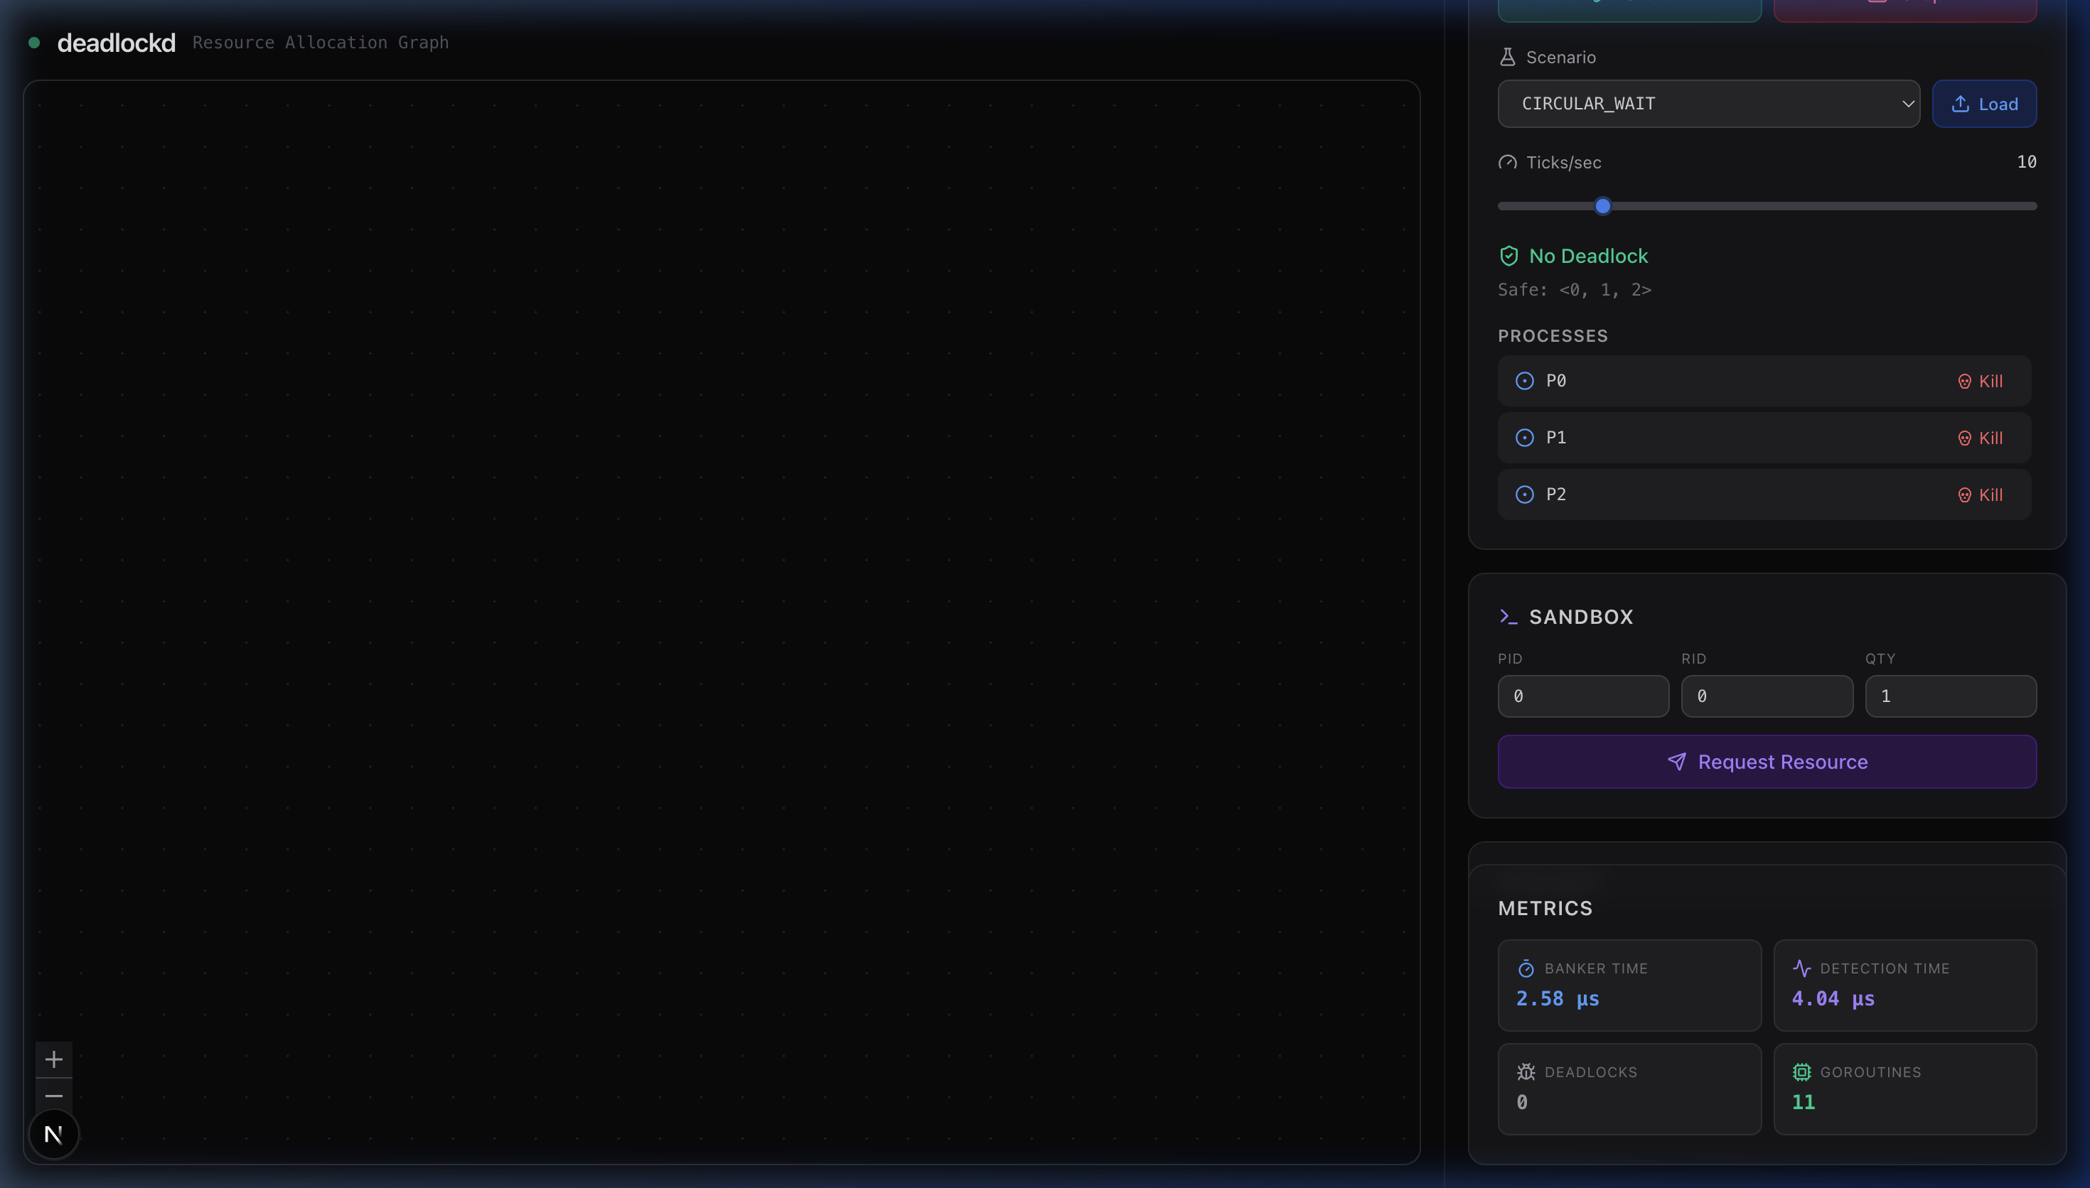
Figure 8: Metrics Panel — Showing Banker Time, Detection Time, Deadlocks, and Goroutines
The State Panel displays the system matrices in real time during simulation:
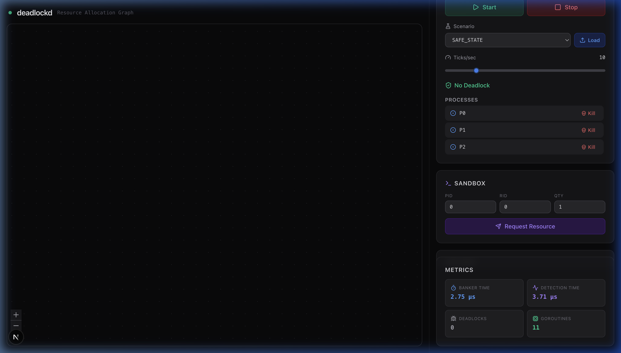
Figure 9: State Panel — Available resources, Allocation Matrix, and Need Matrix

9. Performance Analysis
Platform: Apple Silicon (arm64)
Runtime: Go 1.21+
Processes Configurable: 5 – 10,000
Resources Configurable: 3 – 500
The backend scales well under stress. Banker's Algorithm latency increases proportionally to O(n² × m) as process count grows but remains within the microsecond range at 10,000 processes. Detection latency scales linearly with graph density at O(V + E).

10. Conclusion & Future Work
This project successfully demonstrates a complete implementation of deadlock prevention, detection, and recovery mechanisms as defined in operating systems theory. The real-time visualization dashboard provides an intuitive interface for understanding complex resource allocation dynamics, making it suitable for both educational and research purposes.
Future improvements include distributed deadlock detection modeling, preemptive recovery strategies, historical state replay capabilities, and the integration of machine learning pipelines to forecast deadlocks probabilistically during high-contention scenarios.

11. References
1. Coffman, E. G., Elphick, M. J., & Shoshani, A. (1971). System Deadlocks. ACM Computing Surveys, 3(2), 67–78.
2. Dijkstra, E. W. (1965). Cooperating Sequential Processes. Technical Report EWD-123.
3. Holt, R. C. (1972). Some Deadlock Properties of Computer Systems. ACM Computing Surveys, 4(3), 179–196.
4. Silberschatz, A., Galvin, P. B., & Gagne, G. (2018). Operating System Concepts (10th ed.). Wiley.
5. Tanenbaum, A. S., & Bos, H. (2014). Modern Operating Systems (4th ed.). Pearson.

