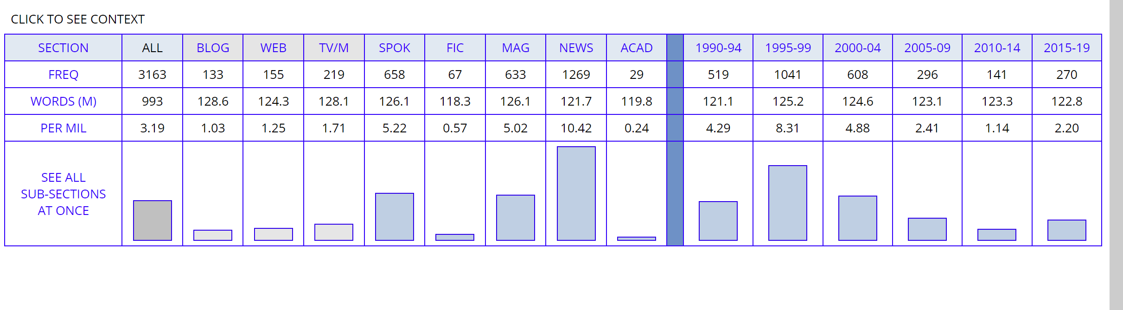

Michael Jordan is a retired professional basketball player. He was a lot in talk during 1995-99 which was his prime years. Some says that he was the best basketball player ever which could easily seen by the frequency. Phil Jackson his coach was also in talks regarding the Greatest Player of All Time “Michael Jordan or Kobe Bryant?”