Report
Approach:
- Find the probability distribution for all the 3 categories.
- This gives us idea about the distribution of the data.

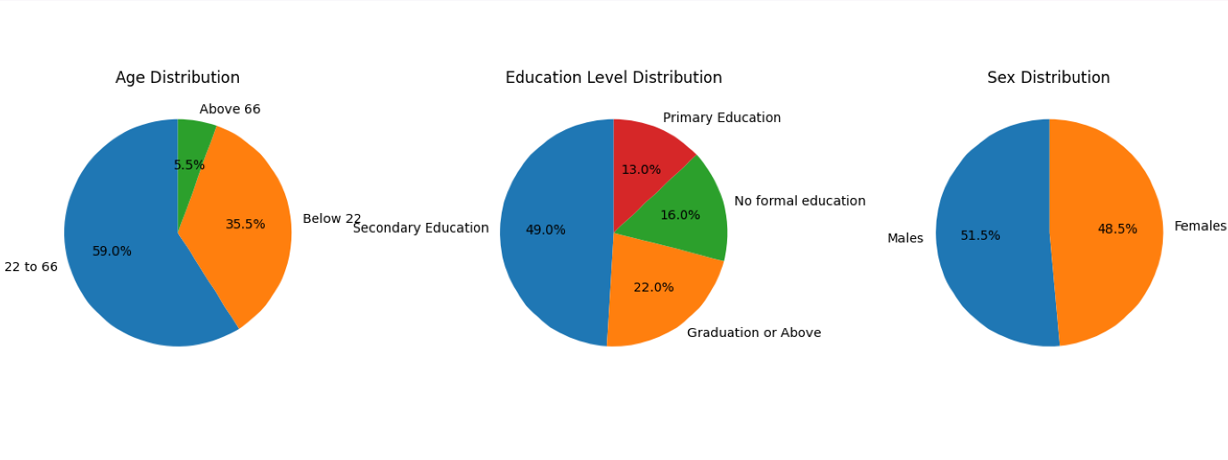3) Then we use groupby() to get the related distribution and the fraction of population corresponding to each category.
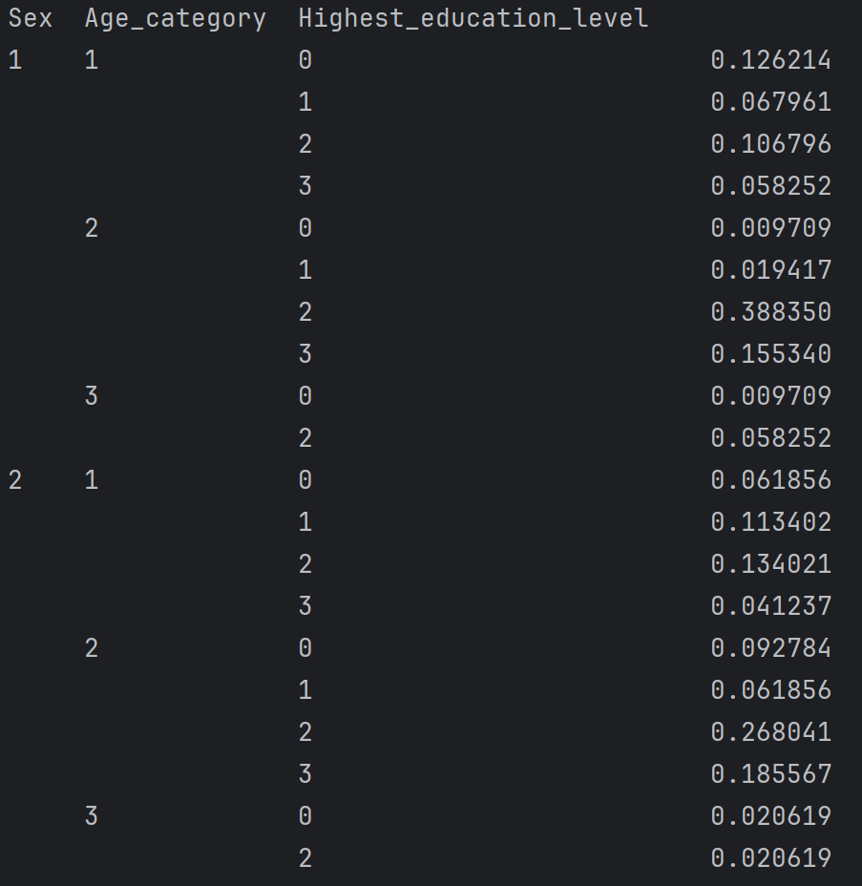
4 ) Now we will generate 4800 individuals and assign them sex according to the fractions given above.
5) We do this process using random library so that the data is not fixed but is near the correct ratio.
6) Then we make similar distribution for Age and Education.
7) After that we make relations between sex, age and education according to the frequency distribution of source data.
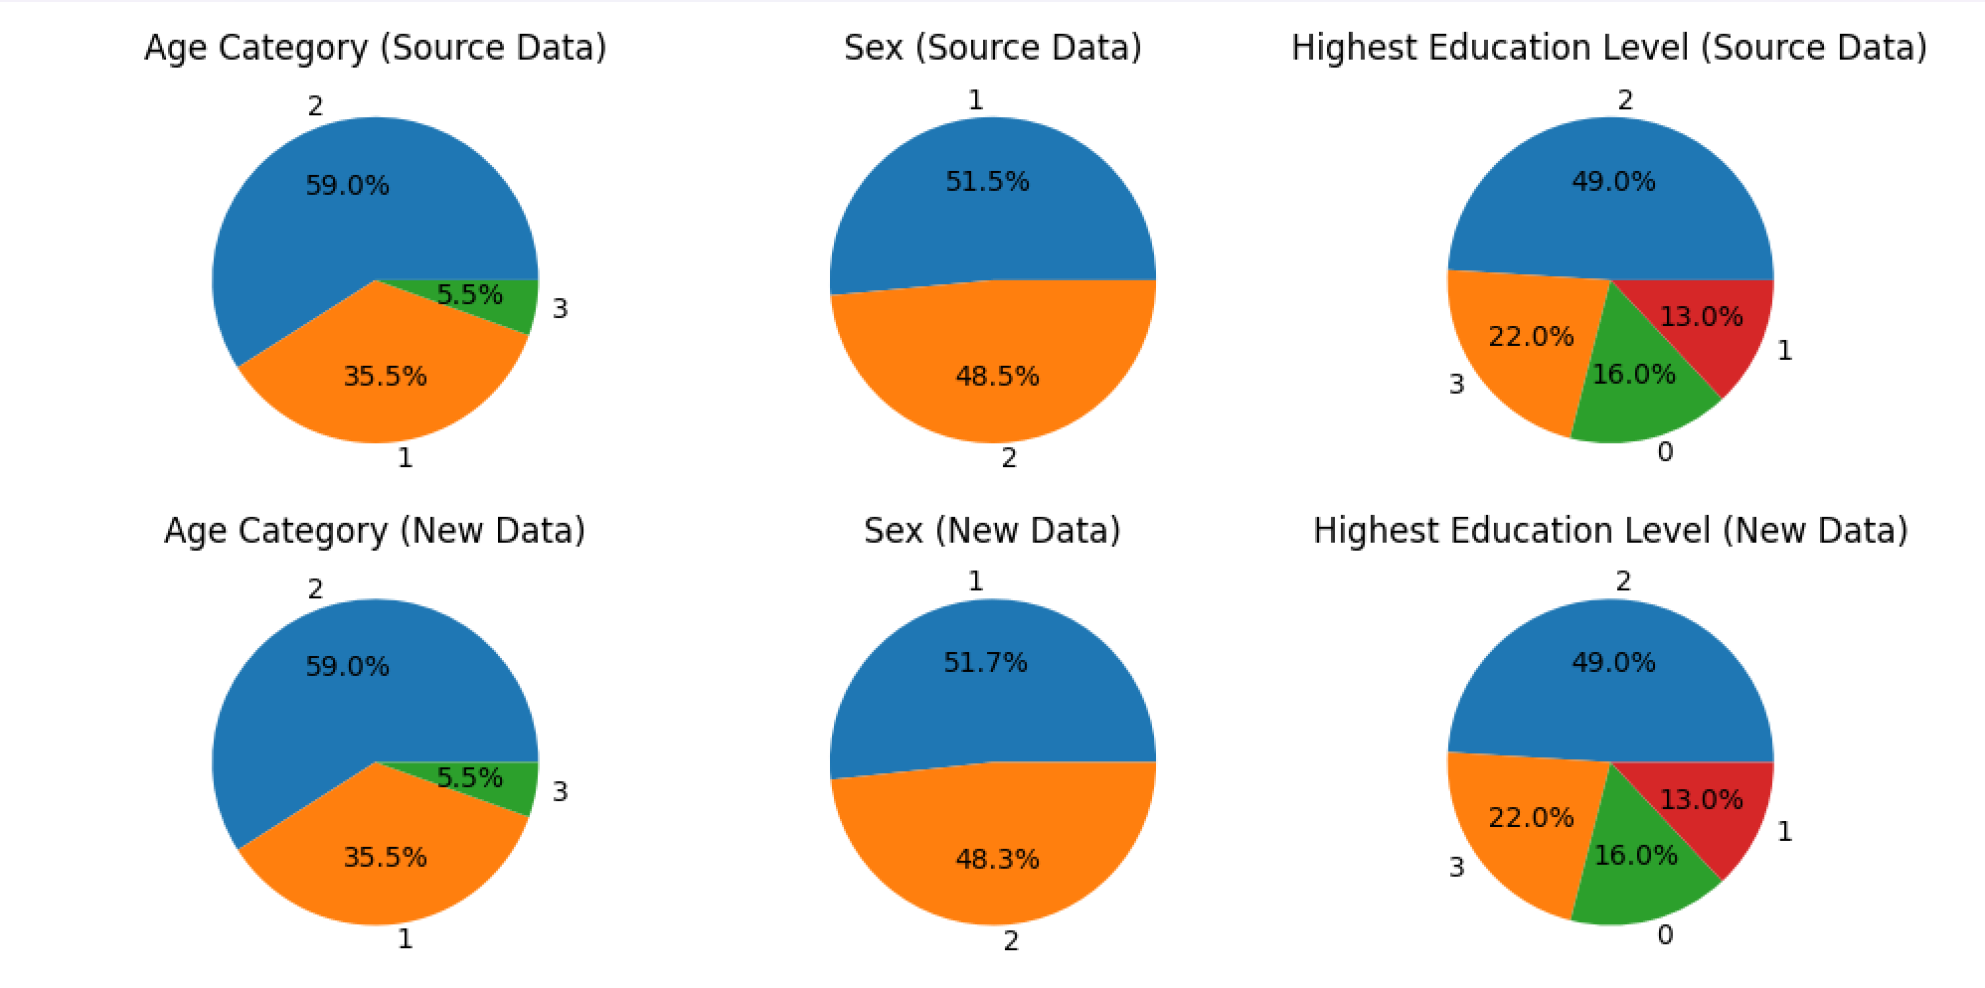
8) The above pie charts show comparison between the new generated data and the
the source data.
9) After this we concatenate both the source and new data into new data.
10) After this we make a table using groupby() on new data.
Pseudocode:
1. Freq of each category= source_data[category]/200.
2. Make the pie charts.
3. Education_sex_age_relation=source_data.groupby() [ gives complete distribution].
4. Divide entry by size of source data to get fraction of each category.
5. Normalise the entries according to their sex. So that males fraction add upto 1 and females fraction add upto 1.
6. Use random to divide 4800 individuals into males and females.
7. Multiply them into their respective entries.
8. Do data distribution analysis.
9. If it matches then we can proceed further.
10. Concatenate both source and new into new.
11. Use groupby().size() to get distribution.
12. Output them into .txt file.

