n8n Order-to-Invoice Workflow
Complete Runbook with PowerShell Commands
Hinglish Step-by-Step Guide for Running, Testing, Debugging and Delivery

Is DOCX ka goal
Is guide ko padhkar tu apna Client Order-to-Invoice n8n workflow local system par run karega, PowerShell se webhook payload bhejega, Airtable row verify karega, Twilio WhatsApp check karega, PDF branch samjhega, aur common errors ko quickly fix karega. Yeh guide specifically tere project paths aur workflow ke liye banayi gayi hai.

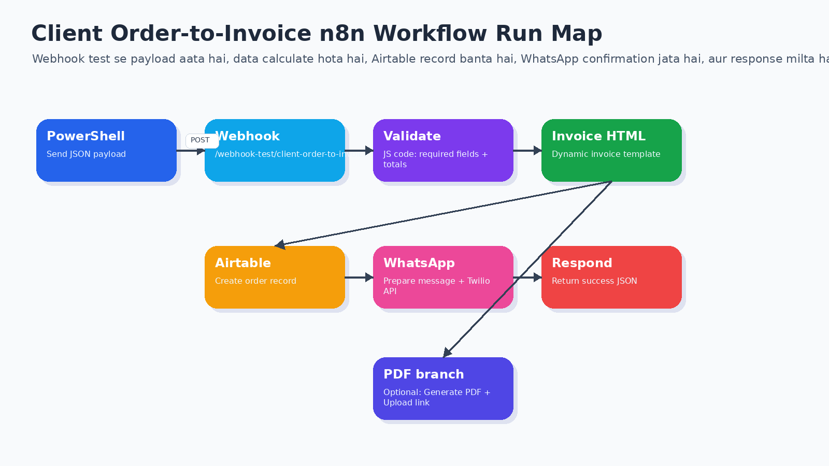

Table of Contents
━━━━━━━━━━━━━━━━━━━━━━━━━━━━━━━━━━━━━━━━━━━━━━━━━━━━━━━━
◆ 1. Project folder and files overview
◆ 2. Required tools checklist
◆ 3. n8n start karne ke PowerShell commands
◆ 4. Workflow open/import ka process
◆ 5. Test URL vs production URL difference
◆ 6. Sample payload edit karna
◆ 7. PowerShell se payload bhejna
◆ 8. Full workflow connection map
◆ 9. Validate + Calculate Invoice node JavaScript setup
◆ 10. Airtable node run and verify
◆ 11. Twilio WhatsApp node run and verify
◆ 12. PDF Invoice branch run and customer delivery logic
◆ 13. Common errors and exact fixes
◆ 14. Final demo checklist
◆ 15. GitHub/security checklist

1. Project Folder and Files Overview
━━━━━━━━━━━━━━━━━━━━━━━━━━━━━━━━━━━━━━━━━━━━━━━━━━━━━━━━
Tera n8n project ZIP extract hone ke baad local machine par is folder mein hona chahiye. Agar folder path different hai, commands mein path replace kar dena.
D:\Client_Order_to_Invoice_Automation_n8n
├── n8n_workflows
│ └── Client_Order_to_Invoice_Automation.json
├── sample_payloads
│ └── sample_order_payload.json
├── templates
│ ├── invoice_template.html
│ └── whatsapp_message.txt
├── airtable
│ └── airtable_schema.csv
├── docs
│ ├── Setup_Guide.md
│ ├── Workflow_Explanation.md
│ └── Portfolio_Case_Study.md
└── README.md

File/Folder | Use
n8n_workflows JSON | n8n mein import karne wala actual workflow
sample_payloads JSON | PowerShell se webhook test ke liye order data
templates | Invoice HTML aur WhatsApp message templates
airtable_schema.csv | Airtable tables/fields banane ke reference
docs | Portfolio explanation, setup guide, case study
README.md | GitHub project overview

2. Required Tools Checklist
━━━━━━━━━━━━━━━━━━━━━━━━━━━━━━━━━━━━━━━━━━━━━━━━━━━━━━━━
Tool | Required for | Check command / URL
Node.js + n8n | Local n8n run karne ke liye | npx n8n
PowerShell | Webhook payload bhejne ke liye | Windows built-in
Airtable | Order record save karne ke liye | https://airtable.com
Twilio | WhatsApp confirmation ke liye | https://console.twilio.com
PDFShift or PDF API | Invoice PDF generate karne ke liye | API key dashboard
Git/GitHub | Project upload ke liye | git --version

Important security note
Twilio Auth Token, Airtable PAT, PDFShift API key, .env, credentials.json ko kabhi GitHub pe upload mat karna. Token accidentally share ho jaye toh rotate/regenerate kar dena.

3. n8n Start Karne ke PowerShell Commands
━━━━━━━━━━━━━━━━━━━━━━━━━━━━━━━━━━━━━━━━━━━━━━━━━━━━━━━━
Sabse pehle n8n local server start karo. n8n normally localhost:5678 par open hota hai.
# Option A: Direct n8n start
npx n8n
# Browser mein open karo:
# http://localhost:5678

Agar n8n already installed globally hai, toh ye bhi chal sakta hai:
n8n

Terminal band mat karna
Jis PowerShell window mein n8n running hai, usko band mat karna. Agar terminal band ho gaya toh localhost:5678 bhi band ho jayega.

4. Workflow Import/Open Process
━━━━━━━━━━━━━━━━━━━━━━━━━━━━━━━━━━━━━━━━━━━━━━━━━━━━━━━━
Agar workflow already imported hai, direct workflow open kar. Agar nahi hai, JSON import kar.
# Workflow JSON path
D:\Client_Order_to_Invoice_Automation_n8n\n8n_workflows\Client_Order_to_Invoice_Automation.json

◆ n8n open karo: http://localhost:5678
◆ Workflows -> Import from File
◆ Upar wala JSON select karo
◆ Workflow canvas open hone ke baad Save karo
◆ Nodes ki connections verify karo
5. Test URL vs Production URL Difference
━━━━━━━━━━━━━━━━━━━━━━━━━━━━━━━━━━━━━━━━━━━━━━━━━━━━━━━━
URL type | URL | Kab use hota hai
Test URL | http://localhost:5678/webhook-test/client-order-to-invoice | Jab Webhook node mein Listen for test event / Execute workflow dabate ho
Production URL | http://localhost:5678/webhook/client-order-to-invoice | Jab workflow Active ON hota hai
Editor URL | http://localhost:5678/workflow/xxxx | Sirf workflow edit/open karne ke liye, payload bhejne ke liye nahi

404 webhook not registered ka reason
Test webhook sirf ek call ke liye register hota hai. Har test se pehle Webhook node mein Listen for test event ya canvas par Execute workflow dabana zaroori hai.

6. Sample Payload Edit Karna
━━━━━━━━━━━━━━━━━━━━━━━━━━━━━━━━━━━━━━━━━━━━━━━━━━━━━━━━
Twilio test karne ke liye payload mein customer_phone apna WhatsApp number rakhna hai, wahi number jisse Twilio sandbox join kiya hai.
notepad "D:\Client_Order_to_Invoice_Automation_n8n\sample_payloads\sample_order_payload.json"

Payload file mein yeh value update karo:
"customer_phone": "+91XXXXXXXXXX"

Agar PowerShell se direct update karna hai toh:
$path = "D:\Client_Order_to_Invoice_Automation_n8n\sample_payloads\sample_order_payload.json"
(Get-Content $path -Raw) -replace '"customer_phone"\s*:\s*"[^"]+"', '"customer_phone": "+91YOUR_NUMBER"' | Set-Content $path

7. PowerShell se Payload Bhejna
━━━━━━━━━━━━━━━━━━━━━━━━━━━━━━━━━━━━━━━━━━━━━━━━━━━━━━━━
Ye sabse important section hai. Pehle n8n mein Webhook node par Listen for test event dabao. Phir PowerShell se payload bhejo.
# 1) Payload file read karo
$body = Get-Content "D:\Client_Order_to_Invoice_Automation_n8n\sample_payloads\sample_order_payload.json" -Raw
# 2) Test webhook ko POST request bhejo
Invoke-RestMethod -Uri "http://localhost:5678/webhook-test/client-order-to-invoice" -Method POST -ContentType "application/json" -Body $body

Agar production mode mein workflow Active ON hai, toh production URL use karo:
$body = Get-Content "D:\Client_Order_to_Invoice_Automation_n8n\sample_payloads\sample_order_payload.json" -Raw
Invoke-RestMethod -Uri "http://localhost:5678/webhook/client-order-to-invoice" -Method POST -ContentType "application/json" -Body $body

Uri prompt error fix
Agar PowerShell bole: Supply values for parameter Uri, matlab command incomplete paste hui hai. Ctrl+C dabao aur Invoke-RestMethod wali command ek hi line mein paste karo.

8. Full Workflow Connection Map
━━━━━━━━━━━━━━━━━━━━━━━━━━━━━━━━━━━━━━━━━━━━━━━━━━━━━━━━


Final successful demo ke liye main chain aisi honi chahiye:
Webhook - New Order
-> Validate + Calculate Invoice
-> Generate Invoice HTML
-> Airtable - Create Order Record
-> Prepare WhatsApp Message
-> Twilio - Send WhatsApp Confirmation
-> Respond - Success

PDF branch parallel reh sakti hai. PDF ko directly Respond se connect mat karo jab tak special PDF response nahi chahiye.
Generate Invoice HTML
-> Generate PDF Invoice # optional parallel branch
-> Airtable - Create Order Record -> Prepare WhatsApp -> Twilio -> Respond

9. Validate + Calculate Invoice Node Setup
━━━━━━━━━━━━━━━━━━━━━━━━━━━━━━━━━━━━━━━━━━━━━━━━━━━━━━━━
Is node ka Language JavaScript hona chahiye. Python selected hoga toh error aayega: Python runner unavailable.
// Validate + Calculate Invoice node should be JavaScript, not Python.
const body = $json.body || $json;
const required = ['order_id', 'customer_name', 'customer_phone', 'items'];
const missing = required.filter(k => !body[k]);
if (missing.length) throw new Error('Missing fields: ' + missing.join(', '));
const items = Array.isArray(body.items) ? body.items : [];
let subtotal = 0;
const normalizedItems = items.map((item, index) => {
const qty = Number(item.quantity || 1);
const price = Number(item.unit_price || 0);
const total = qty * price;
subtotal += total;
return { line_no: index + 1, sku: item.sku || '', product_name: item.product_name || 'Product', quantity: qty, unit_price: price, line_total: total };
});
const taxRate = Number(body.tax_rate || 0.18);
const tax = +(subtotal * taxRate).toFixed(2);
const shipping = Number(body.shipping || 0);
const discount = Number(body.discount || 0);
const grandTotal = +(subtotal + tax + shipping - discount).toFixed(2);
const invoiceNo = body.invoice_no || `INV-${new Date().getFullYear()}-${body.order_id}`;
return [{ json: { ...body, items: normalizedItems, invoice_no: invoiceNo, subtotal, tax, shipping, discount, grand_total: grandTotal, status: 'INVOICE_GENERATED' } }];

10. Airtable Node Run and Verify
━━━━━━━━━━━━━━━━━━━━━━━━━━━━━━━━━━━━━━━━━━━━━━━━━━━━━━━━
Setting | Value
Operation | Create
Base | By ID -> app... Base ID
Table | By ID -> Orders table ID
Credential | Airtable Personal Access Token
Mapping mode | Define Below / Values to Send

Start mein sirf safe fields rakho:
Airtable field | n8n expression
Order ID | {{ $json.order_id }}
Invoice No | {{ $json.invoice_no }}
Customer Name | {{ $json.customer_name }}
Customer Phone | {{ $json.customer_phone }}
Customer Email | {{ $json.customer_email }}
Grand Total | {{ Number($json.grand_total) }}
Status | {{ $json.status }}
Payment Method | {{ $json.payment_method }}

Customer Address error fix
Agar Customer Address invalid input de, mapping se Customer Address remove kar do ya Airtable field type Long text/Single line text karo. Pehle core row create successful karao.

Successful Airtable node output mein recXXXXXXXX jaisa record ID aayega. Airtable Orders table refresh karke search karo:
ORD-10047

11. Twilio WhatsApp Node Run and Verify
━━━━━━━━━━━━━━━━━━━━━━━━━━━━━━━━━━━━━━━━━━━━━━━━━━━━━━━━
Twilio node HTTP Request node hai. Isme Basic Auth credential use karna hai.
Setting | Correct value
Method | POST
URL | https://api.twilio.com/2010-04-01/Accounts/YOUR_ACCOUNT_SID/Messages.json
Authentication | Generic Credential Type
Generic Auth Type | HTTP Basic Auth
Username | Account SID, starts with AC...
Password | Auth Token only
Body Content Type | Form URL Encoded

Body field name | Body value
From | whatsapp:+14155238886
To | ={{ "whatsapp:" + $json.customer_phone }}
Body | ={{ $json.whatsapp_message }}

401 invalid username fix
Username field mein sirf Account SID daalna hai. -u, colon, phone number, email, ContentSid, ya Twilio password mat daalna. Password field mein sirf Auth Token hona chahiye.

12. PDF Invoice Branch
━━━━━━━━━━━━━━━━━━━━━━━━━━━━━━━━━━━━━━━━━━━━━━━━━━━━━━━━
Generate PDF Invoice node optional branch hai. PDF generate karna aur customer ko bhejna do alag steps hain. Twilio ko PDF directly n8n binary se nahi milti; pehle PDF public link par upload karni hoti hai.
Step | Node/Action
1 | Generate Invoice HTML
2 | Generate PDF Invoice using PDFShift/PDF API
3 | Upload PDF to Google Drive/S3/Cloudinary
4 | Create public/signed invoice URL
5 | Twilio body mein MediaUrl parameter add karo

PDFShift node rough settings:
Method: POST
URL: https://api.pdfshift.io/v3/convert/pdf
Authentication: None
Send Headers: ON
Header Name: X-API-Key
Header Value: YOUR_PDFSHIFT_API_KEY
Send Body: ON
Body Content Type: JSON
JSON body:
={{
{
"source": $json.invoice_html,
"filename": $json.invoice_no + ".pdf"
}
}}
Response Format: File
Output Property Name: invoice_pdf

PDF customer ko bhejne ke liye Twilio node mein ek aur body parameter add hota hai:
Name: MediaUrl
Value: {{ $json.invoice_pdf_url }}

13. Common Errors and Exact Fixes
━━━━━━━━━━━━━━━━━━━━━━━━━━━━━━━━━━━━━━━━━━━━━━━━━━━━━━━━
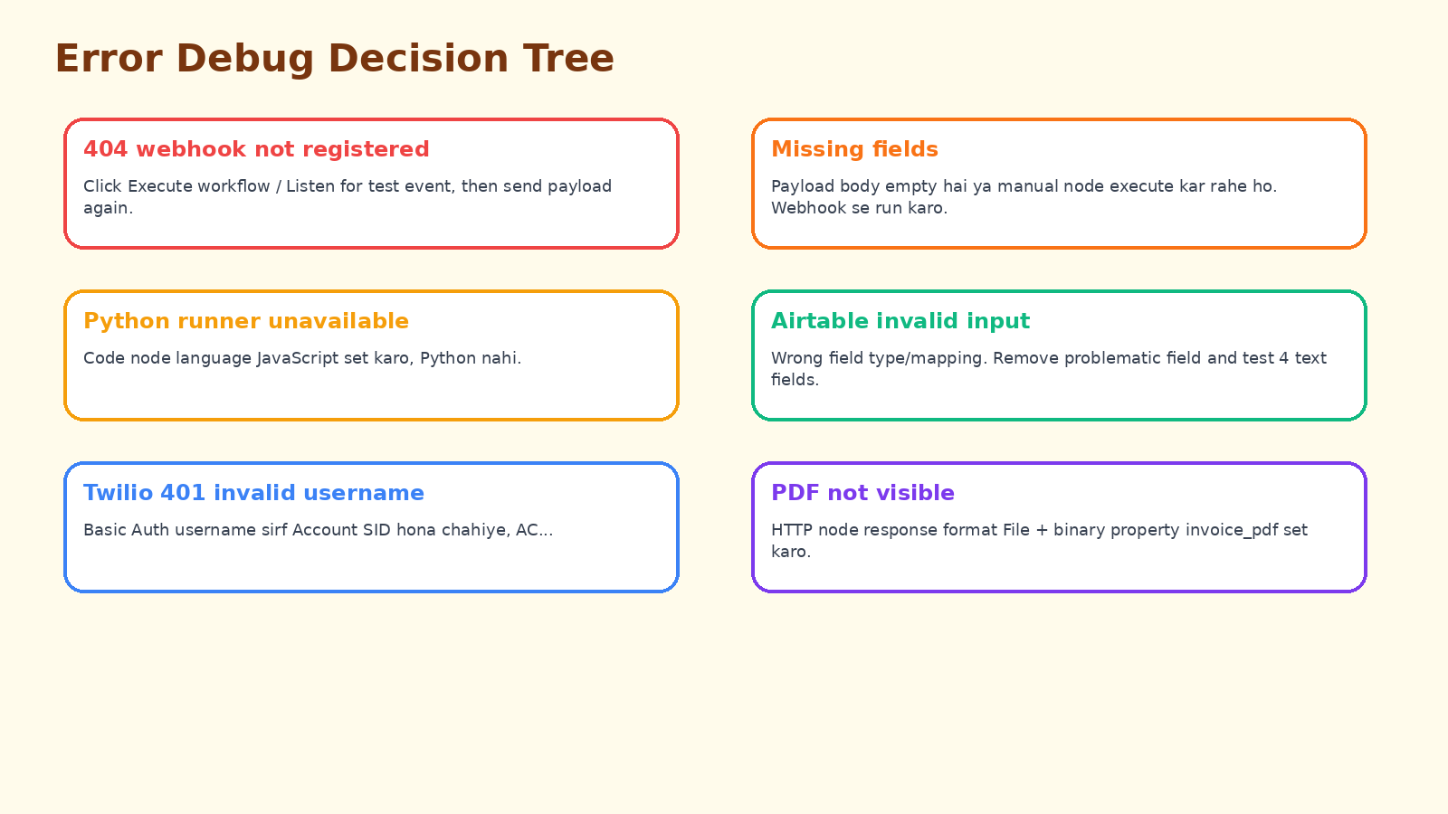

Error | Cause | Fix
404 webhook not registered | Listen for test event nahi dabaya | Webhook node -> Listen for test event -> command run
Missing fields | Payload empty/manual execute | Webhook se run karo, JSON body bhejo
Python runner unavailable | Code node Python mode mein hai | Language JavaScript set karo
Airtable no columns found | Wrong table/token scope | Table By ID use karo, schema.bases:read scope add
Airtable invalid input | Field type mismatch | Problem field remove karo, type text/number karo
Twilio credential missing | Old deleted credential ID | Fresh HTTP Basic Auth credential create karo
Twilio 401 invalid username | Username wrong | Username = Account SID only
PDF binary not visible | Response not file | Response Format File + invoice_pdf set karo

14. Final Successful Demo Checklist
━━━━━━━━━━━━━━━━━━━━━━━━━━━━━━━━━━━━━━━━━━━━━━━━━━━━━━━━
◆ n8n running on http://localhost:5678
◆ Workflow imported and saved
◆ Webhook node Listen for test event clicked
◆ PowerShell payload sent successfully
◆ Validate node green
◆ Generate Invoice HTML node green
◆ Airtable node green and output recXXXX shown
◆ Airtable Orders table mein ORD-10047 row visible
◆ Prepare WhatsApp node green
◆ Twilio node green
◆ WhatsApp confirmation received
◆ Respond Success node green
◆ Screenshots captured for portfolio
15. Screenshot and Portfolio Checklist
━━━━━━━━━━━━━━━━━━━━━━━━━━━━━━━━━━━━━━━━━━━━━━━━━━━━━━━━
Screenshot | Caption
Full green workflow | End-to-end order-to-invoice automation successfully executed
Webhook payload output | New order received through webhook test URL
Airtable recXXXX output | Order record created automatically in Airtable
Airtable Orders table | Invoice-ready record saved without manual entry
WhatsApp message | Customer confirmation sent through Twilio WhatsApp
PowerShell response | Webhook tested using PowerShell Invoke-RestMethod

16. GitHub and Secrets Safety Checklist
━━━━━━━━━━━━━━━━━━━━━━━━━━━━━━━━━━━━━━━━━━━━━━━━━━━━━━━━
GitHub par upload se pehle workflow JSON mein real secrets check karna zaroori hai.
cd "D:\Client_Order_to_Invoice_Automation_n8n"
notepad "n8n_workflows\Client_Order_to_Invoice_Automation.json"

◆ Ctrl+F se AC..., token, auth, PDFShift, pat, key search karo
◆ Real Twilio Auth Token ko YOUR_TWILIO_AUTH_TOKEN se replace karo
◆ Airtable Personal Access Token ko YOUR_AIRTABLE_TOKEN se replace karo
◆ PDFShift key ko YOUR_PDFSHIFT_API_KEY se replace karo
◆ Auth Token accidentally share hua ho toh rotate/regenerate karo
Git push commands:
cd "D:\Client_Order_to_Invoice_Automation_n8n"
git init
git add .
git commit -m "Initial commit - Client Order to Invoice n8n automation"
git branch -M main
git remote add origin https://github.com/Saksham-dev-del/Client_Order_to_Invoice_Automation_n8n.git
git push -u origin main

Agar fetch first aaye:
git pull origin main --allow-unrelated-histories --no-rebase
git push -u origin main

17. One-Page Quick Run Recipe
━━━━━━━━━━━━━━━━━━━━━━━━━━━━━━━━━━━━━━━━━━━━━━━━━━━━━━━━
Daily testing shortcut
1) npx n8n chalao
2) http://localhost:5678 open karo
3) Webhook node -> Listen for test event
4) PowerShell se payload POST karo
5) Green nodes + Airtable + WhatsApp verify karo

# Start n8n
npx n8n
# In another PowerShell window:
$body = Get-Content "D:\Client_Order_to_Invoice_Automation_n8n\sample_payloads\sample_order_payload.json" -Raw
Invoke-RestMethod -Uri "http://localhost:5678/webhook-test/client-order-to-invoice" -Method POST -ContentType "application/json" -Body $body

