A/B Testing Implementation in a Fully Dynamic Website

Step 1: Identifying the User (Without Login)
- Use Cookies or Local Storage
Whenever a new user visits, generate a unique identifier (such as UUID).
- Check if the User Has Visited Before
If the identifier is already saved in local storage or cookies, display the same version.
- Assign Random A/B Version for First-Time Visitors
Use Math.random() or simple logic for randomization.
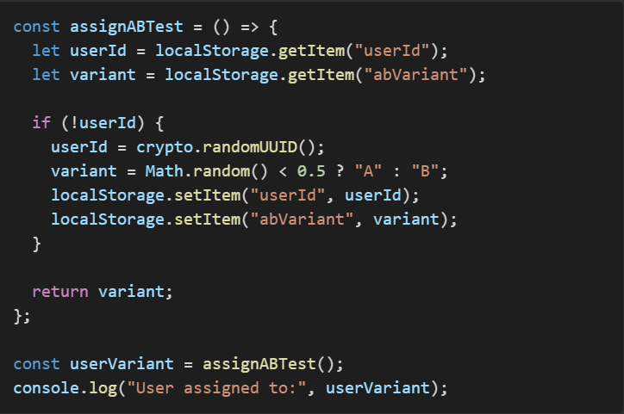

Step 2: Rendering Website Dynamically Based on Variant
If your website follows a component-based structure in React, you can implement conditional rendering based on the variant.
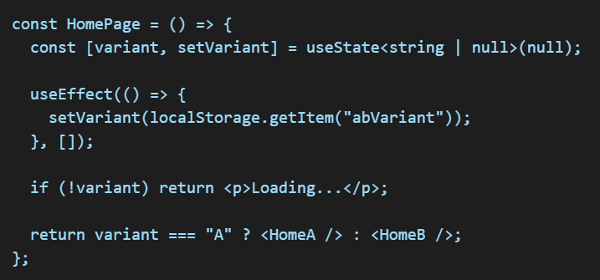

Step 3: Tracking User Activity (Saving Undo Actions)
If you need to track user actions for undo functionality, save them in Local Storage or API.
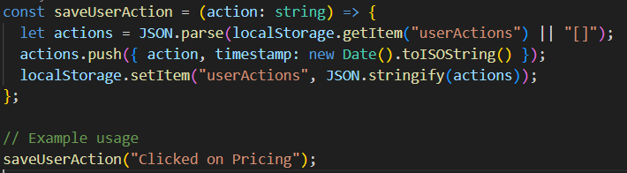
To enable undo functionality, allow users to delete the last recorded action:
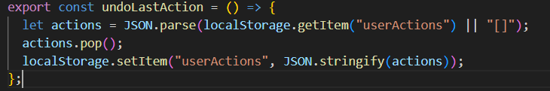

Step 4: Sending Data to Backend for Analytics
If you want to track A/B testing data in the backend, send an API call:
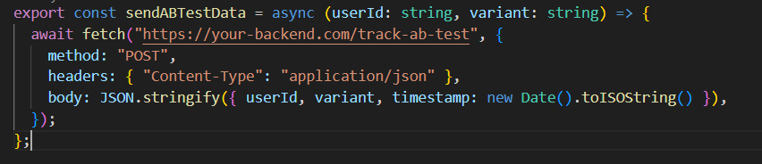
You can also integrate tools like Google Analytics or Mixpanel.

Conclusion
You can implement A/B testing without login by:
- Identifying the user via Local Storage or Cookies.
- Randomly assigning and tracking the A/B test variant.
- Dynamically rendering the UI based on the variant.
- Storing user actions and providing an undo option.
- Using backend APIs or external tools for analytics.
If you want A/B testing to be dynamically controlled via backend, you can fetch the variant using an API.

