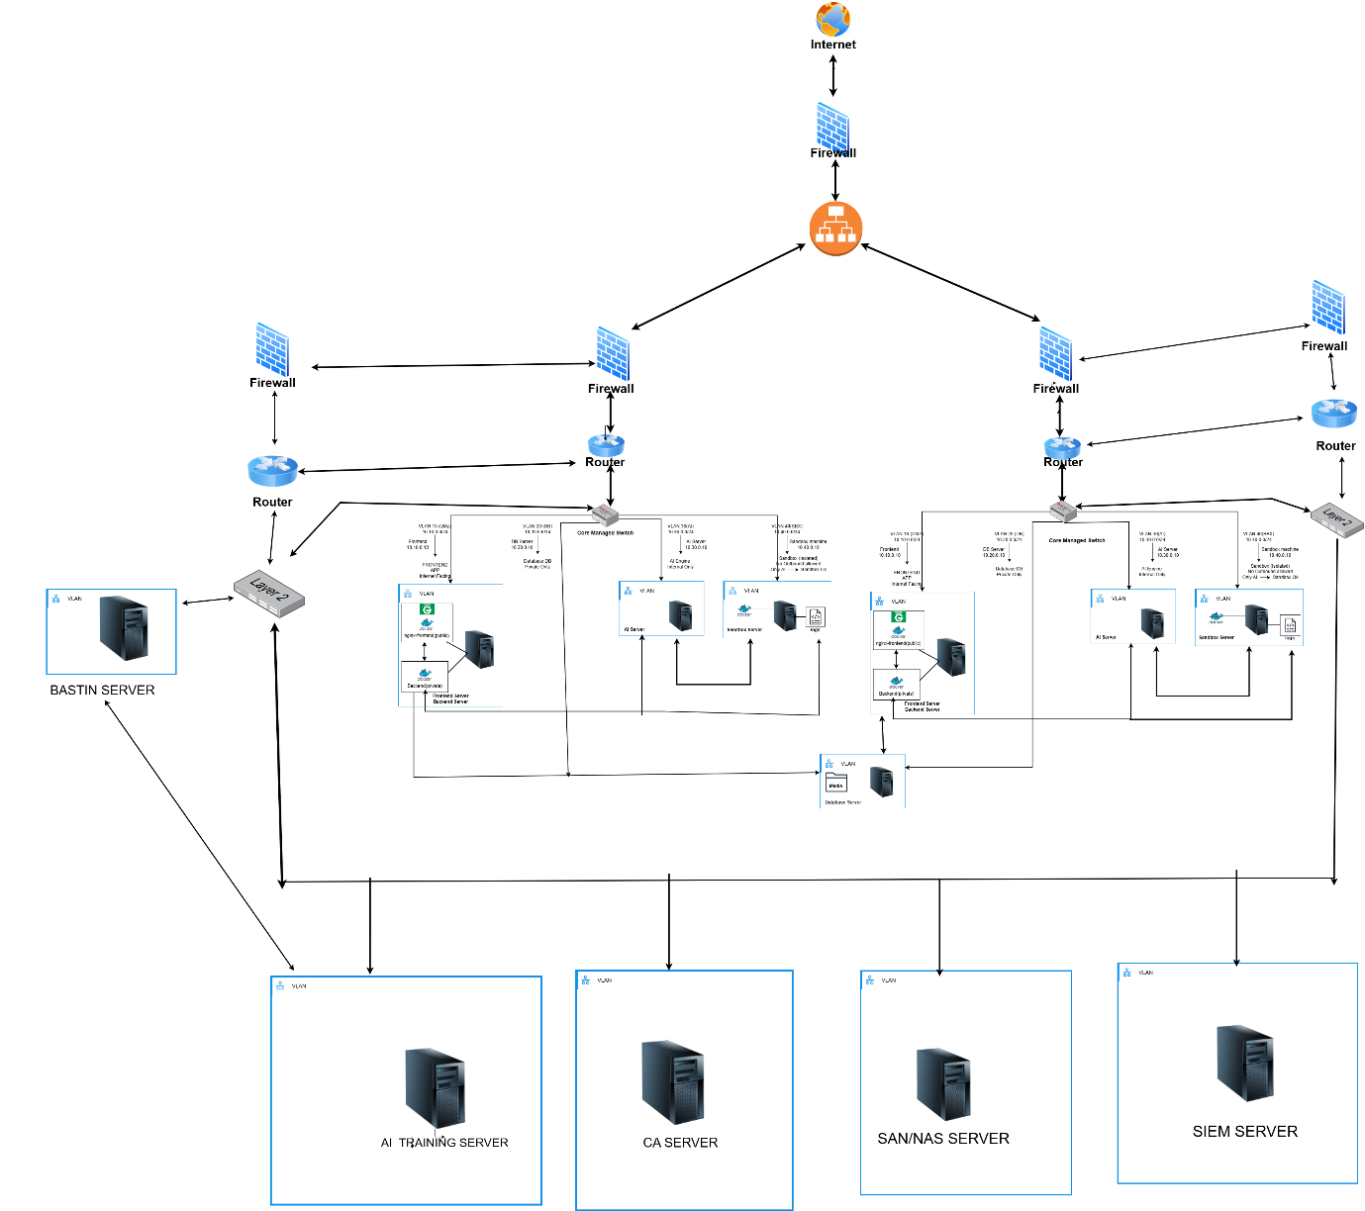

Server Architecture
5.1 Production Servers
- Application servers
- Database servers
- Internal APIs
- No direct internet exposure
5.2 Training Servers
- AI model training
- Controlled dataset access
- Isolated from production
5.3 MLOps Server
- Model versioning
- Training sync
- Deployment approvals
- Drift detection

6. Security Infrastructure
6.1 Zero Trust Implementation
- MTLS for all service-to-service communication
- No trust based on network location
- Identity + certificate required for access
6.2 PKI & Certificate Management
- Internal Root CA
- Intermediate CA
- Server & client certificates
- Automated certificate distribution
- Root CA stored offline (powered off)

7. Storage Architecture
7.1 SAN & NAS
Storage Type | Purpose
SAN | Databases, structured data
NAS | Logs, email files, CDR files
7.2 WORM Storage
Write Once Read Many (Immutable Storage)
Used for:
- Security logs
- Audit trails
- Compliance evidence

8. Data Classification
8.1 Database (SAN)
- Rough data
- License data
- Dispute history
- Metadata
8.2 File Storage (NAS)
- Application logs
- Email files
- CDR files
- Archived outputs

9. AI & Model Security
9.1 AI Training Pipeline
- Version-controlled datasets
- Isolated training environment
- Approved promotion to production
9.2 Model Poisoning Protection
- Dataset validation
- Hash verification
- Human approval gate
- Training data source allow-listing
⚠️ Reality check: Without dataset provenance validation, model poisoning is almost guaranteed over time.

10. Monitoring & Governance
Security & Ops Tools
- SIEM – Central log correlation
- DCIM – Infrastructure monitoring
- BAS – Breach & attack simulation
- HSM – Secure key storage
- TPM 2.0 – Hardware trust
- NAT – Controlled outbound access

11. End-to-End Network Flow (Text-Based)
[Internet / ISP]
|
v
[Firewall]
- IDS/IPS
- MTLS Enforcement
|
v
[Router (Primary)]
|
v
[L3 Core Switch]
├── VLAN 1 → Management
├── VLAN 5 → Production Servers
├── VLAN 7 → Training Servers
├── VLAN 8 → AI / MLOps Servers
└── Blackhole VLAN → Unused Ports
|
v
[Internal DNS Resolver]
|
v
[Application / AI / Storage Access]

12. AI Training Flow
Dataset (NAS)
|
v
Training Server (VLAN 7)
|
v
AI Training Compute (VLAN 8)
|
v
Model Validation & Versioning (MLOps)
|
v
Approved Model → Production (VLAN 5)

13. Assumptions & Risks (Critical Thinking)
Area | Risk | Mitigation
AI Training | Model poisoning | Dataset validation & approvals
VLANs | Mis-tagged ports | Blackhole VLAN
Certificates | CA compromise | Offline Root CA
Logs | Tampering | WORM storage

1. Network Zones (as per your diagram)
Define clear security zones first (this is critical for correct rule design):
External
- WAN / Internet
DMZ / Perimeter
- Public Firewall
- Public-facing services (if any)
Internal Zones
- Bastion Zone
- App / Web Servers
- DB Servers
- AI Training Server
- CA Server
- SAN / NAS Storage
- SIEM Server
- Management / Admin Network

2. High-Level Firewall Design Principle
Default policy everywhere: DENY ALL
Only explicitly required traffic is allowed.
Rule order matters:
- Anti-spoofing
- Management access
- Application traffic
- Logging & monitoring
- Default deny (log enabled)

3. Firewall Rules – Internet → Perimeter Firewall
Allow (ONLY if required)
Source | Destination | Port | Protocol | Purpose
Any (Internet) | Public App/Web IP | 443 | TCP | HTTPS access
Any (Internet) | Public App/Web IP | 80 | TCP | Redirect to HTTPS (optional)
Deny
Source | Destination | Any | Any | Log
Any | Any | Any | Any | YES

4. Perimeter Firewall → Internal Firewalls
Allow
Source | Destination | Port | Purpose
Perimeter FW | Internal FW | ESTABLISHED, RELATED | Stateful traffic
Deny
All other traffic blocked.

5. Bastion Server Firewall Rules (CRITICAL)
Inbound to Bastion
Source | Destination | Port | Protocol | Purpose
Admin IP Range | Bastion Server | 22 | TCP | SSH
Admin IP Range | Bastion Server | 3389 | TCP | RDP (if Windows)
❌ No Internet-wide SSH/RDP allowed
Outbound from Bastion
Source | Destination | Port | Purpose
Bastion | Internal Servers | 22 / 3389 | Admin access

6. App / Web Servers Firewall Rules
Inbound
Source | Destination | Port | Purpose
Perimeter FW | App Servers | 443 | HTTPS
Bastion | App Servers | 22 | Admin SSH
Outbound
Source | Destination | Port | Purpose
App Servers | DB Servers | 3306 / 5432 | DB access
App Servers | SMTP Gateway | 25 / 587 | OTP / Email
App Servers | SIEM | 514 | Syslog
App Servers | Internet | 443 | API updates (if required)

7. Database Servers Firewall Rules
Inbound
Source | Destination | Port | Purpose
App Servers | DB Servers | 3306 / 5432 | DB access
Bastion | DB Servers | 22 | Admin
Outbound
Source | Destination | Port | Purpose
DB Servers | SAN/NAS | 2049 / 445 | Storage
DB Servers | SIEM | 514 | Logs
❌ DB → Internet BLOCKED

8. AI Training Server Firewall Rules
Inbound
Source | Destination | Port | Purpose
Bastion | AI Server | 22 | Admin
App Servers | AI Server | Custom API Port | Model requests
Outbound
Source | Destination | Port | Purpose
AI Server | SAN/NAS | Storage ports
AI Server | Internet | 443 | Model updates (optional)
AI Server | SIEM | 514 | Logs

9. CA Server Firewall Rules (Highly Restricted)
Inbound
Source | Destination | Port | Purpose
Internal Servers | CA Server | 443 / 389 | Cert requests
Bastion | CA Server | 22 | Admin
Outbound
Source | Destination | Port | Purpose
CA Server | Internal Servers | 443 | Cert distribution
CA Server | SIEM | 514 | Logs
❌ CA → Internet BLOCKED

10. SAN / NAS Firewall Rules
Inbound
Source | Destination | Port | Purpose
App Servers | SAN/NAS | 2049 | NFS
DB Servers | SAN/NAS | 445 | SMB
AI Server | SAN/NAS | Storage
Outbound
Source | Destination | Port | Purpose
SAN/NAS | SIEM | 514 | Logs
❌ No Internet access

11. SIEM Server Firewall Rules
Inbound
Source | Destination | Port | Purpose
All Servers | SIEM | 514 / 6514 | Logs
Bastion | SIEM | 22 | Admin
Outbound
Source | Destination | Port | Purpose
SIEM | Internet | 443 | Threat feeds (optional)

12. Inter-VLAN Rules (Switch / NACL)
On your managed switch (D-Link / NAC):
- Block VLAN-to-VLAN by default
- Allow only:
  - App → DB
  - Servers → SAN
  - Servers → SIEM
  - Bastion → All (admin only)

VLAN-Based Security Zones

2.1 VLAN 10 — Frontend & Backend (Public Application Zone)
Purpose
Hosts user-facing services and application orchestration logic.
Components
- Nginx (Reverse Proxy)
- Backend API Services
Traffic Rules
Allowed
- Internet → Frontend (Ports 80, 443)
- Backend → Database (VLAN 20)
- Backend → AI Server (VLAN 30)
- Internal Frontend ↔ Backend communication
Blocked
- SSH / Admin access from Internet
- Direct access to Sandbox (VLAN 40)
- Any VLAN-to-VLAN communication without firewall inspection

2.2 VLAN 20 — Database Zone (Restricted Zone)
Purpose
Secure isolation of all persistent data storage.
Components
- Database Server (MySQL / PostgreSQL)
Traffic Rules
Allowed
- Backend (VLAN 10) → Database
  - Ports: 3306 (MySQL) / 5432 (PostgreSQL)
Blocked
- Direct Internet access
- AI Server → Database
- Sandbox → Database
- Any reverse or lateral access
This zone follows a one-way access model.

2.3 VLAN 30 — AI Server Zone (Internal Restricted)
Purpose
Executes AI processing workloads while preventing data leakage.
Components
- AI Processing Containers / Services
Traffic Rules
Allowed
- Backend (VLAN 10) → AI Server (task submission)
- AI Server → Sandbox (VLAN 40) (job trigger)
- AI Server → Backend (result callback)
Blocked
- Any Internet access (air-gapped design)
- AI Server → Database (must always go through Backend)
- AI Server → Frontend
- Sandbox → AI Server (reverse initiation denied)

2.4 VLAN 40 — Sandbox Server (Hazard Zone)
Purpose
Execution and analysis of potentially malicious or untrusted files.
Components
- Isolated VMs / Containers
Hardening Controls
- No privileged container mode
- seccomp and AppArmor enforced
- Strict CPU and RAM limits
- Ephemeral execution (VM/container destroyed after analysis)
Traffic Rules
Allowed
- Sandbox → Internet (Ports 80/443)
(only for malware/sample download)
Blocked
- CRITICAL: Sandbox → Internal Network
  - VLAN 10 (Frontend/Backend)
  - VLAN 20 (Database)
  - VLAN 30 (AI Server)
This zone is fully isolated from internal systems.

3. User Request Processing Flow
- Internet User → Nginx Frontend (HTTPS/443)
- Frontend → Backend API
- Backend → Database (read/write)
- Backend → AI Server (if AI processing required)
- AI Server → Sandbox (submit scan job)
- Sandbox → Internet (download malware/sample if required)
- Sandbox executes → logs generated → VM/container destroyed
- AI Server retrieves results → sends response to Backend
- Backend → Frontend → User receives final output

4. Firewall Rules Matrix

4.1 Inbound Firewall Rules (WAN → Internal)
Only HTTP/HTTPS access to the Frontend is permitted.
Rule ID | Source | Destination | VLAN | Ports | Action | Notes
IN-1 | Internet | VIP → Frontend | 10 | 80 | ALLOW | HTTP → HTTPS redirect
IN-2 | Internet | VIP → Frontend | 10 | 443 | ALLOW | Public application access
IN-3 | Internet | Backend | 10 | ALL | DENY | Backend not public
IN-4 | Internet | Database | 20 | 3306/5432 | DENY | DB never exposed
IN-5 | Internet | AI Server | 30 | ALL | DENY | Internal-only
IN-6 | Internet | Sandbox | 40 | ALL | DENY | Hazard isolation
IN-7 | Internet | SMTP | Any | 25/465/587 | DENY | OTP is outbound only
IN-8 | Internet | SSH/RDP | Any | ALL | DENY | Admin access internal only
IN-9 | Internet | Any VLAN | Any | ALL | DENY | Zero Trust default

4.2 Outbound Firewall Rules (Internal → WAN)
Rule ID | Source VLAN | Destination | Ports | Action | Purpose
OUT-1 | VLAN 10 | SMTP Provider | 587 / 465 | ALLOW | OTP email delivery
OUT-2 | VLAN 10 | Internet | 80 / 443 | ALLOW | API calls, updates
OUT-3 | VLAN 40 | Internet | 80 / 443 | ALLOW | Malware/sample download
OUT-4 | VLAN 40 | Any Internal VLAN | ALL | DENY | Critical isolation
OUT-5 | VLAN 20 | Internet | ALL | DENY | Prevent data exfiltration
OUT-6 | VLAN 30 | Internet | ALL | DENY | Air-gapped AI design
OUT-7 | VLAN 30 | VLAN 40 | Job Port | ALLOW | AI → Sandbox job trigger
OUT-8 | VLAN 10 | VLAN 20 | 3306 / 5432 | ALLOW | Backend → DB

4.3 Inter-VLAN (East–West) Access Control
Source VLAN | Destination VLAN | Action | Ports | Notes
VLAN 10 | VLAN 20 | ALLOW | 3306/5432 | Backend → DB
VLAN 10 | VLAN 30 | ALLOW | 5000–6000 | Backend → AI
VLAN 30 | VLAN 10 | ALLOW | 5000–6000 | AI → Backend callback
VLAN 30 | VLAN 40 | ALLOW | Job Port | AI → Sandbox
VLAN 40 | VLAN 30 | DENY | ALL | Sandbox isolation
VLAN 40 | VLAN 10/20 | DENY | ALL | Hazard zone
VLAN 20 | ANY | DENY | ALL | DB one-way access
VLAN 10 | VLAN 10 | ALLOW | Required | Internal app traffic

5. Open Ports Summary
Inbound (WAN → LAN)
Port | Allowed | Destination | Reason
80 | ✔ | Frontend (VLAN 10) | Redirect
443 | ✔ | Frontend (VLAN 10) | Public access
587/465 | ❌ | None | OTP outbound only
3306/5432 | ❌ | Database | Security
AI Ports | ❌ | AI Server | Internal only
Sandbox Ports | ❌ | Sandbox | Zero Trust
SSH (22) | ❌ | None | VPN/Bastion only
Outbound (LAN → WAN)
Port | Allowed | Source VLAN | Reason
587/465 | ✔ | VLAN 10 | OTP emails
80/443 | ✔ | VLAN 10 | Updates / APIs
80/443 | ✔ | VLAN 40 | Sample download
ALL | ❌ | VLAN 20 | DB isolation
ALL | ❌ | VLAN 30 | AI air-gapped

6. Firewall Rule Mapping to Application Flow
- User → Frontend (443)
- Frontend → Backend (Internal)
- Backend → Database
- Backend ↔ AI Server
- AI Server → Sandbox
- Sandbox → Internet
- Sandbox executes → VM destroyed
- AI → Backend (results)
- Backend → Frontend → User

