Differential Gene Expression and Pathway Analysis of Alzheimer's Disease
A Transcriptomic and Network-Based Investigation of Entorhinal Cortex Using GEO Dataset GSE118553
Bioinformatics Portfolio Project 2
Prepared: September 2026
Tools: R (GEO2R, clusterProfiler, pathview) · STRING-db · Cytoscape

Abstract
This project analyzed the publicly available gene expression dataset GSE118553 from the Gene Expression Omnibus (GEO), comparing entorhinal cortex transcriptomic profiles from 37 Alzheimer's disease (AD) patients and 24 healthy controls (Illumina HumanHT-12 V4.0 platform). Asymptomatic AD (AsymAD) samples present in the original dataset were deliberately excluded to preserve a clean, clinically-defined two-group comparison. Differential expression analysis via GEO2R identified 163 significant probes meeting strict thresholds (adjusted p-value < 0.05, |logFC| > 1), corresponding to 138 unique genes after deduplication, of which 23 were upregulated and 115 downregulated in AD. Functional enrichment using clusterProfiler identified 5 significantly enriched KEGG pathways, centered on a shared set of cell-adhesion and cytoskeletal-ECM linkage genes, and 25 enriched Gene Ontology Biological Process terms (simplified to 16 non-redundant terms), which separated into two distinct biological themes: cilium/flagellum assembly and cell adhesion. Protein-protein interaction network analysis via STRING and Cytoscape identified CD44 as the dominant network hub (degree = 20), alongside ERBB2, CCL2, and VCAM1 as secondary hubs, with a structurally separate ciliary-gene module (ARMC3, RSPH4A, CFAP43, CFAP53) forming its own cluster. These findings converge on disrupted cell adhesion and structural/ECM integrity — plausibly reflecting blood-brain barrier and basement membrane changes — as a defining transcriptomic signature of AD in this brain region.

1. Introduction
Alzheimer's disease (AD) is a progressive neurodegenerative disorder characterized by amyloid-beta plaque accumulation, neurofibrillary tangles, synaptic loss, and region-specific neuronal degeneration. The entorhinal cortex is one of the earliest and most severely affected brain regions in AD, making it a well-established target for transcriptomic investigation of early disease mechanisms.
This project applies the same differential expression -> functional enrichment -> network analysis pipeline used in a prior asthma transcriptomics project (Project 1) to a public AD gene expression dataset (GSE118553), in order to (a) identify genes significantly dysregulated in AD entorhinal cortex relative to healthy controls, (b) determine the biological pathways and processes these genes participate in, and (c) identify the most highly connected genes within the resulting protein interaction network.

2. Methods

2.1 Dataset
Dataset: GSE118553 (Gene Expression Omnibus), entorhinal cortex subset
Attribute | Value
Platform | Illumina HumanHT-12 V4.0 expression beadchip (GPL10558)
Brain region used | Entorhinal cortex (one of four regions profiled in the full series)
AD group | 37 samples
Control group | 24 samples
Excluded | Asymptomatic AD (AsymAD) samples, and all non-entorhinal-cortex regions (cerebellum, temporal cortex, frontal cortex)
Organism | Homo sapiens

Note on group definition: The full GSE118553 series profiles four brain regions and includes an asymptomatic AD (AsymAD) category in addition to AD and control. AsymAD samples were deliberately excluded from this analysis to avoid diluting the AD-vs-control contrast with a clinically intermediate group, and only entorhinal cortex samples were used to avoid confounding brain-region differences with disease-driven differences. This mirrors the group-exclusion approach used in published re-analyses of this dataset.

2.2 Differential Expression Analysis
Differential expression analysis was performed using GEO2R (limma). Probes were considered differentially expressed if they met both of the following criteria:
- Adjusted p-value (Benjamini-Hochberg) < 0.05
- Absolute log fold-change (logFC) > 1
This yielded 163 significant probes. Because the Illumina platform can map multiple probes to the same gene, probes were deduplicated by gene symbol, retaining the probe with the lowest adjusted p-value per gene. This produced a final list of 138 unique differentially expressed genes (DEGs), of which 131 (95%) mapped successfully to Entrez Gene IDs via org.Hs.eg.db.

2.3 Functional Enrichment Analysis
Functional enrichment was performed in R using clusterProfiler, identically to Project 1: KEGG pathway enrichment (enrichKEGG, organism = “hsa”, p-value cutoff = 0.05) and GO Biological Process enrichment (enrichGO, ontology = “BP”, p-value cutoff = 0.05), followed by redundancy reduction via simplify() (similarity cutoff = 0.7). Pathway-level fold-change visualization was generated using pathview, mapping logFC values onto the KEGG ECM-receptor interaction pathway (hsa04512).

2.4 Protein-Protein Interaction Network Analysis
The 138 DEGs were submitted to STRING-db (Homo sapiens). The resulting network (93 annotated nodes, 207 edges) was imported into Cytoscape. Network Analyzer (undirected mode) computed node degree; nodes were styled by degree (continuous mapping to node size and fill color, edge-weighted by combined_score), and a Prefuse Force Directed layout was applied.

3. Results

3.1 Differential Expression Overview
Of 138 unique DEGs identified, 23 (17%) were upregulated and 115 (83%) were downregulated in AD relative to control. This strong skew toward downregulation is consistent with the well-documented pattern of widespread transcriptional suppression — particularly of synaptic and metabolic genes — seen in AD brain tissue, and contrasts with the roughly balanced up/down signature observed in the Project 1 asthma analysis.
Gene | logFC | Adj. p-value | Direction
ANTXR1 | -1.34 | 2.13e-14 | Downregulated
DSG2 | -1.28 | 2.13e-14 | Downregulated
ECHDC3 | -1.19 | 2.13e-14 | Downregulated
FBLN1 | -1.34 | 2.73e-14 | Downregulated

3.2 KEGG Pathway Enrichment
Five KEGG pathways were significantly enriched (adjusted p < 0.05). Notably, all five are labeled in KEGG's database under cardiac/muscle-related categories (e.g., “Hypertrophic cardiomyopathy”, “Dilated cardiomyopathy”, “Arrhythmogenic right ventricular cardiomyopathy”), driven almost entirely by the same shared set of genes.
Pathway | Gene ratio | Adj. p-value
Arrhythmogenic right ventricular cardiomyopathy | 7/66 | 0.00035
ECM-receptor interaction | 5/66 | 0.0335
Hypertrophic cardiomyopathy | 5/66 | 0.0358
Dilated cardiomyopathy | 5/66 | 0.0358
Cytoskeleton in muscle cells | 7/66 | 0.0409

Important interpretive note: the driving genes behind all five pathways (ITGB4, ITGA6, ITGB5, DSG2, GJA1, SSPN, SNTB1, CD44, CD36, FBLN1) are cell-adhesion, gap-junction, and cytoskeleton-ECM linkage genes. KEGG labels these pathways primarily by their best-characterized tissue context (cardiac/skeletal muscle), but the same gene module functions broadly in cell-cell junction integrity and cytoskeleton-to-ECM anchoring, including at the blood-brain barrier and basement membrane. This is interpreted here as a cell-adhesion/structural-integrity signature rather than a cardiac-specific finding. CD36 is additionally notable for its established role in microglial amyloid-beta clearance.

3.3 Gene Ontology Enrichment
GO Biological Process enrichment returned 25 significant terms, reduced to 16 non-redundant terms after semantic similarity filtering. These terms separated into two distinct biological themes:
GO term | Description | Gene count | Adj. p-value
GO:0045785 | Positive regulation of cell adhesion | 13 | 0.00068
GO:0009611 | Response to wounding | 13 | 0.00072
GO:0044782 | Cilium organization | 12 | 0.00072
GO:0031589 | Cell-substrate adhesion | 10 | 0.00076
GO:0060271 | Cilium assembly | 11 | 0.00090

Theme 1 — Cell adhesion / wound response: driven by SFRP1, ERBB2, VCAM1, DSG2, CD36, FBLN1, CD44, CCL2, ANXA1. This theme overlaps directly with the KEGG results and the network hub genes (below), representing the strongest, most cross-validated finding of this analysis.
Theme 2 — Cilium/flagellum assembly: driven by DNALI1, CFAP53, CFAP43, ZMYND10, MNS1, CFAP206, RSPH4A, SPAG8, DYNLRB2, ARMC3. While GO's term naming defaults to reproductive contexts (e.g., “sperm flagellum assembly”), the same structural genes build motile cilia on ependymal cells lining the brain's ventricles. Altered ependymal ciliary gene expression has been reported in some neurodegeneration literature; however, this signal may also partly reflect differences in cell-type composition between AD and control tissue samples rather than a purely disease-driven transcriptional change, and is reported with that caveat.
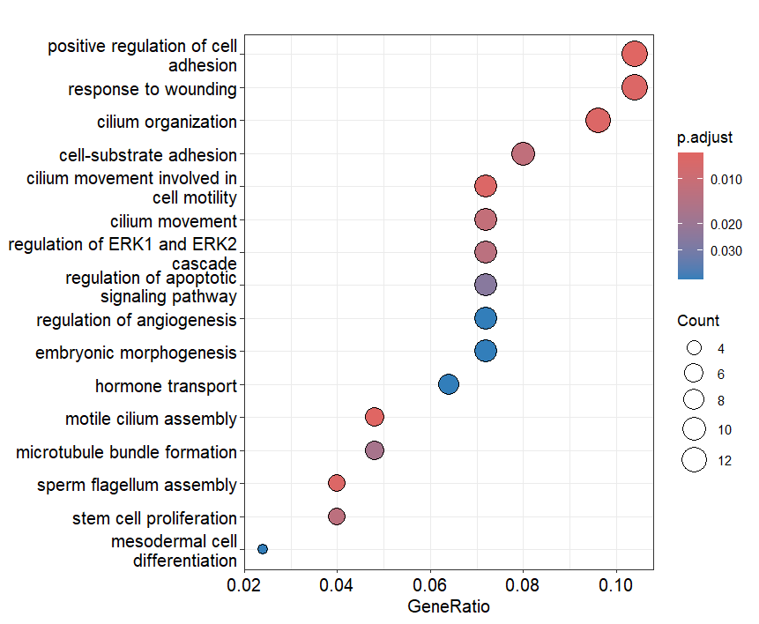
Figure 1. Top 16 non-redundant enriched GO Biological Process terms (dot plot; dot size = gene count, color = adjusted p-value). Terms span both the cell-adhesion/wounding theme and the cilium-assembly theme.
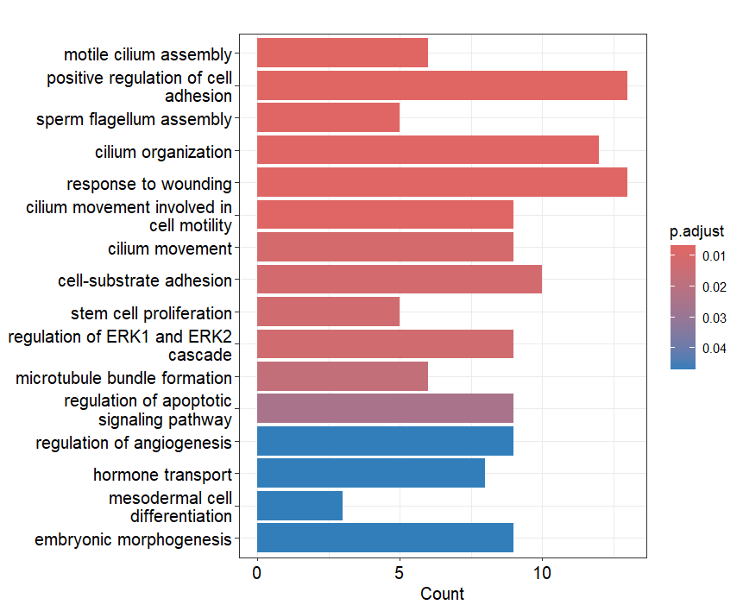
Figure 2. Same 16 GO terms shown as a bar plot (gene count, colored by adjusted p-value), for comparison.

3.4 Pathway-Level Visualization
Fold-change values were mapped onto the KEGG ECM-receptor interaction pathway (hsa04512), the most biologically interpretable of the five KEGG hits.
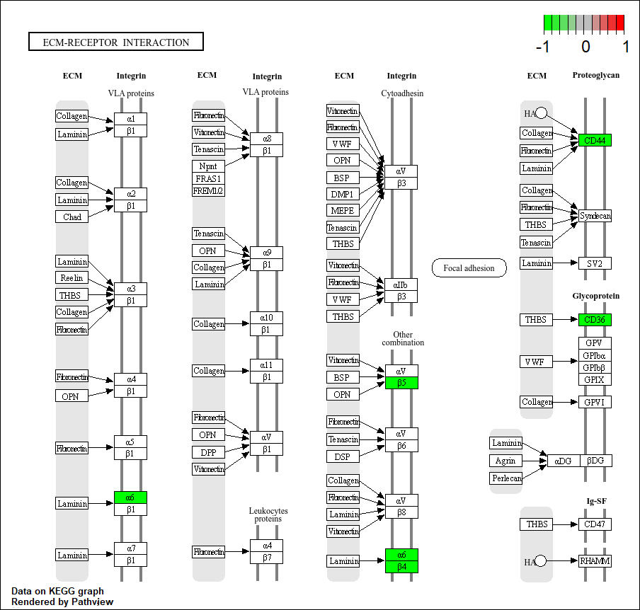
Figure 3. KEGG ECM-receptor interaction pathway (hsa04512) with DEGs highlighted (green = downregulated, log2FC scale shown top-right). All five highlighted genes — ITGA6, ITGB4, ITGB5, CD44, CD36 — are downregulated and cluster around laminin-binding integrin complexes (α6β1, α6β4) and the CD44/CD36 receptor systems.
All five pathway genes are downregulated, and they cluster specifically around laminin-binding integrins and CD44/CD36 receptor systems — both central to basement membrane and blood-brain barrier anchoring. This coordinated downregulation is consistent with the well-documented phenomenon of blood-brain barrier integrity loss in Alzheimer's disease, though this is an association from expression data and does not by itself establish a causal mechanism or its direction.

3.5 Protein-Protein Interaction Network and Hub Genes
The 138 DEGs were submitted to STRING-db, returning a network of 93 connected/annotated nodes and 207 interaction edges across 5 connected components. Network topology analysis in Cytoscape identified the following top hub genes by degree:
Rank | Gene | Degree | Biological role
1 | CD44 | 20 | Cell adhesion receptor; ECM/hyaluronan binding
2 | ERBB2 | 15 | Receptor tyrosine kinase, cell signaling
3 | CCL2 | 14 | Chemokine (MCP-1); microglial recruitment, established AD neuroinflammation marker
3 | VCAM1 | 14 | Vascular adhesion molecule; BBB/immune cell adhesion
5 | ARMC3 | 13 | Ciliary gene (hub of the separate cilium module)
6 | CALML4 | 10 | Calcium-binding protein
6 | GJA1 | 10 | Gap junction protein (connexin-43)
6 | CD36 | 10 | Amyloid-beta clearance receptor
9 | EZR | 9 | Ezrin — cytoskeleton-membrane linker
— | NEFL | 7 | Neurofilament light chain; established blood/CSF AD biomarker

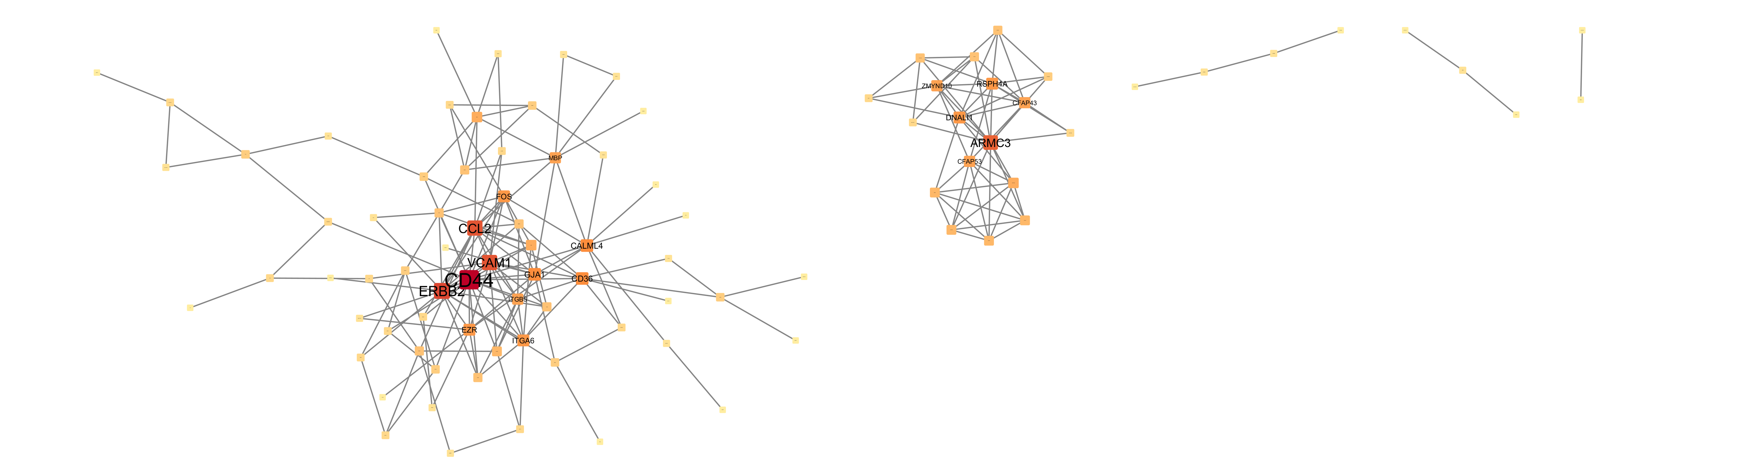
Figure 4. Protein-protein interaction network of the 138 DEGs (STRING-db, visualized in Cytoscape; edge layout weighted by combined_score). Node size/color scaled to degree. Left: main adhesion/inflammation cluster with CD44 as dominant hub. Middle: structurally separate ciliary-gene module (ARMC3, RSPH4A, CFAP43/53, ZMYND10, DNALI1). Right: peripheral, weakly-connected genes.
CD44 is the clear dominant hub, with substantially more connections than any other node — directly bridging the KEGG (ECM-receptor interaction) and GO (cell adhesion) findings into a single, cross-validated result. CCL2's prominence as a hub is independently notable given its established role as a key neuroinflammatory chemokine in AD, tied to microglial activation and recruitment. NEFL's appearance, while a lower-degree hub, is also worth highlighting given its recognized use as a real-world AD/neurodegeneration blood and CSF biomarker.
The network visually separates into a large adhesion/inflammation cluster (containing CD44, ERBB2, CCL2, VCAM1, CD36, GJA1, ITGA6, ITGB5, EZR) and a structurally distinct ciliary-gene cluster (ARMC3, RSPH4A, CFAP43, CFAP53, ZMYND10, DNALI1) with no direct connections to the main cluster — confirming that the two GO themes identified in Section 3.3 correspond to two genuinely separate biological modules, not an artifact of enrichment analysis.

4. Discussion
Three independent analytical approaches — KEGG pathway enrichment, GO Biological Process enrichment, and protein-protein interaction network analysis — converged on a consistent theme: AD entorhinal cortex in this cohort is characterized by downregulated cell-adhesion and structural-ECM genes, centered on CD44, CD36, and laminin-binding integrins (ITGA6, ITGB4, ITGB5), alongside elevated involvement of the neuroinflammatory chemokine CCL2 and the vascular adhesion molecule VCAM1.
This pattern is consistent with two well-documented, complementary features of AD pathology: (1) blood-brain barrier and basement membrane integrity loss, reflected in downregulated laminin-integrin and CD44 signaling, and (2) neuroinflammatory activation, reflected in CCL2 and VCAM1 involvement. The identification of CD36 among both the KEGG and network hub results is notable given its specific, literature-established role in microglial amyloid-beta clearance — its downregulation here is consistent with, though does not by itself prove, impaired amyloid clearance capacity in this tissue.
The separate ciliary-gene module (ARMC3, RSPH4A, CFAP43, CFAP53, ZMYND10, DNALI1) represents a secondary, structurally distinct finding. While a plausible link to ependymal cell cilia and CSF flow regulation exists in the literature, this analysis cannot distinguish a genuine disease-driven transcriptional change from a difference in cell-type composition between AD and control tissue samples, and this finding is reported with that caveat rather than as a primary conclusion.

5. Limitations
- KEGG's pathway labels for the top enriched pathways (cardiomyopathy-related) reflect the tissue context in which these genes were first characterized, not the tissue analyzed here; the underlying genes were reinterpreted based on their known adhesion/cytoskeletal function rather than taken at face value from the pathway name.
- The cilium/flagellum GO signal may partly reflect differences in cell-type or tissue composition between AD and control samples rather than a purely disease-driven transcriptional change.
- This analysis is based on bulk entorhinal cortex tissue and does not resolve cell-type-specific expression changes (e.g., neuronal vs. glial vs. vascular contributions).
- AsymAD samples were excluded from this analysis; a separate comparison of Control vs. AsymAD vs. AD could reveal early/intermediate-stage transcriptional changes not captured here.
- STRING interactions include both experimentally validated and computationally predicted/text-mined associations; not all edges represent direct physical interactions.
- As a re-analysis of a single publicly deposited dataset, these findings represent an association study and would require independent validation before drawing causal conclusions.

6. Conclusion
This project applied the same reproducible bioinformatics workflow used in Project 1 — differential expression analysis, functional enrichment, pathway visualization, and network topology analysis — to a public Alzheimer's disease entorhinal cortex dataset. The results converge on downregulated cell-adhesion and ECM-linkage signaling, centered on CD44, CD36, and laminin-binding integrins, alongside elevated neuroinflammatory chemokine involvement (CCL2, VCAM1), as the central molecular signature distinguishing AD from healthy controls in this region. A structurally separate ciliary-gene module was also identified, reported with appropriate caveats regarding potential cell-composition confounding. Together with Project 1, this demonstrates a consistent, transferable analytical pipeline applied across two distinct disease contexts.

Appendix: Tools and Software
Step | Tool | Purpose
Data retrieval & DEG analysis | GEO2R (NCBI GEO) | Differential expression analysis via limma
Enrichment analysis | R — clusterProfiler, org.Hs.eg.db | KEGG & GO Biological Process enrichment
Pathway visualization | R — pathview | Fold-change overlay on KEGG pathway diagrams
Interaction data | STRING-db | Protein-protein interaction network retrieval
Network analysis & visualization | Cytoscape (NetworkAnalyzer) | Hub gene identification, network styling

