Differential Gene Expression and Pathway Analysis of Breast Cancer
A Transcriptomic and Network-Based Investigation Using GEO Dataset GSE42568
Bioinformatics Portfolio Project 3
Prepared: September 2026
Tools: R (GEO2R, clusterProfiler, pathview) · STRING-db · Cytoscape

Abstract
This project analyzed the publicly available gene expression dataset GSE42568 from the Gene Expression Omnibus (GEO), comparing 104 breast cancer tumor samples with 17 normal breast tissue samples (Affymetrix Human Genome U133 Plus 2.0 platform). Given the substantially larger effect sizes typical of tumor-vs-normal comparisons, a stricter significance threshold (adjusted p-value < 0.05, |logFC| > 3) was applied than in prior projects, yielding 412 unique differentially expressed genes (117 upregulated, 295 downregulated) after deduplication. Functional enrichment identified 9 significant KEGG pathways and 480 enriched GO Biological Process terms (simplified to 179). Both analyses were dominated by an adipose-tissue and lipid-metabolism signature (PPAR signaling, lipolysis regulation, lipid storage/catabolism), most parsimoniously explained by reduced adipocyte content in tumor tissue relative to normal breast tissue, which is predominantly composed of fat. A secondary, genuinely tumor-relevant signature was also identified, including ERBB2 (HER2), IGF1, and extracellular matrix remodeling genes. Protein-protein interaction network analysis of 371 mapped genes (330 connected nodes, 1,425 edges) identified CDH1 (E-cadherin) as the dominant hub (degree = 61), followed by PPARG, LEP, ERBB2, and IGF1 — with the network visually separating into an adipose/metabolic cluster and a cancer-intrinsic cluster. This project illustrates both genuine breast cancer biology and an important methodological lesson: differential expression in tumor-vs-normal-tissue comparisons can reflect changes in tissue composition as much as tumor-cell-intrinsic signaling.

1. Introduction
Breast cancer is the most commonly diagnosed cancer among women worldwide, and gene expression profiling of tumor versus normal tissue has been widely used to identify diagnostic, prognostic, and therapeutic biomarkers. Unlike the disease-vs-healthy comparisons in Projects 1 (asthma) and 2 (Alzheimer's disease), a tumor-vs-normal-tissue comparison introduces an additional analytical consideration: tumor and adjacent normal tissue can differ substantially not only in cell-intrinsic gene regulation but also in overall tissue composition (e.g., proportion of epithelial, stromal, immune, and adipose cells).
This project applies the same differential expression -> functional enrichment -> network analysis pipeline used in Projects 1 and 2 to a public breast cancer dataset (GSE42568), with particular attention to distinguishing tumor-cell-intrinsic signals from tissue-composition confounds — a distinction that became directly relevant to interpreting the results (see Sections 3.2–3.4).

2. Methods

2.1 Dataset
Dataset: GSE42568 (Gene Expression Omnibus)
Attribute | Value
Platform | Affymetrix Human Genome U133 Plus 2.0 Array (GPL570)
Tumor group | 104 samples
Normal group | 17 samples
Organism | Homo sapiens

Note on group balance: the tumor and normal groups are unevenly sized (104 vs. 17), reflecting the practical difficulty of collecting matched normal breast tissue relative to tumor tissue. This is a common design in cancer GEO datasets; limma/GEO2R statistical testing accounts for unequal group sizes, but the imbalance is noted here for transparency.

2.2 Differential Expression Analysis
Differential expression analysis was performed using GEO2R (limma). Given that tumor-vs-normal comparisons typically show substantially larger fold-changes than the disease-vs-healthy comparisons used in Projects 1–2, a stricter cutoff was deliberately applied to keep the resulting gene list interpretable:
- Adjusted p-value (Benjamini-Hochberg) < 0.05
- Absolute log fold-change (logFC) > 3 (compared to > 1 in Projects 1–2)
Cutoff justification: at the standard |logFC| > 1 threshold, 4,156 unique genes passed — far too many for interpretable enrichment or network analysis, and reflective of the substantially larger transcriptional differences typical of tumor vs. normal tissue comparisons. Progressively stricter cutoffs were tested (see analysis_pipeline.R), and |logFC| > 3 was selected as a threshold that retained a substantial, statistically robust gene set (412 genes) while remaining analytically tractable.
Probes were deduplicated by gene symbol (keeping the lowest adjusted p-value probe per gene), yielding 412 unique DEGs (117 upregulated, 295 downregulated), of which 371 (90%) mapped successfully to Entrez Gene IDs via org.Hs.eg.db.

2.3 Functional Enrichment Analysis
Functional enrichment was performed in R using clusterProfiler, identically to Projects 1–2: KEGG pathway enrichment (enrichKEGG, organism = “hsa”, p-value cutoff = 0.05) and GO Biological Process enrichment (enrichGO, ontology = “BP”, p-value cutoff = 0.05), followed by redundancy reduction via simplify() (similarity cutoff = 0.7). Pathway-level fold-change visualization was generated using pathview, mapping logFC values onto the KEGG Regulation of Lipolysis in Adipocytes pathway (hsa04923), selected as the top-ranked (lowest adjusted p-value) KEGG hit.

2.4 Protein-Protein Interaction Network Analysis
The 371 mapped DEGs were submitted to STRING-db (Homo sapiens). The resulting network (330 annotated nodes, 1,425 edges) was imported into Cytoscape. Network Analyzer (undirected mode) computed node degree; nodes were styled by degree (continuous mapping to node size and fill color), and a Prefuse Force Directed layout (weighted by combined_score) was applied.

3. Results

3.1 Differential Expression Overview
Of 412 unique DEGs, 117 (28%) were upregulated and 295 (72%) were downregulated in tumor relative to normal tissue — a stronger skew toward downregulation than either Project 1 (balanced) or Project 2 (83% downregulated), consistent with the combined effects of tumor-intrinsic gene silencing and loss of normal-tissue-specific gene expression (see Section 3.2).
Gene | logFC | Adj. p-value | Direction
LOC284825 | -4.16 | 7.46e-38 | Downregulated
FHL1 | -5.37 | 6.08e-37 | Downregulated
ACSM5 | -4.37 | 1.33e-36 | Downregulated
PGM5-AS1 | -3.58 | 1.43e-36 | Downregulated

3.2 KEGG Pathway Enrichment
Nine KEGG pathways were significantly enriched (adjusted p < 0.05), led by PPAR signaling pathway and Regulation of lipolysis in adipocytes.
Pathway | Gene ratio | Adj. p-value
PPAR signaling pathway | 15/213 | 3.45e-08
Regulation of lipolysis in adipocytes | 11/213 | 1.06e-05
AMPK signaling pathway | 14/213 | 5.27e-05
Proteoglycans in cancer | 14/213 | 0.0142
Hormone signaling | 14/213 | 0.0235
Cytoskeleton in muscle cells | 14/213 | 0.0331

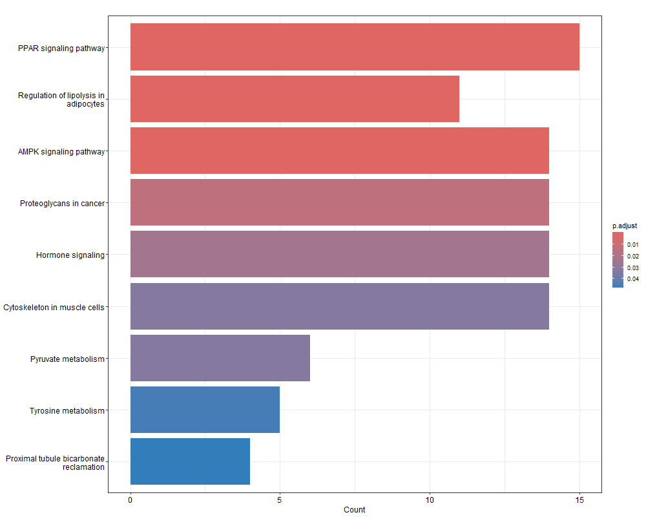
Figure 1. All 9 significantly enriched KEGG pathways (bar plot, gene count colored by adjusted p-value).
Interpretive note: the genes driving the top two pathways (PLIN1, PLIN4, FABP4, FABP5, ADIPOQ, LEP, LIPE, CIDEC, CIDEA, MGLL, ACSL1, GOS2) form a textbook adipocyte gene signature. Their downregulation most likely reflects reduced adipocyte content in tumor tissue — which physically displaces fat tissue as it grows — relative to normal breast tissue, which is predominantly adipose. This is a well-documented confound in breast tumor-vs-normal-tissue comparisons and is not necessarily a tumor-cell-intrinsic regulatory change. Separately, genuine tumor-relevant genes were also identified: ERBB2 and ERBB3 (the HER2 receptor family, a major clinical breast cancer biomarker and drug target), IGF1, PRLR and GHR (hormone/growth signaling), and ECM remodeling genes (COL11A1, ITGA7, SDC1, GPC3), consistent with known tumor stroma and growth-signaling biology.

3.3 Gene Ontology Enrichment
GO Biological Process enrichment returned 480 significant terms, reduced to 179 after semantic similarity filtering — by far the largest result across all three projects, reflecting both the larger gene list and the breadth of biological systems affected by the tumor/normal-tissue contrast. The top-ranked terms by adjusted p-value were overwhelmingly dominated by adipose and lipid-metabolism processes, echoing the KEGG results.
GO term | Description | Gene count | Adj. p-value
GO:0008015 | Blood circulation | 35 | 2.62e-09
GO:0019216 | Regulation of lipid metabolic process | 28 | 6.47e-09
GO:0006641 | Triglyceride metabolic process | 15 | 8.26e-08
GO:0001659 | Temperature homeostasis | 20 | 8.26e-08
GO:1990845 | Adaptive thermogenesis | 18 | 1.55e-07

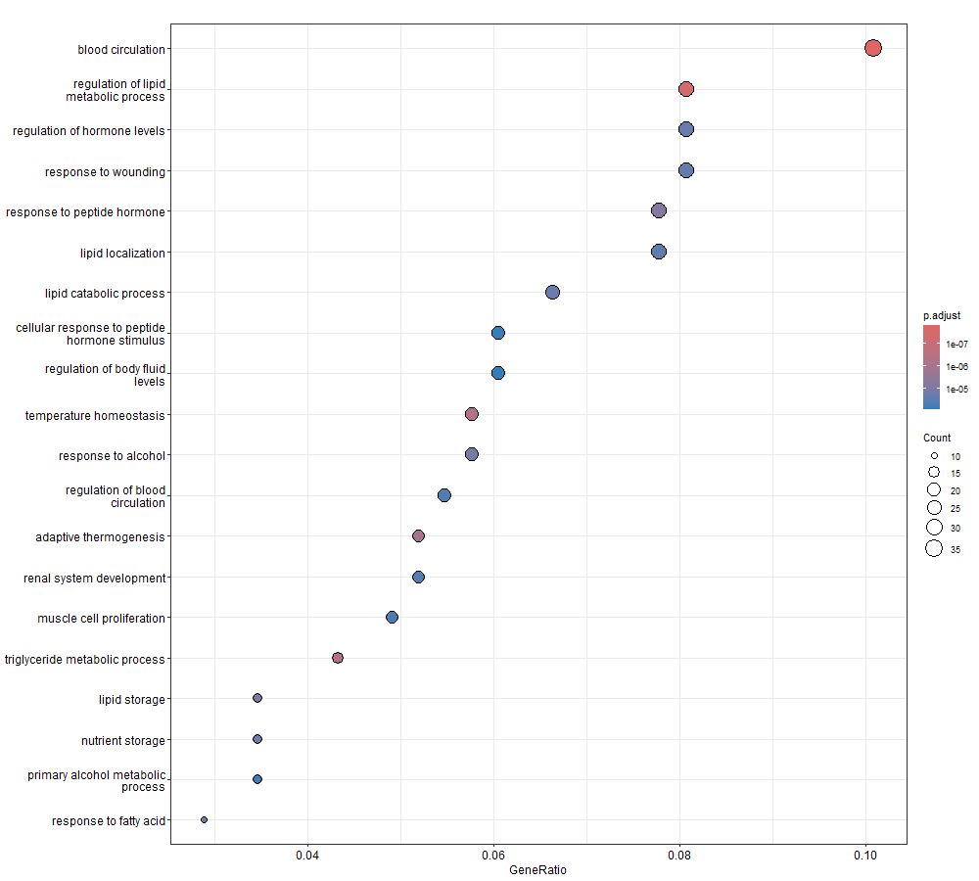
Figure 2. Top 20 non-redundant enriched GO Biological Process terms (dot plot; dot size = gene count, color = adjusted p-value).
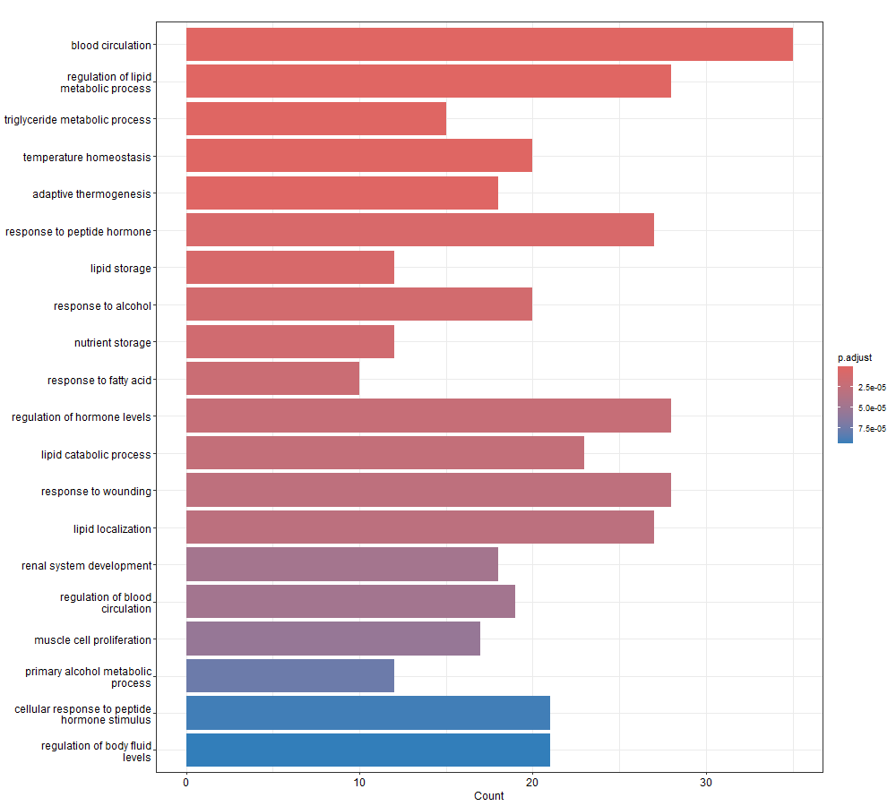
Figure 3. Same 20 GO terms shown as a bar plot, for comparison.
A notable methodological observation: none of the top-ranked GO terms are classic cancer proliferation/cell-cycle processes (e.g., mitotic cell cycle, DNA replication), despite these being commonly reported in other published re-analyses of this same dataset at looser cutoffs. This is most likely a direct consequence of the |logFC| > 3 cutoff applied here: proliferation/cell-cycle genes typically show moderate fold-changes in cancer (often logFC 1.5–2.5), while adipose-tissue-loss genes show extremely large fold-changes given the near-complete absence of adipocytes in tumor tissue. The strict cutoff, chosen for analytical tractability, therefore selectively enriched for the most dramatic tissue-composition differences over more moderate tumor-intrinsic signaling changes — an important limitation to keep in mind when interpreting these results (see Section 5).

3.4 Pathway-Level Visualization
Fold-change values were mapped onto the KEGG Regulation of Lipolysis in Adipocytes pathway (hsa04923), the top-ranked KEGG hit by adjusted p-value.
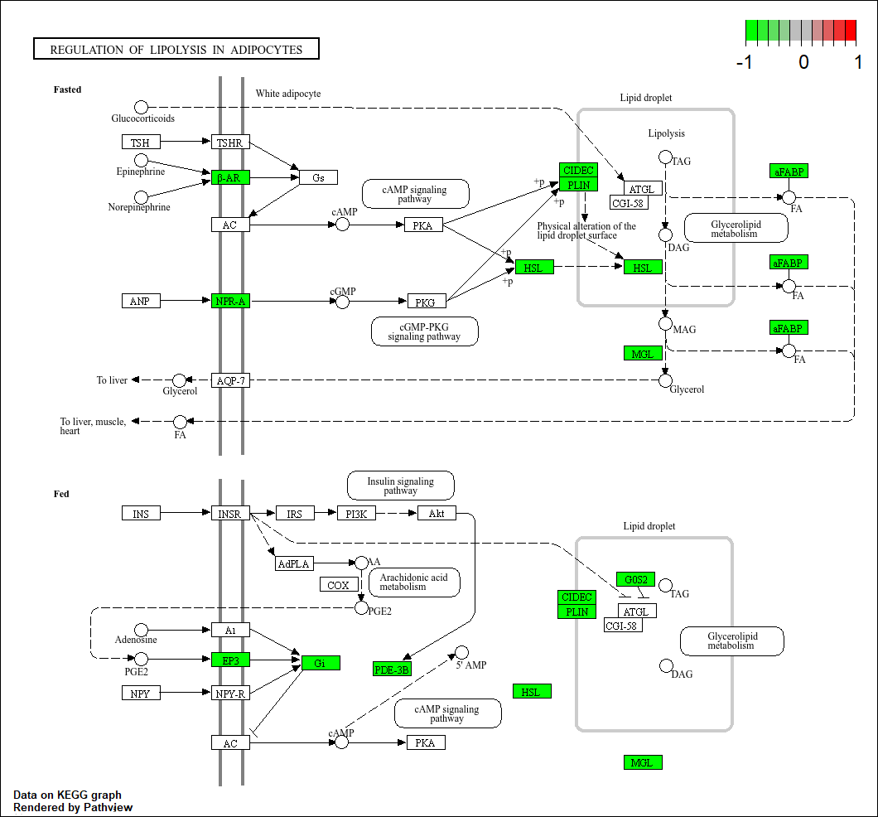
Figure 4. KEGG Regulation of Lipolysis in Adipocytes pathway (hsa04923) with DEGs highlighted (green = downregulated, log2FC scale shown top-right). Every highlighted gene across both the fasted and fed states of the pathway — β-AR, NPR-A, CIDEC, PLIN, HSL, MGL, aFABP, EP3, PDE-3B, G0S2 — is downregulated.
Every gene in this pathway is downregulated, with no exceptions — a complete, coordinated shutdown of the adipocyte lipolysis machinery rather than a partial or mixed signal. Given that this pathway consists of adipocyte-specific enzymes and regulators, this pattern most likely reflects the absence of the cell type that normally expresses them (i.e., reduced adipocyte content in tumor tissue) rather than active tumor-cell suppression of a signaling pathway. This distinction — tissue-composition effect versus tumor-intrinsic regulation — is an important general principle in interpreting tumor-vs-normal-tissue differential expression studies, and is a central finding of this project's discussion.

3.5 Protein-Protein Interaction Network and Hub Genes
The 371 mapped DEGs were submitted to STRING-db, returning the largest and densest network of the three projects: 330 connected nodes and 1,425 interaction edges. Network topology analysis in Cytoscape identified the following top hub genes by degree:
Rank | Gene | Degree | Biological role
1 | CDH1 | 61 | E-cadherin — cell-cell adhesion, tumor suppressor; loss is a hallmark of invasive breast cancer, especially lobular carcinoma
2 | PPARG | 54 | Master regulator of adipocyte differentiation and lipid metabolism
3 | LEP | 44 | Leptin — adipokine, adipose-tissue marker
4 | ERBB2 | 42 | HER2 — major clinical breast cancer biomarker and drug target
5 | IGF1 | 40 | Growth factor signaling; breast cancer proliferation
6 | CD36 | 39 | Fatty acid uptake receptor (also a hub gene in Project 2)
7 | FABP4 / CAV1 | 35 | Adipocyte fatty-acid binding protein / caveolin (signaling scaffold, tumor suppressor)
— | MUC1 / KRT19 / EPCAM | 34 / 32 / 31 | Classic luminal epithelial / breast cancer markers
— | EZH2 | 29 | Epigenetic regulator; well-established oncogene in breast cancer

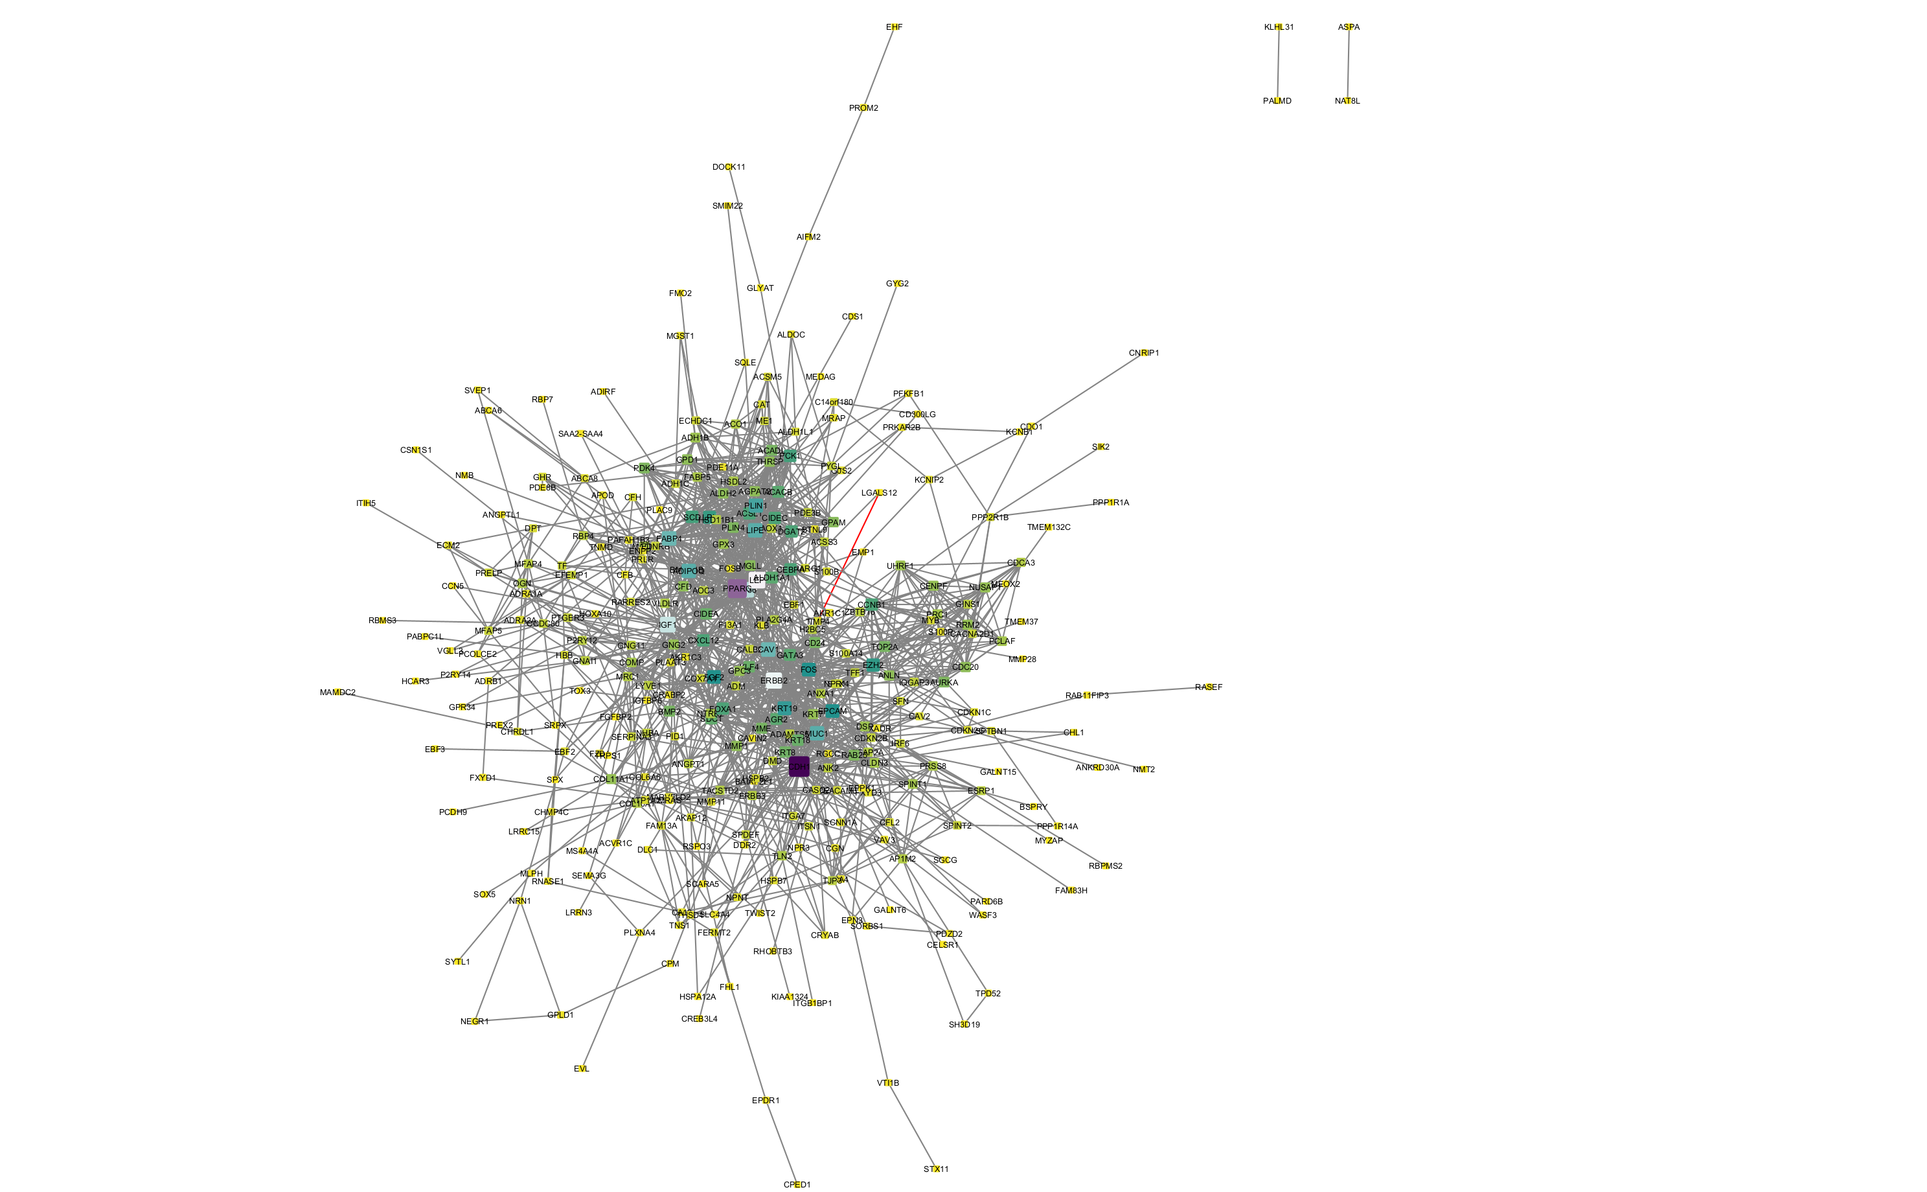
Figure 5. Protein-protein interaction network of the 371 mapped DEGs (STRING-db, visualized in Cytoscape). Node size/color scaled to degree; CDH1 (dark, center-right) is the dominant hub, followed by PPARG. Given the network's density (330 nodes), only major hub genes are fully legible at this scale; see Table above for the complete top-hub list.
CDH1 (E-cadherin) is the clear dominant hub — a genuinely notable, clinically significant result, given E-cadherin's established role as a tumor suppressor whose loss defines invasive lobular breast carcinoma specifically. This is a stronger, more directly cancer-relevant hub finding than either prior project's top hub. The network visually separates into two overlapping but distinguishable clusters: an adipose/metabolic cluster (PPARG, LEP, CD36, FABP4, LIPE, ADIPOQ, PLIN1, LPL, PCK1, SCD) and a cancer-intrinsic cluster (CDH1, ERBB2, IGF1, MUC1, KRT19, EPCAM, EZH2, FOS, CAV1) — mirroring the dual biological themes already identified in the KEGG and GO results.

4. Discussion
This project's results are best understood as two overlapping but distinct biological signals. The first, and statistically dominant, signal is an adipose-tissue and lipid-metabolism signature (PPARG, LEP, CD36, FABP4, LIPE, ADIPOQ, PLIN1/4, CIDEC/CIDEA, driving both the top KEGG pathways and the majority of top GO terms). This signal is most parsimoniously explained by a tissue-composition confound: normal breast tissue is predominantly adipose, while tumor tissue is predominantly epithelial/stromal, so a tumor-vs-normal comparison will inevitably show strong depletion of adipocyte-specific genes regardless of any tumor-intrinsic regulatory changes.
The second, smaller but genuinely tumor-relevant signal includes CDH1 (the network's dominant hub and a well-established tumor suppressor whose loss is linked to invasive breast carcinoma), ERBB2/ERBB3 (the clinically critical HER2 receptor family), IGF1 and hormone receptor signaling (PRLR, GHR), EZH2 (an established breast cancer oncogene), and ECM remodeling genes (COL11A1, ITGA7, SDC1). This signal is consistent with genuine, well-documented breast cancer biology and represents the more analytically interesting and clinically relevant finding of this project, even though it is statistically smaller than the adipose signal.
Distinguishing these two signals — rather than treating all enriched pathways as equally reflective of tumor biology — is the central analytical lesson of this project, and is a direct consequence of using a bulk tumor-vs-normal-tissue comparison rather than a purified cell population or single-cell approach.

5. Limitations
- The dominant enriched signal (adipose/lipid metabolism) likely reflects tissue-composition differences between tumor and normal breast tissue rather than tumor-cell-intrinsic regulation; this cannot be definitively confirmed without histological data on adipocyte content per sample, which was not available in this dataset.
- The strict |logFC| > 3 cutoff, chosen for analytical tractability, likely under-represents genuine tumor-intrinsic signaling changes (e.g., cell-cycle/proliferation genes), which often show more moderate fold-changes than the tissue-composition-driven genes that dominate this gene list.
- The tumor (n=104) and normal (n=17) groups are unevenly sized, reflecting practical sample availability rather than a matched-pairs design.
- This analysis is based on bulk tissue and does not resolve cell-type-specific expression (e.g., tumor epithelial cells vs. stroma vs. residual adipocytes vs. immune infiltrate).
- The STRING PPI network (330 nodes) is dense enough that only major hub genes are individually legible in the exported figure; smaller/peripheral genes are represented in the underlying data but not visually distinguishable at this scale.
- As a re-analysis of a single publicly deposited dataset, these findings represent an association study and would require independent validation before drawing causal or clinical conclusions.

6. Conclusion
This project applied the same reproducible bioinformatics workflow used in Projects 1 and 2 to a public breast cancer tumor-vs-normal-tissue dataset. The results revealed two overlapping biological signals: a dominant adipose-tissue/lipid-metabolism signature best explained by tissue-composition differences between tumor and normal breast tissue, and a smaller but genuinely tumor-relevant signature centered on CDH1 (E-cadherin, the network's dominant hub), ERBB2 (HER2), IGF1, and EZH2 — all well-established breast cancer genes. Beyond the specific biological findings, this project demonstrates an important general analytical principle: differential expression in tumor-vs-normal-tissue comparisons can reflect changes in tissue composition as much as tumor-cell-intrinsic signaling, and distinguishing between these two sources of signal is essential for accurate biological interpretation. Together with Projects 1 and 2, this completes a three-project portfolio demonstrating a consistent, transferable bioinformatics pipeline applied across three distinct disease contexts — an inflammatory disease (asthma), a neurodegenerative disease (Alzheimer's), and a cancer (breast cancer) — each requiring context-appropriate analytical judgment rather than mechanical reapplication of identical parameters.

Appendix: Tools and Software
Step | Tool | Purpose
Data retrieval & DEG analysis | GEO2R (NCBI GEO) | Differential expression analysis via limma
Enrichment analysis | R — clusterProfiler, org.Hs.eg.db | KEGG & GO Biological Process enrichment
Pathway visualization | R — pathview | Fold-change overlay on KEGG pathway diagrams
Interaction data | STRING-db | Protein-protein interaction network retrieval
Network analysis & visualization | Cytoscape (NetworkAnalyzer) | Hub gene identification, network styling

