Differential Gene Expression and Pathway Analysis of Asthma
A Transcriptomic and Network-Based Investigation Using GEO Dataset GSE152004
Bioinformatics Portfolio Project 1
Prepared: September 2026
Tools: R (GEO2R, clusterProfiler, pathview) · STRING-db · Cytoscape

Abstract
This project analyzed the publicly available gene expression dataset GSE152004 from the Gene Expression Omnibus (GEO), comparing whole-blood transcriptomic profiles from 257 asthma patients and 136 healthy controls (Illumina platform, 393 total samples). Differential expression analysis via GEO2R identified 33 genes meeting strict significance thresholds (adjusted p-value < 0.05, |log2 fold-change| > 1). Functional enrichment analysis using clusterProfiler identified 9 significantly enriched KEGG pathways and 165 enriched Gene Ontology Biological Process terms (simplified to 53 non-redundant terms), with strong convergence on chemokine signaling and leukocyte chemotaxis. Protein-protein interaction network analysis via STRING and Cytoscape identified interferon-gamma (IFNG) as the dominant network hub, with a tightly interconnected chemokine cluster (CXCL10, CXCL11, CXCL13, CCL20, CD163) surrounding it. These findings are consistent with established asthma immunopathology, in which interferon-driven chemokine signaling recruits leukocytes to airway tissue, and demonstrate a complete, reproducible bioinformatics workflow from raw dataset to biological interpretation.

1. Introduction
Asthma is a chronic inflammatory airway disease characterized by immune cell infiltration, airway hyperresponsiveness, and reversible airflow obstruction. It affects an estimated 260 million people worldwide and remains a leading cause of chronic disease burden, yet the transcriptional programs underlying disease heterogeneity are not fully characterized.
Publicly available gene expression datasets, such as those deposited in the NCBI Gene Expression Omnibus (GEO), provide an opportunity to re-analyze large patient cohorts computationally without new data generation. This project applies a standard differential expression → functional enrichment → network analysis pipeline to a large asthma cohort (GSE152004) in order to (a) identify genes that are significantly dysregulated in asthma, (b) determine which biological pathways and processes these genes participate in, and (c) identify the most highly connected — and therefore potentially most biologically central — genes within the resulting interaction network.

2. Methods

2.1 Dataset
Dataset: GSE152004 (Gene Expression Omnibus)
Attribute | Value
Platform | Illumina (bead-based expression array)
Total samples | 393
Asthma group | 257 samples
Control group | 136 samples
Organism | Homo sapiens

2.2 Differential Expression Analysis
Differential expression analysis was performed using GEO2R, GEO's built-in implementation of the limma statistical framework. Samples were assigned to “Asthma” and “Control” groups based on the dataset's characteristic annotations. Genes were considered differentially expressed (DEGs) if they met both of the following criteria:
- Adjusted p-value (Benjamini-Hochberg) < 0.05
- Absolute log2 fold-change > 1
This threshold combination yielded 33 differentially expressed genes, all of which mapped successfully to Entrez Gene IDs via the org.Hs.eg.db annotation database (100% mapping rate, 33/33).

2.3 Functional Enrichment Analysis
Functional enrichment was performed in R using the clusterProfiler package (v4, Bioconductor). Two analyses were run on the 33-gene DEG list:
- KEGG pathway enrichment (enrichKEGG, organism = “hsa”, p-value cutoff = 0.05)
- Gene Ontology Biological Process enrichment (enrichGO, ontology = “BP”, p-value cutoff = 0.05), followed by semantic redundancy reduction using simplify() (similarity cutoff = 0.7)
Pathway-level visualization of fold-change data was generated using the pathview package, mapping log2 fold-change values onto the KEGG chemokine signaling pathway diagram (hsa04062).

2.4 Protein-Protein Interaction Network Analysis
The 33 DEGs were submitted to STRING-db (Homo sapiens) to retrieve known and predicted protein-protein interactions. The resulting interaction network was imported into Cytoscape for topological analysis. Network Analyzer (undirected mode) was used to compute node degree for each gene. Nodes were styled by degree (continuous mapping to both node size and fill color) to visually highlight hub genes, and a force-directed layout was applied for readability.

3. Results

3.1 Differential Expression Overview
Of the genes profiled, 33 passed the strict significance and fold-change thresholds. Despite the large sample size (n = 393), a focused gene set passed the strict |log2FC| > 1 cutoff, suggesting that the genes identified represent a robust, high-confidence “core” signature of asthma-associated transcriptional change rather than a broad, noisy signal. Representative top DEGs (by adjusted p-value) are shown below.
Gene | log2FC | Adj. p-value | Direction
LILRB2 | 1.52 | 2.57e-11 | Upregulated
LILRA5 | 1.90 | 2.57e-11 | Upregulated
ZBP1 | 1.31 | 1.40e-10 | Upregulated
SLAMF7 | 1.01 | 2.65e-08 | Upregulated
LILRB4 | 1.09 | 5.80e-08 | Upregulated
APOBEC3A | 1.32 | 2.91e-07 | Upregulated

3.2 KEGG Pathway Enrichment
Nine KEGG pathways were significantly enriched (adjusted p < 0.05). The two most directly relevant pathways to asthma pathophysiology were Cytokine-cytokine receptor interaction and Chemokine signaling pathway, both reflecting the core inflammatory machinery that recruits immune cells to airway tissue.
Pathway | Gene ratio | Adj. p-value
Influenza A | 5/24 | 0.0032
Viral protein interaction with cytokine/receptor | 4/24 | 0.0037
Osteoclast differentiation | 4/24 | 0.0096
Renin secretion | 3/24 | 0.0109
Cytokine-cytokine receptor interaction | 5/24 | 0.0109
Chemokine signaling pathway | 4/24 | 0.0128

Note: Influenza A and viral-interaction pathway hits are expected here — these pathways share interferon-response and chemokine genes with asthma-relevant immune signaling, and viral infection is a well-documented asthma trigger, so this overlap is biologically consistent rather than a false positive. The Osteoclast differentiation hit likely reflects shared immune-signaling genes (CXCL and immunoglobulin-receptor family members) rather than a direct biological link to asthma, and should be interpreted cautiously. The Renin secretion pathway had the weakest support (lowest gene count) and is treated as a low-confidence hit.

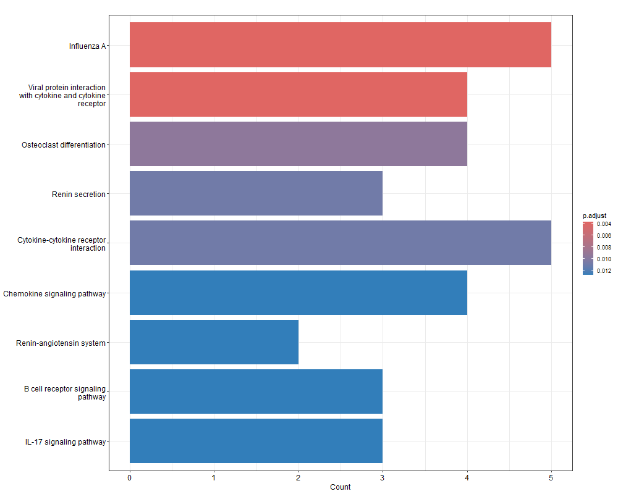
Figure 1. Top significantly enriched KEGG pathways (bar plot, gene count x -log10 adjusted p-value).

3.3 Gene Ontology Enrichment
GO Biological Process enrichment returned 165 significant terms, reduced to 53 non-redundant terms after semantic similarity filtering. The top terms were dominated by immune cell recruitment and chemotaxis processes:
GO term | Description | Gene count | Adj. p-value
GO:0060326 | Cell chemotaxis | 7 | 1.5e-04
GO:0071674 | Mononuclear cell migration | 6 | 1.5e-04
GO:0030595 | Leukocyte chemotaxis | 6 | 1.5e-04
GO:0031640 | Killing of cells of another organism | 5 | 1.5e-04
GO:0141061 | Disruption of cell in another organism | 5 | 1.5e-04

The genes CXCL10, CXCL11, CXCL13, CCL20, TNFAIP6, CTSG, and EDN2 recurred across the majority of top-ranked terms, identifying them as the primary drivers of the enriched biological processes — the same core gene set that also dominated the KEGG results, providing cross-validation between the two independent enrichment methods.
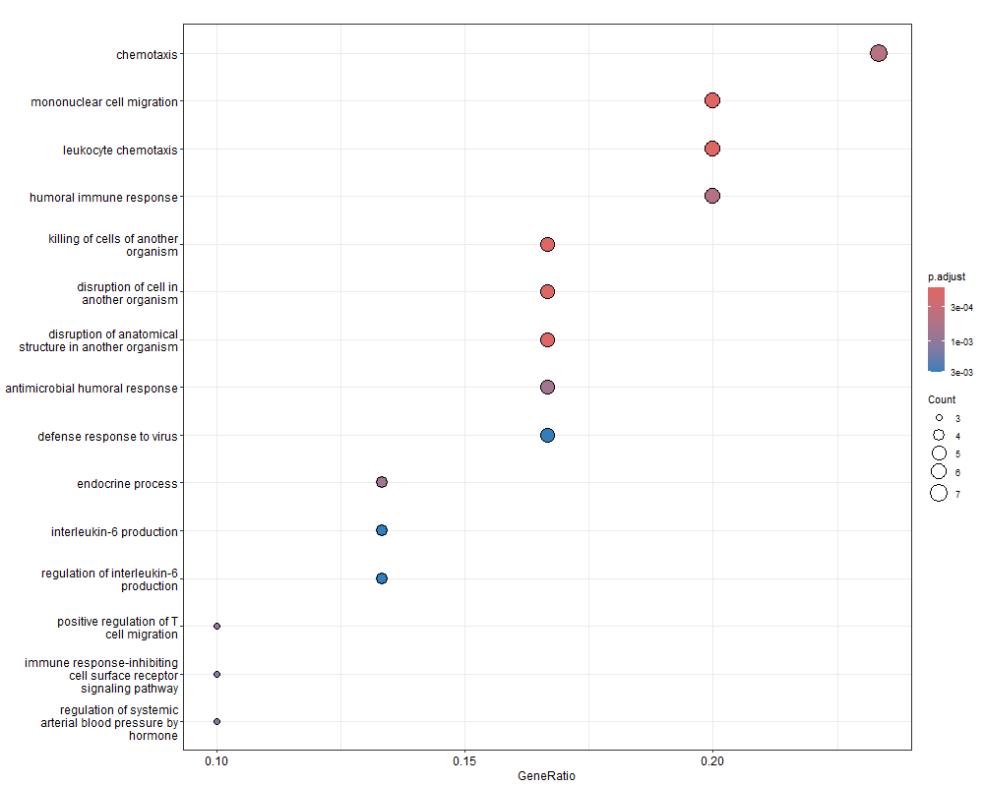
Figure 2. Top 15 non-redundant enriched GO Biological Process terms (dot plot; dot size = gene count, color = adjusted p-value).

3.4 Pathway-Level Visualization
To contextualize the DEGs within a specific signaling cascade, fold-change values were mapped onto the KEGG Chemokine Signaling Pathway diagram (hsa04062), the top-ranked pathway from the enrichment analysis.
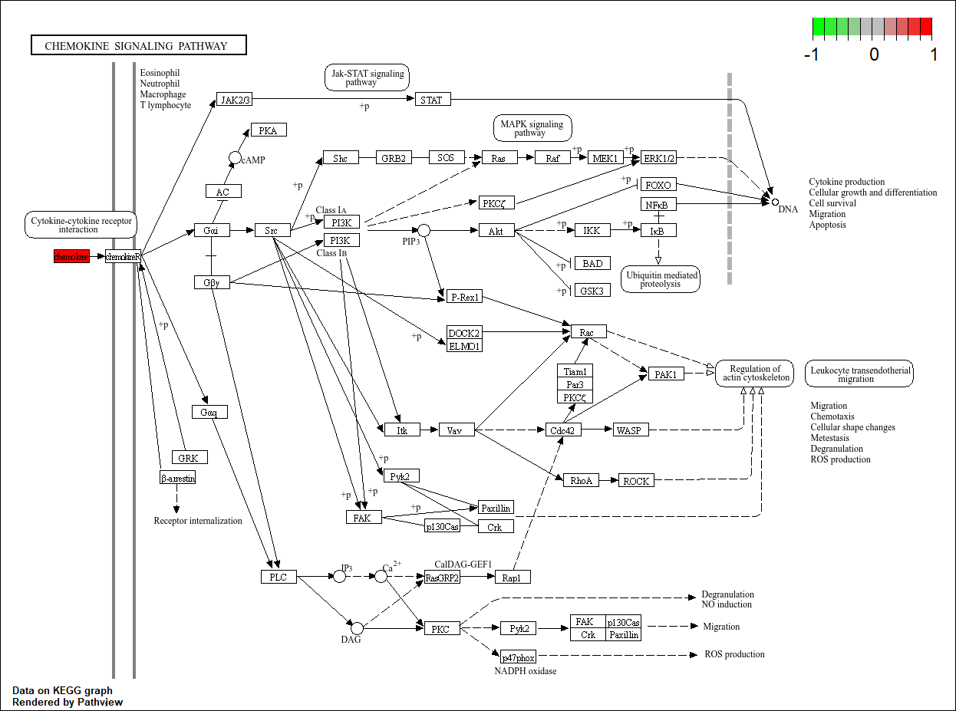
Figure 3. KEGG Chemokine Signaling Pathway (hsa04062) with pathway entry point highlighted in red (upregulated, log2FC scale shown top-right). The upregulated chemokine ligand sits at the pathway's entry point, feeding into downstream JAK-STAT, MAPK/ERK, and PI3K/Akt cascades that converge on cytokine production, immune cell migration, and chemotaxis.
This visualization demonstrates that the DEG signature is not scattered across unrelated pathway components but is concentrated at the initiating step of chemokine receptor signaling — consistent with a coordinated, biologically coherent upregulation of the inflammatory cascade in asthma.

3.5 Protein-Protein Interaction Network and Hub Genes
The 33 DEGs were submitted to STRING-db, returning a network of 26 connected/annotated nodes and 55 interaction edges. Network topology analysis in Cytoscape identified the following genes as the most highly connected (highest-degree) hub nodes:
Rank | Gene | Degree (connections) | Biological role
1 | IFNG | 12 | Interferon-gamma — master regulator of immune/inflammatory response
2 | CXCL10 | 9 | Interferon-induced chemokine, T-cell recruitment
2 | CD163 | 9 | Macrophage scavenger receptor / activation marker
4 | CXCL11 | 7 | Chemokine, T-cell recruitment (paired with CXCL10)
5 | LILRB2 | 6 | Immune inhibitory receptor
5 | CCL20 | 6 | Chemokine, mucosal immune cell recruitment
5 | CXCL13 | 6 | B-cell chemoattractant
5 | CPA3 | 6 | Mast cell protease (carboxypeptidase A3)

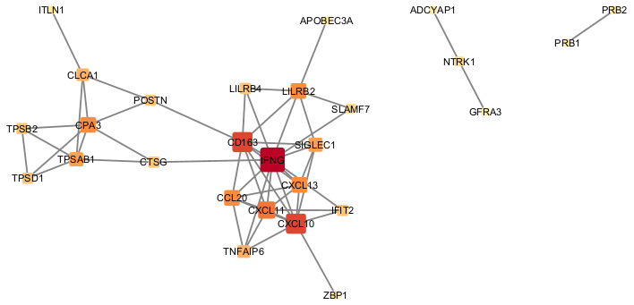
Figure 4. Protein-protein interaction network of the 33 DEGs (STRING-db, visualized in Cytoscape). Node size and color intensity are scaled to degree centrality; IFNG (dark red, center) is the dominant hub. A distinct mast cell protease sub-cluster (CPA3, TPSAB1, TPSB2, TPSD1, CTSG) and several disconnected genes (ADCYAP1-NTRK1-GFRA3; PRB1-PRB2) are also visible.
IFNG (interferon-gamma) emerged as the clear dominant hub, with more than double the connections of any other node. This is biologically consistent with its established role as a master regulator sitting upstream of much of the chemokine signaling identified in the KEGG and GO analyses — IFNG is known to induce CXCL10 and CXCL11 expression, which in turn drive the leukocyte chemotaxis processes highlighted throughout this analysis.
Two substructures are notable. First, a mast cell protease module (CPA3, TPSAB1, TPSB2, TPSD1, CTSG) forms a tightly interconnected but largely separate sub-cluster, reflecting a distinct but complementary asthma mechanism — mast cell degranulation — linked to the main network only loosely via CLCA1 and POSTN. Second, three genes (ADCYAP1, NTRK1, GFRA3) and a separate pair (PRB1, PRB2) had no connections to the main immune network, suggesting either incidental findings or roles not yet well characterized in curated interaction databases.

4. Discussion
Three independent analytical approaches — KEGG pathway enrichment, GO Biological Process enrichment, and protein-protein interaction network analysis — converged on a consistent biological narrative: asthma in this cohort is characterized by upregulated interferon-driven chemokine signaling, centered on IFNG, CXCL10, and CXCL11, which recruits leukocytes to airway tissue and drives the chemotaxis and inflammatory processes captured in the GO enrichment results.
This is consistent with well-established asthma immunopathology, in which Th1/Th2-associated cytokine signaling and chemokine-mediated leukocyte recruitment are central to airway inflammation. The identification of IFNG as the dominant network hub is particularly notable, as it suggests this gene may act as a coordinating regulator of the broader inflammatory signature observed, and could represent a point of biological interest for further investigation, though this analysis is correlational and does not establish causality.
The mast cell protease sub-cluster identified in the network analysis (CPA3, TPSAB1, TPSB2, TPSD1, CTSG) represents a biologically distinct but well-documented asthma mechanism, reflecting mast cell activation and degranulation, a process known to contribute independently to airway hyperresponsiveness alongside the chemokine-driven leukocyte recruitment pathway.

5. Limitations
- Enrichment analyses were performed on a relatively small gene set (n = 33) resulting from a strict fold-change threshold; a looser threshold may reveal additional relevant pathways not captured here, at the cost of increased false-positive risk.
- This analysis is based on whole-blood or bulk-tissue expression data (per GEO2R defaults for this dataset) and does not resolve cell-type-specific expression changes; observed signals may partly reflect shifts in immune cell composition rather than within-cell transcriptional changes.
- STRING interactions include both experimentally validated and computationally predicted/text-mined associations; not all edges represent direct physical interactions.
- As a re-analysis of a single publicly deposited dataset, these findings represent an association study and would require independent validation (e.g., qPCR, an independent cohort) before drawing causal or clinical conclusions.
- The KEGG “Osteoclast differentiation” and “Renin secretion” pathway hits are of uncertain direct relevance to asthma and are reported for completeness rather than as primary findings.

6. Conclusion
This project applied a complete, reproducible bioinformatics workflow — differential expression analysis, functional enrichment, pathway visualization, and network topology analysis — to a large public asthma gene expression dataset. The results converge consistently on interferon-gamma-driven chemokine signaling as the central molecular signature distinguishing asthma from healthy controls in this cohort, with IFNG identified as the most highly connected gene in the resulting interaction network. This demonstrates both a sound understanding of standard transcriptomic analysis methodology and the ability to synthesize multiple analytical outputs into a coherent biological interpretation.

Appendix: Tools and Software
Step | Tool | Purpose
Data retrieval & DEG analysis | GEO2R (NCBI GEO) | Differential expression analysis via limma
Enrichment analysis | R — clusterProfiler, org.Hs.eg.db | KEGG & GO Biological Process enrichment
Pathway visualization | R — pathview | Fold-change overlay on KEGG pathway diagrams
Interaction data | STRING-db | Protein-protein interaction network retrieval
Network analysis & visualization | Cytoscape (NetworkAnalyzer) | Hub gene identification, network styling

