**Project Report**

**Computational Thinking and Programming (ECSE105L)**

**MAZER**



**Bennett University**

**School of Engineering & Applied Sciences**

**Department of Computer Sciences & Information Technology**

**Submitted by:**

**Da Moon (EB05)**

PARITOSH TRIPATHI(E20CSE067)

SHREYA BOSE(E20CSE016)

ALTAMASH ALAM (E20CSE055)

AYUSH AGARWAL (E20CSE043)

SAKSHAM JOHARI(E20CSE076)

**ACKNOWLEDGEMENT**

I would like to express my special thanks of gratitude to our CSE Professor Mr. Shashank Sheshar and Mr. Deepak Singh for their able guidance and support in completing our project MAZER. I would also like to thank my friends and family for helping me in difficult phases in the project. Last but not the least, I would also like to thank my teammates and batchmates who have helped me a lot.

**ABSTRACT**

*The game is inspired from the retro game like Pacman and one of the modern games like Among Us.* *The player is the reaper which is being chased by the mobs (called ghosts).* Reaper must avoid the ghosts’ direct contact and at the same time should attack the ghosts at the right time to score points. This is a “Fight to Survive” kind of game where the ghosts randomly keep spawning to keep making the game difficult. The game is maze bound for the Reaper while ghosts can bypass the walls and other obstacles. This game keeps on getting fun as the number of ghosts increase and you must strategically and smartly avoid the ghosts and not lose your lives.This game would even give you an immersive experience when you have your earphones/headphones on and your atmosphere to the amazing retro background music while playing the game.

**Table of Contents**

**1** **Introduction**

[1.1 Problem Statement............................................... 1](https://inc-word-edit.officeapps.live.com/we/wordeditorframe.aspx?ui=en%2DIN&rs=en%2DUS&wopisrc=https%3A%2F%2Fbennettu-my.sharepoint.com%2Fpersonal%2Fe20cse067_bennett_edu_in%2F_vti_bin%2Fwopi.ashx%2Ffiles%2Fa5d9e4d9fd0c420db3034ad984a7c0d9&wdenableroaming=1&mscc=1&wdodb=1&hid=00000000-0000-0000-0000-000000000000&wdorigin=Sharing&jsapi=1&jsapiver=v1&newsession=1&corrid=a1b05ae0-9313-4f04-b110-83bda534ae77&usid=a1b05ae0-9313-4f04-b110-83bda534ae77&sftc=1&mtf=1&instantedit=1&wopicomplete=1&wdredirectionreason=Unified_SingleFlush&rct=Medium&ctp=LeastProtected#_Toc40385857)

1.2 Objectives.............................................................

[1.3 Importance and Need of your Project.................. 1](https://inc-word-edit.officeapps.live.com/we/wordeditorframe.aspx?ui=en%2DIN&rs=en%2DUS&wopisrc=https%3A%2F%2Fbennettu-my.sharepoint.com%2Fpersonal%2Fe20cse067_bennett_edu_in%2F_vti_bin%2Fwopi.ashx%2Ffiles%2Fa5d9e4d9fd0c420db3034ad984a7c0d9&wdenableroaming=1&mscc=1&wdodb=1&hid=00000000-0000-0000-0000-000000000000&wdorigin=Sharing&jsapi=1&jsapiver=v1&newsession=1&corrid=a1b05ae0-9313-4f04-b110-83bda534ae77&usid=a1b05ae0-9313-4f04-b110-83bda534ae77&sftc=1&mtf=1&instantedit=1&wopicomplete=1&wdredirectionreason=Unified_SingleFlush&rct=Medium&ctp=LeastProtected#_Toc40385859)

[**2 Proposed Solution/Approach/Technique**](https://inc-word-edit.officeapps.live.com/we/wordeditorframe.aspx?ui=en%2DIN&rs=en%2DUS&wopisrc=https%3A%2F%2Fbennettu-my.sharepoint.com%2Fpersonal%2Fe20cse067_bennett_edu_in%2F_vti_bin%2Fwopi.ashx%2Ffiles%2Fa5d9e4d9fd0c420db3034ad984a7c0d9&wdenableroaming=1&mscc=1&wdodb=1&hid=00000000-0000-0000-0000-000000000000&wdorigin=Sharing&jsapi=1&jsapiver=v1&newsession=1&corrid=a1b05ae0-9313-4f04-b110-83bda534ae77&usid=a1b05ae0-9313-4f04-b110-83bda534ae77&sftc=1&mtf=1&instantedit=1&wopicomplete=1&wdredirectionreason=Unified_SingleFlush&rct=Medium&ctp=LeastProtected#_Toc40385860)

[2.1 Proposed Methodology........................................ 2](https://inc-word-edit.officeapps.live.com/we/wordeditorframe.aspx?ui=en%2DIN&rs=en%2DUS&wopisrc=https%3A%2F%2Fbennettu-my.sharepoint.com%2Fpersonal%2Fe20cse067_bennett_edu_in%2F_vti_bin%2Fwopi.ashx%2Ffiles%2Fa5d9e4d9fd0c420db3034ad984a7c0d9&wdenableroaming=1&mscc=1&wdodb=1&hid=00000000-0000-0000-0000-000000000000&wdorigin=Sharing&jsapi=1&jsapiver=v1&newsession=1&corrid=a1b05ae0-9313-4f04-b110-83bda534ae77&usid=a1b05ae0-9313-4f04-b110-83bda534ae77&sftc=1&mtf=1&instantedit=1&wopicomplete=1&wdredirectionreason=Unified_SingleFlush&rct=Medium&ctp=LeastProtected#_Toc40385861)

**3 Project Execution**

[3.1 Project Setup........................................................ 3](https://inc-word-edit.officeapps.live.com/we/wordeditorframe.aspx?ui=en%2DIN&rs=en%2DUS&wopisrc=https%3A%2F%2Fbennettu-my.sharepoint.com%2Fpersonal%2Fe20cse067_bennett_edu_in%2F_vti_bin%2Fwopi.ashx%2Ffiles%2Fa5d9e4d9fd0c420db3034ad984a7c0d9&wdenableroaming=1&mscc=1&wdodb=1&hid=00000000-0000-0000-0000-000000000000&wdorigin=Sharing&jsapi=1&jsapiver=v1&newsession=1&corrid=a1b05ae0-9313-4f04-b110-83bda534ae77&usid=a1b05ae0-9313-4f04-b110-83bda534ae77&sftc=1&mtf=1&instantedit=1&wopicomplete=1&wdredirectionreason=Unified_SingleFlush&rct=Medium&ctp=LeastProtected#_Toc40385863)

[3.2 Results and discussion.......................................... 3](https://inc-word-edit.officeapps.live.com/we/wordeditorframe.aspx?ui=en%2DIN&rs=en%2DUS&wopisrc=https%3A%2F%2Fbennettu-my.sharepoint.com%2Fpersonal%2Fe20cse067_bennett_edu_in%2F_vti_bin%2Fwopi.ashx%2Ffiles%2Fa5d9e4d9fd0c420db3034ad984a7c0d9&wdenableroaming=1&mscc=1&wdodb=1&hid=00000000-0000-0000-0000-000000000000&wdorigin=Sharing&jsapi=1&jsapiver=v1&newsession=1&corrid=a1b05ae0-9313-4f04-b110-83bda534ae77&usid=a1b05ae0-9313-4f04-b110-83bda534ae77&sftc=1&mtf=1&instantedit=1&wopicomplete=1&wdredirectionreason=Unified_SingleFlush&rct=Medium&ctp=LeastProtected#_Toc40385864)

[**4 Conclusion and Future Work** 4](https://inc-word-edit.officeapps.live.com/we/wordeditorframe.aspx?ui=en%2DIN&rs=en%2DUS&wopisrc=https%3A%2F%2Fbennettu-my.sharepoint.com%2Fpersonal%2Fe20cse067_bennett_edu_in%2F_vti_bin%2Fwopi.ashx%2Ffiles%2Fa5d9e4d9fd0c420db3034ad984a7c0d9&wdenableroaming=1&mscc=1&wdodb=1&hid=00000000-0000-0000-0000-000000000000&wdorigin=Sharing&jsapi=1&jsapiver=v1&newsession=1&corrid=a1b05ae0-9313-4f04-b110-83bda534ae77&usid=a1b05ae0-9313-4f04-b110-83bda534ae77&sftc=1&mtf=1&instantedit=1&wopicomplete=1&wdredirectionreason=Unified_SingleFlush&rct=Medium&ctp=LeastProtected#_Toc40385865)

[**5 Major Contributions** 5](https://inc-word-edit.officeapps.live.com/we/wordeditorframe.aspx?ui=en%2DIN&rs=en%2DUS&wopisrc=https%3A%2F%2Fbennettu-my.sharepoint.com%2Fpersonal%2Fe20cse067_bennett_edu_in%2F_vti_bin%2Fwopi.ashx%2Ffiles%2Fa5d9e4d9fd0c420db3034ad984a7c0d9&wdenableroaming=1&mscc=1&wdodb=1&hid=00000000-0000-0000-0000-000000000000&wdorigin=Sharing&jsapi=1&jsapiver=v1&newsession=1&corrid=a1b05ae0-9313-4f04-b110-83bda534ae77&usid=a1b05ae0-9313-4f04-b110-83bda534ae77&sftc=1&mtf=1&instantedit=1&wopicomplete=1&wdredirectionreason=Unified_SingleFlush&rct=Medium&ctp=LeastProtected#_Toc40385866)

**6 References** 6

**INTRODUCTION**

Most of the group members have played python made games and since python is also an extremely popular language. So, we have decided to explore python using pygame. We are making a game name ‘MAZER’, inspired by ‘PACMAN-The game’ which will have maze stimulate into our game.

The significance of the project is to stimulate the working environment and get a glance of the professional world. It would also make us improve our knowledge and strengthen the command over python language.

There are a couple of aims that need to be said starting from the formation of player class AKA ‘Reaper’, the movement of the reaper, features of the reaper, mob class, features of mobs, collision, hit boxes, various kinds of sounds background music.

ROADMAP-

1.We started with making a repository on GitHub and making multiple branches to work with the code

2.Then we have started to distribute the task based on preference of members.

The task was-

-building the reaper class and working on movement.

-building the maze.

-Constructing the main menu and U.I.

-defining the hitboxes.

-attack the players.

3. Using classes and then converting it into the modules and then using it as it is the main code is making the work a lot easier. We divided the making multiple classes work among all team members and since all were taking multiple approaches, we were able to find the best way of work.

4.The longest and the hardest part was to compile the code from various members and perfecting the code.

**Note: Picture of the game(beta)**

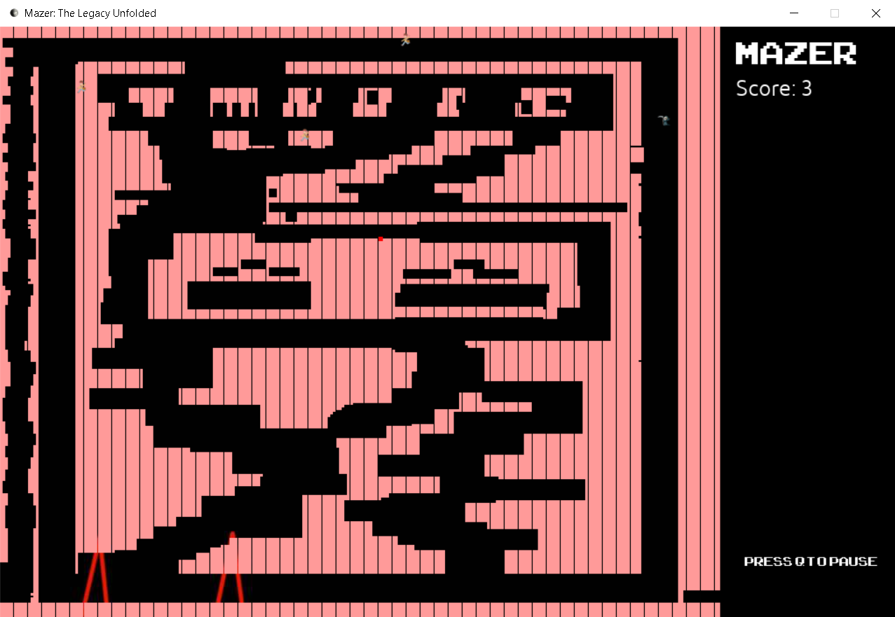

**1.1 PROBLEM SOLVING**

Every development phase is faced with problems and bugs that must be fixed; the team left no stone unturned to get the bugs fixed.

Challenge 1: The issue of making a maze.

The first problem we met was how to make a maze. We tried different methodologies to make the maze like drawing it using lines or by drawing rectangles but the best approach we discovered was to use a list to define the maze.

Challenge 2: Creating the reaper control.

This was a typical challenge to overcome. We tried to tackle this by working with the if-else ladder, but it only ended in making the code more tedious and complex. And then we discovered classes which made our work so easier. We defined the characteristics of the reaper like its speed and maneuvering controls. Also gave the capabilities of attacking and taking damage. Doing this made us work our project more efficiently.

Challenge 3: Creating the mobs (Ghosts)

All games require some enemies, so does Mazer. We tried to create a single instance of ghost. which would follow that reaper. But the issue was the same, we used the if-else ladder and that made the code buggy. This issue was also solved the same way by method of classes. Classes worked like a charm.

**1.2 OBJECTIVES**

**-Building the reaper class and working on movement:** We first defined a class of reaper in which we defined features like movement of the reaper, direction of the reaper, character looks of the reaper, health of the reaper. Along with that we also made the boundary limitations of the reaper.

**-Building the maze:** The maze has 64,000 characters in total which was made using the use of mathematical functionality and algorithms used. The code held many modules for compiling the maze using random, math, OS and pygame.

**-Constructing the main menu and U.I.:**

**It is build using the pygame menu module .**

**-Defining the hitboxes:**

We have created a box outside the player by using there co –ordinates we are able to check its Collison with the maze and ghost.

**-Attack the mobs:** We can use bullets or melee weapons to attack the players. Bullets will be used as special weapons that will be used to instant kill the mobs that will be on cooldown.

**1.1 Importance and Need of your Project.**

The main importance of making our project is to learn and implement our understanding of python and Pygame. Along with that the project management made us work like professionals working in a team and have a clear focus on what we want to make. Team discussion also made us get a greater view and immense number of ideas. One of the needs of making this project is to also to learn how to use classes which not only makes the code shorter but also helps to organize the code in the cleaner way. Another need is that Python focuses on core functionality of the application by taking care of common programming tasks, so it is good opportunity to get to an advanced level.

Apart from all this there is a competition held every year in IIT DELHI for maze building for which also have multiple teams taking part each year.

### **Onsite/Offline Written Contest**

Maze Runner is a game which searches for a puzzle solving spirit with acute programming sense. “It provides a challenge to justify or build a stronghold of the most basic programming paradigms.” (“ACES ACM, IIT Delhi - Posts | Facebook”) So come on board and join the bot in its flight through the galaxy where the stars are but only stars and the wormholes supply a teleportation route between the galaxies, cautiously using your fuel stock. “Look at the target path and writing down a code on your sheet to make your robot take you to victory !!” (“ACES ACM, IIT Delhi - Posts | Facebook”)

[**2.**](https://inc-word-edit.officeapps.live.com/we/wordeditorframe.aspx?ui=en%2DIN&rs=en%2DUS&wopisrc=https%3A%2F%2Fbennettu-my.sharepoint.com%2Fpersonal%2Fe20cse067_bennett_edu_in%2F_vti_bin%2Fwopi.ashx%2Ffiles%2Fa5d9e4d9fd0c420db3034ad984a7c0d9&wdenableroaming=1&mscc=1&wdodb=1&hid=00000000-0000-0000-0000-000000000000&wdorigin=Sharing&jsapi=1&jsapiver=v1&newsession=1&corrid=a1b05ae0-9313-4f04-b110-83bda534ae77&usid=a1b05ae0-9313-4f04-b110-83bda534ae77&sftc=1&mtf=1&instantedit=1&wopicomplete=1&wdredirectionreason=Unified_SingleFlush&rct=Medium&ctp=LeastProtected#_Toc40385860) **Proposed Solution and approach**

**2.1 Methodology**

We are starting to work using OOP in this project. Python is a great programming language that supports OOP. You will use it to define a class with attributes and methods, which you will then call. (“Object-Oriented Programming in Python - Data Camp”) Python offers several benefits compared to other programming languages like Java, C++ or R.

**First step -**

Defining the player class, A.K.A reaper. In this class we will setup all the things needed like player image, player position using rect function, player speed in this maze, move function use to move in maze.

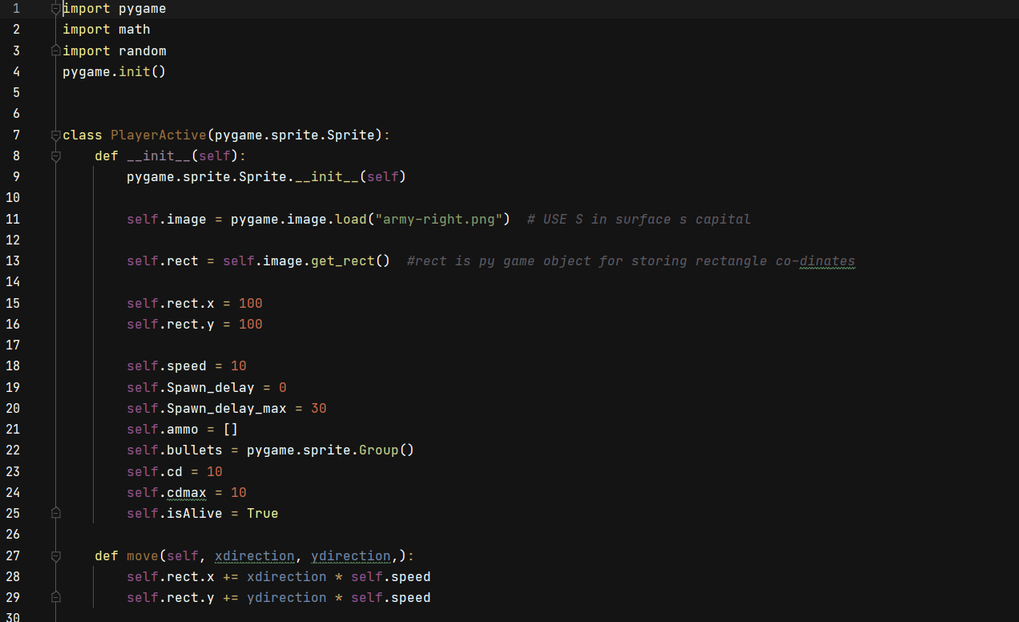

**Second step -**

Making attack class which we used many approaches first we decided to make bullets and we will make its speed zero of bullets, but it will unwanted since it has another basic method which is easier than defining class.

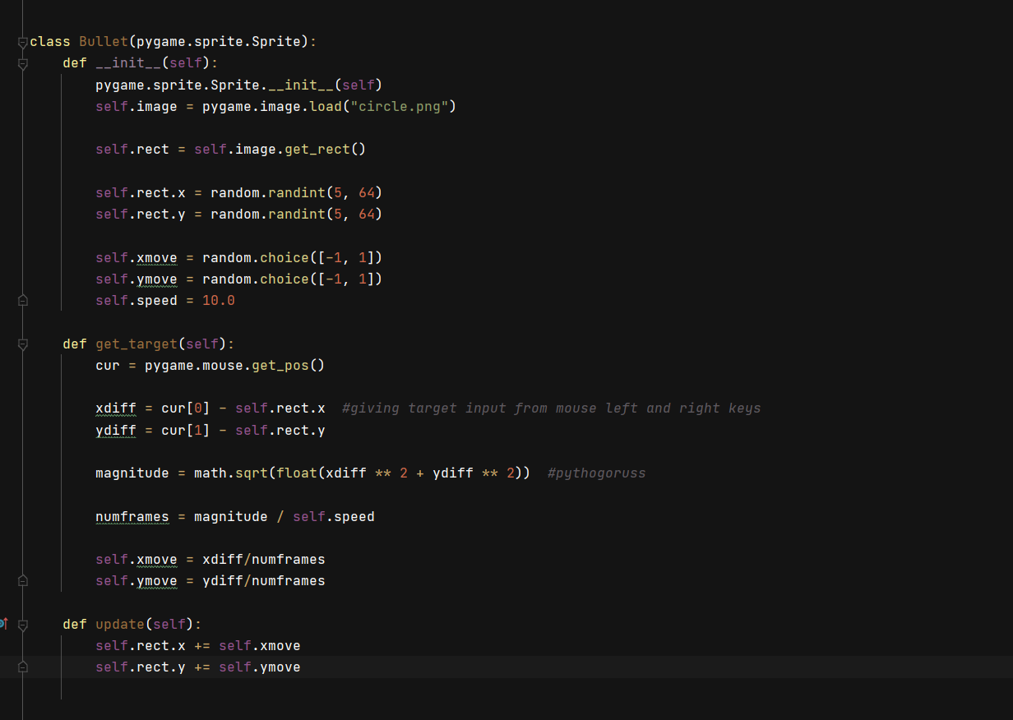

**Third step -**

Making enemy class was interesting part of the game. The ghost follows the player and have no restrictions in maze while player has restrictions in maze and have limited speed.

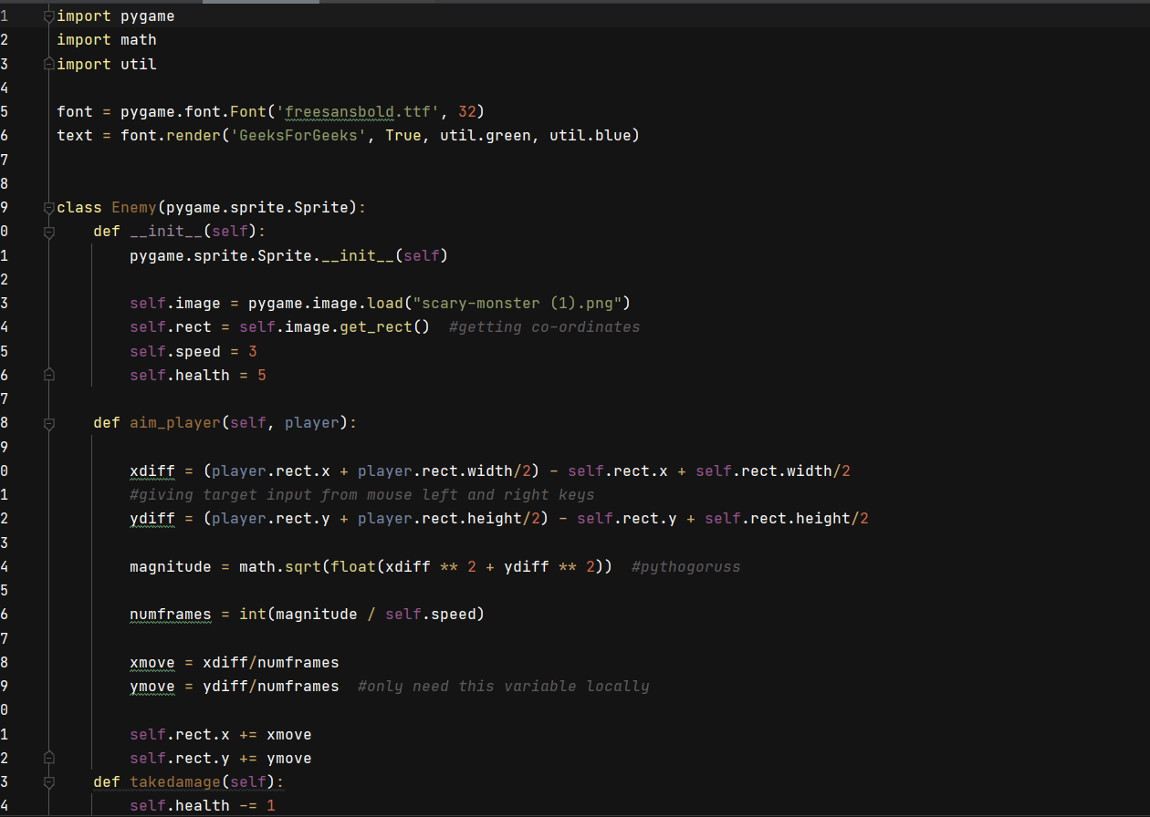

**Fourth step -**

Maze has been built in the list. With more than 64000 characters in the list. Here is the design of the maze.

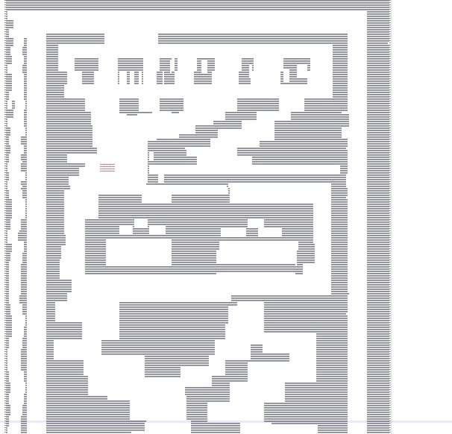

**Fifth step -**

Adding and customization of main menu which is basically interface for the game which will have game start and sound setting choice. We have taken OG retro game songs

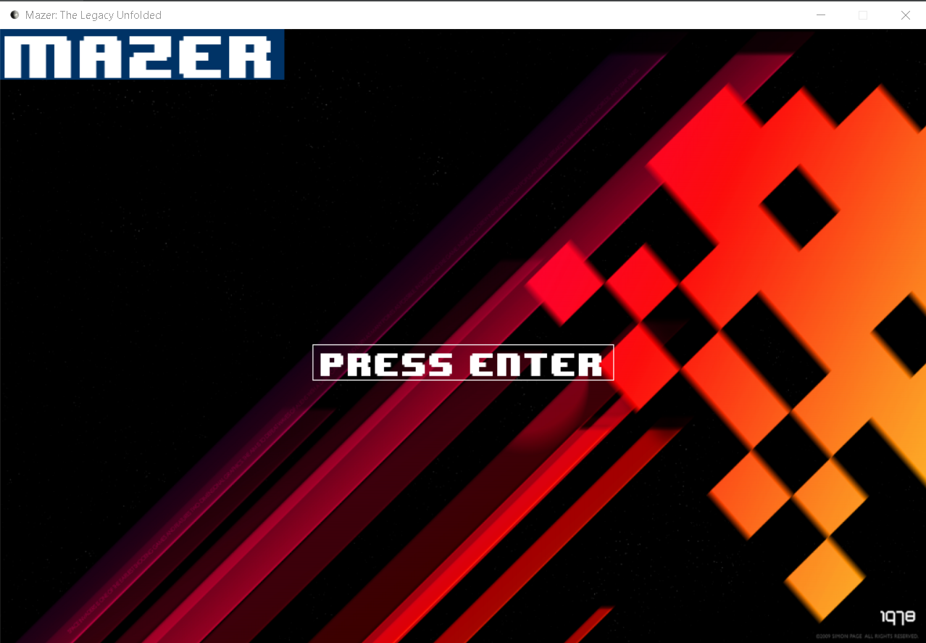.

**Sixth step -**

Completing all other miscellaneous tasks like making scoreboard, adding songs, adding player models and enemy models, adding background and maze color.



# **3.Project Execution**

‘MAZER’ is a game based on python which we decided to make. Our teammates planned to put in action based on certain algorithms and tools. Also, the use of hardware and softwires used including the features, functionality and characteristics are shown in the code clearly as well as the information is also uploaded on the GitHub as well as YouTube.

## **3.1 Project Setup**

**Hardwares and software's used:**

|  |  |
| --- | --- |
| **#** | **Decision Description** |
| 1 | O.S: Windows 7 or higher |
| 2 | Hardware needed – any computer that can run python. |
| 3 | internet required. |
| 4 | Headphones recommended. |

**3.2 Results and Conclusions**

All and all, we would like to conclude that it is an immense learning experience while preparing our project ‘MAZER’. We not only got an insight about the advance level python and pygame but also got a peak of how professionally project management in a team is executed.

We are highly grateful for the help and support we have received from my professors and friends.

# **4Conclusion and Future Work**

Maze algorithm enhancing, prim’s method.

**5.Major Contributions**

In this project, we had divided our coding part and extra work as shown below:

Altamash Alam: Made and assembled the mob spawn and controls using classes and algorithms used. Mob controls include the random motion, boundary fixing, and character looks of the mob. He has also been the manager of doing the overall code debugging and putting the whole code together.

Saksham Johari: Made the 2D maze of the game, along with which he has also made the health bar and scoring bar and did overall designing of the project. He has also made the maze wall and boundary arrangement.

Shreya Bose: Made the reaper controls using classes which includes the movement, character looks, direction of the reaper. Along with that has also done the creative work in the game as well as in presentations. Has been a part of making the heath bar.

Paritosh Tripathi: Made the attack and collision code which includes how the reaper attacks the Mobs and kills them. He has also made code of the hitbox collision in the game.

Ayush Agarwal: Made the Main menu in the game which includes the basic features needed before starting a given game like ‘Start’, ’scoring list’, ‘Settings’ etc. Along with that he has also been part of making the scoring bar in the game.

**ALL** team members were equally associated in making the team presentations and documentations. Along with that YouTube video was made and each member had taken on the parts in video and described it well. The GitHub profile is made, and link has been shared as given below:

[**https://github.com/Saksham2002/Mazer**](https://github.com/Saksham2002/Mazer)

**6.References**

* “Mcgugan - Beginning Game Development with Python and Pygame (A press, 2007)” **(“python - Pygame Invalid Syntax I just can't figure out - Stack Overflow”)**
* YouTube for better understanding in pygames:
* "Tech with Tim" YOUTUBE CHANNEL FOR HELP
* "pgwurt" YouTube channel for help
* pygame official documentation