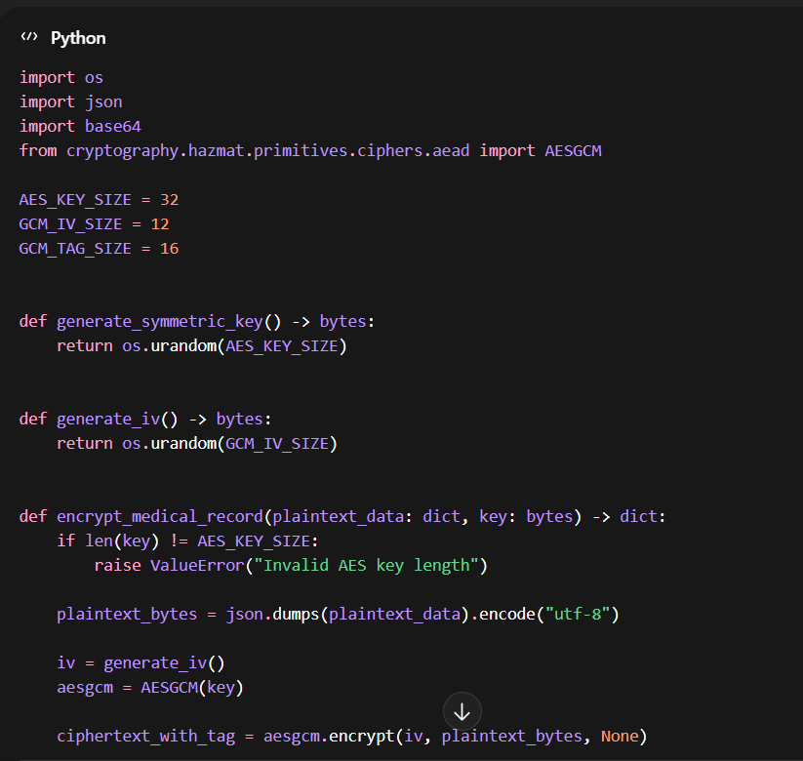
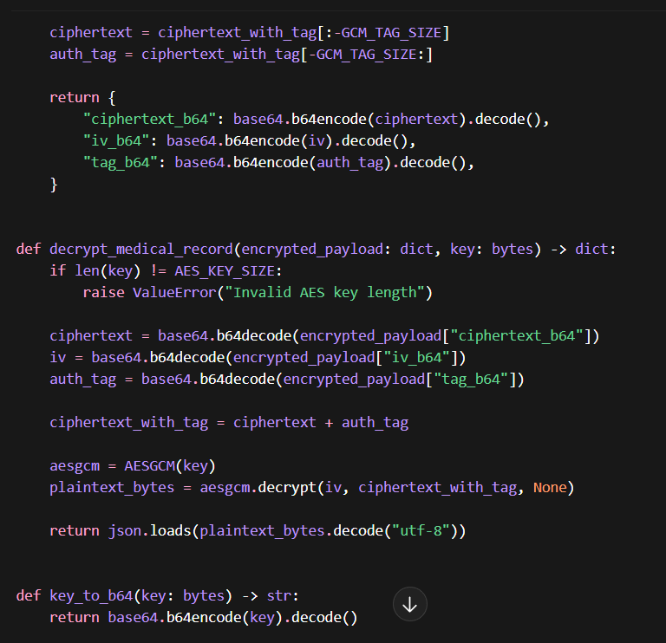
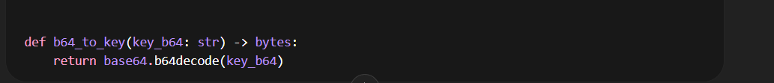

os.urandom(32):
This creates a 256-bit secret key, Only someone with this key can decrypt the data.

