Quarterly Sales Figures
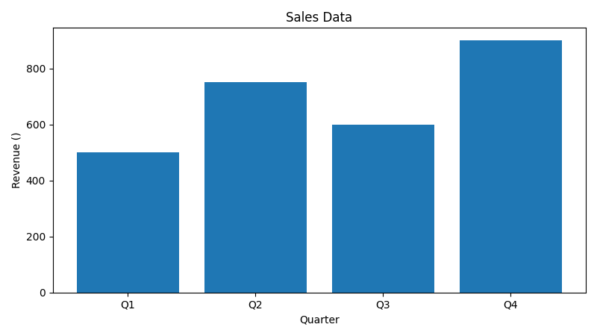

Next Steps
- Review Q4 performance in upcoming meeting


