

ASSIGNMENT-1

Course Name: Programming for Problem Solving Using Python
Assignment Title: Attendance Tracker
Student Name : SAKSHAM SHARMA
Roll No. : 2501940007
Program : MCA (AI & ML)
Semester : 1st
Session : 2025-26
Faculty Name : Ms. Neha Kaushik
Date of Submission : 09/11/2025

Attendance Tracker Program
This system helps you record students' names along with their check-in time, prevents duplicate entries, and automatically generates a detailed summary. It allows users to record attendance with arrival times, calculates the number of absentees, and exports the complete attendance record to a CSV file for easy sharing and storage.

Features:
- Allows adding multiple students at once
- Prevents duplicate attendance entries
- Generates a clean, formatted attendance summary
- Calculates total present and absent students
- Saves the attendance record to a CSV file for convenient sharing and long-term storage

Tracker.py
CODE:
# Name: SAKSHAM SHARMA
# Date: 11/11/25
# Assignment Title: Student Attendance Tracker

#code starts
from datetime import datetime
def line():
print("=" * 60)
print(" Welcome to Student Attendance System ")
line()
print("This system helps you record student's names along with their check-in time, prevents duplicate entries, and shows a summary automatically.")
line()
print()
# ask for total number of students
total_count = input("Enter total number of attendees: ")

while not total_count.isdigit() or int(total_count) <= 0:
line()
print(" Please enter a valid positive number.")
line()
total_count = input("Enter total number of attendees: ")

total_count = int(total_count)
line()

attendance = {}

for slot in range(1, total_count + 1):
while True:
student = input(f"Enter the name of {slot} student: ").strip()

if student == "":
line()
print("Name field cannot be empty, Please enter again.")
line()
continue

# input check-in time
check_time = input("Enter check-in time (e.g. 09:30 AM): ").strip()
while check_time == "":
line()
print(" Time field is *required*, Please re-enter.")
line()
check_time = input("Enter check-in time (e.g. 09:30 AM): ").strip()

line()

# if student already present in the dictionary
if student not in attendance:
attendance[student] = check_time
break
else:
line()
print(f" {student} is already marked present.")
line()
continue

print()
line()
print("Name of Student\t\tCheck-In Time")
line()

for person, timing in attendance.items():
print(f"{person}\t\t\t{timing}")

line()
print(f"Total Students Present: {len(attendance)}")
line()

choices = input('Do you want to save the data? Enter "Y" for Yes or "N" for No:').strip().upper()

if choices == "Y":
timestamp = datetime.now().strftime("%Y-%m-%d %H:%M:%S")
with open("attendance_log.txt", "w") as f:
f.write("=" * 60 + "\n")
f.write(f"Attendance Report Generated On: {timestamp}\n")
f.write("=" * 60 + "\n")
f.write("Name of Student\t\tCheck-In Time\n")
f.write("=" * 60 + "\n")
for person, timing in attendance.items():
f.write(f"{person}\t\t{timing}\n")
f.write("=" * 60 + "\n")
f.write(f"Total Students Present: {len(attendance)}\n")
f.write("=" * 60 + "\n")
print(" Attendance successfully saved to 'attendance_log.txt'")
else:
print(" Attendance not saved, Thank you for using the system!")

Output:
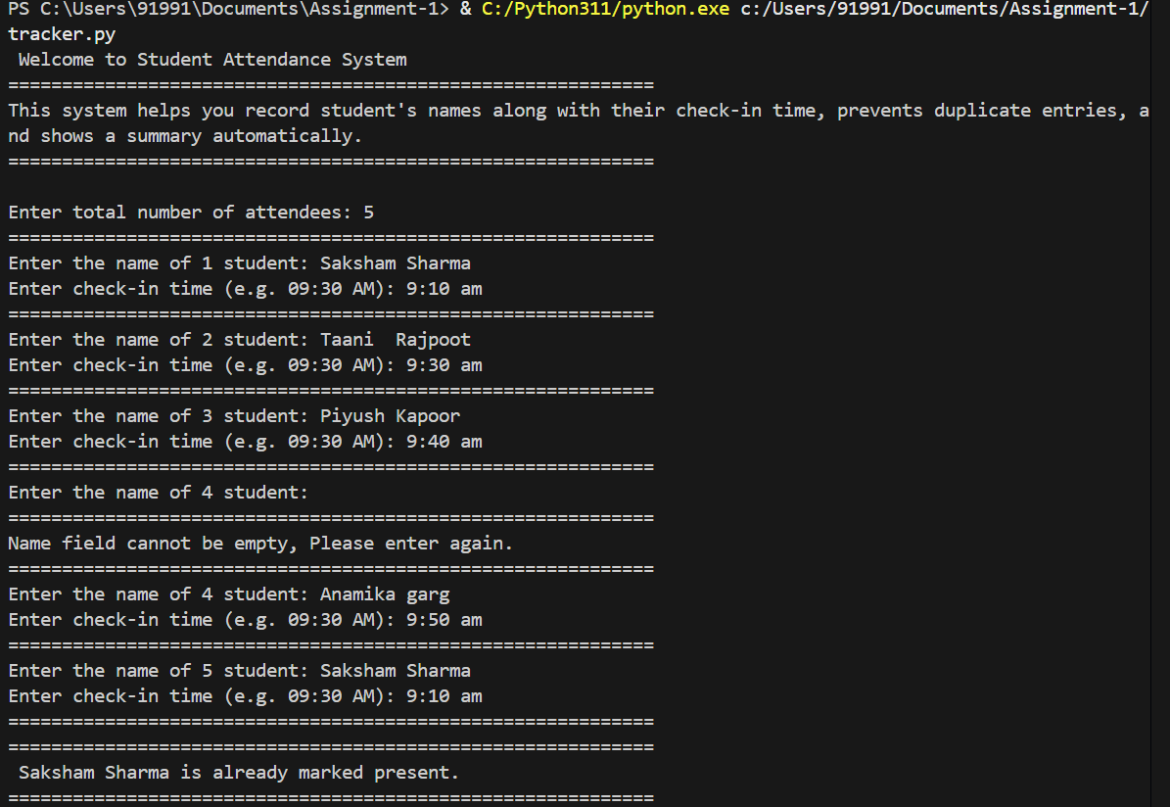

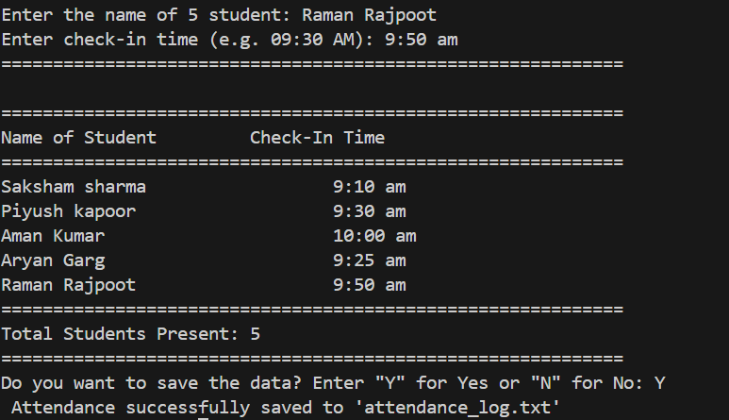

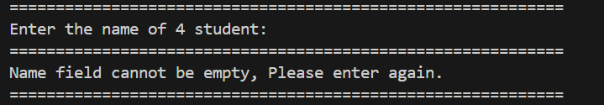
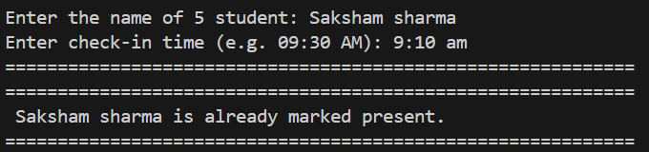

Attendance_log.csv
============================================================
Attendance Report Generated On: 2025-11-12 21:36:34
============================================================
Name of Student Check-In Time
============================================================
Saksham Sharma 9:10 am
Taani Rajpoot 9:30 am
Piyush Kapoor 9:40 am
Anamika garg 9:50 am
Saurabh Sharma 10:00 am
============================================================
Total Students Present: 5
============================================================

