Cardinality Before Contention: A Factorial Decomposition of Per-Command Observability Overhead in a Concurrent In-Memory Key-Value Store
Saksham Kapoor Independent Researcher, Delhi, India sakshamkapoor810@gmail.com ORCID: 0000-0000-0000-0000 (placeholder — register at orcid.org and replace before submission; see submission/SUBMISSION_CHECKLIST.md)
Prepared for submission to Software: Practice and Experience (Wiley), with Journal of Systems and Software as the backup venue. Reference style and section numbering are to be converted to the target journal’s template at submission; the content below is venue-neutral. Every table, figure, and quoted statistic regenerates from committed artifacts via scripts/analyze_design_axes.py and scripts/generate_design_axes_figures.py (Appendix A).

Abstract
Practitioner guidance treats per-operation telemetry cost as a synchronization problem: replace the global counter lock with a sharded or lock-free structure. On a thread-pool concurrent server this optimizes the smaller of two costs. We instrument a Rust Redis-compatible in-memory key-value store with six per-command metrics collectors chosen so that adjacent pairs differ along exactly one design axis — synchronization discipline, metric key cardinality, aggregation locality, per-sample payload — turning a strategy comparison into a factorial decomposition, priced by Randomized Multiple Interleaved Trials on fourteen separately provisioned Azure VMs.
Moving the metric key from a 2-entry command-name label to a 10,000-entry data-key label costs 1.66× what replacing a global mutex with a 64-way sharded map saves, inverting the advice: the sharded map at high cardinality is slower than the global lock at low cardinality. The axes obey different scaling laws: none responds to a 30× rise in client concurrency on a saturated server, while the synchronization axis tracks worker-thread count instead, so client load is the wrong experimental knob. Overhead has an axis-dependent rigidity: counter costs dissipate into queueing slack at the tail, whereas histogram-payload cost arrives undiminished at p99, producing a percentile-dependent rank inversion that throughput-only evaluation reports as a confident null. A collector whose per-operation work is identical at every cardinality then confirms the effect is live entry count, not key allocation, and bounds it: below ~1,000 entries it is indistinguishable from zero.
Observability overhead should therefore be budgeted per design axis and per target percentile, not as one headline percentage.
Keywords: instrumentation overhead; metric cardinality; performance measurement; tail latency; key-value stores; cloud benchmarking

1. Introduction
Every production server carries telemetry, and every telemetry design makes a choice about how counters are stored and updated on the request path. The received wisdom about that choice is remarkably uniform. Practitioner guidance converges on “keep the hot path lock-free” [5, 6, 8, 17]: hold a per-metric atomic handle, shard the counter map, or accumulate per-thread and merge later. The Prometheus Go client, for instance, deliberately removed the mutex from its histogram observation path on the grounds that mutexes are “very slow in highly-concurrent scenarios” [5]; the standard operational and systems-performance references give the same advice [8, 17], as does the reference text on Rust concurrency [6]. The implicit model is that instrumentation overhead is contention overhead, and that contention grows with load.
This paper tests that model and finds it misleading in two separate ways on a class of system where it is routinely applied: a single-process, thread-pool concurrent in-memory key-value server, driven over TCP by a co-located loopback client (§4.2).
The difficulty in testing it is that “which metrics strategy is fastest” is the wrong question, because a strategy is a bundle of decisions. A thread-local histogram collector differs from a global-mutex counter in at least four ways at once — where the synchronization happens, how many distinct counter entries exist, whether aggregation is eager or deferred, and how much work each sample costs — so a ranking of strategies tells an engineer nothing about which of those decisions to revisit. We therefore choose the six collectors so that adjacent pairs differ along exactly one axis, which converts a strategy comparison into a factorial decomposition and lets each axis be priced separately (§3).
Pricing them separately is what produces the paper’s main result. The axis practitioners are told to optimize — synchronization discipline — is worth 0.52 percentage points of throughput on 8 worker threads. The axis they are told to worry about only for storage cost — metric key cardinality — is worth 0.87 pp, 1.66× more. Because those two numbers are differences against a common reference, their gap is algebraically identical to the direct comparison between the two strategies: a 64-way sharded concurrent map keyed by a high-cardinality label is 0.34 pp slower than a single global mutex keyed by a low-cardinality one. Replacing the lock while leaving the label alone is a net loss.
High metric cardinality is a well-known problem, but the literature and the practitioner writing we surveyed frame it almost exclusively as a backend cost — time-series database memory, index size, query CPU, and per-series billing. We found no controlled measurement of cardinality as a server-side request-path throughput cost, and none comparing it head-to-head against the synchronization cost that the same audience is told to prioritize.
Two further results follow from the same design. Neither the cardinality nor the payload axis responds to client concurrency at all over a 30× range, while the synchronization axis responds to worker-thread count instead — so the standard practice of “turn up the client count until contention shows” cannot, even in principle, expose these costs on a thread-pool server, because the number of threads able to touch the counter structure is bounded by the pool, not by the client population (§5.2). And overhead turns out to have a rigidity that differs by axis: most instrumentation cost is elastic and vanishes into queueing slack at the tail, but histogram-payload cost is rigid and arrives undiminished at p99, which inverts the cost ranking between percentiles and makes throughput-only evaluation actively misleading (§5.3).

1.1 Contributions
- A factorial decomposition of per-command observability overhead into four separately-priced design axes (§3, §5.1), rather than a ranking of strategy bundles, with an explicit account of what each contrast does and does not isolate (§3.3).
- The cardinality-dominance result (§5.1): high-cardinality dynamic labeling costs 1.66× what the entire global-lock-to-sharded-map transition saves, inverting the usual optimization priority, and reproducing on both VM sizes (4.5× on the 4-worker VM, 1.66× on the 8-worker one; 4.51× and 1.58× when the two are matched on workload and client load, §5.2). A dedicated eight-VM experiment (§5.4) shows the effect is cardinality itself and not the key allocation bundled with it, and bounds where it applies: below ~10³ entries it is indistinguishable from zero.
- A scaling-law separation (§5.2): telemetry axes are invariant to client concurrency over a 30× range on a saturated server, while the synchronization axis tracks worker-thread count — with the methodological consequence that client load is the wrong experimental knob.
- Overhead rigidity and the percentile-dependent rank inversion (§5.3): a tail-concentration index separating elastic from rigid costs, and a demonstration that a comparison reported as statistically unresolved under a throughput budget resolves in opposite directions at p50 and p99.
- An instrument for pricing metric cardinality in isolation (§5.4): a collector that holds per-operation work byte-for-byte constant while the live entry count sweeps 3.5 decades, which is a cleaner control than sweeping the workload key space (that would vary the request distribution too). It is reusable by anyone asking the same question of another system.
- A reproducible measurement design and artifact (§4, Appendix A): 29,520 RMIT runs over fourteen cloud VMs, cluster-aware inference, and committed scripts that regenerate every number in the paper.

2. Background and Related Work
Instrumentation overhead. That measurement perturbs what it measures is long established; Tallent et al. [41] show it specifically for lock-contention tooling, dynamic binary instrumentation costs a large multiple of native execution time [25], and production tracing systems bound their own cost by sampling precisely because it is not negligible [19, 40]. Recent empirical work prices whole instrumentation frameworks. Nõu et al. [31] measure OpenTelemetry and Elastic APM on microservice and serverless workloads and report throughput reductions of 19–80% and latency increases up to 175%, attributing the largest single share to serializing trace data for export. Reichelt et al. [36] extend the MooBench monitoring benchmark to OpenTelemetry and compare it against inspectIT and Kieker [45]; a later study by the same group isolates the instrumentation technology rather than the framework and finds spreads of up to 30% between technologies monitoring the same code [37]. These studies answer “what does turning on this framework cost?” They do not decompose that cost into the design decisions that produced it, which is the gap this paper addresses.
Metric cardinality. Cardinality is one of the most discussed operational problems in modern monitoring, but essentially always as a storage-side concern: each distinct label combination creates a time series with memory, disk, index, and billing cost. The design of large-scale metric systems is organized around that fact. Gorilla [34] and Monarch [3] both describe in-memory time-series stores whose capacity is denominated in active series, and a survey of observability data management identifies series count as the scaling bottleneck for the class as a whole [21]. The remedy offered is accordingly bounded-cardinality labels, and the reasons given are backend reasons: the Prometheus project instructs users not to put high-cardinality dimensions such as user IDs or email addresses into labels because each distinct combination creates another time series [35]; operational handbooks repeat the advice with the same justification [8]; and the OpenTelemetry specification goes as far as defining aggregation cardinality limits in the SDK so that a misbehaving producer cannot overwhelm a backend [32]. The producer-side request-path cost of a high-cardinality label — the extra work the server itself does per operation — is, to our knowledge, not measured in a controlled setting, and never compared against the synchronization cost it is traded against in practice.
Concurrent counting. The structures we compare descend from a long line of work on reducing counter contention: counting networks [4], scalable lock algorithms that bound remote memory references per acquisition [27], the per-core “sloppy counters” that removed kernel counter bottlenecks in Linux [7], and the general replacement of coarse locks with concurrency-friendly structures that lifted key-value throughput in MemC3 [14] and MICA [24] and that underpins production Memcached deployments [30]. David et al. [12] establish that synchronization cost is strongly hardware-dependent, which is the premise behind our worker-count comparison in §5.2. The concrete structures under test here are a Rust standard-library mutex over a HashMap, the sharded concurrent map DashMap [46], and thread-local accumulation on the Tokio asynchronous runtime [43]. This literature is the source of the guidance we test: it is correct that sharded and per-thread counting reduce contention, and our SYNC axis confirms it. The finding here is about relative magnitude — that the contention saved is smaller than the cardinality cost typically incurred alongside it.
Benchmarking methodology. Measured performance depends on setup details experimenters rarely control [29], so rigorous practice reports intervals over repeated runs [16, 20] and randomizes factors that should not matter [11]; Papadopoulos et al. [33] consolidate these into methodological principles specifically for cloud experiments. Cloud environments add time-varying noise in compute [26] and network [44], and that variability is itself patterned and partly predictable across providers and instance types [23]. Randomized Multiple Interleaved Trials (RMIT) was introduced by Abedi, Heard and Brecht [2] and shown necessary in clouds by Abedi and Brecht [1], who found differences up to 37.8% between two identical systems under non-randomized designs. Duet benchmarking [9] instead runs artifacts simultaneously, which does not suit a saturating client-server benchmark where two server instances would contend. Laaber et al. [22] combine RMIT-style sampling, bootstrap intervals, A/A tests, and injected-slowdown detectability analysis for cloud microbenchmarks, and explicitly disclaim load and stress tests. We adopt RMIT and their inferential posture; the technique is theirs, not ours. Our methodological addition is narrower and specific to pooled replicates: inference clustered on independent VM runs rather than on the correlated blocks within them (§4.3). For key-value systems YCSB [10] is the standard suite and Reniers et al. [38] survey under-reporting in NoSQL benchmarking; Fruth et al. [15] show harnesses themselves distorting measured tail latency, which is part of why §5.3 reports tail results as relative paired ratios against a baseline measured by the same harness.
Positioning. RMIT, bootstrap intervals, and detectability analysis are prior art. What is new here is the factorial decomposition of telemetry overhead into separately-priced axes, the finding that the cardinality axis dominates the synchronization axis, the separation of client-concurrency from worker-count scaling, and the percentile-dependent rigidity result.

3. System Under Study and the Factorial Design

3.1 The server
RustRedis is a Redis-compatible in-memory key-value server in Rust (~3,500 LOC). A Tokio multi-threaded runtime accepts TCP connections, one task per connection; tasks parse RESP frames and execute against shared state. The runtime is configured with flavor = "multi_thread" and default worker count, so the number of OS threads that can concurrently enter the metrics path equals the vCPU count — 8 on Standard_D8s_v6, 4 on Standard_D4s_v6 — regardless of how many clients are connected. This property is what §5.2 exploits.
On every command the server records the command name, an optional borrowed key hint, and the execution duration, then calls the active collector. Crucially, the timing itself (Instant::now(), elapsed()) and the key-hint lookup run identically for all strategies including the disabled baseline, so those costs cancel in the paired comparison. The only thing that varies is the body of record().

3.2 The six collectors as a factorial design
The collectors (src/command_metrics.rs) are selected so that adjacent pairs differ along one axis:
Strategy | Synchronization | Cardinality | Aggregation | Payload
disabled | — | 0 | — | —
global_mutex | one global Mutex<HashMap> | 2 | eager, shared | counter
sharded_2key | DashMap, 64 shards | 2 | eager, shared | counter
sharded_n | DashMap, 64 shards | ~10,000 | eager, shared | counter
thread_local | thread-local map + periodic flush | 2 | deferred, private | counter
hdr_histogram | thread-local map + periodic flush | 2 | deferred, private | counter + HDR histogram
The hdr_histogram collector records each command’s execution duration into an HdrHistogram [42] — a fixed-precision, logarithmically bucketed histogram designed to record latency at a bounded and roughly constant per-sample cost — using the Rust port of the reference implementation [18]. Every other collector stores only a count and a running duration sum per key, so this collector is the paper’s per-sample payload treatment.
Cardinality 2 means the metric is keyed by command name (GET, SET); cardinality ~10,000 means it is keyed by the request’s data key, over a 10,000-key workload — the direct analogue of a high-cardinality label such as user_id in a production metric. This yields four contrasts:
Axis | Contrast | Question it prices
SYNC | global_mutex − sharded_2key | What does a global lock cost versus a 64-way sharded map?
CARD | sharded_n − sharded_2key | What does high-cardinality dynamic labeling cost?
DEFER | sharded_2key − thread_local | What does eager shared aggregation cost versus deferred thread-local?
PAYLOAD | hdr_histogram − thread_local | What does a latency histogram cost versus a plain counter?
Because all four are differences against a shared reference, arbitrary strategy comparisons are recoverable by arithmetic. In particular CARD − SYNC is algebraically identical to sharded_n − global_mutex, which is why §5.1’s headline has a direct physical reading.

3.3 What each contrast does and does not isolate
Isolating one axis per contrast is the design intent; the implementation is not perfectly clean, and we state the residual differences explicitly because two of them bear on the headline claim.
- SYNC is contaminated against our own hypothesis. global_mutex additionally instruments itself: it brackets the lock acquisition with two Instant reads and accumulates the wait into a shared AtomicU64 on every operation. That atomic is a single contended cache line, and it is work the other five strategies do not perform. The measured SYNC penalty therefore overstates the cost of the global lock as such. Since our claim is that SYNC is smaller than CARD, this confound biases against the claim, and the claim survives it — the true gap is if anything wider than reported. We report the measured value and treat it as a conservative upper bound on the synchronization axis.
- CARD bundles cardinality with owned-key allocation — and §5.4 separates them. sharded_n keys its map by an owned String, allocated per operation, whereas sharded_2key uses a &'static str. As specified, the contrast therefore prices “labeling by a high-cardinality dynamic value” as a package — map growth to ~10,000 entries plus the per-operation key materialization that such labeling requires. That package is the practically relevant quantity, since a dynamic label in a real system (a user ID, a route, a tenant) must be materialized on every operation too. But the attribution between the two components mattered enough to measure directly, and §5.4 reports a dedicated eight-run experiment that does so: the entry count accounts for essentially all of CARD. The axis is cardinality, not an allocation artifact.
- PAYLOAD shares that allocation term — and §5.4 separates it too. hdr_histogram also keys by an owned String while thread_local uses &'static str, so PAYLOAD as specified prices the histogram plus the same key materialization. Its cardinality is 2, so no map-growth component is involved. §5.4 finds roughly 80% of PAYLOAD is the histogram itself.
- DEFER is close to clean. Both sides use &'static str keys at cardinality 2. thread_local additionally increments a shared atomic flush counter per operation and performs a periodic batch push, which is intrinsic to deferred aggregation rather than incidental to it.
Two axes (SYNC, DEFER) are therefore clean-to-conservative, and two (CARD, PAYLOAD) price a coherent package that includes a shared allocation term. §5.4 decomposes that package with a separate experiment and finds the package is dominated by the axis it is named for in both cases.

4. Experimental Methodology

4.1 Design
Throughput on lightly controlled machines drifts over a run, so a blocked design would confound strategy with machine state [1]. We use RMIT: each repetition (“block”) runs every (strategy, concurrency, workload) configuration exactly once in a fresh independent random permutation, and the server is restarted before every run. A machine-state snapshot (CPU frequency, governor, thermal zone, memory, swap, load average) is logged immediately before each run.
All overhead figures are paired within-block ratios against the disabled baseline in the same block. This is the comparison RMIT makes valid: every strategy in a block met the same machine conditions, so a condition that slowed the block slows numerator and denominator alike.

4.2 Datasets
Dataset | Hardware | Design | Runs
azure_d4s_v6 | Standard_D4s_v6, 4 vCPU / 16 GB, Central India | 6 strategies × 8 concurrency (100–1000) × 30 blocks, mixed workload | 1,440
azure_d8s_v6 (pooled) | Standard_D8s_v6, 8 vCPU / 32 GB, 5 VMs across 3 regions | 6 strategies × 8 concurrency (100–3000) × 3 workloads × 15 blocks, × 11 independent runs | 23,760
azure_d8s_v6_followup (§5.4) | Standard_D8s_v6, 8 VMs across 3 regions | 12 strategy configs (incl. a 5-point cardinality sweep) × 3 concurrency × 1 workload × 15 blocks, × 8 independent runs | 4,320
29,520 runs in total, of which 25,200 are the main design and 4,320 the axis-separation experiment of §5.4. Each VM was provisioned solely for the benchmark and deleted afterwards; nothing else ran on it. The eleven D8s_v6 runs use distinct random seeds across five separately-provisioned VMs in three regions: the initial validation run on its own Central India VM, then runs 01-10 distributed over two further Central India VMs, one South India VM, and one West US 3 VM. All eleven report the same processor (Intel Xeon Platinum 8573C), so the pooled dataset is homogeneous in microarchitecture and varies only in instance, region, and date. Workloads are 50/50 mixed, 80/20 read-heavy, and 20/80 write-heavy over a 10,000-key space with 64-byte values. Pooling offsets each run’s block_id so paired comparisons never mix blocks from different VMs.
Client placement: loopback and co-located. The load generator runs on the same VM as the server and connects over the loopback interface. There is therefore no physical network between client and server, and the client competes with the server for the same 8 (or 4) vCPUs. We describe the setup as a loopback, co-located client rather than as a network-bound measurement, and two consequences follow. First, every overhead figure in §5 is a paired within-block ratio against a disabled baseline measured by the same co-located client under the same conditions, so the client’s own CPU consumption is common to numerator and denominator and cancels — which is why the design tolerates co-location at all. Second, the vCPU count bounds client and server threads jointly, so the 4-versus-8-worker comparison changes the client’s CPU budget along with the server’s worker pool. That bears directly on §5.2’s worker-count result and is taken up there.

4.3 Inference
For the pooled dataset the 165 blocks per cell are 11 independent runs × 15 correlated within-run blocks, not 165 independent samples: blocks from one run share that VM’s hardware, neighbours, and network path. Treating them as independent would overstate precision by roughly 20% on this data. Every interval we report for the pooled dataset therefore clusters on the run: per-block values are collapsed to one mean per run, and a t-interval with 10 degrees of freedom is formed over those eleven numbers. Directional claims are additionally checked with an exact two-sided sign test over the eleven runs, which assumes nothing about the distribution of the effect.
The single-run D4s_v6 dataset has no run-level replication, so its intervals bootstrap over that run’s 30 repetition blocks (20,000 resamples) and are not directly comparable in strength to the pooled intervals.
Slopes against concurrency (§5.2) are fitted within each run and then averaged across runs, so between-run level differences cannot leak into the slope.

4.4 A failure mode worth recording
The first attempt at the D8s_v6 design reported exactly 0 ops/sec for every configuration above ~1000 clients, with return code 0 and well-formed output. The cause was the default open-file-descriptor limit (1024) on a fresh VM, far below the tested concurrency; every client connection failed and the client counted the failures internally rather than aborting. The runner now raises RLIMIT_NOFILE at startup and warns if the achieved limit cannot cover the requested concurrency. We record this because it is the inverse of the failure RMIT defends against: randomizing order protects against noisy, drifting confounds, whereas this was a systematic failure producing suspiciously clean and consistent numbers. No experimental design substitutes for reading a small dry run’s raw per-sample output.

5. Results
Unless stated otherwise, results are from the 11-run pooled D8s_v6 dataset (3,960 complete blocks × 6 strategies), intervals are 95% and clustered on the eleven runs, and “pp” denotes percentage points of throughput relative to disabled.

5.0 The strategy ranking depends on the budget metric
Before decomposing, Table 1 prices each strategy under four budget metrics.
Table 1. Cost of each strategy versus disabled, by budget metric (%, paired within block; 95% CI clustered on 11 runs).
Strategy | Throughput | Mean latency | p50 latency | p99 latency
ThreadLocal | 0.53 [0.42, 0.65] | 0.62 [0.50, 0.74] | 0.72 [0.58, 0.85] | 0.43 [0.22, 0.64]
Sharded-2key | 0.84 [0.77, 0.92] | 0.94 [0.86, 1.01] | 1.13 [1.03, 1.23] | 0.54 [0.31, 0.77]
GlobalMutex | 1.37 [1.27, 1.46] | 1.49 [1.39, 1.58] | 1.79 [1.71, 1.88] | 0.78 [0.54, 1.02]
HdrHistogram | 1.42 [1.32, 1.52] | 1.53 [1.42, 1.64] | 1.66 [1.56, 1.75] | 1.37 [1.09, 1.65]
Sharded-N | 1.71 [1.58, 1.84] | 1.85 [1.70, 1.99] | 2.19 [2.01, 2.36] | 0.83 [0.60, 1.07]
All overheads are small in absolute terms (≤ 2.2%), consistent with the general finding that per-command telemetry is affordable for this class of system. But the ordering already differs by metric:
Budget metric | Ranking (cheapest → costliest)
Throughput | ThreadLocal < Sharded-2key < GlobalMutex < HdrHistogram < Sharded-N
Mean latency | ThreadLocal < Sharded-2key < GlobalMutex < HdrHistogram < Sharded-N
p50 latency | ThreadLocal < Sharded-2key < HdrHistogram < GlobalMutex < Sharded-N
p99 latency | ThreadLocal < Sharded-2key < GlobalMutex < Sharded-N < HdrHistogram
HdrHistogram moves from rank 4 under throughput to rank 3 at p50 and rank 5 at p99. §5.3 shows this is not noise.

5.1 Result 1 — Cardinality costs more than synchronization discipline
Table 2. The four design axes priced separately (pp of throughput). D8s_v6 intervals cluster on 11 runs; D4s_v6 bootstraps over 30 blocks.
Axis | Contrast | D8s_v6 (8 workers) | Runs agreeing | D4s_v6 (4 workers)
CARD | sharded_n − sharded_2key | 0.87 [0.73, 1.00] | 11/11 | 0.79 [0.62, 0.96]
PAYLOAD | hdr_histogram − thread_local | 0.89 [0.80, 0.97] | 11/11 | 1.00 [0.71, 1.28]
SYNC | global_mutex − sharded_2key | 0.52 [0.42, 0.63] | 11/11 | 0.18 [−0.02, 0.38]
DEFER | sharded_2key − thread_local | 0.31 [0.21, 0.41] | 11/11 | 0.26 [−0.00, 0.51]
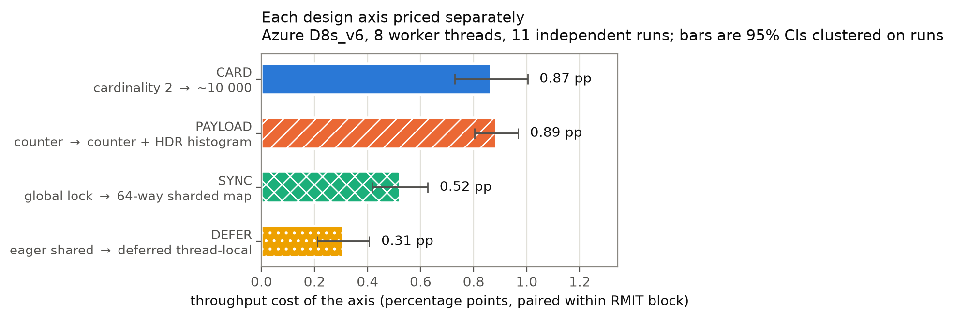
Design-axis decomposition
Figure 1. Each design axis priced separately on the pooled D8s_v6 dataset. Bars are cluster-aware 95% CIs over the eleven runs.
The cardinality axis is the largest counter-related cost in the system, and it exceeds the synchronization axis:
- CARD = 0.87 pp, SYNC = 0.52 pp, ratio 1.66×
- CARD − SYNC = 0.34 pp, 95% CI [0.19, 0.50] (excludes zero)
- CARD > SYNC in 10 of 11 independent runs, exact sign test p = 0.012, paired t(10) = 4.99
- On D4s_v6 the same comparison gives 4.5× (0.79 vs 0.18 pp). That dataset is mixed-workload and ≤ 1000 clients throughout, so it is not directly comparable to the 1.66× above, which pools eight concurrency levels and three workloads; §5.2 compares the two worker counts on a matched slice instead
Because both axes are differences against sharded_2key, their gap is the direct strategy comparison:
A 64-way sharded concurrent map keyed by a ~10,000-value label is 0.34 pp slower (95% CI [0.19, 0.50]) than a single global mutex keyed by a 2-value label.
This inverts the standard optimization priority. An engineer who replaces the global counter lock with a sharded map but keeps a high-cardinality label has, on this system, made throughput worse than leaving the lock in place and reducing the label. Recall from §3.3 that the SYNC measurement is inflated by global_mutex’s self-instrumentation, so the real inversion is if anything larger than measured.
We note the PAYLOAD axis is statistically indistinguishable from CARD here (0.89 vs 0.87 pp); we do not claim an ordering between them. The claim concerns CARD versus SYNC.

5.2 Result 2 — The axes obey different scaling laws
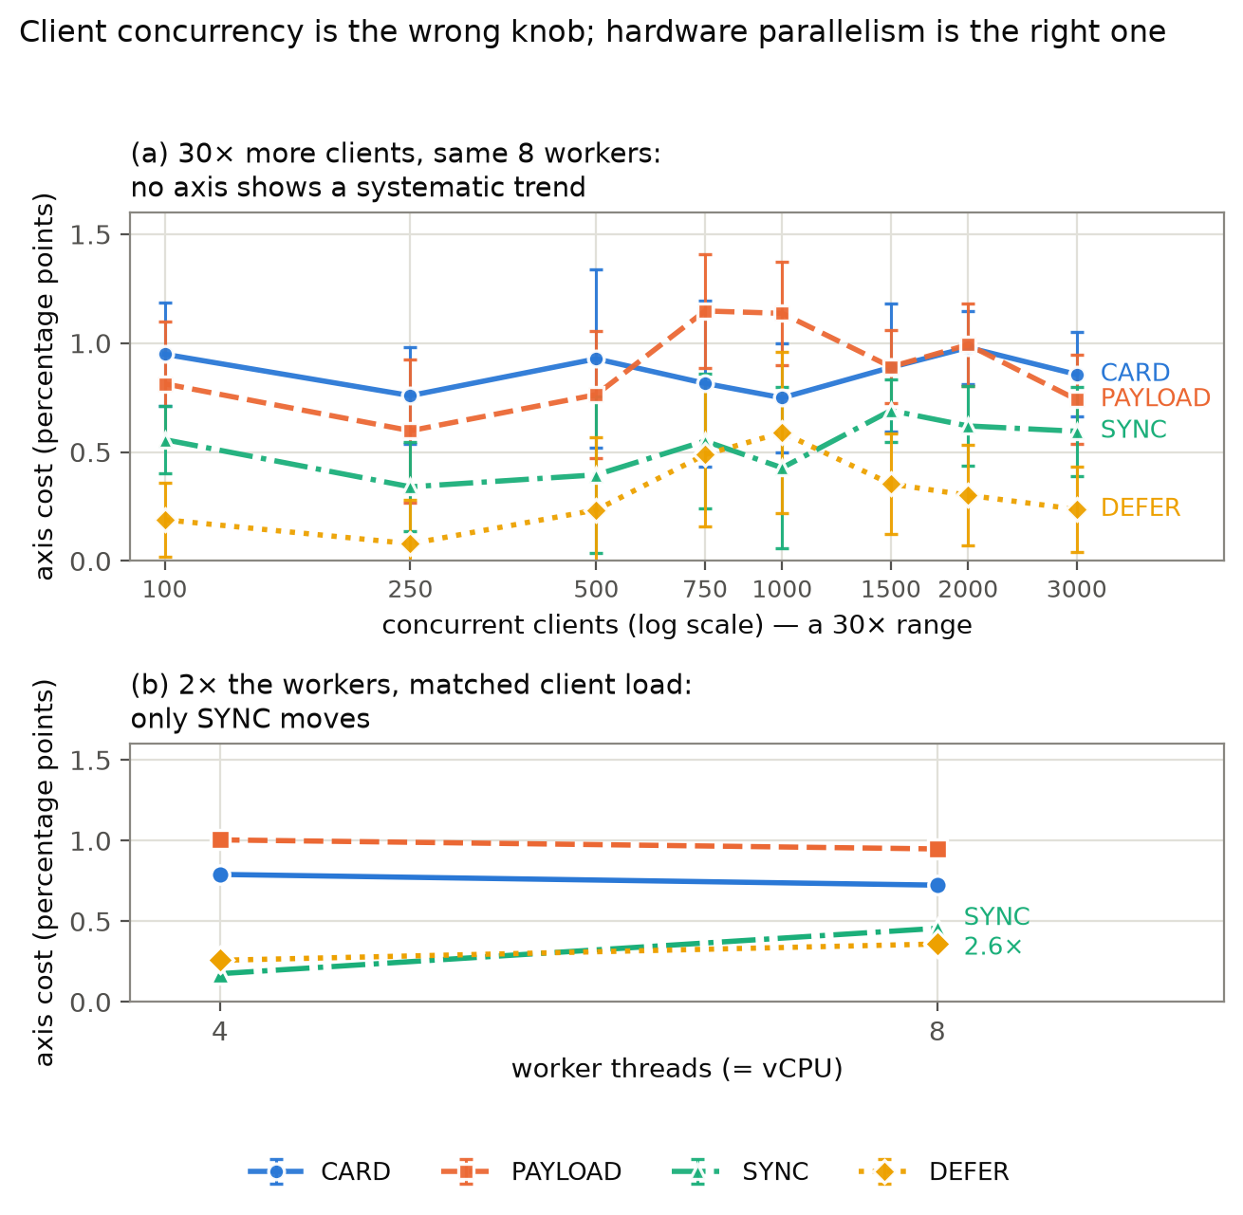
Scaling behaviour
Figure 2. (a) Axis cost against client concurrency, 8 workers throughout, with cluster-aware 95% CIs; the point-to-point variation lies inside the noise band. (b) The same axes at 4 versus 8 worker threads at matched client load.
Client concurrency does not move any axis. Fitting each axis against log₂(concurrency) within run over 100–3000 clients (§4.3):
Axis | Slope (pp per doubling) | 95% CI | Runs positive | c=100 → c=3000
CARD | 0.0004 | [−0.026, 0.027] | 4/11 | 0.95 → 0.86 pp (0.90×)
SYNC | 0.037 | [−0.007, 0.080] | 10/11 | 0.56 → 0.60 pp (1.07×)
DEFER | 0.041 | [−0.009, 0.092] | 8/11 | 0.19 → 0.24 pp (1.25×)
PAYLOAD | 0.038 | [−0.024, 0.100] | 7/11 | 0.81 → 0.74 pp (0.91×)
No axis has a slope distinguishable from zero. The CARD slope is not merely insignificant but numerically negligible (0.0004 pp per doubling, four positive runs of eleven — a coin flip).
This is not because the server is idle. Over the same range the disabled baseline is unambiguously saturated:
Clients | Throughput (ops/s) | p50 | p99
100 | 290,540 | 0.32 ms | 0.76 ms
1000 | 291,054 | 1.94 ms | 14.58 ms
3000 | 259,932 | 2.27 ms | 78.85 ms
p99 grows 104x and throughput declines 10.5%; the queue is deep and real. The telemetry cost simply does not participate.
Worker threads do move the synchronization axis. At matched client load (mixed workload, ≤ 1000 clients), comparing 4 versus 8 worker threads:
Axis | 4 workers | 8 workers | Ratio
SYNC | 0.18 pp | 0.46 pp | 2.60×
DEFER | 0.26 pp | 0.36 pp | 1.39×
PAYLOAD | 1.00 pp | 0.95 pp | 0.94×
CARD | 0.79 pp | 0.72 pp | 0.92×
The interpretation is mechanical and follows from §3.1. In a thread-pool server, adding clients adds queued work, not concurrent contenders: at most nproc threads can be inside the metrics path at any instant, whether 100 or 3000 clients are connected. Contention-sensitive costs therefore scale with the pool, and per-operation costs (materializing a key, growing a map, recording a histogram) scale with neither — they are constants per request.
Two consequences follow. Methodologically, the conventional way to expose telemetry contention — raise the client count until it shows — cannot work on this architecture; the informative axis is core count.
For extrapolation, because SYNC grows with parallelism while CARD does not, their ratio must close. Both ends of that ratio have to be read off the matched-load table above rather than mixed with §5.1’s pooled estimate: matched on workload and client load, CARD/SYNC is 0.790/0.175 = 4.51× at 4 workers and 0.724/0.457 = 1.58× at 8. (§5.1’s 1.66× is the unmatched pooled estimate over all eight concurrency levels and three workloads; it is the right number for the headline claim but the wrong one to pair with a 4-worker figure drawn from one workload and one concurrency range.) Extending the matched SYNC trend — a factor 2.60 per doubling of workers — with CARD held at its 8-worker value puts the crossover at about 11 workers; fitting SYNC linearly in worker count instead puts it at about 12. Beyond that, contention would again dominate.
Two reasons to treat this as a hypothesis rather than a result. It is an extrapolation from two worker-count points on differently-provisioned VMs, not a fitted law. And because client and server are co-located on one VM (§4.2), moving from 4 to 8 vCPUs doubles the server’s worker pool and relaxes the client’s CPU constraint at the same time, so the contrast varies two things at once. The second factor cannot manufacture the effect we report — a less CPU-starved client would, if anything, reduce the contention measured at the server, and all four axes experience the identical change in client conditions while only SYNC moves — but it does mean the 4-versus-8 contrast is a direction-of-effect observation, not a rate. The present claim is bounded to 4–8 cores, and §7 states the experiment that would settle it.

5.3 Result 3 — Overhead rigidity and the percentile-dependent inversion
Overhead is usually quoted as one number. It is not one number: how much of it reaches a given percentile depends on the axis. Define the tail-concentration index as a strategy’s p99 cost divided by its p50 cost — how much of the median-level cost survives into the tail.
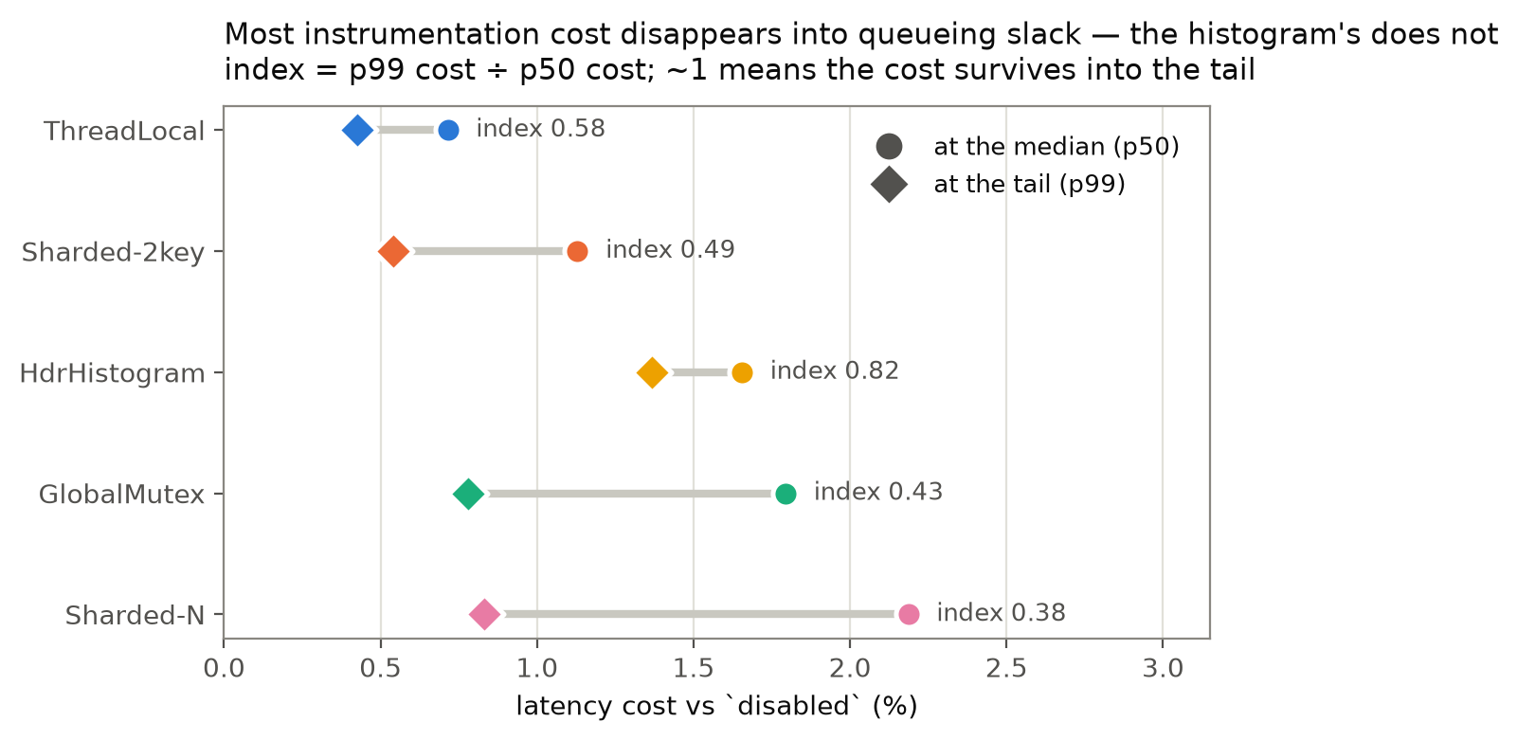
Median versus tail cost
Figure 3. Each strategy’s cost at the median and at p99. Short dumbbells (high index) indicate cost that persists into the tail.
Strategy | p50 cost | p99 cost | Index | 95% CI
Sharded-N | 2.19% | 0.83% | 0.38 | [0.28, 0.48]
GlobalMutex | 1.79% | 0.78% | 0.43 | [0.30, 0.55]
Sharded-2key | 1.13% | 0.54% | 0.49 | [0.27, 0.71]
ThreadLocal | 0.72% | 0.43% | 0.58 | [0.36, 0.81]
HdrHistogram | 1.66% | 1.37% | 0.82 | [0.68, 0.96]
Four of five strategies retain only 38–58% of their median cost at p99: their overhead is elastic, absorbed by queueing slack, because a few extra microseconds of counter work are negligible against a 79 ms queue. HdrHistogram retains 82% — its overhead is rigid. The distinction matters because the tail, not the median, is what composes across a request fan-out and what latency objectives are written against [13].
The axis decomposition localizes the rigidity precisely. Pricing each axis under each budget metric:
Axis | Throughput | Mean | p50 | p99
SYNC | +0.52 | +0.55 | +0.67 | +0.24 [−0.01, 0.49]
CARD | +0.87 | +0.91 | +1.06 | +0.29 [0.05, 0.53]
DEFER | +0.31 | +0.32 | +0.41 | +0.11 [−0.11, 0.33]
PAYLOAD | +0.89 | +0.91 | +0.94 | +0.94 [0.76, 1.12]
SYNC, CARD and DEFER all shrink by roughly 60–75% from p50 to p99 — elastic. PAYLOAD is statistically flat across all four metrics (0.89–0.94 pp) — rigid. The histogram is the only axis whose cost arrives undiminished at the tail.
We offer a mechanism, and label it interpretation rather than measurement: hdr_histogram accumulates into a thread-local histogram and periodically merges into a shared one under a global lock, and merging HDR histograms is an O(buckets) operation over thousands of buckets, orders of magnitude more expensive than merging a two-entry counter map (thread_local’s flush). A per-operation cost is elastic because it competes with queueing; a periodic multi-millisecond stall is rigid because it creates tail events. We did not instrument the merge directly, so this mechanism is consistent with the data, not established by it (§7).
The rank inversion. This has a sharp consequence for evaluation practice. Consider the two comparisons involving HdrHistogram:
Comparison | Throughput | Mean | p50 | p99
Hdr − GlobalMutex | +0.05 [−0.02, 0.13] 8/11 p = 0.23 | +0.04 [−0.03, 0.12] p = 0.23 | −0.14 [−0.19, −0.09] 0/11 p = 0.001 | +0.59 [0.37, 0.80] 11/11 p = 0.001
Hdr − Sharded-N | −0.29 [−0.42, −0.15] p = 0.012 | −0.31 [−0.46, −0.17] p = 0.012 | −0.53 [−0.70, −0.36] p = 0.001 | +0.54 [0.32, 0.75] 11/11 p = 0.001
Under a throughput budget, HdrHistogram versus GlobalMutex is statistically unresolved (p = 0.23), and remains so under 11× replication — it is the one comparison in this dataset that pooling further runs does not settle, and it grew weaker rather than stronger as runs were added (p ≈ 0.11 at ten runs, 0.23 at eleven). The decomposition shows why: the comparison is not weak, it is sign-ambiguous. HdrHistogram is decisively cheaper at the median (0 of 11 runs disagree, p = 0.001) and decisively costlier at p99 (11 of 11, p = 0.001). Throughput, an aggregate sitting between them, nets the two opposing effects to approximately zero and reports “no difference.”
A throughput-only evaluation does not merely lose power here. It returns a null result for a pair whose true relationship is a sign reversal — and the reversal is the operationally important fact, since a team choosing HdrHistogram for tail-latency visibility is paying for it in tail-latency cost.

5.4 Result 4 — Separating the bundled axes: the cardinality is real
§3.3 noted that two of the four contrasts bundle an extra cost with the axis they name: both sharded_n and hdr_histogram key their maps by an owned String allocated per operation, while their comparators use a &'static str. Whether CARD measures cardinality or merely that allocation is not a detail — it decides whether the practitioner advice is “shrink the label set” or “intern the label”. We therefore ran a dedicated experiment.
Instruments. Two collectors were added (src/command_metrics.rs). sharded_bucketed keys a DashMap by "<CMD>#<fnv1a(logical key) mod C>", with C set per run. The point is that per-operation work is identical at every C — one hash, one modulo, one format!, one allocation, one map lookup — so sweeping C varies the number of live entries and nothing else. This is a stronger instrument than sweeping the workload key space, which would vary the request distribution alongside the cardinality. thread_local_owned is a line-for-line twin of the HdrHistogram collector with CommandStat substituted for the histogram, isolating the histogram payload.
Design. Eight independently provisioned Standard_D8s_v6 VMs (two rounds of four, across Central India ×2, South India, and West US 3; same Xeon Platinum 8573C and toolchain as the main batch), 12 strategy configurations × 3 concurrency levels × 15 blocks = 540 runs each, 4,320 runs in total. §5.2’s concurrency-invariance result is what licenses the reduced concurrency coverage here. Intervals cluster on the eight runs, t(7).
The anchors reproduce, so the batch is comparable: SYNC 0.527 (main batch 0.522), DEFER 0.290 (0.309), PAYLOAD 0.967 (0.885). CARD is 0.642 here against 0.866 in the main batch — intervals overlap, but this batch covers three concurrency levels and one workload rather than eight and three, so the main batch remains the reference for CARD’s magnitude.
Table 6. The bundled axes, decomposed (pp of throughput, 95% CI clustered on 8 runs).
Quantity | Estimate | 95% CI
pure cardinality (2 → 13,040 entries, per-op work identical) | 0.652 | [0.280, 1.024] | resolved
CARD total (sharded_n − sharded_2key) | 0.642 | [0.316, 0.967] | resolved
histogram alone (hdr_histogram − thread_local_owned) | 0.773 | [0.539, 1.006] | resolved
PAYLOAD total (hdr_histogram − thread_local) | 0.967 | [0.709, 1.226] | resolved
key construction, FNV + format! (sharded_bucketed@1 − sharded_2key) | 0.855 | [0.393, 1.317] | resolved
owned-key allocation, TLS path (thread_local_owned − thread_local) | 0.195 | [−0.017, 0.407] | not resolved
Two conclusions follow. The CARD axis is genuinely cardinality: the pure entry-count effect (0.652) accounts for essentially all of CARD’s total (0.642), leaving no room for a material allocation component in sharded_n’s key path. The PAYLOAD axis is genuinely the histogram: 0.773 of 0.967, or about 80%, with the residual allocation term not resolved. Both bundles are dominated by the axis they are named for, which is the outcome that supports the paper’s framing rather than overturning it.
The key-construction figure is separately interesting — building a key with a hash and a format! costs 0.855 pp, comparable to the whole cardinality effect — but it is the bucketed collector’s own key path, not a component of CARD, and we do not fold it into the headline.
The cardinality cost is not linear in entries; it appears above ~10³.
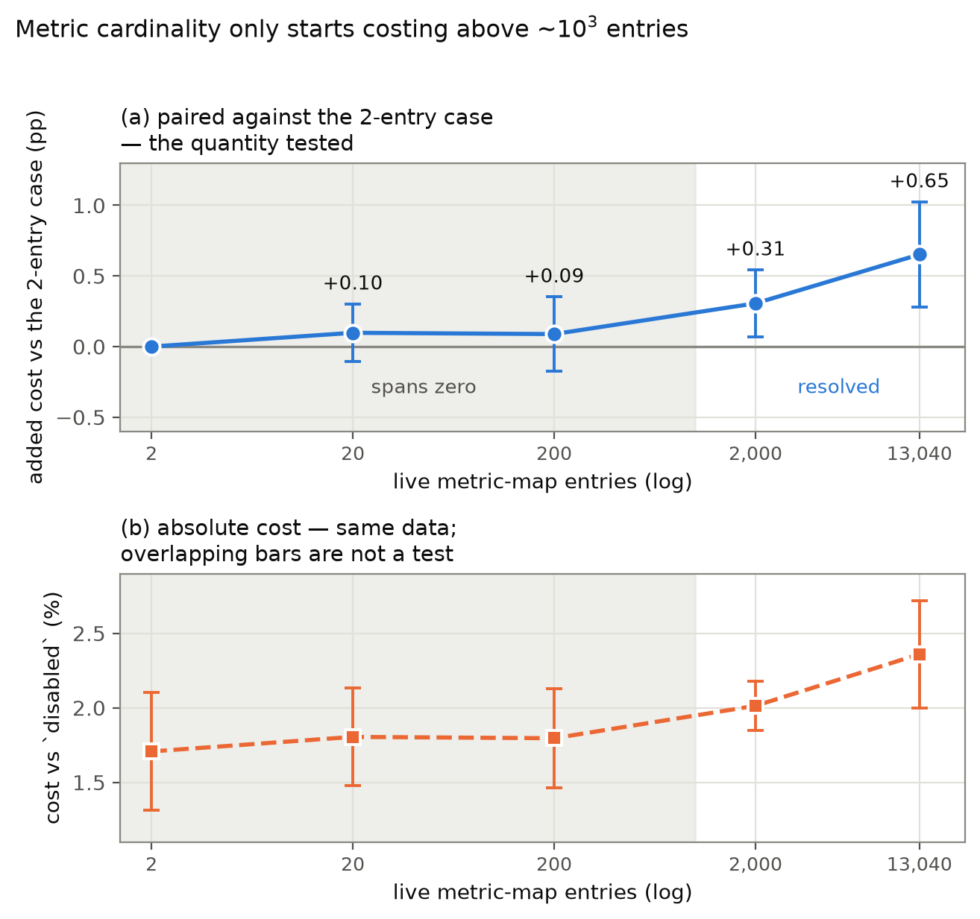
Cost against live metric-map entries
Figure 4. Cost as the live entry count sweeps 3.5 decades with per-operation work held constant, shown two ways from the same data. (a) the paired difference against the 2-entry configuration — the quantity actually tested, and the intervals the resolved/unresolved verdict rests on. (b) each configuration’s absolute cost. Panel (b) is included because reading it alone invites a specific error: its intervals overlap between adjacent cardinalities, which resembles “no difference”, but overlapping intervals are not a test of a difference. The two forms have broadly similar interval widths here; the paired comparison wins by removing the baseline instrumentation cost common to every cardinality, not by being tighter.
Data entries | Cost vs disabled | vs 2 entries
2 | 1.707% | (reference)
20 | 1.805% | +0.097 [−0.107, 0.302] | not resolved
200 | 1.796% | +0.089 [−0.175, 0.352] | not resolved
2,000 | 2.014% | +0.306 [0.069, 0.543] | resolved
13,040 | 2.360% | +0.652 [0.280, 1.024] | resolved
Below roughly a thousand entries the effect is indistinguishable from zero at this design’s resolution. Practitioners bounding label cardinality in the tens or low hundreds are therefore not buying throughput by doing so — the server-side cost only becomes measurable in the thousands. (The backend argument for bounding cardinality is unaffected; it is a different cost.)
What this experiment does not establish. The strong form of §5.1 — that cardinality alone outranks the synchronization axis — is not resolved here: pure cardinality minus SYNC is +0.125 pp, 95% CI [−0.358, 0.607], agreeing in direction in only 4 of 8 runs (1.24×). §5.1’s claim concerns CARD, the package, against SYNC, and that comparison stands on the eleven-run main batch; the present batch establishes what the package is made of, not a new ordering.
An unplanned demonstration of why the paired design matters. One of the eight VMs (run_06) returned absolute throughput about 30% below its peers across every configuration — a degraded or noisy instance of exactly the kind §2 warns about. Recomputing every contrast in Table 6 with that run excluded moves each by less than 0.05 pp, because the paired within-block ratio cancels a level shift that affects numerator and denominator alike. A design comparing absolute throughputs across instances would have been badly distorted by the same run.

6. Discussion and Implications
For engineers instrumenting a similar server. Per-command telemetry costs at most ~2.2% here, so the question is rarely whether to instrument but how. Given that budget, the priority order implied by these results differs from the common one:
- Reduce metric key cardinality before optimizing the lock — above ~10³ labels. The cardinality axis is worth 1.66× the synchronization axis on the 8-core VM and 4.5× on the 4-core one (4.51× and 1.58× when the two counts are matched on workload and client load, §5.2), and a sharded map with a high-cardinality label is slower than a global mutex with a low-cardinality one (§5.1). §5.4 shows this is the entry count itself rather than the key allocation bundled with it, and puts a threshold on the advice: below roughly a thousand live entries the server-side effect is indistinguishable from zero, so a team already holding label cardinality to the tens or low hundreds gains no throughput by shrinking it further. (The backend argument for bounding cardinality is a separate cost and unaffected.) Where cardinality is in the thousands and above, it is the larger producer-side cost and the two arguments point the same way.
- Choose the collector against the percentile you actually budget. ThreadLocal is cheapest under every metric and is the default choice. If per-command histograms are required, HdrHistogram costs ~1.4% throughput — affordable — but it is the most expensive strategy at p99 and the only one whose cost does not dilute under load (§5.3). On a latency-SLO service, that is the number to budget against, and a less frequent or cheaper merge is the thing to tune.
- Do not expect client load to reveal telemetry contention. On a thread-pool server, contention is bounded by the pool. Scale the core count, not the client count (§5.2).
The collectors here are hand-written, which is what makes the one-axis-per-pair design possible: a general-purpose metrics library fixes several of the axes at once. The axes themselves are not specific to hand-written code — the Rust prometheus and metrics crates [28, 39] both expose exactly the choice this paper prices, between a label whose value is a bounded command name and one whose value is a request datum — and §7 states what a library-level replication would and would not settle.
For performance engineers designing such a study. Three transferable points. First, compare designs along axes, not as bundles: a ranking of five strategies is five facts, while a decomposition into four axes is a model that predicts configurations never measured — and here the decomposition, not the ranking, produced every result. Second, report against more than one budget metric; §5.3 is a worked case where a single-metric evaluation reports a confident null for a genuine sign reversal, which is worse than low power. Third, when pooling independent cloud instances, cluster the inference on instances: the 165 blocks here are 11 runs, and treating them as independent overstates precision by roughly 20%.

7. Threats to Validity
Internal. Contrast purity (§3.3) was the principal threat: CARD and PAYLOAD each bundle an owned-key allocation with the axis they name. §5.4 resolves it with a dedicated eight-run experiment — the entry count accounts for essentially all of CARD, and the histogram for about 80% of PAYLOAD — so both bundles are dominated by the axis they are named for. What remains open from that experiment is narrower and stated there: the owned-key allocation term in the TLS path is not resolved (0.195 pp, CI spanning zero), and the pure cardinality effect is indistinguishable from zero below roughly 10³ entries, so the CARD magnitude reported in §5.1 should be read as specific to a ~10⁴-entry label, not as a general per-entry rate.
Conversely, the SYNC axis is inflated by global_mutex’s self-instrumentation (two Instant reads and a contended atomic per operation), which biases against the paper’s headline claim; the claim therefore survives this confound rather than depending on it. §5.1’s claim is about CARD — the package an engineer actually adopts when they label by a dynamic value — versus SYNC. The stronger statement that cardinality alone outranks the synchronization axis is not supported: §5.4 puts that difference at +0.125 pp with an interval spanning zero. We make the package claim and not the stronger one.
The §5.3 merge-stall mechanism is an interpretation consistent with the data, not a measurement; direct instrumentation of flush duration would test it.
Construct. The benchmark client is custom, not YCSB [10], so absolute throughputs are not comparable to published YCSB results; the paired within-block ratios are unaffected, since every strategy is compared against a disabled baseline measured by the same client. Client and server share one VM and communicate over loopback (§4.2), so this is not a network-bound measurement: there is no physical network path, and at the highest concurrencies it is a thread-oversubscription stress test rather than an isolated server measurement. For §5.2’s negative result that direction is conservative — co-location should if anything amplify any concurrency-dependence of overhead, and none appears. For §5.2’s worker-count result it is not conservative, because changing the vCPU count changes the client’s CPU budget as well as the server’s pool; that limitation is stated where the result is claimed. The server is restarted per run, but OS state (page cache, socket buffers, port reuse) carries over.
External. Both VM sizes are the same Azure family and x86-64 image, so they replicate across size, region, and workload but not across hardware families, architectures, or clouds. The worker-count comparison rests on two points (4 and 8) that differ in VM size, region mix, and measurement date, so it is a direction-of-effect observation, not a scaling law. It is further limited by an artifact of the D4s_v6 run: a logging bug recorded a placeholder processor string in that run’s metadata, so while all eleven D8s_v6 runs verifiably share one CPU model (Intel Xeon Platinum 8573C), we cannot confirm from the artifact that the 4-vCPU VM used the same microarchitecture. A microarchitectural difference would confound the SYNC growth we attribute to worker count, and the crossover extrapolation in §5.2 is explicitly a hypothesis. The collectors are also hand-written rather than drawn from a metrics library, so the measured magnitudes are properties of these implementations. Nothing here is claimed for NUMA systems, substantially higher core counts, or non-x86 architectures. The cardinality curve of §5.4 is measured with one instrument on one server; the ~10³-entry threshold it reports may be a property of this DashMap configuration rather than of the class.
Three experiments would address these limits, and we state them precisely so that the present claims can be read against them. For the worker-count result: a sweep over 2, 4, 8, 16 and 32 vCPUs within one VM family and region, with the load generator on a separate VM so that the vCPU count changes only the server’s worker pool, would turn a two-point observation into a fitted law and test the ~11–12-worker crossover directly. For client placement: repeating the main contrasts at two or three concurrency levels with the load generator on a second Standard_D8s_v6 in the same region would confirm that CARD > SYNC survives removal of the co-located client — §5.2’s concurrency-invariance result is what makes so reduced a replication informative. For generality beyond hand-written collectors: the same two contrasts built on the Rust prometheus or metrics crate [28, 39], one labelled by command name and one by the request’s data key, would test whether the ordering of the axes survives a production library’s own fixed costs, which is the form of the claim that would transfer.
Statistical. Two different quantities have detectability floors here, and conflating them would make §5.1’s headline look unsupported, so we state which is which. The figure of roughly 0.6–0.75% applies to a single cell: the smallest overhead of one strategy against disabled, within one (strategy, concurrency, workload) cell, that this design detects at 80% power. Three calculations agree on it — 0.58% treating all 165 pooled blocks as independent, 0.69% cluster-aware on the eleven run-level means, and ~0.75% from the injected-effect simulation (scripts/compute_mde.py, compute_mde_clustered.py, simulate_mde.py respectively).
The headline CARD − SYNC estimate is not a quantity of that kind, and the floor above does not apply to it. It is a difference of two paired within-block ratios that share the sharded_2key reference, aggregated over all 120 cells, with one number per run as the unit of analysis. Differencing two contrasts against a common reference cancels the baseline-level noise that dominates a single-cell estimate, and aggregating over cells averages the rest down. Its realised standard error over the eleven runs is 0.069 pp, so the corresponding 80%-power floor for that quantity is (1.96 + 0.84) × 0.069 ≈ 0.19 pp. A 0.34 pp difference is therefore resolved — CI [0.19, 0.50], sign test p = 0.012 — with no tension against the single-cell figure, which is a three- to fourfold coarser quantity measured on a different unit.
The per-cell floor remains the correct number for per-cell claims, and it is what rules out an ordering between PAYLOAD and CARD: that gap is 0.02 pp, below every floor quoted here, and no ordering between them is claimed.
The eleven runs support cluster-aware t-intervals with 10 degrees of freedom, which are wide; the sign tests are exact and distribution-free, and we report both. We ran no live A/A experiment; false-positive calibration comes from a resampling-based simulated null, which validates the test but not the end-to-end procedure. Pooling more runs did not uniformly tighten every statistic — a raw-throughput CI width widened with the eleventh run — a reminder that between-run variance is real and that “more data helps” is a claim about a specific estimator.

8. Conclusion
We decomposed per-command observability overhead in a concurrent in-memory key-value store into four separately-priced design axes, measured across 29,520 RMIT benchmark runs on fourteen dedicated cloud VMs with inference clustered on independent runs. The decomposition contradicts the standard optimization priority: the metric-cardinality axis costs 1.66× the synchronization axis on the 8-worker VM and 4.5× on the 4-worker one (4.51× and 1.58× matched on workload and client load), so a sharded concurrent map carrying a high-cardinality label is measurably slower than a single global mutex carrying a low-cardinality one. It also shows that these costs answer to different variables — no axis responds to a 30× increase in client concurrency on a thoroughly saturated server, while the synchronization axis grows 2.6× with a doubling of worker threads — so the client-load knob that benchmarks conventionally turn cannot expose telemetry contention on a thread-pool architecture. Finally, overhead proves not to be a single number: counter costs are elastic and largely vanish into queueing slack at the tail, whereas histogram-payload cost is rigid and statistically identical at the median and at p99. That difference produces a sign reversal which a throughput-only evaluation reports as a confident null.
A separate eight-VM experiment settles what the cardinality axis is actually made of. Using a collector whose per-operation work is held byte-for-byte constant while the live entry count sweeps 3.5 decades, the entry count is shown to account for essentially all of the axis, and the histogram for about 80% of the payload axis — so both bundles are dominated by the axis they are named for. The same experiment marks the boundary of the result: the effect is indistinguishable from zero below roughly 10³ entries, and cardinality alone does not statistically outrank the synchronization axis, so the claim we make is about high-cardinality labeling as a package, which is the thing an engineer actually adopts.
The unifying claim is that observability overhead should be budgeted per design axis and per target percentile. A single headline percentage, measured under a single metric at a single client load, can be simultaneously accurate and useless for the decision it is meant to inform. The natural next steps are to instrument the histogram merge directly, to test whether the axes keep their separate scaling laws past eight cores, and to check whether the ~10³-entry threshold is a property of this server or of the class.

Data Availability
All source code, raw benchmark data (29,520 runs), analysis scripts and figure code are in the public repository https://github.com/Saksham932007/RustRedis. The version corresponding to this manuscript is tagged v1.0-paper and archived with a persistent identifier: DOI: 10.5281/zenodo.XXXXXXX (placeholder — the Zenodo deposition is created from the v1.0-paper GitHub release and the DOI inserted here before submission; see submission/SUBMISSION_CHECKLIST.md). Appendix A lists the commands that regenerate every table, figure and quoted statistic in §5 from the committed raw data.

Declaration of Generative AI Use
Generative AI tools (large language models accessed through a coding assistant) were used during this work for code authoring and refactoring of the experiment runner, analysis scripts and figure code; for drafting and copy-editing of the manuscript text; and for literature search. They were not used to generate, simulate, impute or alter any experimental measurement: every number reported here derives from the committed raw benchmark data by the committed analysis scripts, each of which was run and inspected by the author. The author designed the experiments, verified the analyses and the cited literature, and takes full responsibility for the content of this manuscript.

References
- Abedi, A. and Brecht, T. (2017). Conducting Repeatable Experiments in Highly Variable Cloud Computing Environments. ICPE ’17, 287–292.
- Abedi, A., Heard, A., and Brecht, T. (2015). Conducting Repeatable Experiments and Fair Comparisons using 802.11n MIMO Networks. ACM SIGOPS Operating Systems Review, 49(1), 41–50.
- Adams, C., Alonso, L., Atkin, B., Banning, J., Bhola, S., Buskens, R., Chen, M., Chen, X., Chung, Y., Jia, Q., Sakharov, N., Talbot, G., Tart, A., and Taylor, N. (2020). Monarch: Google’s Planet-Scale In-Memory Time Series Database. Proceedings of the VLDB Endowment, 13(12), 3181–3194.
- Aspnes, J., Herlihy, M., and Shavit, N. (1994). Counting Networks. Journal of the ACM, 41(5), 1020–1048.
- Bartolomeo, J. (2020). Lock-free Observations for Prometheus Histograms. Grafana Labs Blog. https://grafana.com/blog/2020/01/08/lock-free-observations-for-prometheus-histograms/
- Bos, M. (2023). Rust Atomics and Locks: Low-Level Concurrency in Practice. O’Reilly Media.
- Boyd-Wickizer, S., Clements, A. T., Mao, Y., Pesterev, A., Kaashoek, M. F., Morris, R., and Zeldovich, N. (2010). An Analysis of Linux Scalability to Many Cores. OSDI ’10.
- Brazil, B. (2018). Prometheus: Up & Running — Infrastructure and Application Performance Monitoring. O’Reilly Media.
- Bulej, L., Horký, V., Tůma, P., Farquet, F., and Prokopec, A. (2020). Duet Benchmarking: Improving Measurement Accuracy in the Cloud. ICPE ’20, 100–107.
- Cooper, B. F., Silberstein, A., Tam, E., Ramakrishnan, R., and Sears, R. (2010). Benchmarking Cloud Serving Systems with YCSB. SoCC ’10, 143–154.
- Curtsinger, C. and Berger, E. D. (2013). STABILIZER: Statistically Sound Performance Evaluation. ASPLOS ’13, 219–228.
- David, T., Guerraoui, R., and Trigonakis, V. (2013). Everything You Always Wanted to Know About Synchronization but Were Afraid to Ask. SOSP ’13, 33–48.
- Dean, J. and Barroso, L. A. (2013). The Tail at Scale. Communications of the ACM, 56(2), 74–80.
- Fan, B., Andersen, D. G., and Kaminsky, M. (2013). MemC3: Compact and Concurrent MemCache with Dumber Caching and Smarter Hashing. NSDI ’13, 371–384.
- Fruth, M., Scherzinger, S., Mauerer, W., and Ramsauer, R. (2021). Tell-Tale Tail Latencies: Pitfalls and Perils in Database Benchmarking. TPCTC 2021, LNCS 13169, 119–134.
- Georges, A., Buytaert, D., and Eeckhout, L. (2007). Statistically Rigorous Java Performance Evaluation. OOPSLA ’07, 57–76.
- Gregg, B. (2020). Systems Performance: Enterprise and the Cloud, 2nd edition. Addison-Wesley.
- HdrHistogram contributors. hdrhistogram_rust: A Rust port of HdrHistogram. https://github.com/HdrHistogram/HdrHistogram_rust
- Kaldor, J., Mace, J., Bejda, M., Gao, E., Kuropatwa, W., O’Neill, J., Ong, K. W., Schaller, B., Shan, P., Viscomi, B., Venkataraman, V., Veeraraghavan, K., and Song, Y. J. (2017). Canopy: An End-to-End Performance Tracing and Analysis System. SOSP ’17, 34–50.
- Kalibera, T. and Jones, R. E. (2013). Rigorous Benchmarking in Reasonable Time. ISMM ’13, 63–74.
- Karumuri, S., Solleza, F., Zdonik, S., and Tatbul, N. (2020). Towards Observability Data Management at Scale. ACM SIGMOD Record, 49(4), 18–23.
- Laaber, C., Scheuner, J., and Leitner, P. (2019). Software Microbenchmarking in the Cloud. How Bad is it Really? Empirical Software Engineering, 24(4), 2469–2508.
- Leitner, P. and Cito, J. (2016). Patterns in the Chaos — A Study of Performance Variation and Predictability in Public IaaS Clouds. ACM Transactions on Internet Technology, 16(3), 15:1–15:23.
- Lim, H., Han, D., Andersen, D. G., and Kaminsky, M. (2014). MICA: A Holistic Approach to Fast In-Memory Key-Value Storage. NSDI ’14, 429–444.
- Luk, C.-K., Cohn, R., Muth, R., Patil, H., Klauser, A., Lowney, G., Wallace, S., Reddi, V. J., and Hazelwood, K. (2005). Pin: Building Customized Program Analysis Tools with Dynamic Instrumentation. PLDI ’05, 190–200.
- Maricq, A., Duplyakin, D., Jimenez, I., Maltzahn, C., Stutsman, R., and Ricci, R. (2018). Taming Performance Variability. OSDI ’18, 409–425.
- Mellor-Crummey, J. M. and Scott, M. L. (1991). Algorithms for Scalable Synchronization on Shared-Memory Multiprocessors. ACM Transactions on Computer Systems, 9(1), 21–65.
- metrics-rs contributors. metrics: A metrics ecosystem for Rust. https://github.com/metrics-rs/metrics
- Mytkowicz, T., Diwan, A., Hauswirth, M., and Sweeney, P. F. (2009). Producing Wrong Data Without Doing Anything Obviously Wrong! ASPLOS ’09, 265–276.
- Nishtala, R., Fugal, H., Grimm, S., Kwiatkowski, M., Lee, H., Li, H. C., McElroy, R., Paleczny, M., Peek, D., Saab, P., Stafford, D., Tung, T., and Venkataramani, V. (2013). Scaling Memcache at Facebook. NSDI ’13, 385–398.
- Nõu, A., Talluri, S., Iosup, A., and Bonetta, D. (2025). Investigating Performance Overhead of Distributed Tracing in Microservices and Serverless Systems. ICPE Companion ’25.
- OpenTelemetry Authors. OpenTelemetry Specification. https://opentelemetry.io/docs/specs/otel/
- Papadopoulos, A. V., Versluis, L., Bauer, A., Herbst, N., von Kistowski, J., Ali-Eldin, A., Abad, C. L., Amaral, J. N., Tůma, P., and Iosup, A. (2021). Methodological Principles for Reproducible Performance Evaluation in Cloud Computing. IEEE Transactions on Software Engineering, 47(8).
- Pelkonen, T., Franklin, S., Teller, J., Cavallaro, P., Huang, Q., Meza, J., and Veeraraghavan, K. (2015). Gorilla: A Fast, Scalable, In-Memory Time Series Database. Proceedings of the VLDB Endowment, 8(12), 1816–1827.
- Prometheus Authors. Metric and Label Naming. Prometheus documentation. https://prometheus.io/docs/practices/naming/
- Reichelt, D. G., Kühne, S., and Hasselbring, W. (2021). Overhead Comparison of OpenTelemetry, inspectIT and Kieker. Symposium on Software Performance (SSP) 2021, CEUR Workshop Proceedings Vol. 3043.
- Reichelt, D. G., Bulej, L., Jung, R., and van Hoorn, A. (2024). Overhead Comparison of Instrumentation Frameworks. ICPE ’24 Companion.
- Reniers, V., Van Landuyt, D., Rafique, A., and Joosen, W. (2017). On the State of NoSQL Benchmarks. ICPE ’17 Companion, 107–112.
- Rust Prometheus contributors. rust-prometheus: Prometheus instrumentation library for Rust applications. https://github.com/tikv/rust-prometheus
- Sigelman, B. H., Barroso, L. A., Burrows, M., Stephenson, P., Plakal, M., Beaver, D., Jaspan, S., and Shanbhag, C. (2010). Dapper, a Large-Scale Distributed Systems Tracing Infrastructure. Google Technical Report.
- Tallent, N. R., Mellor-Crummey, J., and Porterfield, A. (2010). Analyzing Lock Contention in Multithreaded Applications. PPoPP ’10, 269–280.
- Tene, G. HdrHistogram: A High Dynamic Range Histogram. https://github.com/HdrHistogram/HdrHistogram
- Tokio Contributors. Tokio: An Asynchronous Runtime for the Rust Programming Language. https://tokio.rs
- Uta, A., Custura, A., Duplyakin, D., Jimenez, I., Rellermeyer, J., Maltzahn, C., Ricci, R., and Iosup, A. (2020). Is Big Data Performance Reproducible in Modern Cloud Networks? NSDI ’20, 513–527.
- van Hoorn, A., Waller, J., and Hasselbring, W. (2012). Kieker: A Framework for Application Performance Monitoring and Dynamic Software Analysis. ICPE ’12, 247–248.
- xacrimon. DashMap: Blazingly Fast Concurrent Map in Rust. https://github.com/xacrimon/dashmap

Appendix A. Reproducibility
All raw data, analysis code, and figure code are committed.
# Every table and statistic in §5.0-§5.3
# (also writes experiments/design_axes_analysis.json)
python3 scripts/analyze_design_axes.py
# Figures 1-4, recomputed from the same helpers the tables use; each is written
# as a 200-dpi PNG and as a vector PDF into docs/figures/
python3 scripts/generate_design_axes_figures.py
# Section 5.4: the axis-separation experiment (8 independent runs)
python3 scripts/combine_iterations.py \
--input-dir experiments/azure_d8s_v6_followup \
--output-dir experiments/azure_d8s_v6_followup/pooled
# (writes experiments/design_axes_followup_analysis.json)
python3 scripts/analyze_design_axes.py --followup-only \
--pooled-csv experiments/azure_d8s_v6_followup/pooled/raw_data_rmit.csv
To regenerate the §5.4 dataset, see docs/followup_experiment_protocol.md; each of the eight runs is one VM:
RMIT_ENVIRONMENT_LABEL=<label> python3 scripts/run_rmit_experiment.py \
--strategies all --cardinalities 1,10,100,1000,10000 \
--runs 15 --concurrency 100,1000,3000 --workloads mixed \
--key-space 10000 --seed <distinct> \
--output-dir experiments/azure_d8s_v6_followup/run_<NN>
To regenerate the datasets themselves (each on a dedicated cloud VM; see docs/rmit_experiment_protocol.md for provisioning):
# D4s_v6: single workload, 30 repetitions
RMIT_ENVIRONMENT_LABEL=<label> python3 scripts/run_rmit_experiment.py \
--runs 30 --concurrency 100,200,300,400,500,600,700,1000 \
--output-dir experiments/azure_d4s_v6
# D8s_v6: 3 workloads x wider concurrency, repeated on independent VMs
for i in $(seq -w 1 10); do
RMIT_ENVIRONMENT_LABEL=<label-$i> python3 scripts/run_rmit_experiment.py \
--runs 15 --concurrency 100,250,500,750,1000,1500,2000,3000 \
--workloads mixed,read-heavy,write-heavy --seed $((1000 + 10#$i)) \
--output-dir experiments/azure_d8s_v6/run_$(printf %02d $i)
done
# Pool the 11 runs, offsetting block_id so paired blocks never span VMs
python3 scripts/combine_iterations.py
Per-run machine specs, commit hash, and full runtime configuration are recorded in each run’s metadata_rmit.json. Supporting analyses referenced in §4.3 and §7 (detectable-effect floors, cluster-aware bounds, injected-effect simulation) are in scripts/compute_mde.py, compute_mde_clustered.py, and simulate_mde.py.
The Python analysis code needs numpy, pandas, scipy and matplotlib; requirements.txt at the repository root pins the set that produced the committed numbers.

Appendix B. Axis arithmetic
Because all four axes are differences against a common reference, any pairwise strategy comparison is recoverable without re-analysis. Writing O(s) for a strategy’s overhead versus disabled:
O(global_mutex) − O(sharded_2key) = SYNC
O(sharded_n) − O(sharded_2key) = CARD
O(sharded_2key) − O(thread_local) = DEFER
O(hdr_histogram) − O(thread_local) = PAYLOAD
O(sharded_n) − O(global_mutex) = CARD − SYNC (§5.1 headline)
O(hdr_histogram) − O(sharded_2key) = PAYLOAD − DEFER
O(hdr_histogram) − O(global_mutex) = PAYLOAD − DEFER − SYNC (§5.3 inversion)
The §5.1 headline is thus not a separate test but a reading of the decomposition: the sign of CARD − SYNC is the ordering of sharded_n against global_mutex.

