INTERNSHIP REPORT
OF
ETHICAL HACKING
Submitted To
School of Computer Science and Engineering
IILM University, Greater Noida, U.P.
In partial fulfilment of the requirement for the degree of
B.Tech (Computer Science & Engineering)
BY
SAKSHAM SINGH
Roll Number: 2410030795
Batch: 2026–2027
EduSkills Academy
AICTE – EduSkills Virtual Internship

1. CANDIDATE’S DECLARATION
I, SAKSHAM SINGH, do hereby declare that the internship report titled “Ethical Hacking” has been completed by me to fulfil the requirement for the award of the degree of Bachelor of Technology in Computer Science and Engineering. All references used in this report have been acknowledged. I affirm that this report represents my internship work and has not been submitted to any other institute for any degree or diploma requirement.
Signature: ______________________________
Student Name: SAKSHAM SINGH
Roll No.: 2410030795

2. ACKNOWLEDGEMENT
I would like to express my sincere gratitude to everyone who supported me throughout my AICTE – EduSkills Virtual Internship. I am thankful for the guidance, structured learning, practical exposure and constructive support provided during the internship. The internship gave me an opportunity to study ethical hacking concepts, cybersecurity fundamentals, social engineering risks, malware, networking, Kali Linux, web application vulnerability assessment and penetration testing.
I am also grateful to my university, faculty members, mentors and my parents for their encouragement and support throughout the internship and in the preparation of this report.
Signature: ______________________________
Student Name: SAKSHAM SINGH
Roll No.: 2410030795

3. INTERNSHIP COMPLETION CERTIFICATE
A copy of the internship completion certificate issued by EduSkills Academy is attached below.
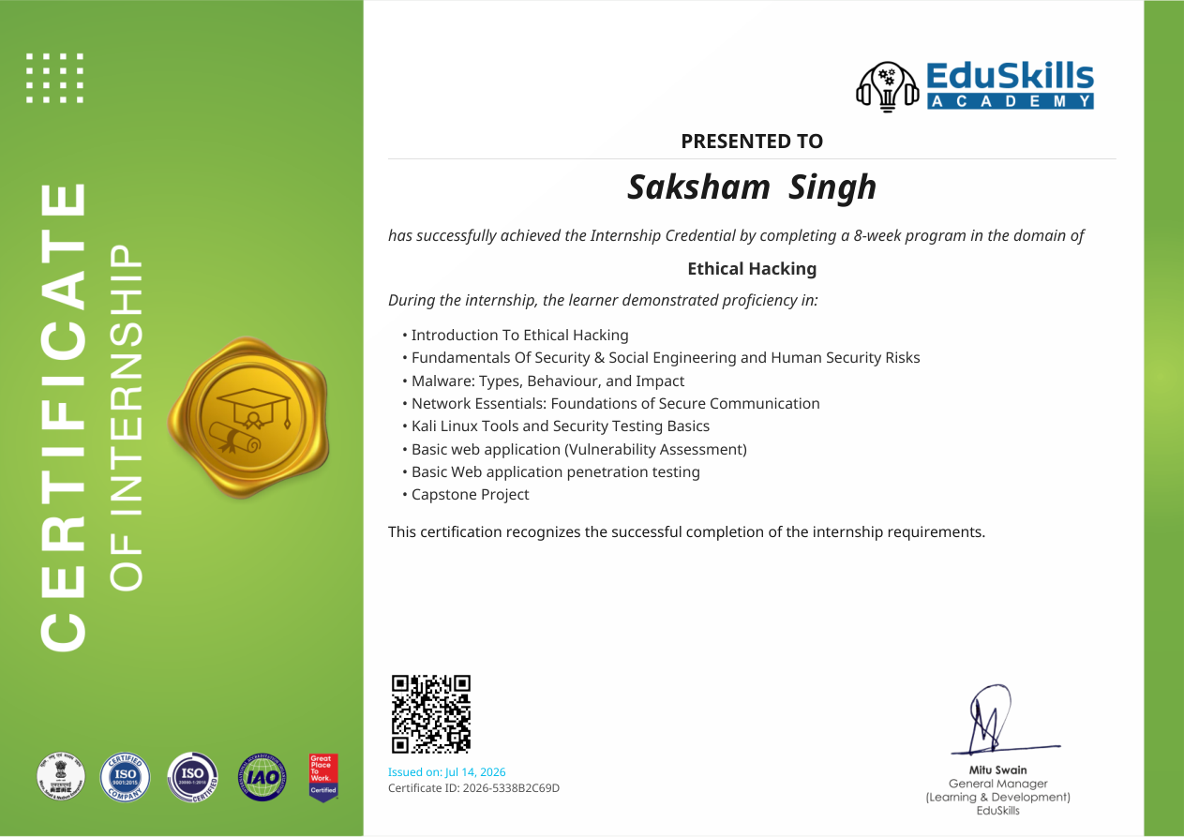

4. PROJECT DESCRIPTION

4.1 Introduction
The AICTE – EduSkills Virtual Internship was an eight-week virtual internship in the domain of Ethical Hacking. According to the offer letter, the program combined structured learning, weekly assessments, project documentation/assignments and a final assessment. The internship covered practical cybersecurity concepts ranging from ethical hacking and security fundamentals to Kali Linux, web application vulnerability assessment and penetration testing.

4.2 Organization Profile
EduSkills Academy is the organization named in the internship offer and completion certificate. The internship certificate confirms successful completion of the eight-week program and recognizes learning across ethical hacking, security, social engineering, malware, networking, Kali Linux, web application vulnerability assessment, penetration testing and a capstone project.

4.3 Problem Statement
The internship addressed the need for practical understanding of cybersecurity threats and defensive security practices. Academic study of security concepts needs to be complemented by hands-on exposure to identifying common risks, understanding how attacks operate, assessing web applications for vulnerabilities and using appropriate security-testing tools in a legal and controlled environment.

4.4 Project Objectives
- Understand the purpose, legality, tools and techniques of ethical hacking.
- Learn fundamental cybersecurity principles, threat types and protection practices.
- Identify common social engineering techniques such as phishing and impersonation.
- Understand malware types, behaviour, impact and basic mitigation approaches.
- Build foundational knowledge of networking, protocols and IP addressing.
- Learn Kali Linux basics and security-testing tools.
- Understand basic web application vulnerability assessment.
- Gain introductory exposure to web application penetration testing.
- Complete the internship's capstone project and required assessments.

4.5 Scope of the Project
The scope covered the learning and practical application of the modules defined in the internship offer letter. It included ethical hacking foundations, cybersecurity, social engineering, malware, networking, Kali Linux, web application vulnerability assessment, penetration testing and the capstone project. Activities were intended for authorized, ethical and controlled security testing.

4.6 Technologies and Tools Used
Technology / Tool | Purpose in Internship
Kali Linux | Security-testing environment and tools for ethical hacking and penetration testing.
Web Application Testing | Basic vulnerability assessment and penetration-testing concepts.
Networking Fundamentals | Protocols, IP addressing and basic network concepts.
Ethical Hacking Techniques | Authorized security assessment concepts and practices.

4.7 System / Security Testing Architecture
A simplified representation of the internship's security-testing workflow is shown below:
1 | Target / Lab Environment | Authorized web application or controlled system
2 | Reconnaissance & Understanding | Identify relevant services, interfaces and attack surface
3 | Vulnerability Assessment | Assess the application/system for known weaknesses
4 | Penetration Testing | Validate selected vulnerabilities in a controlled environment
5 | Reporting & Mitigation | Document findings and recommend protective measures
Figure 4.1: Simplified authorized security-testing workflow.

4.8 Methodology
Week | Module | Description
Week 1 | Introduction to Ethical Hacking | Purpose, legality, tools and techniques of ethical hacking.
Week 2 | Fundamentals of Security | Cybersecurity principles, threats and protection practices.
Week 3 | Social Engineering | Phishing, impersonation and human security risks.
Week 4 | Malware and Their Types | Malware types, identification, analysis and mitigation concepts.
Week 5 | Networking Essentials | Networks, protocols, IP addressing and basic device configuration.
Week 6 | Introduction to Kali Linux | Kali Linux basics, navigation and security-testing tools.
Week 7 | Basic Web Application with Capstone Projects | Web application development and vulnerability assessment.
Week 8 | Penetration Testing Using Kali Linux | Hands-on penetration testing and vulnerability reporting.
Table 4.1: Week-wise internship methodology and learning structure.

4.9 Expected / Achieved Learning Outcomes
- Ability to explain the purpose and legal boundaries of ethical hacking.
- Improved understanding of common cybersecurity threats and protection practices.
- Awareness of social engineering and human-centric security risks.
- Understanding of malware categories and their impact.
- Foundational networking knowledge relevant to security testing.
- Familiarity with Kali Linux and its role in ethical security testing.
- Understanding of basic web application vulnerability assessment.
- Introductory practical exposure to penetration-testing workflow and reporting.
- Completion of the internship requirements and capstone project.

4.10 Certificates of Completion and Supporting Proof
The completion certificate was issued to SAKSHAM SINGH for successful completion of the eight-week Ethical Hacking internship. Certificate ID: 2026-5338B2C69D; issued on July 14, 2026. The internship offer letter reference is C16Y2026M081399492.
The offer letter and completion certificate are retained as supporting internship documents. The university's submission instructions also require completion proof and other relevant communication mail proof to be attached where applicable.

5. BIBLIOGRAPHY / REFERENCES
EduSkills Academy. Internship Offer Letter, Ref No. C16Y2026M081399492, 2026.
EduSkills Academy. Internship Completion Certificate, Certificate ID 2026-5338B2C69D, issued July 14, 2026.
IILM University, School of Computer Science and Engineering. Internship Report Format, Batch 2026–27.

