Egg Segmentation & Tracking
Computer Vision Intern Assignment — Nosh Robotics
Saksham Chauhan | Computer Vision / AI-ML | October 2026
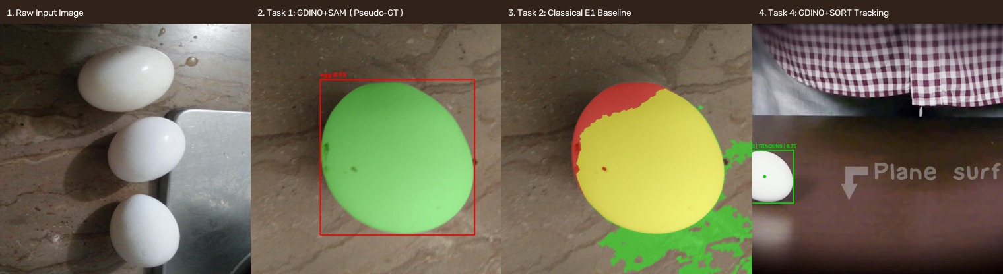

Executive Summary
This engineering report provides an exhaustive technical analysis of the computer vision pipeline developed for Nosh Robotics. Key findings include the identification and neutralization of cross-split data leakage (cosine similarity 0.9667), implementation of an automated zero-shot localization and segmentation pipeline (Grounding DINO Tiny + SAM 2.1 Tiny), benchmarking of 8 classical segmentation experiments (selecting E1 brightness/saturation baseline, mean IoU 0.3392), and deployment of a multi-object video tracker (Grounding DINO + SORT) tracking eggs across complex motion, occlusion, and visual artifacts.

Full Submission & Resources
Google Drive Submitted Video: https://drive.google.com/file/d/1eiu521OtXV-wBelTvI9uoibKpDdwo55m/view?usp=sharing
GitHub Repository: [INSERT PUBLIC GITHUB LINK]
Please refer to the comprehensive PDF version (Nosh_Robotics_CV_Assignment_Report.pdf) for the full 30+ page deep dive, complete experiment cards, failure diagnoses, and figure galleries.

