

BLOODBUDDY: A WEB-BASED BLOOD DONOR MANAGEMENT SYSTEM FOR NEPAL

By :
SAKSHAM MAHARJAN

MATRIC NO: C30101250024

BACHELOR OF INFORMATION & COMMUNICATION TECHNOLOGY
(BICT)

SCHOOL OF SCIENCE AND TECHNOLOGY

ASIA e UNIVERSITY

DATE OF SUBMISSION: 14 MAY 2026

CPP400 PROJECT PROPOSAL
(ADVANCED JAVA PROGRAMMING)

By :
SAKSHAM MAHARJAN

MATRIC NO: C30101250024

BACHELOR OF INFORMATION & COMMUNICATION TECHNOLOGY

(BICT)

SCHOOL OF SCIENCE AND TECHNOLOGY

ASIA e UNIVERSITY

4th SEMESTER

DISCLAIMER

This project proposal has been prepared by Saksham Maharjan as part of the CPP400 coursework for the Bachelor of Information and Communication Technology (BICT) programme at Asia e University. The ideas, system design, and proposed solutions presented in this document are original work developed for academic purposes.
The name “BloodBuddy” reflects a friendly, approachable companion for anyone in need of blood — connecting donors and recipients like a trusted friend. Any resemblance to existing platforms or commercial products is coincidental. This proposal does not represent a commercially deployed system.

ACKNOWLEDGEMENTS

I would like to express my sincere gratitude to my academic supervisor, Mr. Binay Malla, for his invaluable guidance, constructive feedback, and continued encouragement throughout the development of this proposal. I also extend my appreciation to my lecturer, Mr. Asish Koirala, whose teaching and support in Advanced Java have been instrumental in shaping the technical direction of this project.

I also extend my thanks to my fellow students and peers for their constructive discussions, and to my family for their continued support during my academic journey.

This proposal is a reflection of the knowledge and skills I have gained during my studies at Asia e University, and I am grateful for the opportunity to apply them to a problem that holds real significance in the Nepali context.

ABSTRACT

Nepal faces a persistent and life-threatening gap in organised blood donation management. When patients urgently require blood, families and hospitals resort to unstructured appeals on social media platforms such as Facebook, with no guarantee of reaching compatible donors in time. This lack of a centralised, searchable system costs lives.

BloodBuddy is a proposed web-based blood donor management system designed specifically for the Nepali context. The system will allow donors to register with their blood group and location, enabling requesters to search and connect with compatible donors in real time. Hospitals will be able to manage their blood bank inventory through a dedicated portal. An administrative dashboard will oversee platform integrity, user management, and system analytics.

The system will be developed using a full-stack Java approach: Spring MVC for the backend, Hibernate ORM for database management, and standard HTML, CSS, and JavaScript for the frontend. Key features include role-based access control, SMTP email notifications for urgent blood requests, secure image storage in the database, and a fully RESTful API architecture tested via Postman.A core deliverable of this project is the development of dedicated local REST APIs for five partner hospitals in Nepal — enabling each institution to integrate directly with BloodBuddy for real-time blood inventory sharing and request management.

TABLE OF CONTENTS
DISCLAIMER iii
ACKNOWLEDGEMENTS iv
ABSTRACT v
TABLE OF CONTENTS vi
LIST OF TABLES vii
LIST OF FIGURES viii
LIST OF ABBREVIATIONS ix
CHAPTER 1: INTRODUCTION 1
1.1 Overview 1
1.2 Problem Statement 1
1.3 Objectives 2
1.4 Scope 2
1.5 Justifications and Significance of the Study 3
CHAPTER 2: LITERATURE REVIEW 3
2.1 Introduction 3
2.2 Related Concepts 3
2.2.1 Blood Donation Management 3
2.2.2 Web-Based Information Systems 3
2.2.3 Role-Based Access Control (RBAC) 4
2.3 Review of Existing Systems 4
2.3.1 System 1: Hamro Donor (Nepal) 4
2.3.1.1 Issues and Limitations 4
2.3.1.2 Architecture 4
2.3.1.3 Methodology / Tools Used 5
2.3.1.4 Software / Tools 5
2.3.2 System 2: Sankalp India (Comparative Reference) 5
2.3.2.1 Issues and Limitations 5
2.3.2.2 Architecture 5
2.3.2.3 Methodology / Tools Used 5
2.3.2.4 Software / Tools 5
2.4 Summary 5
CHAPTER 3: SYSTEM ANALYSIS 8
3.1 Introduction 8
3.2 Analysis and Findings from the Study 8
3.3 User Requirements 8
3.4 Feasibility Study 9
3.4.1 Technical Feasibility 9
3.4.2 Operational Feasibility 10
3.5 Proposed System Design 10
3.5.2 Class Diagram 11
3.5.3 Entity Relationship Diagram 12
3.6 Benefits of the Proposed System 13
CHAPTER 4: PROJECT TIMELINE 15
CHAPTER 5: CONCLUSIONS 16
REFERENCES 17
APPENDICES 18
Appendix A: Blood Group Compatibility Chart 18
Appendix B: Proposed REST API Endpoints 18

LIST OF TABLES

Table 3-1: User Requirements Summary 9
Table 3-2: Feasibility Analysis 9
Table 4-1: Project Timeline 15

LIST OF FIGURES

Figure 3-1: Proposed System Architecture 10
Figure 3-2: Class Diagram 12
Figure 3-3: Entity Relationship Diagram 13

LIST OF ABBREVIATIONS

API | Application Programming Interface
AJAX | Asynchronous JavaScript and XML
BICT | Bachelor of Information and Communication Technology
BLOB | Binary Large Object
CRUD | Create, Read, Update, Delete
CSS | Cascading Style Sheets
DAO | Data Access Object
HTML | HyperText Markup Language
HTTP | HyperText Transfer Protocol
ICT | Information and Communication Technology
JPA | Java Persistence API
JS | JavaScript
MVC | Model-View-Controller
ORM | Object-Relational Mapping
RBAC | Role-Based Access Control
REST | Representational State Transfer
SME | Small and Medium Enterprise
SMTP | Simple Mail Transfer Protocol
SQL | Structured Query Language
WHO | World Health Organisation

CHAPTER 1: INTRODUCTION

1.1 Overview
Blood is a critical and irreplaceable medical resource. Unlike most medicines, it cannot be manufactured — it must come from voluntary human donors. Every year, millions of lives depend on timely access to safe, compatible blood. According to the World Health Organisation (WHO), developing nations face the most severe shortages, largely due to the absence of organised donation management systems.

In Nepal, the situation is particularly challenging. The majority of blood requests are managed informally through social media posts, word-of-mouth, or direct appeals to hospitals, with no centralised platform to match donors with recipients efficiently. This results in delays that can prove fatal, especially in emergency situations such as accidents, surgeries, and complications during childbirth.

BloodBuddy is proposed as a web-based solution to this problem. The system aims to digitise and streamline the blood donation process by providing a searchable donor registry, a blood request management system, and a hospital blood bank portal, all managed through a centralised administrative dashboard.

1.2 Problem Statement
Nepal currently lacks a dedicated, reliable digital platform for blood donor discovery and management. The existing approach is fragmented and inefficient, characterised by the following critical issues:

- Blood requests are posted on Facebook and other social media platforms in an unstructured manner, with no guarantee of reaching compatible or available donors.
- There is no searchable, verified database of blood donors categorised by blood group and geographic location.
- Hospitals maintain manual blood bank records with no digital integration or real-time inventory visibility.
- There is no automated notification system to alert nearby donors when urgent requests are made.
- The absence of a centralised platform means that duplicate, fraudulent, or outdated requests cannot be moderated.

These gaps result in delayed responses during emergencies, wasted donor effort, and preventable loss of life. BloodBuddy directly addresses each of these issues through a structured, full-stack web application.

1.3 Objectives
The general objective of this study is to design and develop a web-based blood donor management system that bridges the gap between blood donors and recipients in Nepal. The specific objectives are:

- To develop a searchable donor registry that allows users to find compatible blood donors by blood group and location in real time.
- To implement an automated email notification system that alerts nearby registered donors when an urgent blood request is submitted.
- To design a hospital portal for managing blood bank inventory with real-time updates.
- To develop and integrate dedicated local REST APIs for a minimum of five partner hospitals in Nepal (Tribhuvan University Teaching Hospital, Bir Hospital, Patan Hospital, Manmohan Memorial Community Hospital, and Nepal Medical College Teaching Hospital), enabling each institution to expose and consume blood inventory data through standardised, hospital-specific API endpoints.
- To implement role-based access control distinguishing between Donors, Requesters, Hospital Staff, and Administrators.
- To expose all major system operations through a RESTful API architecture, tested and documented using Postman.

1.4 Scope
BloodBuddy is scoped as a web-based application accessible via desktop and mobile browsers, targeting the Nepali population. The system will cover the following functional areas:

- Donor registration, profile management, and availability toggling.
- Blood request submission, tracking, and management by requesters.
- Donor search and filtering by blood group and location (district/city level).
- Hospital blood bank inventory management.
- Local REST API integration with five partner hospitals: Tribhuvan University Teaching Hospital (TUTH), Bir Hospital, Patan Hospital, Manmohan Memorial Community Hospital, and Nepal Medical College Teaching Hospital. Each hospital will have dedicated API endpoints for inventory retrieval, stock updates, and blood request forwarding.
- Administrative controls for user management, request moderation, and system analytics.
- Automated email notifications triggered by registrations and blood requests.

The system will not include a real-time chat feature, mobile native applications, or integration with payment gateways in this proposal phase. These may be considered as future enhancements.

1.5 Justifications and Significance of the Study
The significance of BloodBuddy is both humanitarian and technical. From a humanitarian perspective, an organised blood management system directly contributes to saving lives by reducing the time between a blood request and a successful donor match. Nepal's informal approach to blood requests is a known public health concern, and a digital solution of this nature has clear social value.

From a technical and academic perspective, this project serves as a comprehensive exercise in full-stack Java web development. It integrates backend architecture using Spring MVC, database management via Hibernate ORM, RESTful API design, secure image handling, SMTP integration, and role-based security — all of which align directly with the learning objectives of the 4th Semester Advanced Java curriculum.

Furthermore, the project contributes to Nepal's broader digital transformation goals. Research by the Nepal Economic Forum highlights that 48% of Nepali firms lack any digital presence, and the country's healthcare and emergency response systems remain largely undigitised. BloodBuddy represents a meaningful step toward addressing this gap in a domain where digital tools can have an immediate, measurable, and life-saving impact.

CHAPTER 2: LITERATURE REVIEW

2.1 Introduction
This chapter reviews existing literature, concepts, and systems relevant to the development of BloodBuddy. It examines the theoretical foundations of blood donation management, analyses comparable existing platforms, and identifies the gaps that justify the development of this proposed system. The review draws from academic sources, technology reports, and publicly available system analyses.

2.2 Related Concepts
2.2.1 Blood Donation Management
Blood donation management refers to the systematic process of recruiting, registering, screening, and coordinating blood donors to ensure adequate supply for medical needs. The World Health Organisation defines an effective blood donation management system as one that maintains a voluntary, non-remunerated donor base, ensures safe collection and storage, and enables rapid matching of donors to recipients.

Traditional blood management systems in developing countries rely heavily on replacement donation — where patients' families are required to provide donor substitutes — rather than voluntary community donation. This approach is less reliable and more prone to safety risks. A digital platform that encourages voluntary donation and maintains a searchable registry directly addresses this systemic weakness.

2.2.2 Web-Based Information Systems
A web-based information system is a software application hosted on a server and accessed through a web browser. Such systems are particularly suited to healthcare and emergency management contexts because they require no installation, are accessible across devices, and can be updated centrally. The Spring MVC framework, which forms the backbone of BloodBuddy's backend, follows the Model-View-Controller architectural pattern and is widely adopted in enterprise-grade Java web development due to its modularity and scalability.

2.2.3 Role-Based Access Control (RBAC)
Role-Based Access Control is a security model in which system permissions are assigned based on a user's role rather than their individual identity. In the context of BloodBuddy, RBAC ensures that donors can only manage their own profiles, requesters can only submit and track their own requests, hospital staff can only manage their institution's inventory, and administrators have full system access. This model is both scalable and aligned with standard enterprise security practices.

2.3 Review of Existing Systems
2.3.1 System 1: Hamro Donor (Nepal)
Hamro Donor is one of the few existing attempts at a digital blood donor platform in Nepal. It operates as a mobile-first directory where donors can register their blood group and contact information.

2.3.1.1 Issues and Limitations
- The platform lacks a request management system — it only provides donor contact details, leaving coordination to the requester.
- There is no automated notification system; donors are not alerted when a matching request is submitted.
- The platform has no administrative moderation, resulting in outdated and unverified donor profiles.
- Hospital blood bank inventory is not integrated.

2.3.1.2 Architecture
Hamro Donor operates as a basic listing application with a simple database of donor records. It does not implement a layered backend architecture, nor does it expose a RESTful API.

2.3.1.3 Methodology / Tools Used
The platform uses a mobile application frontend with a basic cloud-hosted backend. No ORM framework or structured database relationship management is documented.

2.3.1.4 Software / Tools
- Mobile application (Android)
- Basic cloud backend
- No documented API layer

2.3.2 System 2: Sankalp India (Comparative Reference)
Sankalp India is a well-established voluntary blood donation platform operating across India. It offers a more comprehensive set of features and serves as a useful benchmark for what a mature blood management system can achieve.

2.3.2.1 Issues and Limitations
- The system is designed for the Indian context and does not address Nepali administrative divisions (districts, municipalities).
- The platform is not open source and cannot be adapted for local deployment in Nepal.
- It does not provide a hospital-facing inventory management module.

2.3.2.2 Architecture
Sankalp operates as a web and mobile platform with a structured backend, donor database, and request tracking. Its architecture demonstrates the value of separating donor management, request management, and administrative functions into distinct modules.

2.3.2.3 Methodology / Tools Used
Sankalp uses a web-based architecture with automated SMS and email notifications. Its donor matching is based on blood group compatibility and geographic proximity — a model that BloodBuddy will adopt and adapt for the Nepali context.

2.3.2.4 Software / Tools
- Web application (responsive)
- Automated email and SMS notifications
- Geolocation-based donor matching

2.4 Summary
The review of existing systems reveals a clear market gap: no existing platform adequately addresses the blood donation management needs of the Nepali population. Hamro Donor lacks automation, moderation, and hospital integration. Sankalp, while feature-rich, is designed for a different national context and is not adaptable for Nepal.

BloodBuddy is positioned to fill this gap by combining the best features of both platforms — a searchable donor registry, automated notifications, request management, and hospital inventory integration — within a system purpose-built for Nepal, developed using enterprise-grade Java technologies.

CHAPTER 3: SYSTEM ANALYSIS

3.1 Introduction
This chapter presents the analysis underpinning the design of BloodBuddy. It documents the findings from the review of existing systems, defines user requirements, evaluates the technical and operational feasibility of the proposed solution, and outlines the proposed system design. The analysis confirms that a full-stack Java web application is the most appropriate and achievable solution given the identified needs and constraints.

3.2 Analysis and Findings from the Study
The literature review and assessment of the current landscape in Nepal yielded the following key findings:

- Blood requests in Nepal are predominantly handled through Facebook posts and WhatsApp messages, with no structured matching or notification mechanism.
- Nepal has no dedicated, maintained web platform for blood donor management that integrates donor registration, request management, and hospital inventory.
- Mobile internet penetration in Nepal is high (88% 4G coverage), meaning a responsive web application is accessible to the target population without requiring a native mobile application.
- Email usage among urban Nepali populations is sufficient to support SMTP-based notification systems, particularly for hospital staff and registered donors.
- The absence of verified donor profiles leads to situations where requesters cannot confirm donor availability, compatibility, or location before making contact.

These findings confirm both the need for the proposed system and the suitability of a web-based approach.

3.3 User Requirements
The following table summarises the functional requirements identified for each user role within BloodBuddy:

User Role | Access Level | Key Requirements
Donor | Registered User | Register profile, set blood group & location, toggle availability, view request history, receive email alerts
Requester | Registered User | Search donors by blood group & location, submit blood requests, track request status, receive email confirmation
Hospital Staff | Registered Institutional User | Manage blood bank inventory, view incoming requests, update stock levels
Administrator | Full System Access | Manage all users, moderate requests, view system analytics dashboard, manage hospital accounts

Table 3-1: User Requirements Summary

3.4 Feasibility Study
Type | Assessment | Details
3.4.1 Technical Feasibility | Feasible | All required technologies — Spring MVC, Hibernate ORM, MySQL, and Spring Mail API — are well-documented and covered in the 4th semester curriculum. The frontend uses standard HTML, CSS, and JavaScript. The N-Tier / Layered architecture ensures clean separation across Controller, Service, and Repository layers. Postman is used for API testing.
3.4.2 Operational Feasibility | Feasible | Designed for users with basic digital literacy. Registration requires only a name, blood group, location, and email address. The responsive design ensures compatibility across mobile and desktop devices, critical given Nepal’s predominantly mobile internet usage. The platform can be maintained by a single administrator, making it operationally sustainable at an early stage.

Table 3-2: Feasibility Analysis
3.5 Proposed System Design
BloodBuddy will be structured around a four-layer architecture as follows: the Presentation Layer (HTML/CSS/JavaScript frontend), the Controller Layer (Spring MVC REST controllers), the Service Layer (business logic including donor matching and notification triggering), and the Repository Layer (Hibernate-managed database interactions with MySQL).

The core database entities will include: User, Donor, BloodRequest, Hospital, and BloodInventory. Relationships will include One-to-Many (Donor to BloodRequests), Many-to-Many (Donor to BloodGroups), and One-to-Many (Hospital to BloodInventory records). All entities will use JPA/Hibernate annotations for mapping.Five partner hospitals — Tribhuvan University Teaching Hospital, Bir Hospital, Patan Hospital, Manmohan Memorial Community Hospital, and Nepal Medical College Teaching Hospital — will each be provisioned with a dedicated local API layer. Each hospital’s API will expose endpoints scoped to that institution’s data only, following the pattern /api/hospitals/{hospitalId}/... to enforce data isolation. These local APIs will be developed as individual Spring MVC controller modules registered under each hospital’s unique ID in the system.

Figure 3-1: Proposed System Architecture

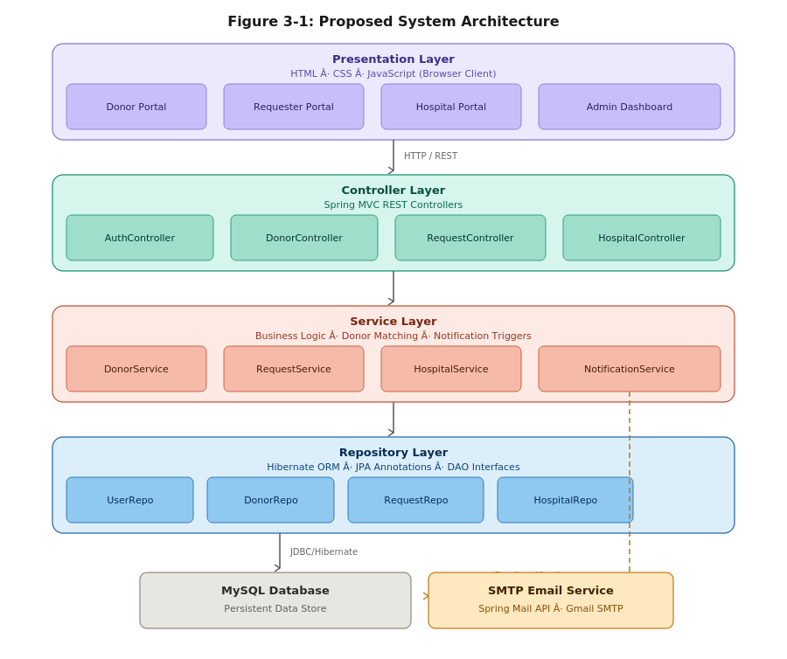

3.5.2 Class Diagram
The class diagram below illustrates the object-oriented structure of BloodBuddy. It shows the core entity classes, their attributes and methods, and the relationships between them, including inheritance from the abstract User base class and associations between Donor, Requester, BloodRequest, Hospital, and BloodInventory.
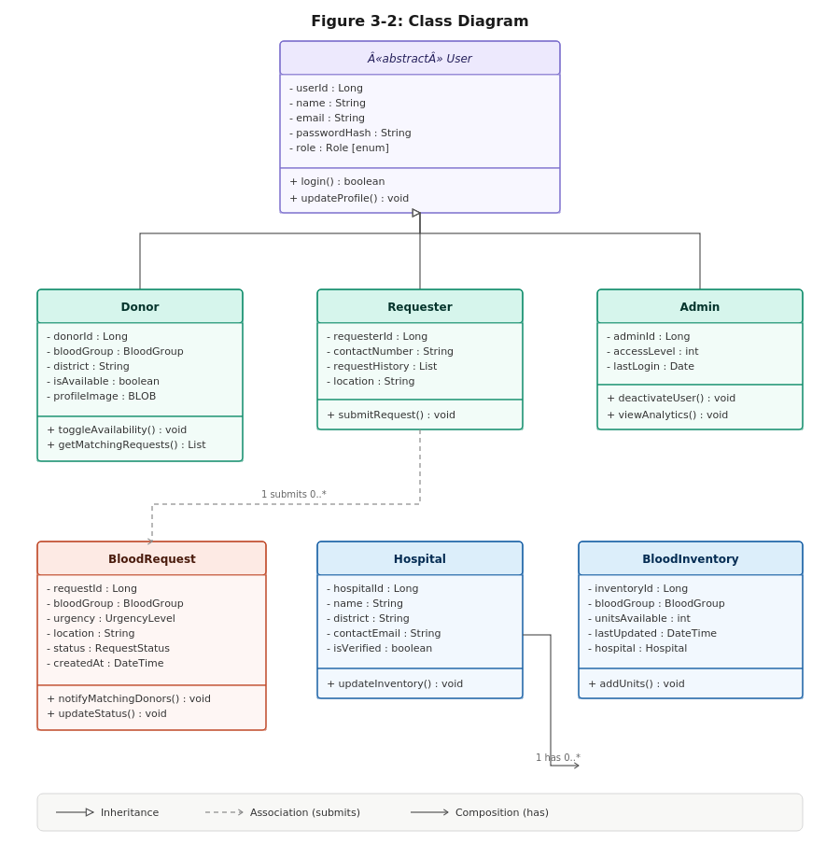
Figure 3-2: Class Diagram
3.5.3 Entity Relationship Diagram
The ER diagram below illustrates the relational database structure of BloodBuddy. It defines six core entities — USER, DONOR, BLOOD_REQUEST, HOSPITAL, BLOOD_INVENTORY, and EMAIL_NOTIFICATION — along with their attributes and foreign key relationships, as managed through Hibernate ORM with MySQL.
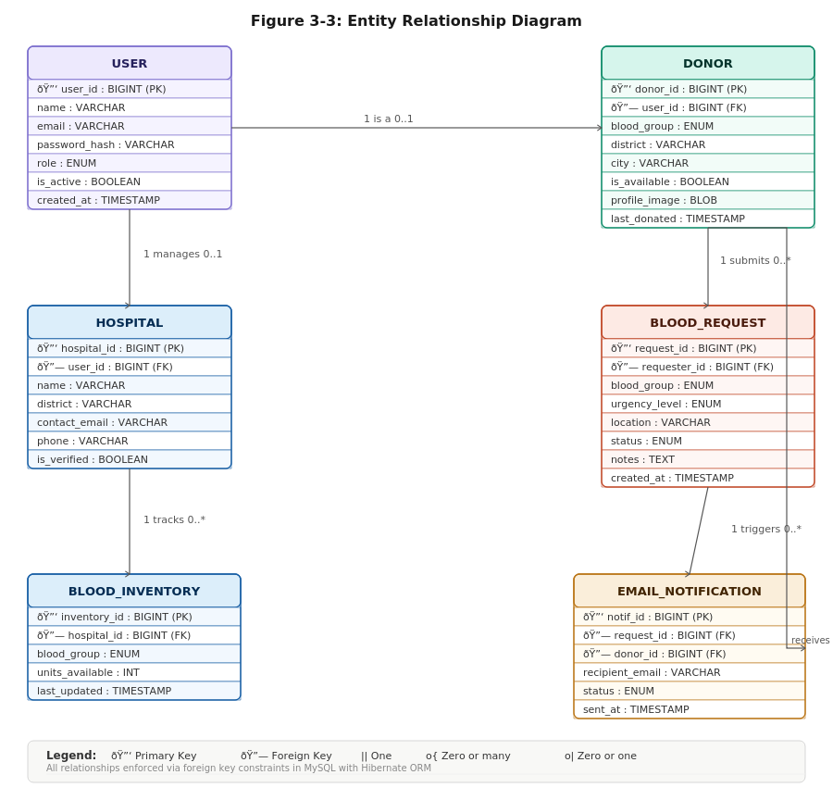
Figure 3-3: Entity Relationship Diagram
3.6 Benefits of the Proposed System
- Reduces the time required to locate a compatible blood donor from hours (via social media) to minutes through a searchable, verified registry.
- Automated email alerts ensure that nearby donors are notified immediately when an urgent request is submitted, without manual intervention.
- Hospital blood bank integration provides real-time inventory visibility, reducing the risk of stock shortages going undetected.
- Centralised administration allows for quality control, removal of inactive profiles, and moderation of fraudulent requests.
- The system contributes to Nepal's digital health infrastructure and serves as a replicable model for other developing-country contexts.

CHAPTER 4: PROJECT TIMELINE

The project is divided into two phases: the Proposal Phase (CPP400) and the Design and Implementation Phase (CPP401). The following table outlines the planned activities and timeline for both phases.

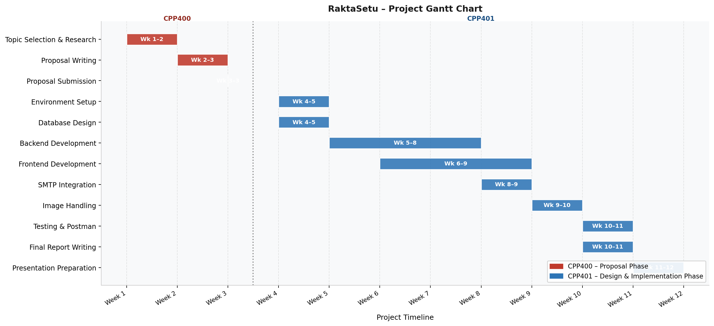

Table 4-1: Project Timeline

CHAPTER 5: CONCLUSIONS

This proposal has presented BloodBuddy, a web-based blood donor management system designed to address a critical and well-documented gap in Nepal's healthcare infrastructure. The absence of any organised, digital platform for blood donor discovery and management in Nepal means that life-saving responses to urgent blood requests are frequently delayed, incomplete, or unsuccessful.

Through a structured analysis of the problem, a review of existing systems, and a thorough assessment of technical and operational feasibility, this proposal has demonstrated that BloodBuddy is both necessary and achievable. The proposed system directly maps to all technical requirements outlined in the 4th Semester Advanced Java Project Specifications, including Spring MVC backend architecture, Hibernate ORM, SMTP email integration, BLOB-based image storage, RESTful API design, and role-based access control.

The market gap analysis confirms that no existing platform — locally or regionally — fully addresses the needs of Nepali donors, requesters, and hospitals within a single integrated system. BloodBuddy fills this gap by combining a verified donor registry, automated notifications, request management, and hospital inventory tracking into a unified, accessible web application.

The project timeline is realistic and structured to allow progressive development across both the CPP400 and CPP401 phases, with sufficient time allocated for testing, documentation, and presentation. Upon completion, BloodBuddy will not only satisfy academic requirements but will represent a genuinely deployable solution with the potential for real-world adoption and social impact in Nepal.

REFERENCES

Nepal Economic Forum. (n.d.). Barriers to Local Digital Innovation in Nepal. Retrieved from https://nepaleconomicforum.org/barriers-to-local-digital-innovation-in-nepal/

World Health Organisation. (2023). Blood safety and availability. WHO Fact Sheets. Retrieved from https://www.who.int/news-room/fact-sheets/detail/blood-safety-and-availability

World Bank. (2025). Unlocking Nepal's Growth Potential: Nepal Economic Memorandum. Washington, D.C.: The World Bank Group.

New Business Age. (2025). Nepal's Digital Crossroads: Growth vs Barriers in the Race to Transform. Retrieved from https://www.newbusinessage.com/news/43801

Spring Framework Documentation. (2024). Spring MVC — Web on Servlet Stack. Retrieved from https://docs.spring.io/spring-framework/reference/web/webmvc.html

Hibernate ORM Documentation. (2024). Hibernate Getting Started Guide. Retrieved from https://docs.jboss.org/hibernate/orm/current/quickstart/html_single/

NIPoRe. (2023). Digitalization of Nepal — Few Policies and Possible Challenges. Retrieved from https://nipore.org/digitalization-of-nepal-few-policies-and-possible-challenges/

APPENDICES

Appendix A: Blood Group Compatibility Chart

The following compatibility chart will be used by the donor matching algorithm to suggest compatible donor blood groups when an exact match is unavailable.

Recipient Blood Group | Compatible Donor Blood Groups
A+ | A+, A-, O+, O-
A- | A-, O-
B+ | B+, B-, O+, O-
B- | B-, O-
AB+ | All blood groups (Universal Recipient)
AB- | AB-, A-, B-, O-
O+ | O+, O-
O- | O- (Universal Donor)

Appendix B: Proposed REST API Endpoints

Method | Endpoint | Description
POST | /api/auth/register | Register a new user (donor or requester)
POST | /api/auth/login | Authenticate user and return session token
GET | /api/donors/search | Search donors by blood group and location
GET | /api/donors/{id} | Retrieve a specific donor's profile
POST | /api/requests | Submit a new blood request
GET | /api/requests/{id} | Retrieve details of a specific blood request
GET | /api/hospitals/inventory | Retrieve blood bank inventory for a hospital
POST | /api/hospitals/inventory | Update blood bank stock levels
GET | /api/admin/users | Admin: retrieve all registered users
POST | /api/admin/users/{id}/deactivate | Admin: deactivate a user account
GET | /api/hospitals/{hospitalId}/inventory | Local: retrieve full blood inventory for a specific partner hospital (TUTH, Bir, Patan, Manmohan, or NMCTH)
PUT | /api/hospitals/{hospitalId}/inventory/{bloodGroup} | Local: update stock level for a specific blood group at a partner hospital
POST | /api/hospitals/{hospitalId}/requests | Local: submit a blood request directly to a partner hospital’s queue
GET | /api/hospitals/{hospitalId}/requests/{requestId}/status | Local: check the fulfilment status of a blood request at a partner hospital
GET | /api/hospitals/{hospitalId}/donors/nearby | Local: retrieve registered donors near a partner hospital’s geographic location, filtered by blood group

