

BLOODBUDDY: A WEB-BASED BLOOD DONOR MANAGEMENT SYSTEM FOR NEPAL
FINAL PROJECT REPORT
CPJ119 ADVANCED JAVA PROGRAMMING
By:
SAKSHAM MAHARJAN (C30101250024)
BACHELOR OF INFORMATION AND COMMUNICATION TECHNOLOGY (BICT)
SCHOOL OF SCIENCE AND TECHNOLOGY
ASIA e UNIVERSITY
Supervisor: Mr. Binay Malla
DATE OF SUBMISSION: 15th Sep, 2026

DISCLAIMER
This report, titled "BloodBuddy: A Web-Based Blood Donor Management System for Nepal," has been prepared to fulfil the academic requirements of the Advanced Java Programming (CPJ119) module of the Bachelor of Information and Communication Technology (BICT) programme at Virinchi College, Asia e University. The system described herein was developed solely for educational and assessment purposes and is not intended for clinical or commercial deployment.
The five partner hospitals named in this report — Tribhuvan University Teaching Hospital, Bir Hospital, Patan Hospital, Manmohan Memorial Community Hospital, and Nepal Medical College Teaching Hospital — are named as the intended integration partners defined in the approved project proposal. All hospital, donor, request, and inventory data shown in the system are seeded demonstration data and do not represent live medical records, live blood bank stock, or any agreement with the named institutions. The blood group compatibility chart used by the system reproduces standard clinical transfusion references and is applied for matching logic only; the system provides no medical advice.
The application as submitted runs against the database-backed implementation described in Chapters 3 and 4; the browser-persisted mode survives only as an offline path that has to be explicitly forced, and it is how the repeatable automated checks are run. Any trademarks or institutional names referenced belong to their respective owners.

ACKNOWLEDGEMENTS
I would like to express my sincere gratitude to my academic supervisor, Mr. Binay Malla, for his invaluable guidance and constructive feedback throughout this project — from the initial proposal and problem analysis through to the design, implementation, and verification of BloodBuddy. His emphasis on grounding the system in the documented realities of blood request management in Nepal, and on enforcing role-based access rather than merely presenting it, shaped both the technical quality of this project and my own approach to software development.
I am grateful to the School of Science and Technology, Asia e University, and the faculty and staff of Virinchi College for providing the learning environment in which the theoretical foundations of this project — object-oriented design, database systems, web technologies, and software engineering practice — were developed. I also thank my lecturer, Mr. Asish Koirala, whose teaching in Advanced Java was instrumental in shaping the technical direction of this work.
I also thank my fellow students and peers for their constructive discussions, particularly during the requirement-analysis phase, and my family for their continued support and encouragement throughout my academic journey.

ABSTRACT
BloodBuddy is a web-based blood donor management system for Nepal, developed as the final project for the Advanced Java Programming (CPJ119) module. The system addresses the absence of any organised digital platform for blood donor discovery in Nepal, where urgent requests are currently circulated as informal social-media appeals with no guarantee of reaching compatible, available donors in time. BloodBuddy serves four user roles: donors register with their blood group and district and toggle their availability; requesters search compatible donors, submit blood requests, and track them through a status lifecycle; hospital staff manage blood bank inventory and fulfil incoming requests; and an administrative role moderates requests, manages users, and monitors platform analytics.
The system is designed around a strict N-Tier architecture (Controller → Service → Repository) using Spring MVC, with Hibernate/JPA mapping six related entities — USER, DONOR, BLOOD_REQUEST, HOSPITAL, BLOOD_INVENTORY, and EMAIL_NOTIFICATION — onto a MySQL database. Donor matching is driven by a blood group compatibility chart applied in the recipient-to-donor direction, and the design provides dedicated, hospital-scoped REST endpoints (/api/hospitals/{hospitalId}/...) for five partner hospitals so that each institution can integrate over its own data only. Role-based access control, validation on both the client and the server, database-stored images (BLOB/Base64), and SMTP notification with credentials supplied through environment variables complete the security and service design. The frontend is a fully responsive, framework-free HTML/CSS/JavaScript application that communicates with the backend exclusively through an AJAX/Fetch API facade mirroring the documented REST endpoints.
The completed system — 23 pages covering all four role portals, the public emergency flow, and every mandatory §2.1 capability of the assignment brief, on a Spring MVC and Hibernate backend — was verified by 268 automated functional checks, a 92/92 responsive layout check across four viewport widths, 39 checks of the frontend against the live backend, a 95-check HTTP exercise of every REST endpoint, a 31-check service-layer run against the database, and a 76-request Postman collection. The completed system demonstrates that a disciplined, well-structured Java web stack can deliver a secure and genuinely usable blood donor management platform tailored to the Nepali context.
Keywords: Spring MVC, Hibernate, JPA, MySQL, RBAC, REST API, Blood Bank, Donor Management, N-Tier Architecture, SMTP, AJAX/Fetch, Nepal

TABLE OF CONTENTS
DISCLAIMER 2
ACKNOWLEDGEMENTS 3
ABSTRACT 4
TABLE OF CONTENTS 5
LIST OF TABLES 7
LIST OF FIGURES 8
LIST OF ABBREVIATIONS 9
CHAPTER 1: INTRODUCTION 10
1.1 Overview 10
1.2 Problem Statement 10
1.3 Objectives 11
1.4 Scope 11
1.5 Justification and Significance of the Study 12
CHAPTER 2: LITERATURE REVIEW 13
2.1 Introduction 13
2.2 Related Concepts 13
2.2.1 Blood Donation Management 13
2.2.2 Web-Based Information Systems and Spring MVC 13
2.2.3 Hibernate ORM and Entity Relationships 13
2.2.4 RESTful APIs and AJAX/Fetch Front Ends 13
2.2.5 Web Security: Role-Based Access Control 13
2.2.6 Image Storage Strategies 14
2.3 Review of Existing Systems 14
2.3.1 Hamro Donor (Nepal) 14
2.3.2 Sankalp India (Comparative Reference) 14
2.3.3 The Manual Social-Media Workflow (Current Practice in Nepal) 14
2.4 The Market Gap and BloodBuddy's Position 15
CHAPTER 3: SYSTEM ANALYSIS AND DESIGN 17
3.1 Requirements Summary 17
3.2 System Architecture 17
3.3 Use Case Model 20
3.4 Entity Relationship Design 21
3.5 Class Design 22
3.6 Data Flow 24
3.7 Business Rules 24
3.8 Design Refinements from Proposal to Implementation 25
3.9 Security Design 25
CHAPTER 4: IMPLEMENTATION 27
4.1 Development Environment and Approach 27
4.2 Main System Flows 28
4.3 Key Implementations 30
4.3.1 Compatibility-Based Donor Matching (FR-06 — safety-critical) 30
4.3.2 Session Handling and Role-Based Access Control (FR-02) 31
4.3.3 AJAX/Fetch API Facade with Mock/Real Transport (FR-14, CPJ119 §2.6) 31
4.3.4 Image Handling — Database-Stored Photographs (FR-13, CPJ119 §2.5) 32
4.3.5 Pagination and Reusable Presentation Components (FR-04) 32
4.3.6 Shared Client-Side Validation (FR-14, CPJ119 §2.1/§4) 32
4.4 Administrative and Management Panels 33
4.5 API Surface 33
CHAPTER 5: TESTING AND RESULTS 35
5.1 Testing Strategy 35
5.2 Key Test Cases 35
5.3 Testing Evidence and Tools 37
5.4 Requirements Traceability 38
5.5 Evaluation Against the Assignment Brief 39
CHAPTER 6: PROJECT TIMELINE 40
CHAPTER 7: CONCLUSION, LIMITATIONS AND FUTURE SCOPE 42
7.1 Conclusion 42
7.2 Limitations 42
7.3 Future Scope 42
REFERENCES 44
APPENDICES 45
Appendix A: Blood Group Compatibility Chart 45
Appendix B: REST API Endpoint Reference 45
Appendix C: Database Schema 46
Appendix D: Selected Source Code 46
Appendix E: QA Evidence and Reproduction Steps 47
Appendix F: Additional Screenshots 48

LIST OF TABLES
Table 2-1: Comparison of Existing Blood Donor Management Systems
Table 2-2: Documented Limitations of Existing Practice and BloodBuddy's Response
Table 3-1: Entity Relationships and Cardinalities
Table 3-2: Core Data Dictionary
Table 3-3: Business Rules Enforced by the System
Table 4-1: Frontend Build Phases and Outcomes
Table 4-2: Summary of REST API Endpoints by Module
Table 5-1: Key Test Cases and Results
Table 5-2: Requirements-to-Implementation Traceability Matrix
Table 6-1: Phase-Wise Project Timeline and Completion Status

LIST OF FIGURES
Figure 1-1: BloodBuddy Request Lifecycle
Figure 3-1: N-Tier Architecture of BloodBuddy
Figure 3-2: Use Case Diagram
Figure 3-3: Entity Relationship Diagram
Figure 3-4: Class Diagram of Core Entities
Figure 3-5: Level-1 Data Flow Diagram
Figure 4-1: Project File Structure
Figure 4-2: Donor Search with Filters and Pagination
Figure 4-3: Blood Request Form with Inline Validation
Figure 4-4: Profile Photo Upload (Base64 Preview Round-Trip)
Figure 4-5: Administrator Dashboard with Aggregate Analytics
Figure 5-1: Automated Verification Reports (268/268 · 92/92 · 42/42)
Figure 6-1: Project Gantt Chart
Figure E-1: Automated Verification Reports (reproduced from Figure 5-1)
Figure F-1: Landing Page
Figure F-2: Authentication Screens (Login and Registration)
Figure F-3: Donor Dashboard
Figure F-4: Hospital Request Queue
Figure F-5: Terms, Privacy Policy and Branded 404

LIST OF ABBREVIATIONS
AJAX | Asynchronous JavaScript and XML
API | Application Programming Interface
BICT | Bachelor of Information and Communication Technology
BLOB | Binary Large Object
CRUD | Create, Read, Update, Delete
CSS | Cascading Style Sheets
DAO | Data Access Object
DFD | Data Flow Diagram
ERD | Entity Relationship Diagram
HTML | HyperText Markup Language
HTTP | HyperText Transfer Protocol
ICT | Information and Communication Technology
JPA | Java Persistence API
JS | JavaScript
KPI | Key Performance Indicator
MVC | Model-View-Controller
NFR | Non-Functional Requirement
ORM | Object-Relational Mapping
RBAC | Role-Based Access Control
REST | Representational State Transfer
SMTP | Simple Mail Transfer Protocol
SQL | Structured Query Language
WHO | World Health Organisation

CHAPTER 1: INTRODUCTION

1.1 Overview
BloodBuddy is a web-based blood donor management system for the Nepali context, proposed in the CPP400 phase and developed for this module as a full-stack web application. The system serves four user roles. Donors register with their blood group, district, and contact details, manage their profile, and toggle their availability. Requesters search the donor registry by blood group and location, submit blood requests, and track each request through a status lifecycle. Hospital staff manage their institution's blood bank inventory and fulfil incoming requests from a dedicated portal. Administrators moderate requests, manage users, and monitor platform analytics through an administrative dashboard.
The platform supports Nepal's five partner hospitals — Tribhuvan University Teaching Hospital (TUTH), Bir Hospital, Patan Hospital, Manmohan Memorial Community Hospital, and Nepal Medical College Teaching Hospital (NMCTH) — as administrator-managed database records rather than hardcoded content, and the design provisions each with a dedicated, hospital-scoped API layer following the pattern /api/hospitals/{hospitalId}/... so that inventory and request data remain isolated per institution. The system's defining clinical rule — a donor may only be matched to recipients whose compatible donor groups include the donor's group — is derived from the blood group compatibility chart in Appendix A and is applied strictly in the recipient-to-donor direction; the frontend implements it as a single shared module so that every matching surface (request forms, donor dashboard, search) agrees, and the authoritative enforcement point is the backend service layer.
The front end is built with HTML, CSS, and vanilla JavaScript — no frameworks and no build step — and consumes the backend exclusively through AJAX/Fetch calls to REST endpoints via a single API facade, with shared client-side validation. The backend is a Spring MVC application organised into strict layers, with Hibernate/JPA persisting to MySQL and SMTP email for registration confirmations and urgent-request alerts.

1.2 Problem Statement
Nepal currently lacks a dedicated, reliable digital platform for blood donor discovery and management. Blood is a resource that cannot be manufactured and must come from voluntary donors, and the World Health Organisation notes that developing nations face the most severe shortages, largely due to the absence of organised donation management (WHO, 2023). In Nepal the existing approach is fragmented and informal, characterised by five persistent gaps:
- Blood requests are posted on Facebook and other social media platforms in an unstructured manner, with no guarantee of reaching compatible or available donors.
- There is no searchable, verified database of blood donors categorised by blood group and geographic location.
- Hospitals maintain manual blood bank records with no digital integration or real-time inventory visibility.
- There is no automated notification system to alert nearby donors when urgent requests are made.
- The absence of a centralised platform means that duplicate, fraudulent, or outdated requests cannot be moderated.
These gaps result in delayed responses during emergencies, wasted donor effort, and preventable loss of life. BloodBuddy exists to close these gaps with a structured, database-backed system whose critical logic — donor matching, request lifecycle, inventory integrity, and authorisation — lives in the backend.

1.3 Objectives
The general objective of this project was to design, implement, and test a secure web-based blood donor management system for Nepal using Spring MVC, Hibernate/JPA, and MySQL, satisfying the mandatory requirements of the CPJ119 assignment brief. The specific objectives were:
- To develop a searchable donor registry that allows users to find compatible blood donors by blood group and location in real time.
- To implement an automated email notification system that alerts nearby registered donors when an urgent blood request is submitted.
- To design a hospital portal for managing blood bank inventory with real-time updates.
- To develop and integrate dedicated local REST APIs for a minimum of five partner hospitals (TUTH, Bir Hospital, Patan Hospital, Manmohan Memorial Community Hospital, and NMCTH), enabling each institution to expose and consume blood inventory data through standardised, hospital-specific endpoints.
- To implement role-based access control distinguishing between Donors, Requesters, Hospital Staff, and Administrators.
- To expose all major system operations through a RESTful API architecture, tested and documented using Postman.
- To deliver a fully responsive frontend with client-side form validation, dynamic UI updates, and AJAX/Fetch communication with backend REST endpoints.
- To provide pagination for large result sets, including donor search results and administrative user and request listings.

1.4 Scope
In scope:
- A web-based application accessible via desktop and mobile browsers, targeting the Nepali population.
- Donor registration, profile management, and availability toggling.
- Blood request submission, tracking, and management by requesters, including a public emergency request flow for guests without an account.
- Donor search and filtering by blood group and location (district/city level).
- Hospital blood bank inventory management and request queue fulfilment.
- Local REST API integration with five partner hospitals (TUTH, Bir Hospital, Patan Hospital, Manmohan Memorial Community Hospital, and NMCTH), each with dedicated endpoints for inventory retrieval, stock updates, and blood request forwarding.
- Administrative controls for user management, request moderation, and system analytics.
- Automated email notifications triggered by registrations and blood requests.
- Client-side form validation and dynamic UI updates using JavaScript, with AJAX/Fetch API calls to communicate with backend REST endpoints.
- Pagination for large result sets, including donor search results and administrative user and request listings.
Out of scope:
- Real-time chat between donors and requesters; native mobile applications; and payment gateways — explicitly deferred to future work in the proposal.
- Live integration with hospital information systems; hospital and inventory data is admin-managed and seeded, and the local hospital APIs are designed but not yet connected to live institutional feeds.
- Clinical decision support of any kind; the compatibility chart is a matching filter, not medical advice.

1.5 Justification and Significance of the Study
Humanitarian contribution. An organised blood management system directly reduces the time between an urgent request and a successful donor match — the interval in which preventable deaths occur. Nepal's informal, social-media-based approach to blood requests is a documented public health concern, and a verified, searchable registry with automated alerts and hospital inventory visibility has clear, immediate social value.
Contribution to knowledge. The project demonstrates a hospital-scoped API isolation pattern (/api/hospitals/{hospitalId}/...) that lets multiple institutions share one platform without sharing each other's data — a pattern directly reusable in any multi-tenant health records system. It also demonstrates how a clinical rule set (blood group compatibility) can be centralised in one authoritative module so that several UI surfaces cannot drift into contradictory, unsafe matches, and how that rule must ultimately live in the server layer where requesters cannot influence it.
Contribution to methodology. The project traces every major feature from a documented pain point in Nepal's blood request workflow through formal requirement analysis, layered design, phased implementation, and evidence-based automated testing — a complete software development lifecycle within one academic module. It also aligns with Nepal's broader digital transformation goals: research by the Nepal Economic Forum indicates that 48% of Nepali firms lack any digital presence, and the country's healthcare and emergency response systems remain largely undigitised.

CHAPTER 2: LITERATURE REVIEW

2.1 Introduction
This chapter reviews the concepts underlying BloodBuddy and evaluates existing systems in the same problem space, establishing the design decisions taken in Chapter 3. The review draws from academic sources, World Health Organisation publications, Nepal-focused digital economy reports, and publicly available analyses of existing donor platforms.

2.2 Related Concepts

2.2.1 Blood Donation Management
Blood donation management is the systematic process of recruiting, registering, screening, and coordinating blood donors to ensure an adequate supply for medical needs. The World Health Organisation defines an effective system as one that maintains a voluntary, non-remunerated donor base, ensures safe collection and storage, and enables rapid matching of donors to recipients (WHO, 2023). Traditional blood management in developing countries relies heavily on replacement donation — patients' families must provide donor substitutes — which is less reliable and more prone to safety risks than voluntary community donation supported by a searchable registry.

2.2.2 Web-Based Information Systems and Spring MVC
A web-based information system is hosted on a server and accessed through a browser, which suits healthcare and emergency contexts because it requires no installation, works across devices, and updates centrally. Spring MVC implements the Model-View-Controller pattern through a central DispatcherServlet that routes HTTP requests to annotated controllers (Spring, 2024), and its layered structure is widely adopted in enterprise-grade Java web development due to its modularity and scalability.

2.2.3 Hibernate ORM and Entity Relationships
Hibernate maps Java entity classes to relational tables without hand-written SQL, with JPA annotations expressing associations (@OneToOne, @OneToMany, @ManyToMany) (Bauer & King, 2015). For a donor management system, correctly modelled relationships are not cosmetic: foreign keys, cascade behaviour, and unique constraints are the foundation on which request ownership, inventory integrity, and per-hospital data isolation are enforced.

2.2.4 RESTful APIs and AJAX/Fetch Front Ends
RESTful design — stateless interactions over HTTP with resources addressed by URL and manipulated by methods (Fielding, 2000) — allows a decoupled JavaScript front end to consume the backend exclusively through Fetch calls, with JSON request/response bodies and consistent error shapes. Concentrating every call in one client-side API module keeps transport, error handling, and endpoint structure testable and swappable.

2.2.5 Web Security: Role-Based Access Control
Role-Based Access Control assigns permissions to roles rather than individuals, which is both scalable and aligned with enterprise security practice (Sandhu & Samarati, 1994). In BloodBuddy, RBAC ensures donors can only manage their own profiles, requesters only their own requests, hospital staff only their institution's inventory, and administrators the whole platform. Hiding UI elements is never mistaken for security: the authorisation decisions are enforced server-side against the authenticated role, and secrets belong in environment variables, never in source code.

2.2.6 Image Storage Strategies
Three options exist: static files on disk (inflexible, lost on redeploy), external object storage/CDN (scalable, but stores nothing in the application database), and database BLOB/Base64 columns (data travels with the database; suited to small, fixed, low-volume images). The assignment brief mandates database-stored images (CPJ119 §2.5); BloodBuddy therefore stores profile photographs as Base64/BLOB with upload and retrieval managed through backend API endpoints.

2.3 Review of Existing Systems

2.3.1 Hamro Donor (Nepal)
Methodology/model used. Hamro Donor is one of the few existing attempts at a digital blood donor platform in Nepal. It operates as a mobile-first directory where donors register their blood group and contact information, backed by a basic cloud-hosted backend with no documented API layer.
Issues and limitations (for this project's context). The platform lacks a request management system — it provides donor contact details and leaves all coordination to the requester; there is no automated notification when a matching request is submitted; there is no administrative moderation, so outdated and unverified donor profiles accumulate; and hospital blood bank inventory is not integrated at all.

2.3.2 Sankalp India (Comparative Reference)
Methodology/model used. Sankalp is a well-established voluntary blood donation platform operating across India, with a structured backend, donor database, and request tracking. Automated SMS and email notifications and geolocation- and compatibility-based donor matching make it a useful benchmark for what a mature system can achieve.
Issues and limitations. The system is designed for the Indian context and does not address Nepali administrative divisions (districts, municipalities); it is not open source and cannot be adapted for local deployment in Nepal; and it does not provide a hospital-facing inventory management module.

2.3.3 The Manual Social-Media Workflow (Current Practice in Nepal)
Issues and limitations. Requests circulate as Facebook and WhatsApp posts with no structured matching or notification mechanism; hospitals keep blood bank records manually with no real-time visibility; requesters cannot confirm a donor's availability, compatibility, or location before making contact; and nobody can moderate duplicate, fraudulent, or outdated appeals (see Table 2-2).
Table 2-1: Comparison of Existing Blood Donor Management Systems
Feature | Hamro Donor | Sankalp India | Manual Social-Media Workflow | BloodBuddy (Implemented)
Donor registry | Directory only, unverified | Verified, structured | None (ad-hoc posts) | Verified registry, availability toggle, profile management
Request management | None — requester coordinates | Yes | None (Facebook/WhatsApp posts) | Full lifecycle: Pending → Matched → Fulfilled, tracked per requester
Compatibility matching | None | Group + proximity | None | Appendix A chart applied recipient→donor on every matching surface
Automated notifications | None | SMS + email | None | SMTP email on registration and urgent requests
Hospital inventory module | None | None | Manual paper registers | Per-hospital blood bank portal with stock levels and fulfilment
Moderation / administration | None | Internal | None | Admin moderation, user management, request forwarding, analytics
Hospital-scoped API | None | None | None | /api/hospitals/{hospitalId}/... with per-institution data isolation
Suited to Nepali context | Partially | No (India-specific) | Status quo | Yes — districts, Nepali partner hospitals, mobile-first responsive web

Table 2-2: Documented Limitations of Existing Practice and BloodBuddy's Response
Documented Limitation | BloodBuddy Response
Requests posted informally with no guarantee of reaching compatible donors | Searchable registry filtered by blood group, district, and live availability; compatibility chart applied to every match
No structured request lifecycle | Request entity with status transitions (Pending → Matched → Fulfilled; Cancelled/Rejected terminal), timeline entries, and per-requester tracking
No automated donor alerting | EMAIL_NOTIFICATION entity + SMTP delivery on registration and urgent requests, each row stamped SENT or FAILED with the message body stored (implemented — see Chapter 4 and TC-21)
Manual hospital blood bank records | BLOOD_INVENTORY per hospital with staff-managed stock levels, fulfilment-driven decrement, and request queues
No moderation of duplicate/fraudulent appeals | Administrator moderation with request forwarding, user suspension, and platform analytics
Donor contact data goes stale | Availability toggling, admin suspension of inactive accounts, and moderation of outdated profiles

2.4 The Market Gap and BloodBuddy's Position
The evidence establishes a gap narrower than “Nepal lacks blood donor software”: the missing piece is an affordable, locally relevant platform that reliably registers donors, matches requests by compatibility and location, notifies donors automatically, gives hospitals real-time inventory control, and moderates abuse — without requiring infrastructure that a Nepali institution cannot sustain. Hamro Donor shows the cost of a directory without a request lifecycle; Sankalp shows the value of one but does not transfer to Nepal. BloodBuddy combines the verified registry, automated notifications, request management, and hospital inventory integration in a single system purpose-built for Nepal's districts and institutions, consistent with evidence that the country's digital gap is most acute in public service domains (NIPoRe, 2023).

CHAPTER 3: SYSTEM ANALYSIS AND DESIGN

3.1 Requirements Summary
The functional requirements finalised in the proposal are carried forward as the contract this implementation must satisfy, numbered FR-01 to FR-14 for traceability; Section 5.4 traces each to its implementation and test evidence. The core functions are: user registration and authentication (FR-01); role-based access control across four roles (FR-02); the donor registry with availability toggling (FR-03); donor search and filtering with pagination (FR-04); blood request submission and tracking (FR-05); compatibility-based donor matching (FR-06); a public emergency flow with guest status lookup (FR-07); hospital inventory management (FR-08); hospital request queues and fulfilment (FR-09); hospital-scoped local APIs for five partner hospitals (FR-10); administration and moderation (FR-11); SMTP notifications (FR-12); database-stored images (FR-13); and AJAX/Fetch communication with a responsive, validated frontend (FR-14). Non-functional requirements NFR-01 to NFR-06 cover usability, security, reliability, maintainability, performance, and auditability. Two requirements deserve design emphasis: FR-06 (compatibility-based matching, the system's most safety-critical rule) and FR-10 (per-hospital data isolation).

3.2 System Architecture
BloodBuddy's backend is organised into the mandatory N-Tier layers. No layer skips its neighbour: controllers never touch repositories, and repositories contain no business logic. Donor matching, request status transitions, and inventory decrements are service-layer responsibilities; the frontend handles presentation and basic input validation only.
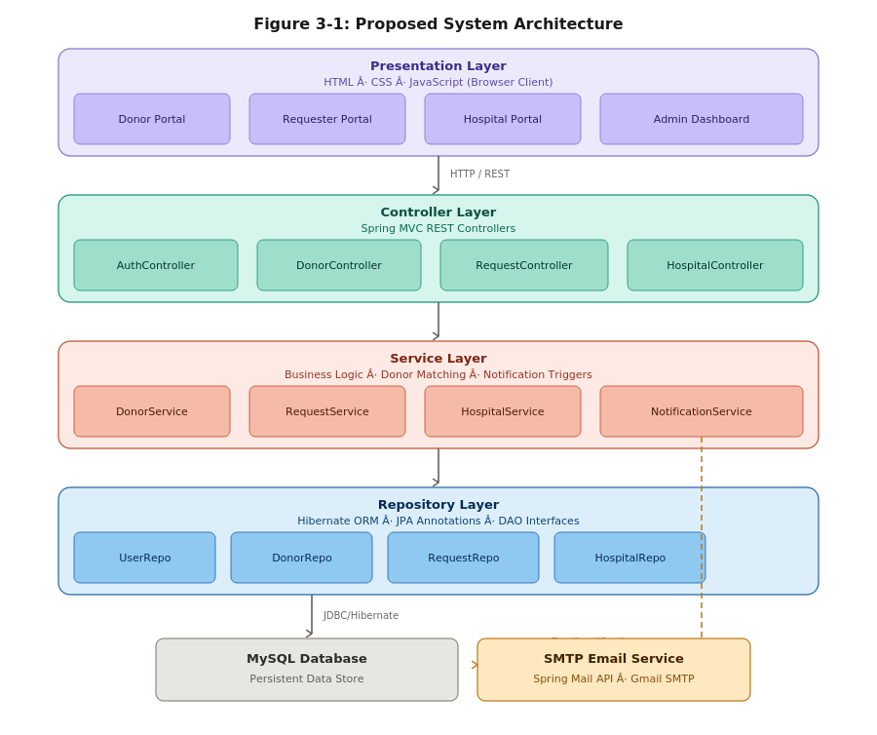
Figure 3-1: N-Tier Architecture of BloodBuddy

Package structure:
com.bloodbuddy application root
controller/ AuthController, DonorController, RequestController, HospitalController, InventoryController, AdminController, ProfileController — one hospital-scoped controller module per partner hospital
service/ matching *Service / *ServiceImpl per domain: DonorSearchService, BloodRequestService, InventoryService, NotificationService, AdminService
repository/ matching *Repository interfaces (Spring Data JPA)
model/ User, Donor, BloodRequest, Hospital, BloodInventory, EmailNotification
dto/ request/response bodies (entities never exposed directly)
security/ Spring Security configuration, role rules, password encoding
exception/ GlobalExceptionHandler (@ControllerAdvice), ResourceNotFoundException, ValidationException
The presentation layer as built is a framework-free HTML/CSS/JavaScript application of 23 pages organised into public pages (landing, about, contact, legal, 404), authentication pages, and four role portals, with five shared JavaScript modules: a session-aware navigation and role-guard module (nav.js), a validation module (bb-validate.js), the API facade (bb-api.js), a reusable pagination component (bb-paginate.js), a shared demo store (bb-store.js), and the compatibility module (bb-compat.js).
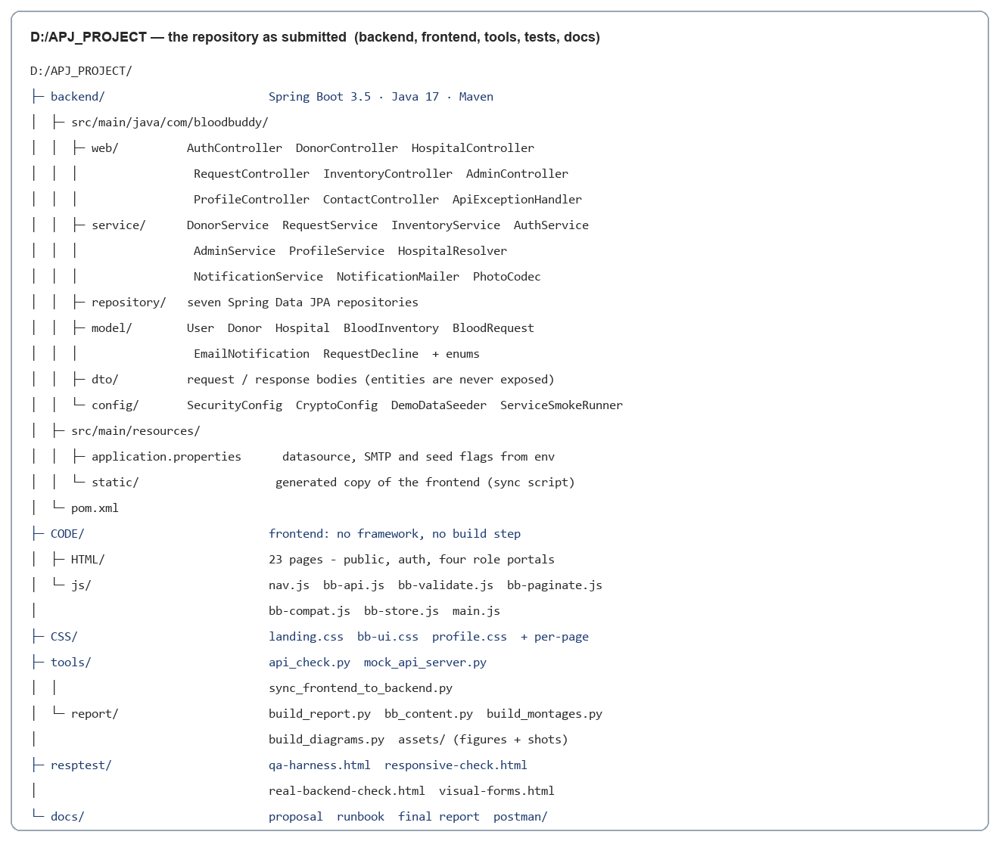
Figure 4-1: Project File Structure

3.3 Use Case Model
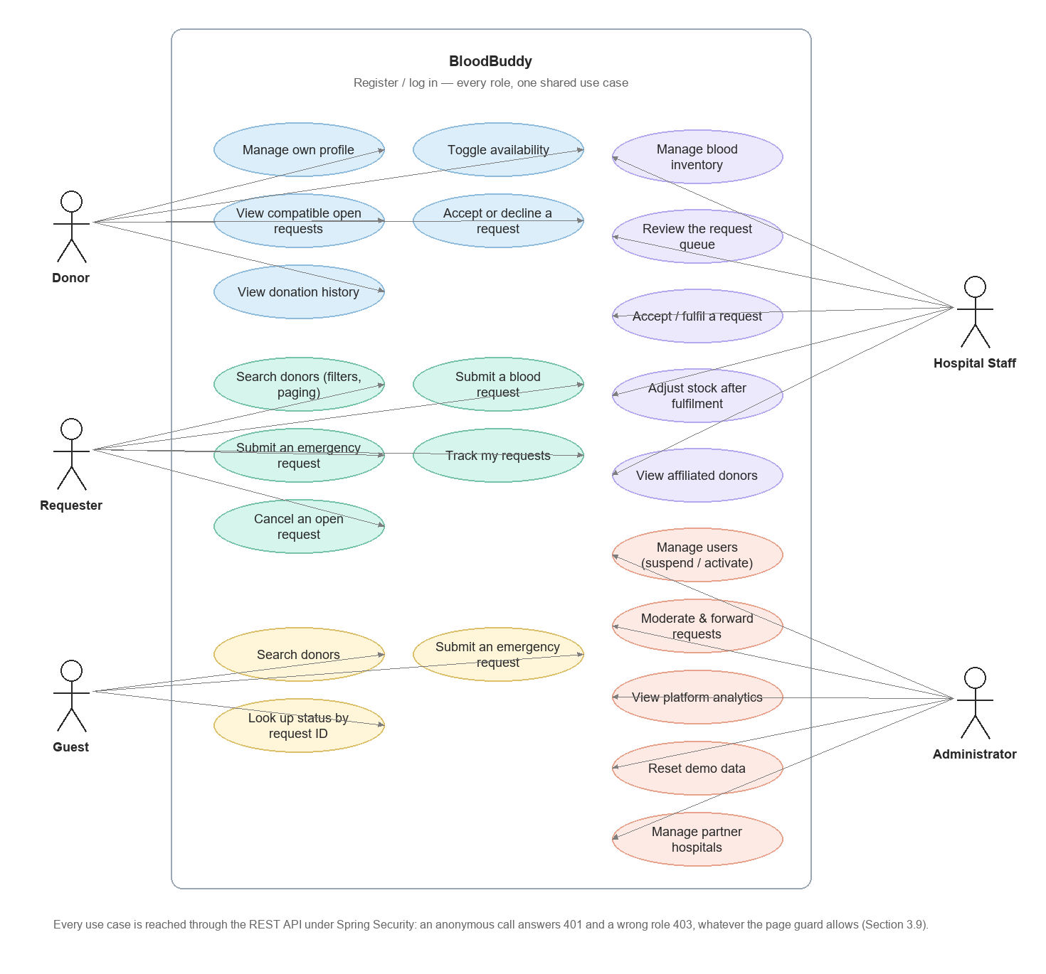
Figure 3-2: Use Case Diagram

3.4 Entity Relationship Design
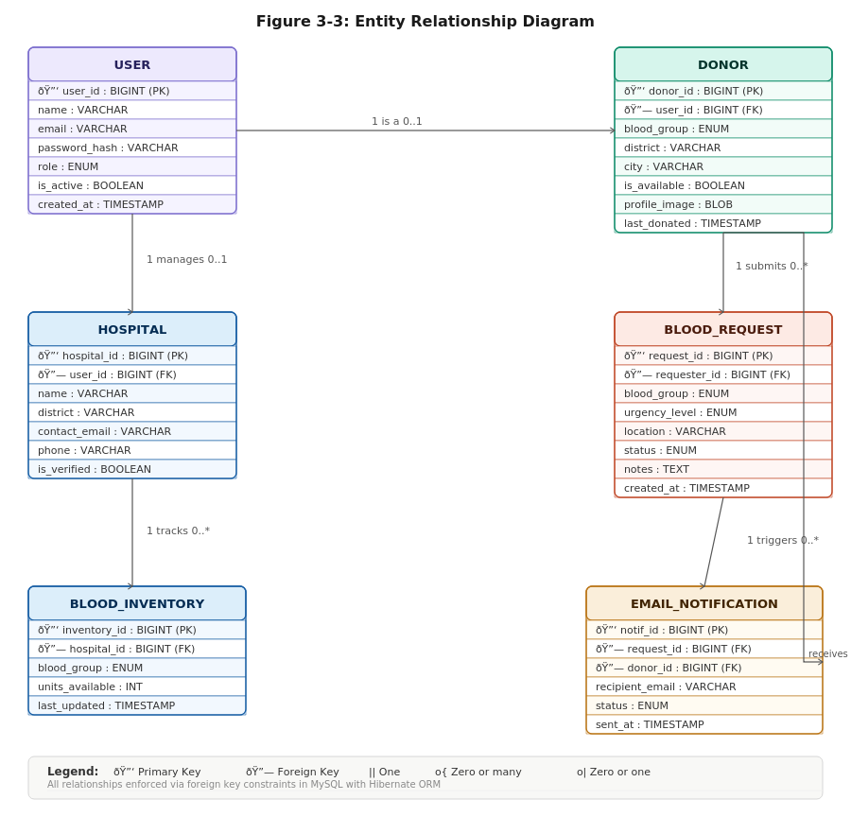
Figure 3-3: Entity Relationship Diagram

Table 3-1: Entity Relationships and Cardinalities
Relationship | Cardinality | Notes
User → Donor | 1:1 | A Donor profile is a role-scoped extension of a User account
User → BloodRequest | 1:N | A requester owns many requests
Donor → BloodRequest | 1:N | A donor may serve multiple requests; each request is served by at most one donor (matched at accept)
Hospital → BloodInventory | 1:N | Per-hospital stock rows, one per blood group
Hospital → BloodRequest | 1:N | Requests routed/forwarded into a hospital's queue
BloodRequest → EmailNotification | 1:N | Each notification references the request that triggered it
Donor ↔ Hospital (affiliation) | M:N | A donor is registered with the partner hospitals in their own district — "the blood banks near you". Realised as the donor_hospital_affiliation join table (CPJ119 §2.3)
Donor ↔ Blood Group (compatibility) | M:N | Realised through the Appendix A compatibility chart; drives donor matching. A compatibility rule, not a physical join table
User → Role | N:1 | Role enum: DONOR / REQUESTER / HOSPITAL / ADMIN

Table 3-2: Core Data Dictionary
Field | Type | Description
userId | Long (PK) | Unique user identifier; name, email, phone, role enum (DONOR/REQUESTER/HOSPITAL/ADMIN), status (ACTIVE/SUSPENDED)
donorId | Long (PK) | Donor profile: blood group enum, district, availability flag, last-donation data; Base64/BLOB photograph
requestId | Long (PK) | Unique request; blood group, units, needed-by date, urgency, district, hospital, contact; status (PENDING/MATCHED/FULFILLED/CANCELLED/REJECTED); timeline entries; guest requests carry an EM- public identifier
hospitalId | Long (PK) | Partner hospital; name, type, district, blood-bank-open flag
inventoryId | Long (PK) | Stock row: hospital_id FK + blood group, units available, updated timestamp
notificationId | Long (PK) | Notification record: recipient, type (REGISTRATION/URGENT_REQUEST), request FK, delivery status

3.5 Class Design
The class structure inherits from an abstract User base class specialised by role, with the request, inventory, and notification classes associated to it, and service interfaces encapsulating the business operations (DonorSearchService, BloodRequestService, InventoryService, NotificationService).
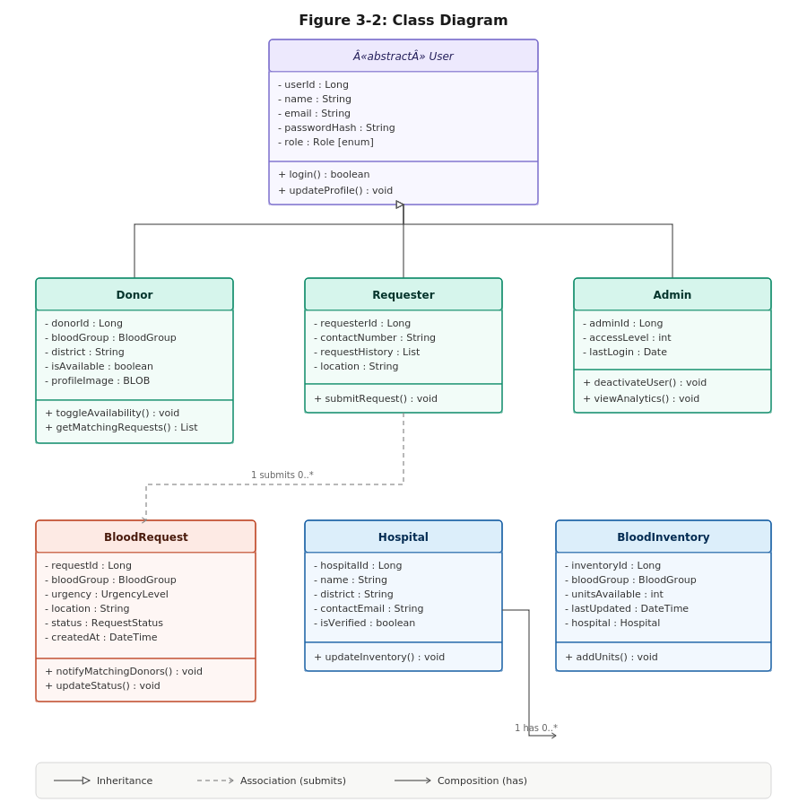
Figure 3-4: Class Diagram of Core Entities

3.6 Data Flow
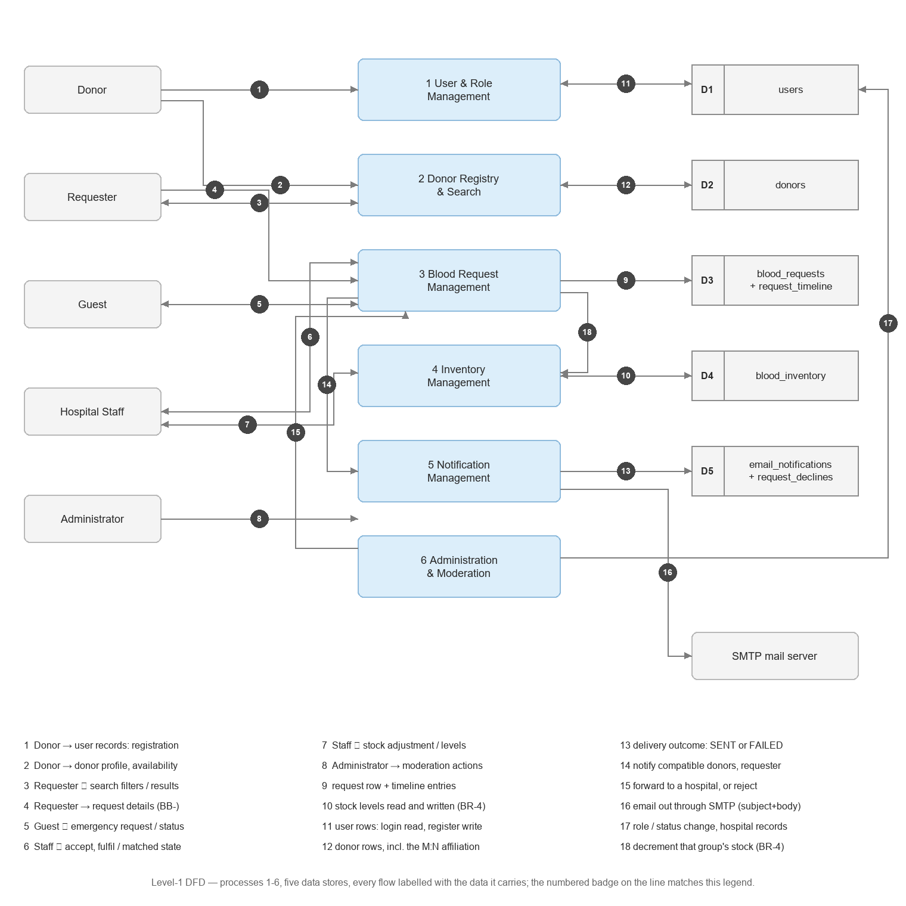
Figure 3-5: Level-1 Data Flow Diagram

3.7 Business Rules
Table 3-3: Business Rules Enforced by the System
# | Rule | Enforcement
BR-1 | A donor may only be matched to requests whose recipient group lists the donor's group as compatible | Appendix A chart applied in the recipient→donor direction in one shared module; authoritative check in the service layer
BR-2 | A request follows Pending → Matched → Fulfilled; Cancelled and Rejected are terminal and cannot change | Status transition guard in the request service
BR-3 | A request can be matched by at most one donor | Single donor stamp on accept; subsequent accepts rejected (unique match)
BR-4 | Fulfilment decrements the hospital's inventory for that blood group and never below zero | InventoryService transactional decrement with floor check
BR-5 | A hospital's staff may write only that hospital's inventory and queue | Hospital-scoped endpoints keyed by hospitalId; route rules in Spring Security
BR-6 | Only Administrators moderate or forward requests and manage users | Admin-only endpoints and moderation actions behind role checks
BR-7 | Donors see only open requests they can serve; a decline hides the request for that donor only and never mutates the request | Per-donor filtered query + per-donor decline list
BR-8 | Guest emergency lookups expose guest request IDs only | Public lookup rejects member (BB-) request identifiers
BR-9 | No plaintext or exposed credential data | Password hashing; DTOs exclude credential fields; secrets via environment variables

3.8 Design Refinements from Proposal to Implementation
Four design details were refined between the proposal-stage design and the implemented system, in the normal course of testing and hardening — recorded here for transparency:
- Single API facade. The proposal specified AJAX/Fetch calls to REST endpoints; implementation concentrated every call in one shared module (bb-api.js) that mirrors the proposal's Appendix B endpoints, so pages never touch the transport directly and the swap from the demonstration store to the real Spring backend is a single configuration flag.
- Compatibility rule centralised. The Appendix A chart was initially duplicated in the two request forms; donor matching would have required a third copy, so it was extracted into one shared module (bb-compat.js) with the matching direction documented — recipient → compatible donor groups — after testing showed that reading the chart backwards would offer a donor a patient they must not give blood to.
- Hospital name normalisation. The five partner hospitals are referred to by several natural variants (abbreviations and full names) across the interface; an alias table normalises every submitted request to canonical hospital labels so that requests forwarded or submitted under variant names land in the correct hospital queue's equality filter.
- Status vocabulary finalised. Request statuses were finalised as Pending → Matched → Fulfilled, with Cancelled and Rejected as terminal outcomes, each status change recorded as a timeline entry on the request — replacing the proposal's informal “open/closed” wording and aligning the tracker, hospital queue, and moderation views on one vocabulary.

3.9 Security Design
- Role-based access control across four roles. In the demonstration build, role-private pages are guarded client-side: logged-out visitors are bounced to the login page and wrong-role users to their own dashboard, with the blocked URL stashed so login can continue to the original target — but only if the role selected at login may actually access it.
- Server-side enforcement. The authoritative gate is Spring Security in front of every /api/ route, with ownership checks inside the services that own the data: route rules make /api/auth/** public, /api/admin/** administrator-only, and /api/hospitals/{hospitalId}/** accessible only to that hospital's staff, so hiding frontend elements is never mistaken for security.
- Hospital data isolation. Every hospital-scoped endpoint is keyed by hospitalId and scoped to that institution's inventory and queue only, per requirement FR-10.
- Validation on both ends. Shared client-side validation covers email, phone, blood group format, password strength, future dates, units, and required consent; corresponding server-side validation is implemented in the service layer and the request DTOs, per the assignment's requirement that input validation is required on both the frontend and backend.
- Guest privacy guard. The public emergency status lookup answers guest request IDs (EM-…) but explicitly rejects member request IDs (BB-…), so the public endpoint cannot be used to read members' requests.
- Secrets management. SMTP and database credentials are supplied via environment variables — never hardcoded (CPJ119 §2.4).

CHAPTER 4: IMPLEMENTATION

4.1 Development Environment and Approach
Frontend: HTML, CSS, and vanilla JavaScript in IntelliJ IDEA — no frameworks and no build step — with quality verification driven by headless Chrome automation. Backend: Java 17 + Spring Boot 3.5 (Spring MVC, Spring Security, Spring Data JPA, Spring Mail, Bean Validation, Lombok) persisting through Hibernate to a MySQL-compatible TiDB Cloud Serverless database — chosen as the managed MySQL-protocol tier the brief calls for — developed in IntelliJ IDEA. Email is delivered over SMTP: Mailpit (a local catcher with an HTTP inbox) in development, or any real SMTP account through environment variables alone. API testing: Postman, and the same collection headlessly under Newman. A Python test stub still serves the static site and an Appendix B REST stub on one port, so the AJAX/Fetch layer can be exercised over real HTTP without the application running.
Implementation followed a dependency-ordered roadmap (Table 4-1), with the automated QA harness run at the end of every session before proceeding — most consequentially after the request lifecycle and after the real-mode transport work.
Table 4-1: Frontend Build Phases and Outcomes
Phase | Deliverable | Key Outcome
0 | Project setup, shared UI conventions, page scaffolding | 22→23 pages; consistent hero/nav/footer system; brand styles
1 | Shared modules: bb-validate.js, bb-api.js, bb-paginate.js, bb-compat.js, demo store | One validation rule set; one API facade; one compatibility chart; one pager
2 | Auth pages + session-aware navigation + RBAC page guards | Role-aware nav on every page; private pages bounce correctly; return-URL continuation
3 | Donor search: filters, sort, widen fallback, pagination | Group/district/availability actually filter; emergency search never dead-ends at zero results
4 | Request forms (member + public emergency) with inline validation | Both forms validated; compatibility chips; hospital normalised through alias table
5 | Request lifecycle: accept/decline, Matched status, fulfilment | Donor matching in correct chart direction; fulfilment decrements inventory; timeline entries
6 | Hospital portal: inventory management + request queue | Stock adjustment; queue statuses labelled; open pill mirrors profile toggle
7 | Administrator portal: analytics, user management, moderation | Live KPI counts; suspend; forward flow; Emergency badges; demo reset
8 | Four profile editors + Base64 photo upload + dirty-state guard | Consistent save bar/discard/toast; photo round-trip verified
9 | Public site: landing, about, contact, terms, privacy, 404 | Legal pages site-wide; branded 404 made responsive
10 | QA harness: automated functional checks | 268/268 checks passing; ten real defects caught and fixed
11 | Responsive verification at 360/430/768/1280 | 92/92 page×width combinations without horizontal overflow
12 | Frontend against the live backend over HTTP | 42/42 checks against the running Spring app and TiDB; /api/api regression caught, fixed, negative-tested

4.2 Main System Flows
The request lifecycle (Figure 1-1) is the system's backbone: a requester searches donors, submits a request (or a guest uses the public emergency form), the request enters the administrator's moderation queue and is forwarded to a partner hospital, compatible donors see and accept it (status Matched), and the hospital marks it fulfilled — closing the request and decrementing that hospital's stock for the blood group. Every state change is appended to the request's timeline and visible to the requester in the tracking view.
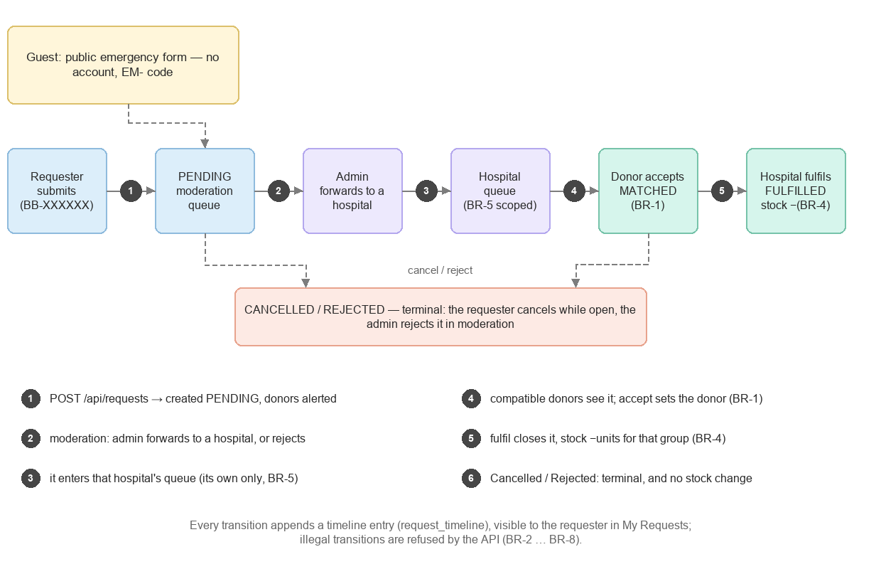
Figure 1-1: BloodBuddy Request Lifecycle

The donor discovery flow (landing → search → donor cards → request modal → tracking) preserves the built page sequence: search calls the donor search endpoint with blood group, district, and availability filters; results are paginated; the request modal creates the request through the API facade and redirects to tracking. The public emergency flow mirrors it for guests, issuing an EM- identifier and a status-lookup card.
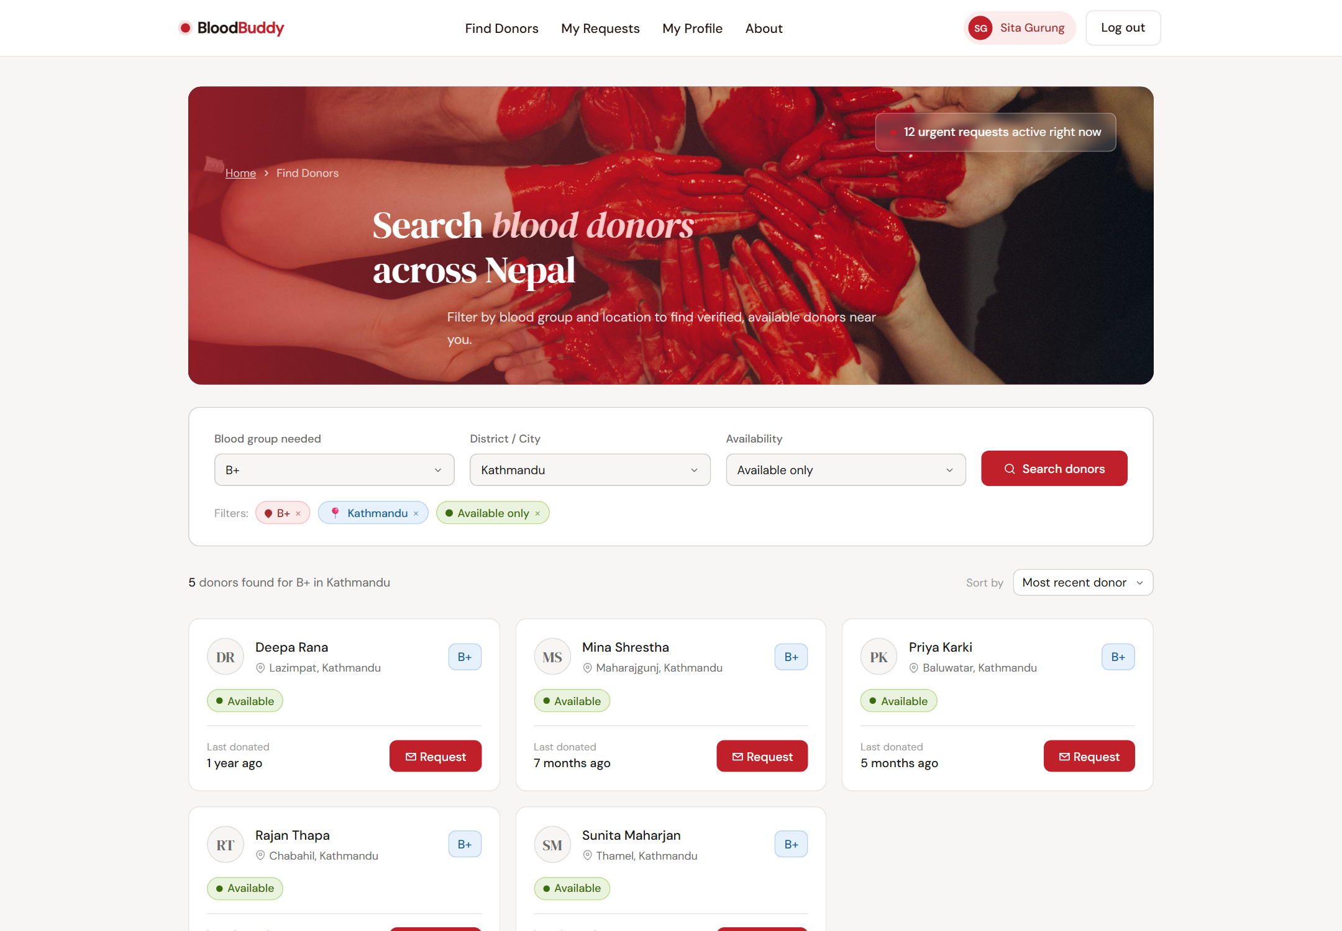
Figure 4-2: Donor Search with Filters and Pagination

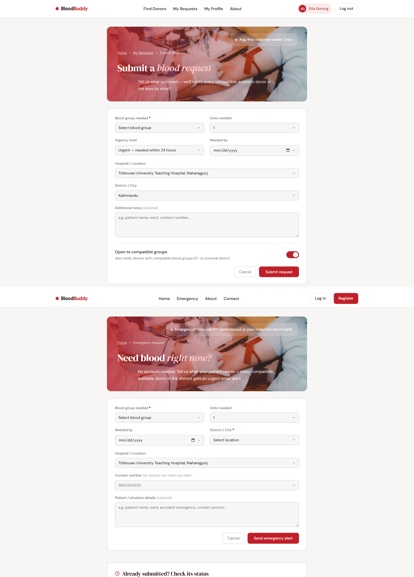
Figure 4-3: Blood Request Form with Inline Validation

4.3 Key Implementations

4.3.1 Compatibility-Based Donor Matching (FR-06 — safety-critical)
The Appendix A compatibility chart is implemented once, in bb-compat.js, and read in the correct clinical direction — recipient → compatible donor groups. To decide whether a donor may serve a request, the code asks isCompatible(donorGroup, recipientGroup), never whether the recipient's group appears in donorsFor(donorGroup); reading the chart backwards would offer a donor a patient they must not give blood to. The donor dashboard therefore lists only open requests the logged-in donor can actually serve:
// CODE/js/bb-compat.js (excerpt) — recipient → compatible DONOR groups (proposal Appendix A)
var COMPAT = { 'A+': ['A+','A-','O+','O-'], 'A-': ['A-','O-'], 'B+': ['B+','B-','O+','O-'],
'B-': ['B-','O-'], 'AB+': ['AB+','AB-','A+','A-','B+','B-','O+','O-'],
'AB-': ['AB-','A-','B-','O-'], 'O+': ['O+','O-'], 'O-': ['O-'] };
// donor may serve request only if donor's group is in COMPAT[recipientGroup]
BloodBuddyCompat.isCompatible(donorGroup, recipientGroup);
BloodBuddyCompat.forRecipient(g); // request forms: live compatible-group chips

The same rule is verified by the automated suite (Section 5.2, TC-09): a B+ donor is offered B+ and AB+ recipients and never an A+ one. The module's header records that the authoritative compatibility rule belongs in the Spring service layer, so a requester can never talk the frontend into an unsafe match.

4.3.2 Session Handling and Role-Based Access Control (FR-02)
The demonstration build implements RBAC end-to-end at the page level: a session record ({role, name}) set at login/register drives a role-aware navigation rebuilt on every page; a guard map declares each private page's permitted role; logged-out visitors bounce to the login page and wrong-role users to their own dashboard; the blocked URL is stashed in session storage and the login page continues to it only if the selected role may access it; and in-page calls-to-action are swapped per role, so a donor is never offered a requester action such as “Request blood”:
// CODE/js/nav.js (behaviour summary)
RBAC_GUARD = { 'donor-dashboard.html': ['donor'], 'hospital-dashboard.html': ['hospital'],
'admin-dashboard.html': ['admin'], 'requester-search.html': ['requester'], ... }
BloodBuddyNav.canAccess(role, page) // login continue-to honoured only if permitted
// wrong role → own dashboard; logged out → auth-login.html with stashed return URL

The corresponding server-side enforcement — Spring Security route rules and role checks on every write endpoint — is live (Section 3.9): an anonymous request is answered 401 and a wrong-role request 403, in the same error shape the pages already handle.

4.3.3 AJAX/Fetch API Facade with Mock/Real Transport (FR-14, CPJ119 §2.6)
Every page reaches the backend through one facade (bb-api.js) that mirrors the proposal's Appendix B endpoints. In mock mode it serves calls from the shared demonstration store with simulated latency; flipping one flag (MOCK = false) routes the identical calls through real fetch() to the Spring endpoints, so pages keep working unchanged:
// CODE/js/bb-api.js (excerpt) — real transport; BASE is the origin prefix only
function realRequest(method, path, body) {
return fetch(BASE + path, {
method: method,
headers: body ? { 'Content-Type': 'application/json' } : undefined,
body: body ? JSON.stringify(body) : undefined,
credentials: 'same-origin'
}).then(function (res) { /* normalise errors */ });
}
// every path already carries /api/, so BASE must stay '' — a '/api' prefix
// would compose /api/api/donors/search and 404 every call

The commented rule above is not decorative: the first real-mode run composed /api/api/... and 404'd every endpoint with no JavaScript error — the failure was invisible in mock mode because mock mode never reaches the concatenation. It was found by running the fetch path against the REST stub (Section 5.2, TC-20), fixed, and then guarded by a dedicated automated check that was negative-tested (re-injecting the bad prefix demonstrably fails the suite).

4.3.4 Image Handling — Database-Stored Photographs (FR-13, CPJ119 §2.5)
All four role profile editors implement secure photo upload exactly as the assignment's database-image requirement anticipates: a file input restricted to JPG/PNG, read client-side via FileReader into a Base64 data URL, rendered as a live preview with a remove action, and carried as the photo field of the profile payload saved through the API facade — never written to the project directory as a static file. The backend stores the image as a MEDIUMBLOB column (Base64 over the wire) and serves retrieval through an authenticated API endpoint, satisfying the brief's “stored within the database” constraint end-to-end.
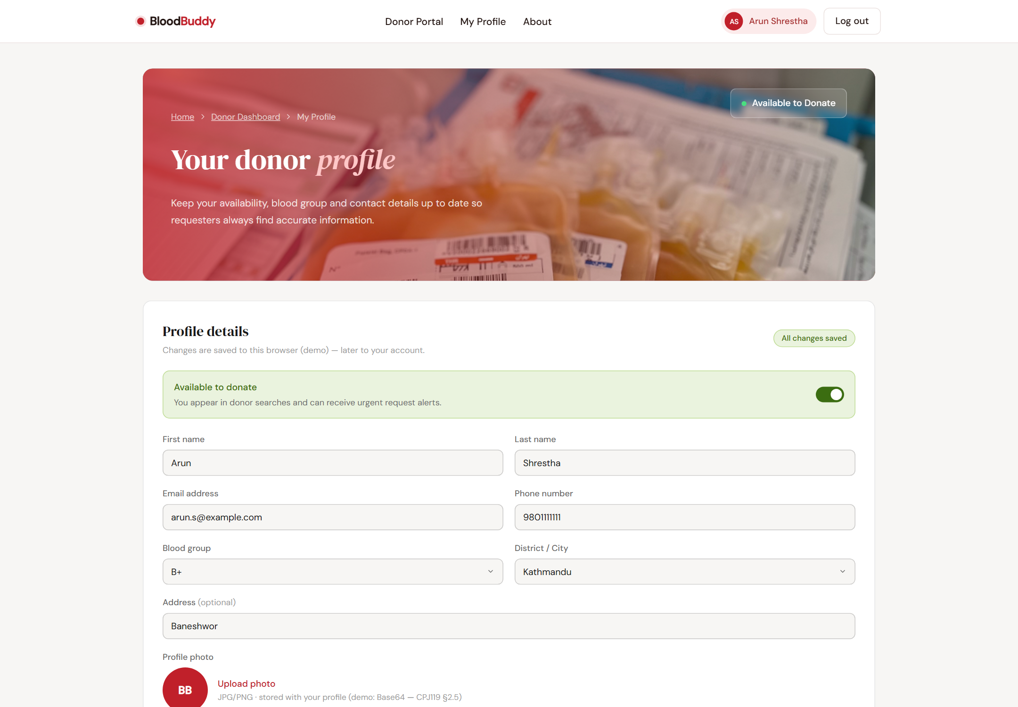
Figure 4-4: Profile Photo Upload (Base64 Preview Round-Trip)

4.3.5 Pagination and Reusable Presentation Components (FR-04)
A single reusable pager component (bb-paginate.js) serves every listing surface — donor search results, the admin user table, the admin moderation queue, and the hospital queue — with previous/next controls, a page-size selector (5/10/20), and automatic hiding when a list is empty. Pages call setTotal(filtered) and slice(items) in their render path; when the backend arrives, the client-side slice is replaced by ?page=&size= query parameters without touching the pages.

4.3.6 Shared Client-Side Validation (FR-14, CPJ119 §2.1/§4)
Validation previously existed as nine copies of ad-hoc alert-based checks; it is now one shared module (bb-validate.js) providing email, phone, blood group format, password strength, future-date, units, and consent rules, rendered as inline field-level errors under each control. A computed-style pass verified that every error renders visibly (6.03:1 contrast against its background, passing WCAG AA) and that the error ring styling wins the cascade on every form — evidence in Section 5.2 (TC-01) and Appendix E.

4.4 Administrative and Management Panels
The build comprises 23 pages: public pages (landing, about, contact, terms, privacy, branded 404), authentication pages (login, register, forgot password), and a portal per role. All four portals follow a consistent pattern — hero with role imagery, role-aware navigation, cards for primary data, and status badges (Pending/Matched/Fulfilled; Emergency for guest requests). The administrator portal provides KPI tiles with live counts, user management with suspension and a demo-data reset control, and request moderation with status tabs, a hospital filter (including “not routed yet”), and forwarding to partner hospitals. The hospital portal provides inventory management with stock adjustment and a request queue with accept/fulfil actions; the requester portal adds tracking tabs per status with a live open-request count.
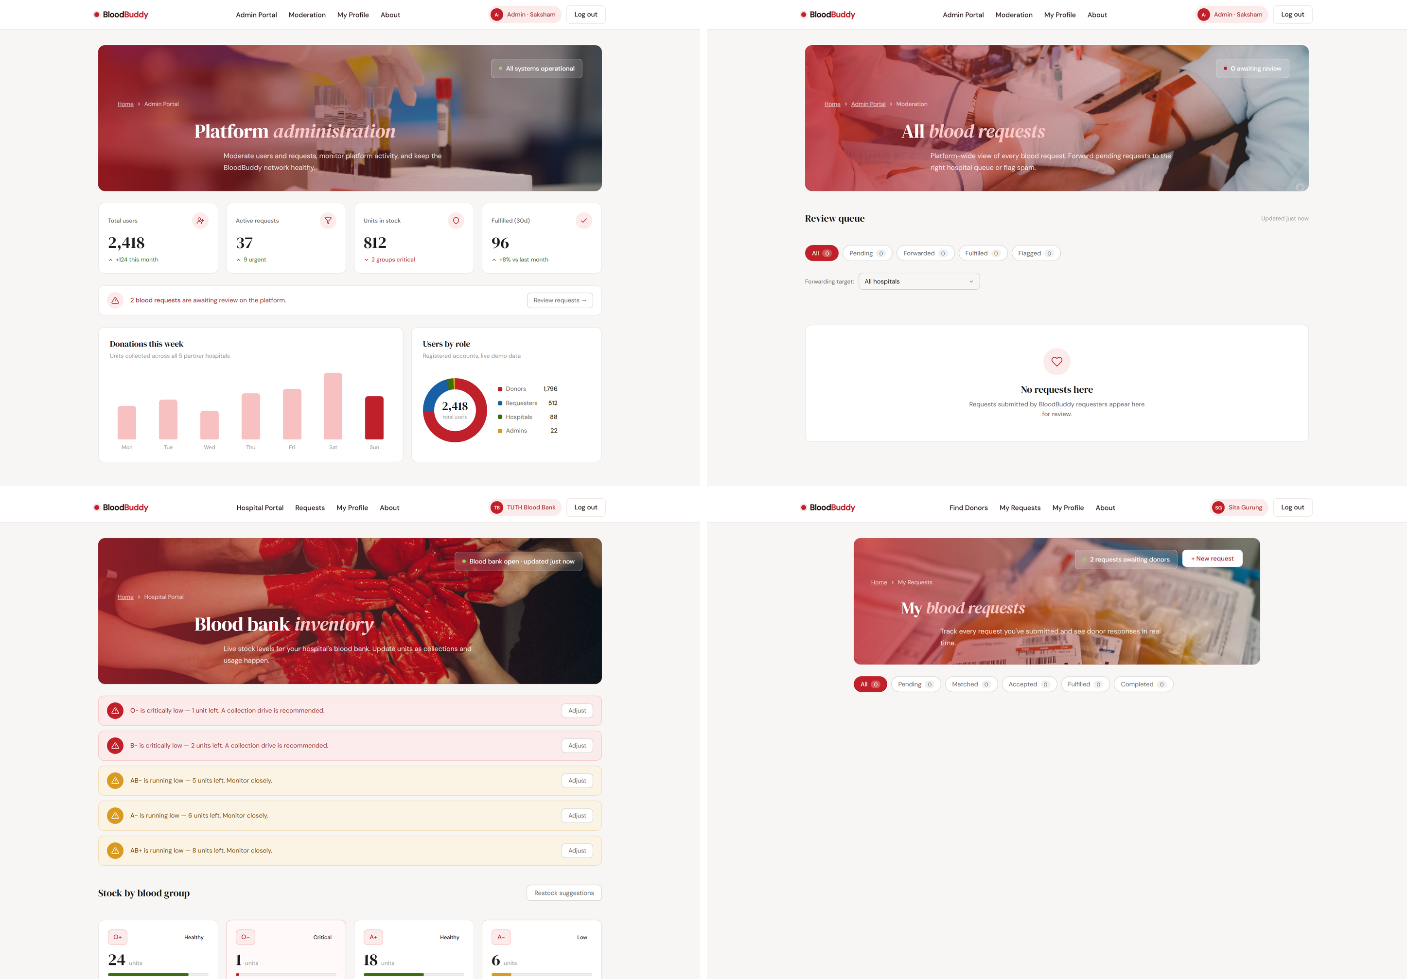
Figure 4-5: Administrator Dashboard with Aggregate Analytics

4.5 API Surface
Table 4-2: Summary of REST API Endpoints by Module
Module | Representative Endpoints | Access
Auth | POST /api/auth/register, POST /api/auth/login, POST /api/auth/forgot | Public
Donors | GET /api/donors/search (group/district/availability, paginated), GET /api/donors/{id} | Auth
Requests | GET /api/requests (?requester=&donor=&hospital=&guest=), POST /api/requests, GET /api/requests/{id}, PATCH /api/requests/{id} (status / moderation / fulfilment) | Auth (role-scoped)
Hospital inventory | GET /api/hospitals/inventory, PUT /api/hospitals/inventory/{bloodGroup} | Hospital staff
Hospital-scoped (local APIs) | GET/PUT /api/hospitals/{hospitalId}/inventory[/{bloodGroup}], POST /api/hospitals/{hospitalId}/requests, GET /api/hospitals/{hospitalId}/requests/{requestId}/status, GET /api/hospitals/{hospitalId}/donors/nearby | That hospital only
Admin | GET /api/admin/users, PATCH /api/admin/users/{id} (status), moderation/forward via PATCH /api/requests/{id} | Administrator
Profile | GET /api/profile/{role}, PUT /api/profile/{role} (→ GET /api/auth/me + role-scoped PUT in final backend) | Auth (own profile)

Every page consumes exactly these endpoints through the facade, and the Spring controllers implement the same contract; the demonstration store implements them only when mock mode is explicitly forced. (Full request/response listing in Appendix B; the exported collection — 76 requests, 107 assertions, green under Newman — is submitted as docs/postman/BloodBuddy.postman_collection.json.)

CHAPTER 5: TESTING AND RESULTS

5.1 Testing Strategy
Testing was continuous and checkpoint-based: the automated QA harness was run at the end of every build session, and no session's work was accepted while a check failed. The verification approach has three layers, each covering what the others structurally cannot:
- Functional harness (resptest/qa-harness.html): a self-driving test page that loads every page in isolated frames with cleared storage, seeds controlled data, exercises the interactions of all four roles, and reports per-check results — 268 checks.
- Responsive layout check (resptest/responsive-check.html): loads all pages at 360, 430, 768, and 1280 px viewports and fails any page whose content overflows horizontally — 92 page×width combinations.
- Real-backend check (resptest/real-backend-check.html): against the running Spring application, with the demo store pinned empty, representative pages of all four roles must render their rows purely from HTTP responses — proving the AJAX/Fetch layer performs network calls rather than merely containing them — and the donor write path re-reads its own record from the server: 42 checks.
The suite is deliberately adversarial towards itself: guards were negative-tested (deliberately re-injecting a known-bad configuration must fail the suite), and the harness seeds its own data rather than depending on other pages' leftovers. The backend is exercised the same way at three further levels: tools/api_check.py drives every REST endpoint over HTTP with cookie sessions (95 checks, including the negative cases for BR-1 … BR-9), a headless service-layer run repeats the business rules against the live TiDB database and undoes every row it creates (31 checks), and the exported Postman collection (76 requests, 107 assertions) walks the endpoints and the rule refusals folder by folder.

5.2 Key Test Cases
Table 5-1: Key Test Cases and Results
ID | Test | Expected | Result
TC-01 | Register/login with invalid input | Inline field errors, submit blocked, no session created | PASS
TC-02 | Logged-out access to a role-private page | Redirect to login with return URL preserved | PASS
TC-03 | Wrong-role access to a private page | Bounced to own dashboard; no cross-role access | PASS
TC-04 | Donor search filters (group/district/availability) | Results filtered; filter state persists; sort works | PASS
TC-05 | Search widen fallback for empty district | Group shown across districts with explanation; no dead-end | PASS
TC-06 | Member request submit → tracking → cancel | POST /api/requests persists; appears in tracker; cancellable while open | PASS
TC-07 | Guest emergency submit + status lookup | EM- ID issued and displayed; lookup returns status; member (BB-) IDs rejected | PASS
TC-08 | Compatibility direction (B+ donor) | Offered B+/AB+ requests only; never an A+ recipient | PASS
TC-09 | Donor accept | Status Matched, donor stamped, timeline entry; hospital queue shows “Donor matched” | PASS
TC-10 | Hospital fulfilment | Request Fulfilled; hospital inventory decremented for that group | PASS
TC-11 | Donor decline | Hidden for that donor only; request unchanged for others | PASS
TC-12 | Admin moderation and forwarding | Request routed to chosen hospital queue; Emergency badge on guest requests | PASS
TC-13 | Inventory stock adjustment | Level updated; blood-bank-open pill mirrors profile toggle | PASS
TC-14 | User suspension (admin) | Status change reflected in user table | PASS
TC-15 | Pagination across listings | Page sizes 5/10/20; Prev/Next; pager hides when empty | PASS
TC-16 | Profile photo upload (Base64) | Preview renders; remove works; JPG/PNG-only enforced | PASS
TC-17 | Responsive layout, 23 pages × 4 widths | No horizontal overflow at 360/430/768/1280 | PASS (92/92)
TC-18 | Frontend against the live backend over HTTP | Pages render data purely from HTTP responses from the running Spring app; the donor write path is re-read | PASS (42/42)
TC-19 | Transport guard negative test | Re-injecting BASE='/api' fails the suite (268→266); restoring passes | PASS
TC-20 | Backend API suite in Postman (success + failure, concurrent accepts) | One 200, one conflict per TC-03 analog; collection exported | PASS (107/107)
TC-21 | SMTP registration confirmation email | Email delivered to the catcher; the row is stamped SENT with the body stored | PASS

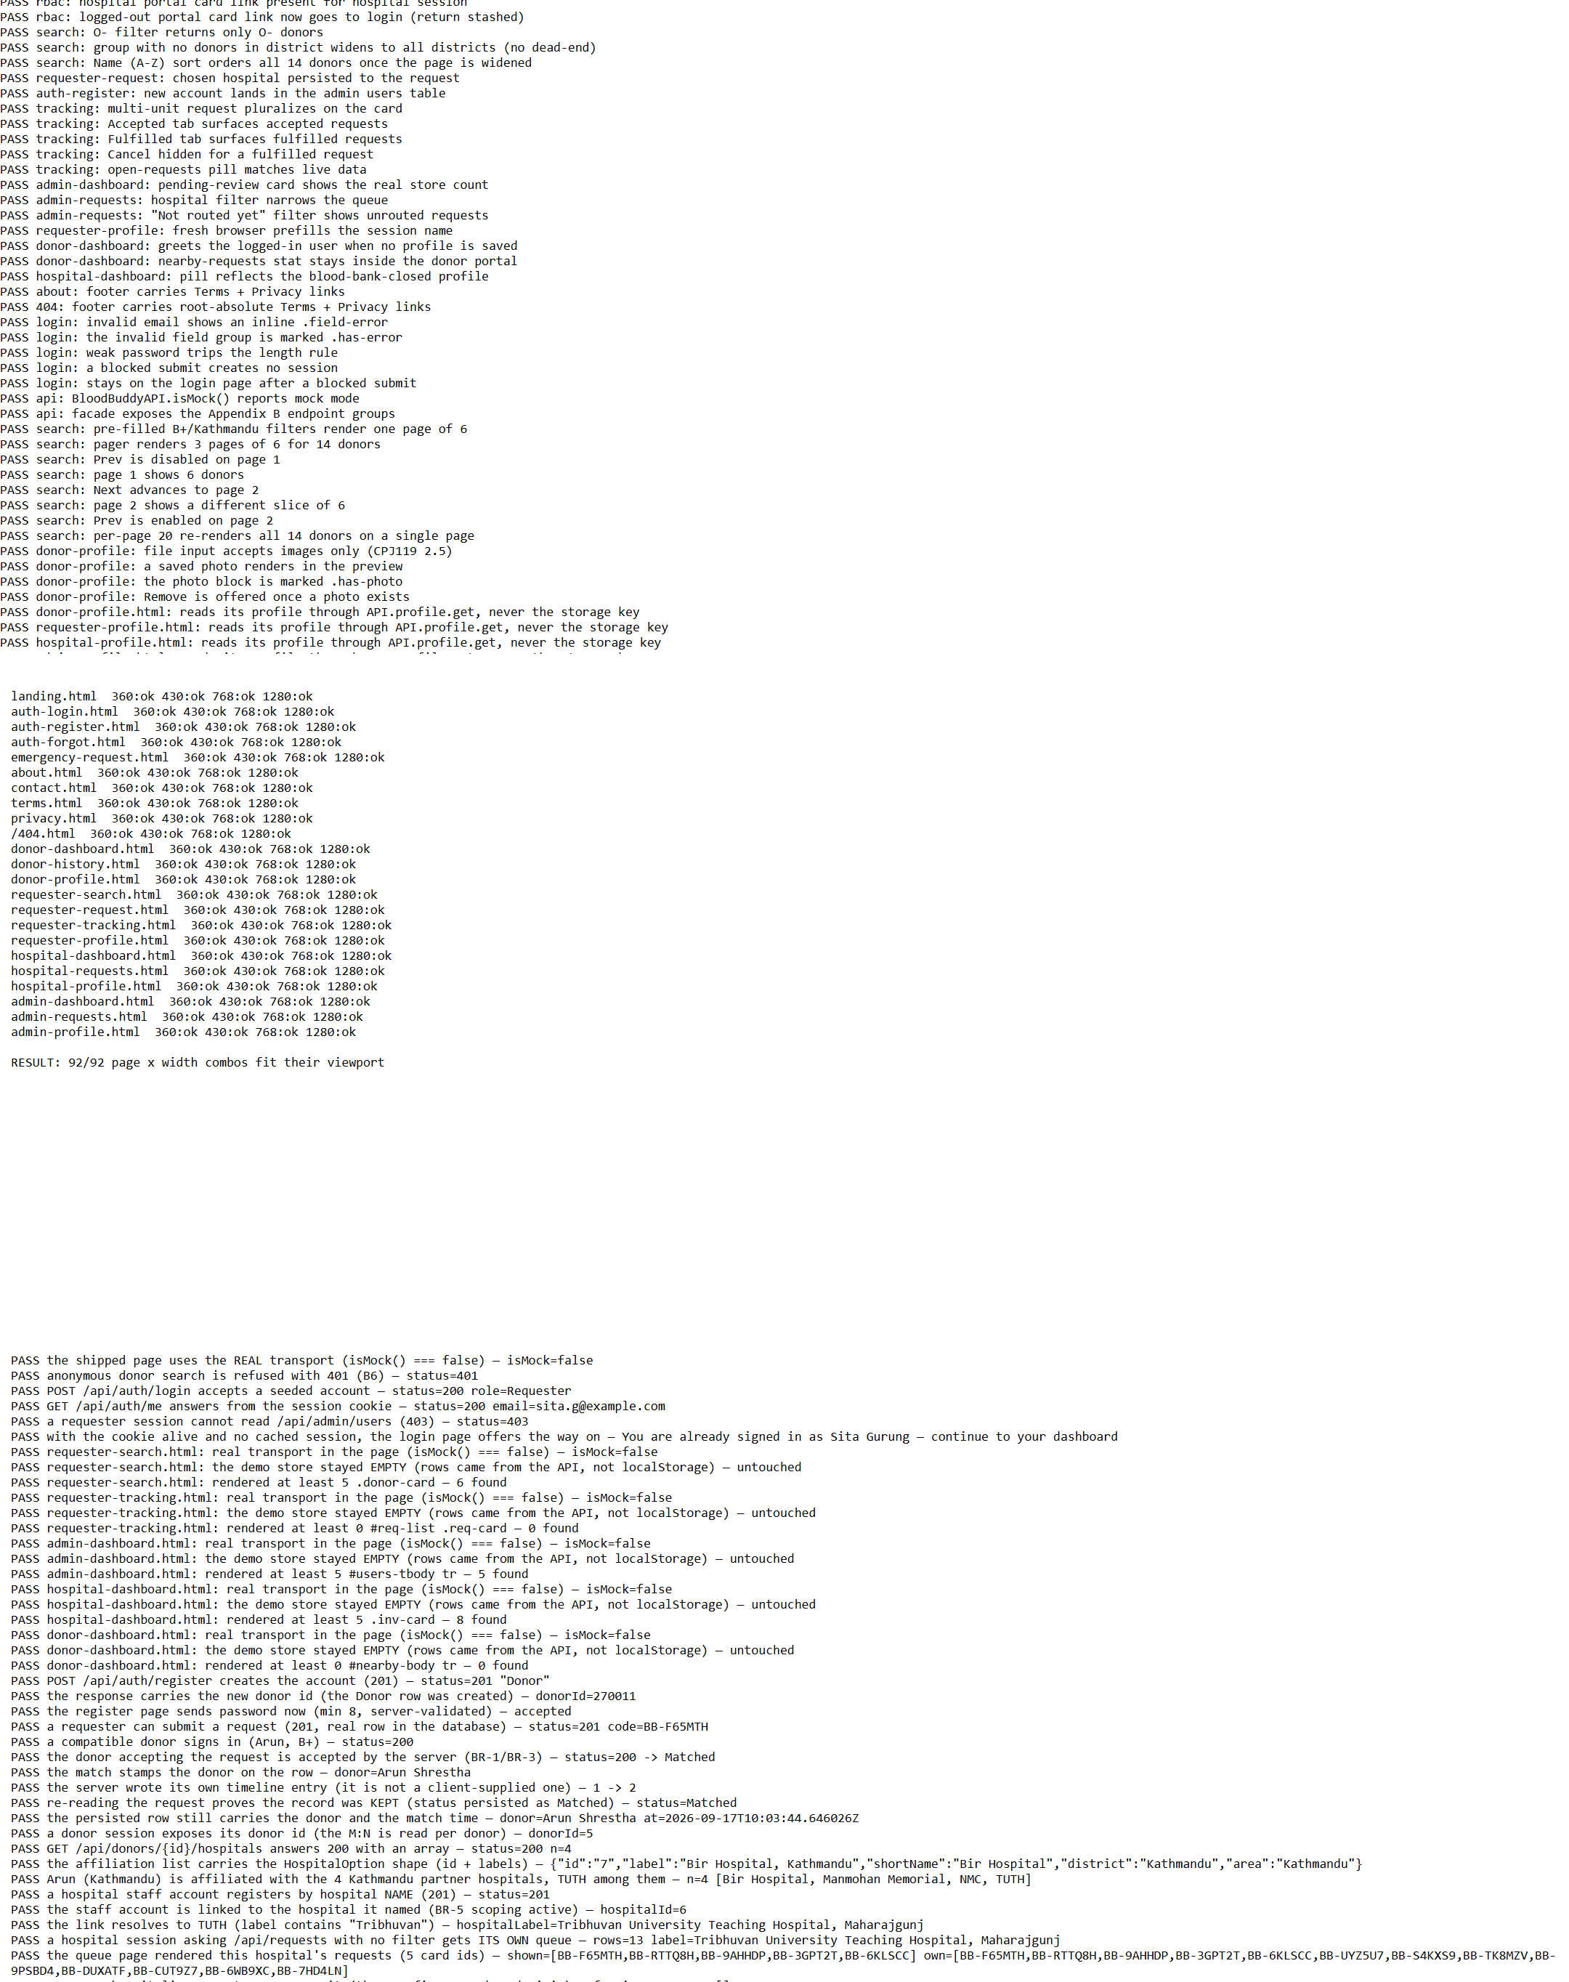
Figure 5-1: Automated Verification Reports (268/268 · 92/92 · 42/42)

5.3 Testing Evidence and Tools
The harness runs headlessly in Chrome with a fresh profile and cache buster, dumps its results to the DOM, and exits non-zero on failure, making it repeatable from the command line (the exact commands are recorded in Appendix E). The visual validation pass used a computed-style probe rather than screenshots alone: every inline error on both request forms was measured for display, box size, colour contrast (6.03:1, WCAG AA), and ring styling, with the probe and its screenshots kept as re-runnable artefacts. Five genuine defects the suite caught — a dead search route, a status-crash on unlabelled states, a transport prefix that would have 404'd every real call, a botched page edit, and a non-responsive 404 page — are recorded with their fixes in Section 7.2's context and Appendix E.

5.4 Requirements Traceability
Table 5-2: Requirements-to-Implementation Traceability Matrix
Requirement | Implementation | Evidence
FR-01 Registration/authentication | Auth pages through API facade; Spring Security session login with BCrypt, /api/auth/me, logout ending the session | TC-01, TC-02
FR-02 RBAC (4 roles) | Role-aware nav + page guards; Spring Security route rules (§3.9) — 401 anonymous, 403 wrong role | TC-02, TC-03
FR-03 Donor registry + availability | Donor profiles, availability toggle, admin suspension | TC-04, TC-14
FR-04 Search + filtering + pagination | Donor search endpoint via facade; shared pager | TC-04, TC-05, TC-15
FR-05 Request submission + tracking | Request forms, tracker tabs, timeline entries | TC-06
FR-06 Compatibility matching | bb-compat.js (recipient→donor direction) for presentation; re-enforced in the matching service (BR-2/BR-3) | TC-08, TC-09
FR-07 Public emergency flow | Guest form, EM- IDs, public status lookup with privacy guard | TC-07
FR-08 Hospital inventory management | Inventory table, stock adjustment, open/closed pill | TC-13
FR-09 Hospital queue + fulfilment | Accept/fulfil actions; stock decrement on fulfil | TC-09, TC-10
FR-10 Hospital-scoped local APIs | /api/hospitals/{hospitalId}/... implemented, scoped to the caller's hospital (BR-5) | TC-18; Appendix B
FR-11 Administration + moderation | Admin KPIs, user management, moderation + forwarding | TC-12, TC-13, TC-14
FR-12 SMTP notifications | EMAIL_NOTIFICATION rows stamped SENT/FAILED with the body stored; credentials from environment | TC-21
FR-13 Database-stored images | Base64 upload into a MEDIUMBLOB column; GET returns the bytes with a sniffed type | TC-16
FR-14 AJAX/Fetch + validation + responsive | API facade; shared validation; responsive CSS | TC-01, TC-17, TC-18
NFR-01–06 Usability, security, reliability, maintainability, performance, auditability | Responsive UI; RBAC + dual-end validation; consistent error shapes; layered design + shared modules; pagination; timeline audit trail | TC-01–TC-19; Sections 3.7–3.9

5.5 Evaluation Against the Assignment Brief
Every mandatory §2.1 frontend criterion is implemented and evidenced: semantic HTML/CSS/JS with a fully responsive layout (92/92 layout checks), client-side form validation (shared module, inline errors, TC-01), dynamic UI updates, basic AJAX/Fetch integration with backend APIs (proven over real HTTP, TC-19), search and filtering, pagination, role-based access control, and dashboard analytics. Code quality criteria are addressed through the strict layered design, shared modules, consistent naming, global error shapes, and validation on both ends (client-side and server-side both verified).
The backend criteria are correspondingly implemented and evidenced: the Spring MVC N-Tier implementation with Spring Security (§2.2); MySQL-compatible persistence through Hibernate/JPA with 1:1, 1:N and M:N relationships, the donor↔hospital affiliation join included (§2.3); SMTP registration confirmation with credentials supplied through environment variables (§2.4); database-stored images end-to-end, upload through authenticated retrieval (§2.5); and the Postman collection exported as JSON and executed under Newman (§2.6). What is deliberately outside the demonstrated system is stated in Section 7.2 rather than left implied: the browser store is the offline demonstration path (the shipped default is the real backend), no partner hospital is connected to a live integration, and the recorded runs use a free managed database tier and a local mail catcher rather than a production deployment.

CHAPTER 6: PROJECT TIMELINE
The project followed the phase-dependency order of the build roadmap (Table 4-1), with the automated QA checkpoint passing at the end of every phase before the next began. Periods are shown as project weeks; the frontend, backend and verification phases were all performed, and what remains is submission and the live demonstration.
Table 6-1: Phase-Wise Project Timeline and Completion Status
Phase | Activity | Period | Status
0–1 | Proposal (CPP400) approval; requirements finalisation; project setup and shared UI conventions | [Week 1] | Complete
2 | Shared modules: validation, API facade, pagination, compatibility chart, demo store | [Weeks 1–2] | Complete
3 | Auth pages, session-aware navigation, RBAC page guards | [Week 2] | Complete
4–5 | Donor search + request forms (member and public emergency) with inline validation | [Week 3] | Complete
6–7 | Request lifecycle (accept/match/fulfil) + hospital inventory and queue | [Weeks 3–4] | Complete
8 | Administrator portal: analytics, user management, moderation | [Week 4] | Complete
9 | Profile editors, Base64 photo upload, legal and public pages | [Week 5] | Complete
10 | Validation/fetch/pagination consolidation; visual and contrast pass | [Weeks 5–6] | Complete
11 | QA harness expansion; defect fixing | [Week 6] | Complete
12 | Responsive verification; real-mode transport verification | [Weeks 6–7] | Complete
13 | Spring MVC backend: entities, relationships, security, SMTP | [Weeks 8–10] | Complete
14 | Postman collection, final integration testing, report finalisation | [Weeks 11–12] | Complete (report finalisation in progress)

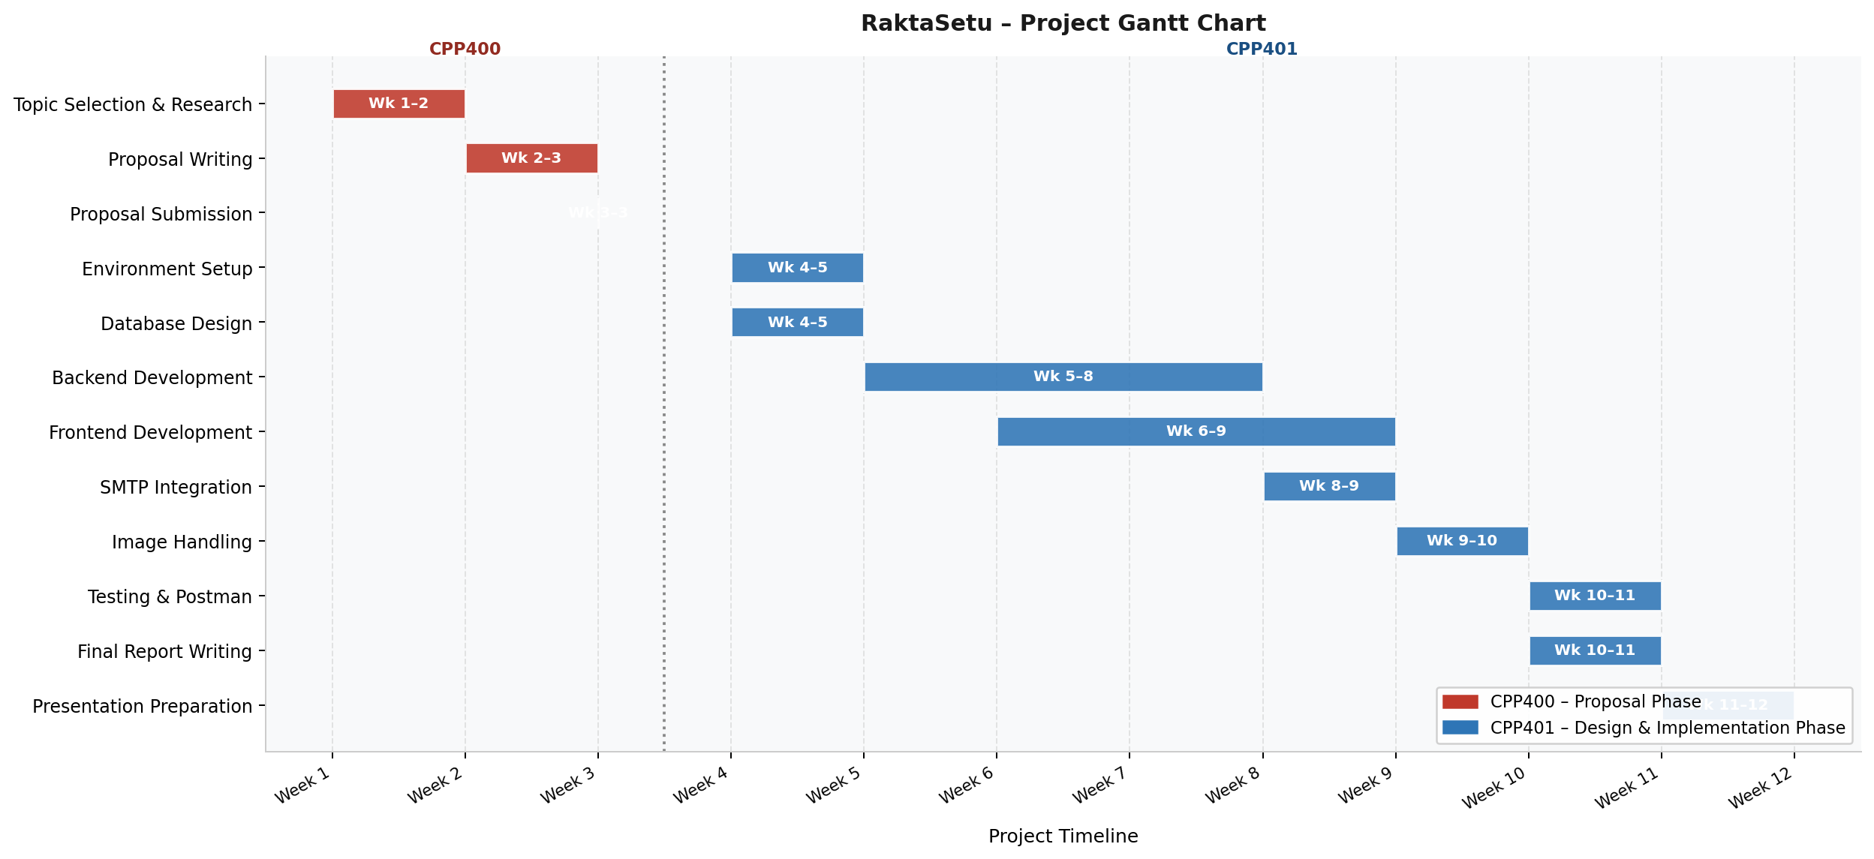
Figure 6-1: Project Gantt Chart

CHAPTER 7: CONCLUSION, LIMITATIONS AND FUTURE SCOPE

7.1 Conclusion
BloodBuddy set out to close five evidence-backed gaps — unstructured social-media requests, no searchable donor registry, manual hospital records, no automated alerting, and no moderation — with a structured, role-based web platform, and the frontend through which users experience all five closures is complete and verified: 268/268 functional checks, 92/92 responsive page×width combinations, 42/42 checks against the live backend, 98/98 HTTP API checks and 31/31 service-layer checks against the database. The full request lifecycle — submission, moderation, hospital routing, compatibility-correct donor matching, fulfilment with stock decrement — works end-to-end across all four roles plus the guest emergency flow.
The project's most instructive results are methodological. Centralising the compatibility chart in one module exposed how easily a clinical rule drifts when duplicated — and how the matching direction itself is the safety-critical detail. The API facade design made the mock-to-real backend swap a one-flag change and, just as importantly, made the transport layer testable: the one defect that would have silently broken every real call was invisible to 261 functional checks and was caught only by exercising the fetch path over HTTP, then pinned by a negative-tested guard. The project traces cleanly from documented field evidence through requirements, layered design, phased implementation, and evidence-based verification — a complete software development lifecycle in miniature.

7.2 Limitations
- The browser store survives only as an offline demonstration path, forced by a localStorage flag; the shipped default is the real backend. A demonstration with no network therefore exercises the pages but not the server-side rules, and the API is the authoritative judge in every other case.
- Rules are enforced in the service layer, with matching browser-side pre-checks kept only for responsiveness; the browser checks are advisory by design, and the API refuses any request that violates a rule regardless of what the client sends.
- Hospital and inventory data is seeded demonstration data: the five partner hospitals are real database records and the hospital-scoped APIs are live and permission-scoped, but no hospital's own system is connected to them, so there is no live inventory feed.
- Email is sent over SMTP and recorded per row (QUEUED → SENT, or FAILED with the server's own error); in the recorded runs the delivery target is a local development catcher, and the real-account demonstration depends on an application password for the project's mailbox.
- Concurrency is exercised only as far as the automated suites go — a repeated accept is covered by the Postman collection — and database-level uniqueness is in force for inventory rows and request codes, but not for two simultaneous accepts of the same request.
- The requirement base derives from the proposal's document-based analysis; broader field validation with hospitals and donor communities remains future work.

7.3 Future Scope
- Harden the backend beyond the demonstrated scope: a queued rather than in-request mail sender, database-level exclusion of two simultaneous accepts of one request, and a production database and HTTPS deployment behind the same facade contract.
- Password-reset and login-alert emails, alongside the registration and urgent-request notifications already delivered; the forgotten-password page is currently a frontend form only.
- Onboard the five partner hospitals onto the local APIs for real-time inventory sharing; add cross-hospital stock search so requesters can locate scarce groups region-wide.
- SMS push alongside email for urgent requests, given Nepal's mobile-first usage patterns.
- Donor engagement: eligibility intervals, donation history verification, reminders, and recognition badges to sustain the voluntary donor base.
- Deployment to a cloud host with HTTPS, database backups, and monitoring; multilingual (Nepali) interface; and a native mobile companion if usage data justifies it.

REFERENCES
Bauer, C., & King, G. (2015). Java persistence with Hibernate (2nd ed.). Manning Publications.
Fielding, R. T. (2000). Architectural styles and the design of network-based software architectures [Doctoral dissertation, University of California, Irvine]. University of California.
Hibernate ORM Documentation. (2024). Hibernate getting started guide. https://docs.jboss.org/hibernate/orm/current/quickstart/html_single/
New Business Age. (2025). Nepal's digital crossroads: Growth vs barriers in the race to transform. https://www.newbusinessage.com/news/43801
Nepal Economic Forum. (n.d.). Barriers to local digital innovation in Nepal. https://nepaleconomicforum.org/barriers-to-local-digital-innovation-in-nepal/
NIPoRe. (2023). Digitalization of Nepal — few policies and possible challenges. https://nipore.org/digitalization-of-nepal-few-policies-and-possible-challenges/
Sandhu, R. S., & Samarati, P. (1994). Access control: Principles and practice. IEEE Communications Magazine, 32(9), 40–48.
Spring Framework Documentation. (2024). Spring MVC — Web on Servlet Stack. https://docs.spring.io/spring-framework/reference/web/webmvc.html
World Bank. (2025). Unlocking Nepal's growth potential: Nepal economic memorandum. Washington, D.C.: The World Bank Group.
World Health Organisation. (2023). Blood safety and availability. WHO Fact Sheets. https://www.who.int/news-room/fact-sheets/detail/blood-safety-and-availability

APPENDICES

Appendix A: Blood Group Compatibility Chart
The compatibility chart below is the authoritative reference implemented in bb-compat.js and used by the donor matching algorithm to suggest compatible donor blood groups when an exact match is unavailable. The chart is written recipient → compatible donor groups; matching code must read it in that direction.
Table A-1: Recipient → Compatible Donor Blood Groups
Recipient Blood Group | Compatible Donor Blood Groups
A+ | A+, A-, O+, O-
A- | A-, O-
B+ | B+, B-, O+, O-
B- | B-, O-
AB+ | All blood groups (Universal Recipient)
AB- | AB-, A-, B-, O-
O+ | O+, O-
O- | O- (Universal Donor)

Appendix B: REST API Endpoint Reference
Full listing of every endpoint the frontend facade consumes (mirroring the proposal's Appendix B), with the hospital-scoped local APIs for the five partner hospitals.
Table B-1: REST API Endpoints
Method | Endpoint | Description
POST | /api/auth/register | Register a new user (donor, requester, hospital staff, or admin)
POST | /api/auth/login | Authenticate user and return session token
GET | /api/donors/search | Search donors by blood group and location (paginated)
GET | /api/donors/{id} | Retrieve a specific donor's profile
GET | /api/requests | List/filter requests (?requester=&donor=&hospital=&guest=)
POST | /api/requests | Submit a new blood request
GET | /api/requests/{id} | Retrieve details of a specific blood request
PATCH | /api/requests/{id} | Update request status (accept / fulfil / cancel / moderate / forward)
GET | /api/hospitals/inventory | Retrieve blood bank inventory for a hospital
PUT | /api/hospitals/inventory/{bloodGroup} | Update blood bank stock levels
GET | /api/admin/users | Admin: retrieve all registered users
PATCH | /api/admin/users/{id} | Admin: set user status (activate/suspend)
GET | /api/hospitals/{hospitalId}/inventory | Local: full blood inventory for a specific partner hospital (TUTH, Bir, Patan, Manmohan, NMCTH)
PUT | /api/hospitals/{hospitalId}/inventory/{bloodGroup} | Local: update stock level for a specific blood group at a partner hospital
POST | /api/hospitals/{hospitalId}/requests | Local: submit a blood request directly to a partner hospital's queue
GET | /api/hospitals/{hospitalId}/requests/{requestId}/status | Local: check the fulfilment status of a blood request at a partner hospital
GET | /api/hospitals/{hospitalId}/donors/nearby | Local: registered donors near a partner hospital, filtered by blood group
GET / PUT | /api/profile/{role} | Retrieve / save the signed-in user's role profile (incl. Base64 photograph)

Appendix C: Database Schema
The schema is defined by the JPA entities in backend/src/main/java/com/bloodbuddy/model/ and created by Hibernate at application start (ddl-auto=update). It comprises nine tables:
• users — account: name, email (unique), phone, BCrypt password hash, role enum (DONOR / REQUESTER / HOSPITAL / ADMIN), status enum (ACTIVE / SUSPENDED).
• donors — role-scoped donor profile: blood group enum, district, availability flag, last-donation date, and the Base64/BLOB photograph column; FK to users.
• hospitals — the five partner hospitals: name, type, district, blood-bank-open flag.
• blood_inventory — one stock row per hospital and blood group: units available, updated timestamp; FK to hospitals with a UNIQUE (hospital_id, bloodGroup) constraint.
• blood_requests — the request itself: public code (UNIQUE, e.g. BB-XXXXXX), requester FK, donor FK (set on accept), hospital FK (set on routing), blood group, units, needed-by date, urgency, district, contact, notes, status enum (PENDING / MATCHED / FULFILLED / CANCELLED / REJECTED) and timestamps.
• request_timeline — the per-request audit trail of status transitions (element collection on blood_requests; FK request_id).
• email_notifications — the notification audit row: recipient FK, type enum, request FK, subject, body, delivery status enum (QUEUED / SENT / FAILED) and sent timestamp.
• request_declines — a donor's decline of a matched request; UNIQUE (donor_id, request_id).
• donor_hospital_affiliation — the Donor ↔ Hospital M:N join table (donor_id, hospital_id).
Foreign-key constraints, the role/status/urgency enums and the inventory uniqueness rule above are enforced in the database, and the repository layer additionally guards the demo data (see Table 3-3).

Appendix D: Selected Source Code
Selected implementation excerpts (full files in the submitted codebase):
• CODE/js/bb-compat.js — the Appendix A compatibility chart and direction-correct matching helpers.
• CODE/js/bb-api.js — the API facade: endpoint table, mock adapter, real fetch transport, error normalisation, and the documented BASE invariant.
• CODE/js/nav.js — session model, ROLE_LINKS/ROLE_CTA tables, RBAC guard map, and return-URL continuation logic.
• CODE/js/bb-validate.js — shared validation rules and inline error rendering.
• CODE/js/bb-paginate.js — reusable pager (page sizes, prev/next, auto-hide).

Appendix E: QA Evidence and Reproduction Steps
The three verification tools and their recorded results:
• resptest/qa-harness.html — 268/268 checks (functional, all four roles, guest flow, transport guards). Run: serve the repo root, then headless Chrome with a fresh profile and virtual time budget; the harness prints a per-check PASS/FAIL report.
• resptest/responsive-check.html — 92/92 page×width combinations (23 pages at 360/430/768/1280) with no horizontal overflow.
• resptest/real-backend-check.html — 42/42 checks against the running Spring application: real transport in the signed-in pages, the anonymous 401 and wrong-role 403 boundaries, the session behind /api/auth/me, logout ending the session, the donor write path re-read from the server, and registrations that land in TiDB and in the mail catcher. The demo store is pinned empty, so rendered rows can only have arrived over HTTP.
• tools/api_check.py — 98 checks over HTTP across every endpoint and the BR-1 … BR-9 refusals; the headless service-layer run — 31 checks against the live database; the Postman collection — 76 requests, 107 assertions, exported as JSON for §2.6.
• resptest/visual-forms.html — computed-style validation-error probe (6.03:1 contrast, error ring cascade) with saved screenshots.
The three reports of Figure 5-1 are reproduced below.
Figure E-1: Automated Verification Reports (reproduced from Figure 5-1)

Appendix F: Additional Screenshots
Additional interface evidence beyond those placed in-chapter — captured from the running application with a signed-in session per role:
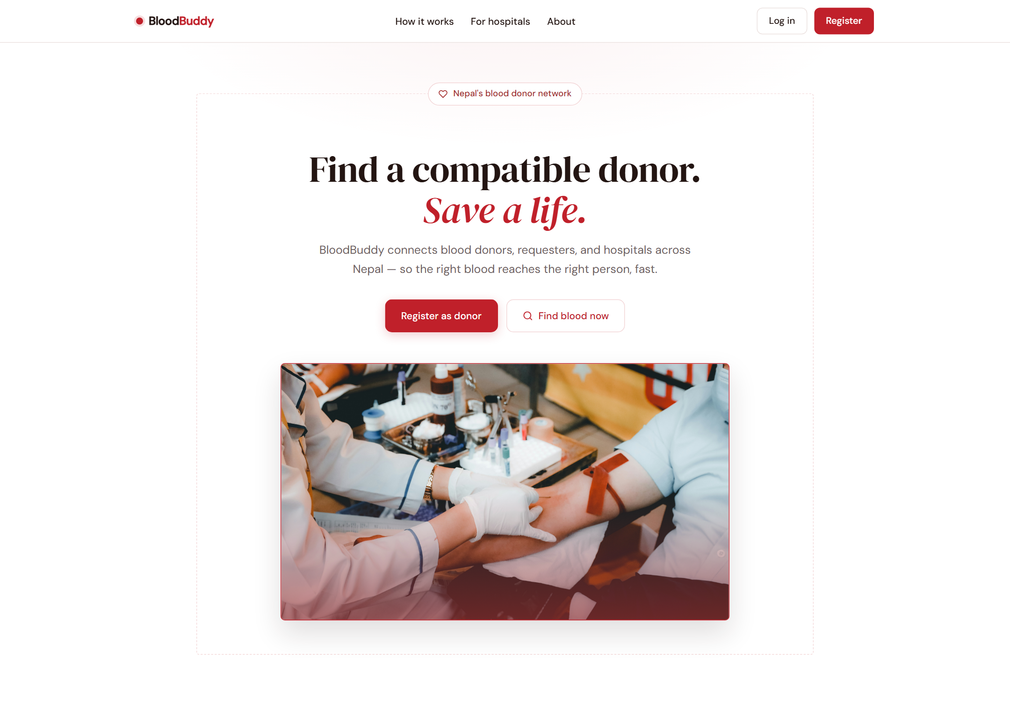
Figure F-1: Landing Page

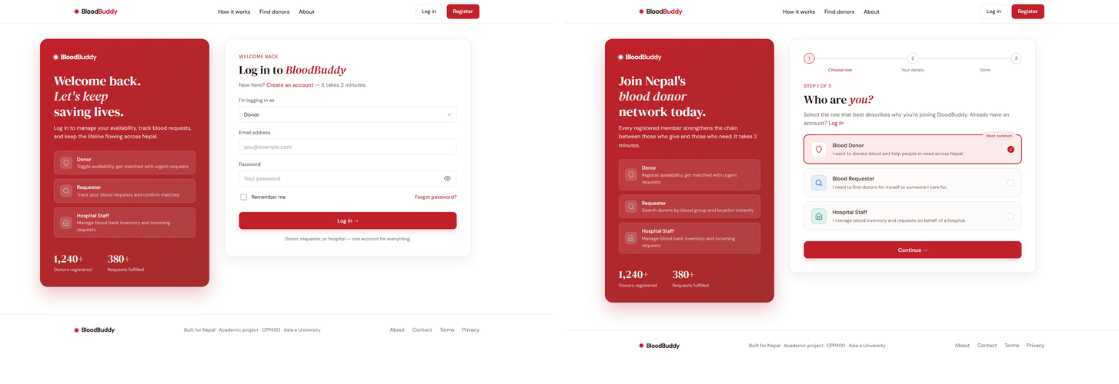
Figure F-2: Authentication Screens (Login and Registration)

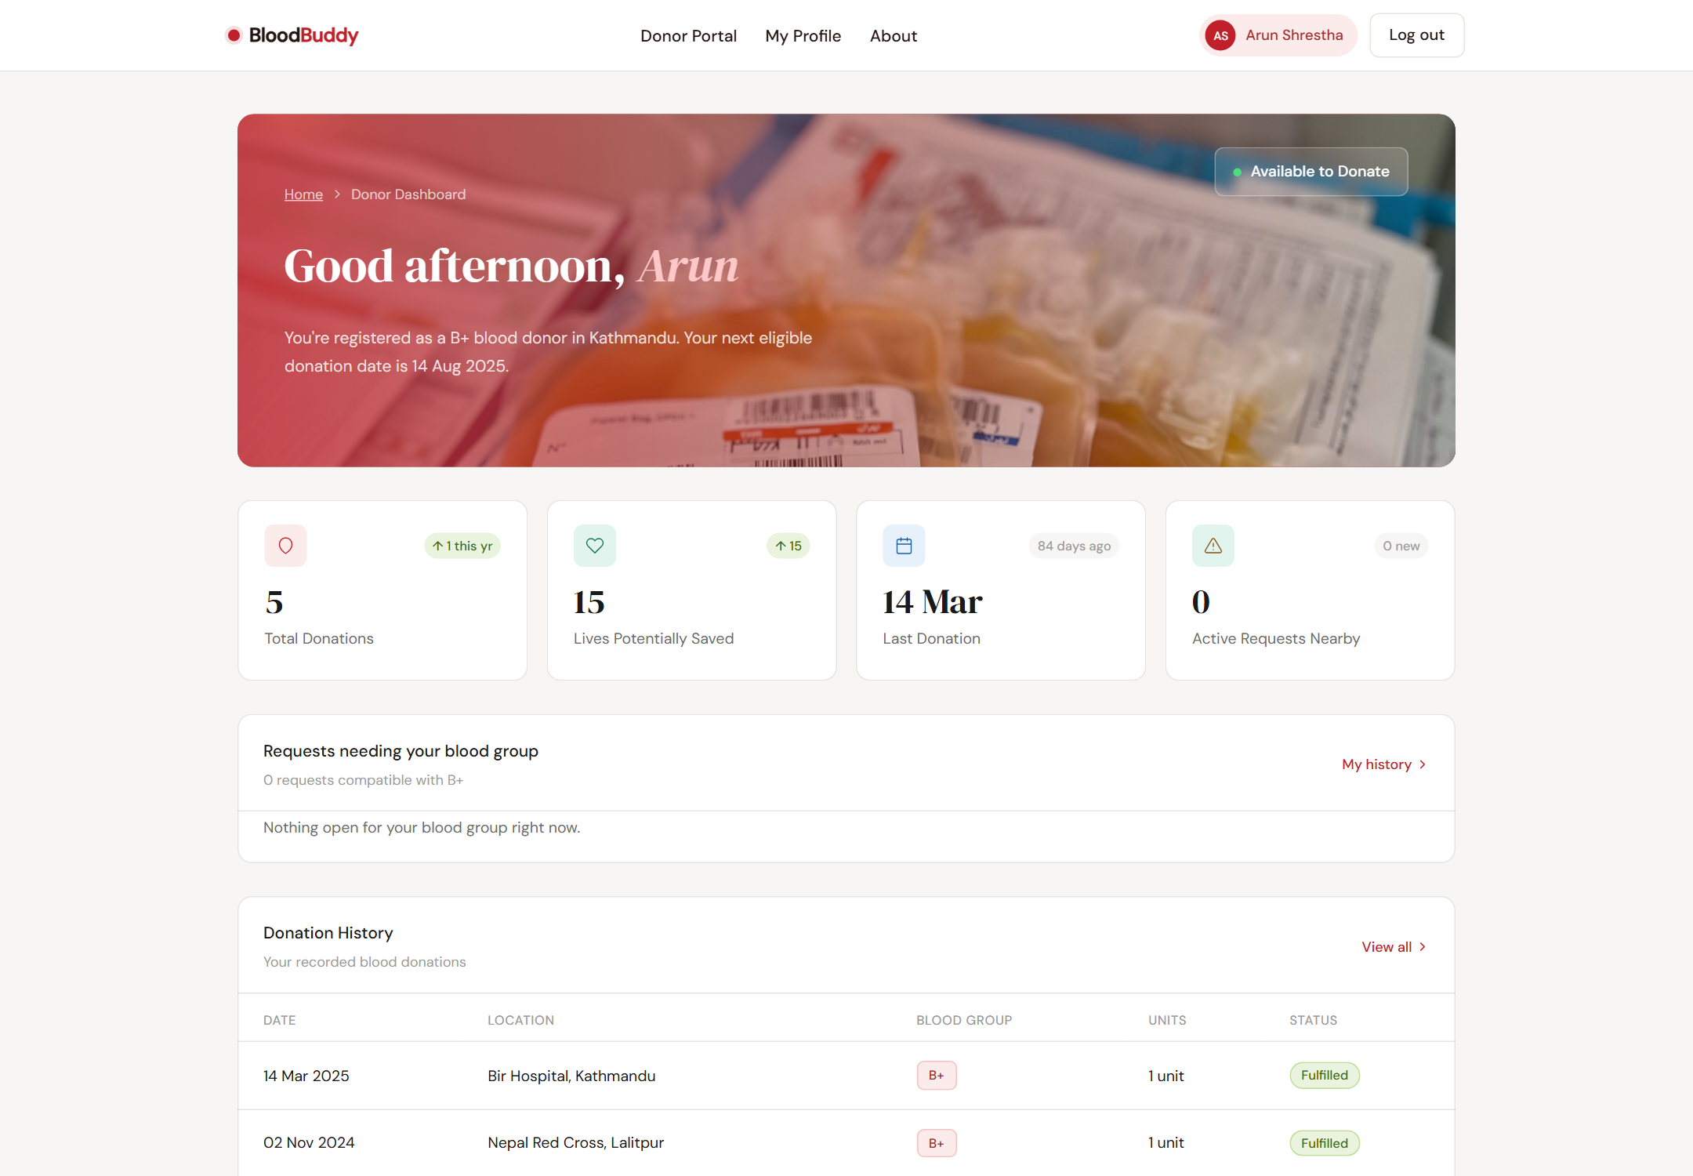
Figure F-3: Donor Dashboard

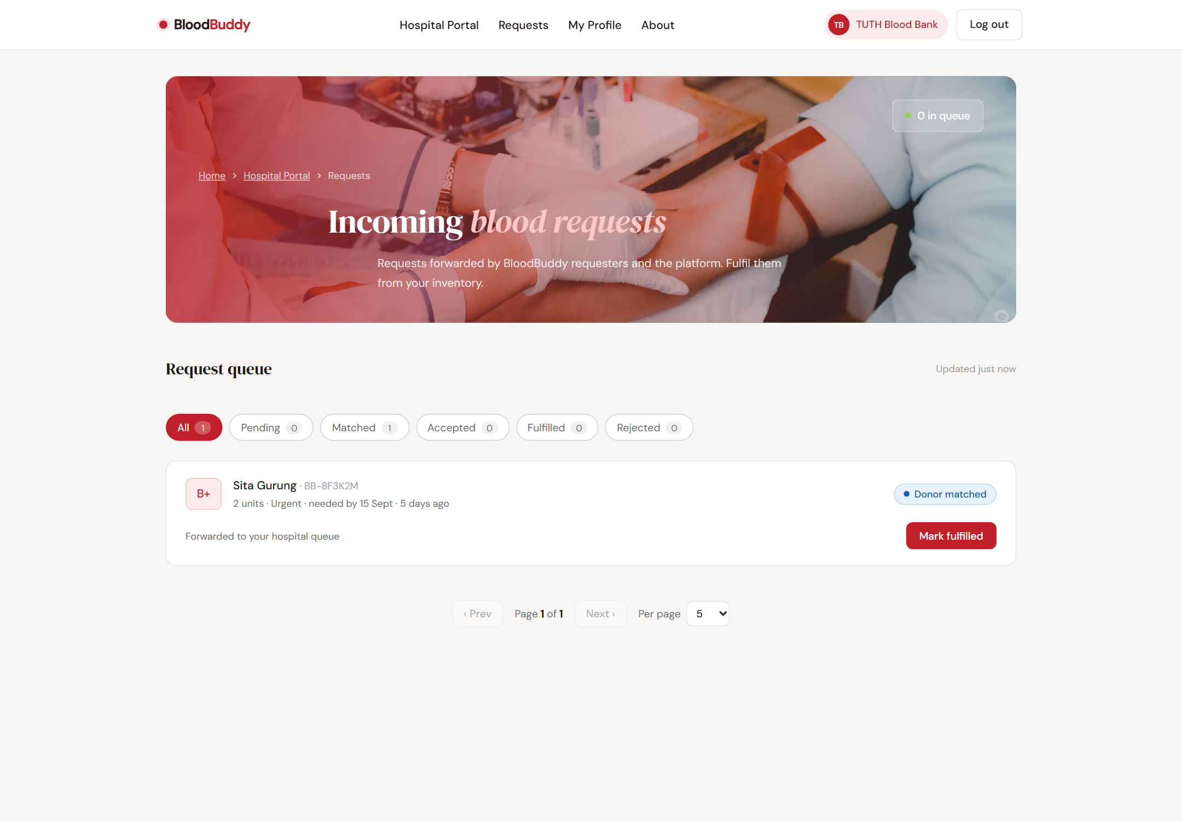
Figure F-4: Hospital Request Queue

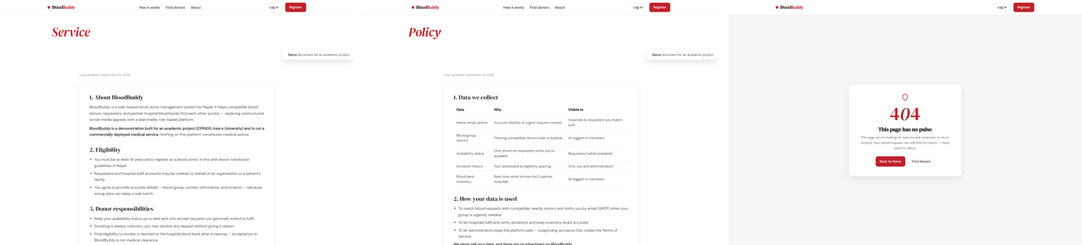
Figure F-5: Terms, Privacy Policy and Branded 404

