Saksham .
+91 9897141667

Graduate Engineer Trainee

PROFESSIONAL BACKGROUND
- hands-on experience in SAP BW/4HANA data modeling and data provisioning, including ODS Views, Calculation Views, and reporting solutions. Skilled in developing efficient data integration and analytics solutions.
- Proficient in SAP ABAP development with experience in Data Dictionary (DDIC), CDS Views, OData Services, RAP (RESTful ABAP Programming Model), and custom report development. Strong understanding of SAP application development concepts.
- Familiar with SAP Basis administration activities such as system
monitoring, transport management, and user administration.

RELEVANT AREAS OF EXPERTISE
Technical Skills
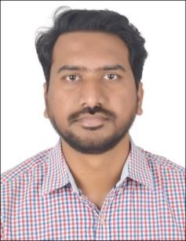
RELEVANT EXPERIENCE

SAP BASIS Administration
- Configured and managed Transport Management System (STMS) for transport
request movement across SAP landscapes.
- Performed client administration activities using SCC4 and client tools.
- Managed static and dynamic parameters for system configuration and performance tuning.
- Created and maintained users, roles, and authorizations.

SAP ABAP Development
- Developed Classical and ALV Reports using Function Modules and Object-Oriented
ABAP methods.
- Created and optimized database operations using Open SQL and Internal Tables.

SAP BW/4HANA
  - Data Modeling
  - Data Processing
  - ODS Views
  - Calculation Views
  - Reporting & Analysis
SAP ABAP
  - Data Dictionary (DDIC)
  - CDS Views
SAP BASIS
  - User Administration
  - Transport Management
  - System Monitoring
  - Client Management(LCC & RCC)
  - Backup and Recovery
  - Developed and tested OData Services for SAP Fiori applications.
  - Built business applications using the ABAP RESTful Application Programming Model (RAP). And Performed debugging, testing, and code optimization.

SAP BW/4HANA Development
  - Designed and implemented data models using ADSOs, InfoObjects, and Composite Providers.
  - Created and managed data loading processes and data flow architectures.
  - Developed reporting solutions to support business analytics requirements.
  - Worked on data extraction, transformation, and loading (ETL) concepts in

  - RAP (Restful ABAP Programming Model)
  - OData Services
  - Report Development
BW/4HANA.

