SAKSHAM SHARMA


B. Tech - Electronics and Communication Engineering (ECE)
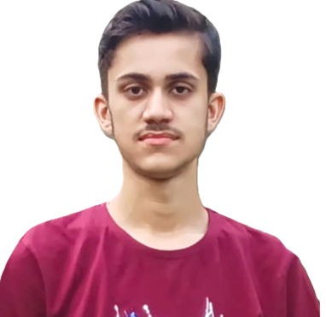

Roll number:22EC8067

Gender: Male
Date of Birth: 08/09/2004
Category: OP
E-mail: sakshamsharma9737@gmail.com
Contact: LinkedIn, Github
Address: Jammu, J&K

Educational Qualification
- Graduation
SEM | 1 | 2 | 3 | 4 | 5 | 6
SGPA | 6.82 | 7.59 | 9.43 | 7.52 | 8.91 | 8.21
CGPA | 6.82 | 7.17 | 7.93 | 7.82 | 8.04 | 8.07

- Higher Secondary & Secondary
Year | Degree/Examination | Institution/Board | CGPA/Percentage
2022 | Class XII | Central Board of Secondary Education | 89.6%
2020 | Class X | Central Board of Secondary Education | 90.3%

Skills Summary
- Technical Skills : React.js, JavaScript, Node.js, MongoDB, HTML, CSS, MySQL, Next.js.
- Non-Technical Skills : Problem Solving, Teamwork, Adaptability, Flexibility, Time Management.

Projects
- ChatWave Github
❖Developed a Real-Time Messaging Application: Utilized React and Socket.IO to create a chat app enabling instant message exchange, ensuring seamless communication between users.
❖Implemented Secure User Authentication: Integrated JWT for secure user authentication, ensuring data privacy and secure user sessions.
- RecipeApp Github
❖Developed a Feature-Rich Recipe Application: Allows users to search, save, and manage recipes efficiently.
❖Integrated External APIs: Leveraged APIs to provide a diverse recipe database, ensuring have access to a wide range of culinary options.

Achievements
❖Solved more than 300 leetcode problems.
❖2 star coder at codechef.

