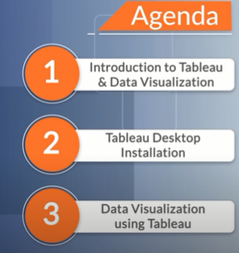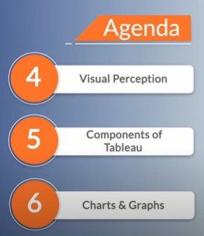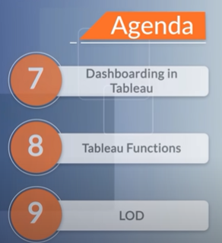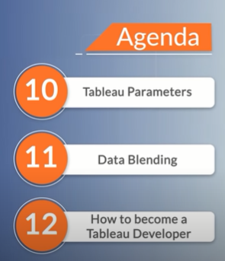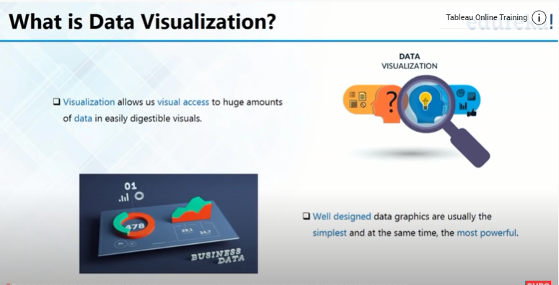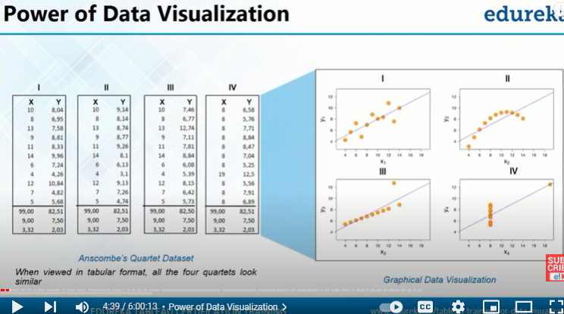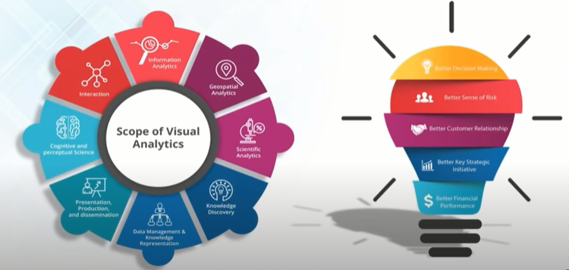

Visual analytics:

\* Taking better decisions

\* Helps studying data and then taking decisions accordingly

\* Helps in future prediction as helps in seeing trends

\* Risk analysis: As help in doing future predictions and hence reduces risk of going wrong

\* Better customer relationship

\* Better key strategic decisions

\* Better financial performances