In [] we don’t need to put ‘\’ before it but when we are using it without [] then it important to use it like ‘\.’

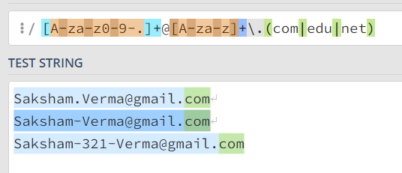

SITE TO CHECK REGULAR EXPRESSION

<https://regex101.com/>

BOUNDARY IN REGULAR EXPRESSION

Word boundary(\b)





Word boundary at the beginning and the end



\bHa\b 🡪 Second one doesn’t matched as the second one Ha{First one} doesn’t has the word boundary at the end

Not a Word boundary(\B)

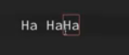

Start and end of a String {MUST BE OUTSIDE THE BOX IF INSIDE THEN EQUALS TO NOT}

* HA$(END)
  + [H][A]$
  + 



* ^HA(START)



* + ^[H][A]
  + 



Not in the SET

* Means Except these.



* Finding every 3 character word that ends with ‘at’ but must not start with ‘b’



[-.] 🡪 Means (. or -)



Mobile Number Starting with 800/900



Ranges in Regular Expression



Quantifiers

 = 

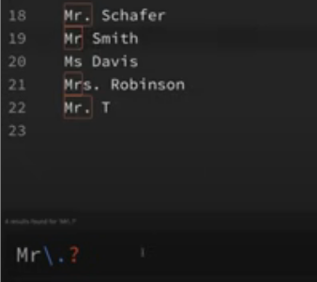

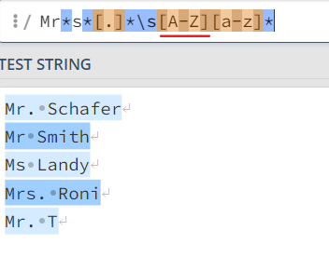

* [A-Z] is there as names always begin with a capital letter

Code for getting Names



Mr?s?[.]\s[A-Z][a-z]\* 🡪 ‘?’ is important as above will also approve Mrrrrrsssss Sakshi

Groups in Regex

Email Regex



We have written ‘.’ as to deal with email like Saksham@gmail.co.in

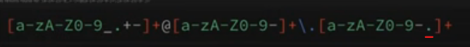

Storing things in a group as to get only the domain name



* For Group 1 / Group 2 / Group 3 respectively
* Group 0 is the every thing we captured

Showing the results



$1 means group1 🡪 Which in above case it like www.