SHOW TABLES AND DATABASE

* show databases;
* show tables;
* See the main command which helped you make this table(Helps you knowing the constraints etc)
  + SHOW CREATE TABLE person;
* Get info about indexes
  + SHOW INDEX FROM person;

USE DATBASE

* use vit_adv_java_19mid0023;

SELECT COMMANDS

* SELECT * from table_name
* NULL
  + SELECT * FROM customer_info WHERE salary is null;
  + SELECT * FROM customer_info WHERE salary is not null;

DROP

* DROP TABLE table_name;
* DROP DATABASE <database_name>;
* ALTER TABLE table_name

DROP COLUMN column_name;

DELETE ALL THE ROWS/COLUMN OF A TABLE

* DELETE FROM table_name;

COMMENTS

* # Single line comment
* /*Multiline comment*/

CREATE DATABASE / TABLEr

* CREATE DATABASE DB_NAME;
* CREATE TABLE table_name ( column1 datatype constraint, column2 datatype constraint, ... columnN datatype constraint);

INSERT/ DELETING ROWS IN A TABLE

* insert into customer_info(first_name, last_name ,salary) values ('John’, ‘Daniel’ ,5000), ('Krish','Naik',60000),('Darius’,'Bengali’,70000),('Chandan’, ‘Kumar',40000),('Ankit', 'Sharma’, NULL);
* DELETE FROM customer_info where last_name is null;
* DEFAULT VALUE
  + 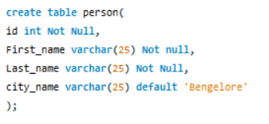

META DATA OF A TABLE

* DESCRIBE TABLE_NAME;
* SELECT Field, Type FROM information_schema.columns WHERE table_name = 'customer_info';

CONSTRAINTS

* create table customer_info{id integer auto_increment,first_name varchar(25),last_name varchar(25),salary integer,primary key(id)}
* Know your constraints
  + SHOW CREATE TABLE person;
  + SELECT *

FROM INFORMATION_SCHEMA.TABLE_CONSTRAINTS

WHERE TABLE_SCHEMA = 'person'

AND TABLE_NAME = 'customers';

* Unique based on two things
  + Alter table person add constraint uc_person unique(age, first_name);
* Modifying constraints
  + alter table student modify age int not null;
* Primary key
  + create table personl(

id int not null,

first_name varchar(25) not null,

last_name varchar(25),

age int,

constraint pk_person primary key(id,last_name));

* + Alter table person1

add primary key(id)

* Dropping primary key
  + ALTER TABLE table_name DROP PRIMARY KEY;
* Dropping a constraint
  + Alter table person drop index uc_person;

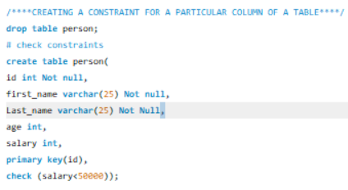

ALTER

* Auto_increment(Setting value for auto increment)
  + ALTER TABLE customer_info AUTO_INCREMENT = 1;
* Adding/ Dropping columns
  + ALTER TABLE my_table ADD COLUMN column1 INT, ADD COLUMN column2 VARCHAR(50), ADD COLUMN column3 DATE;
  + ALTER TABLE my_table DROP COLUMN column1, DROP COLUMN column2, DROP COLUMN column3;
* Modify multiple datatypes
  + ALTER TABLE my_table MODIFY COLUMN column1 VARCHAR(50), MODIFY COLUMN column2 INT, MODIFY COLUMN column3 DATE;
* Modifying constraints
  + alter table student modify age int not null;
* Adding unique after the table is created
  + Alter table person ADD unique(first_name);
* Unique based on two things
  + Alter table person add constraint uc_person unique(age, first_name);
  + Here the constraint name is uc_person
* Dropping a constraint
  + Alter table person drop index uc_person;

Update

* UPDATE customer_info set salary = 50000 where id = 4;

DATATYPES

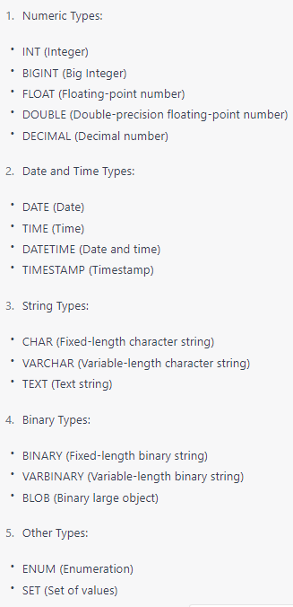

Foreign key

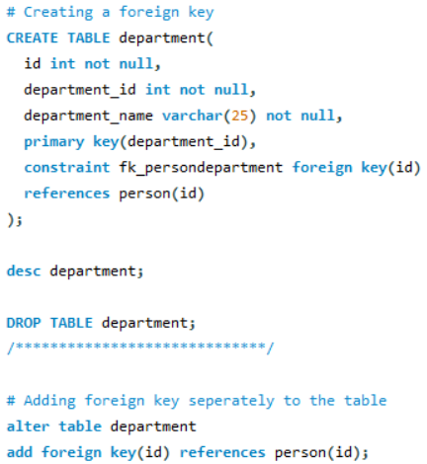

# CREATING A INDEX

create index index_city_first_name

on person(first_name,city_name);

# Dropping Index

alter table student

drop index index_age;

VIEW

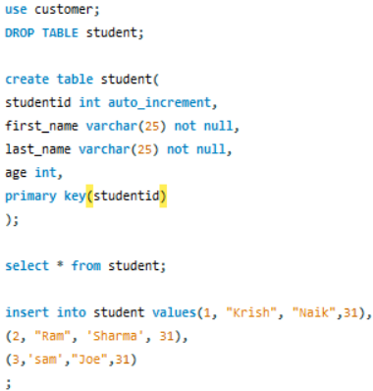

JOIN

* CARTESIAN PRODUCT
  + select student.studentid, first_name,last_name,age,department_name from student inner join department ;
* INNER JOIN
  + Diagram, venn diagram

    Description automatically generated
* FULL OUTER JOIN
  + SELECT column_name(s)  
    FROM table1  
    FULL OUTER JOIN table2ON table1.column_name = table2.column_nameWHERE condition;
* LEFT JOIN
  + 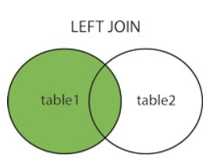
* RIGHT JOIN
  + Diagram, venn diagram

    Description automatically generated

W3 Schools

MySQL

* relational database management system (RDBMS).
* open-source.
* both small and large applications
* very fast, reliable, scalable
* cross-platform
* PHP is server side
* SQL is used to insert, search, update, and delete database records.

RDBMS

* maintain a relational database.
* Defines database relationships in the form of tables.
* The tables are related to each other - based on data common to each.
* Basis for all modern database systems such as MySQL, Microsoft SQL Server, Oracle, and Microsoft Access.
* uses [SQL queries](https://www.w3schools.com/sql/default.asp) to access the data in the database.

What is a Database Table?

* collection of related data entries
* consists of columns and rows
  + Column specific information about every record in the table.
  + Record (or row) is each individual entry

SEMICOLON

* Semicolon is the standard way to separate each SQL statement in database systems that allow more than one SQL statement to be executed in the same call to the server.

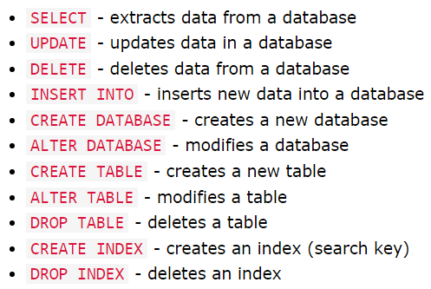

SELECT STATEMENT

* select data from a database.
* data returned is stored in a result table, called the result-set.
  + Select * from table
  + Select column1, column2 From Table
* Select DISTINCT
  + return only distinct (different) values
  + column often contains many duplicate values
    - SELECT DISTINCT column1, column2, ...  
      FROM table_name;
* number of different (distinct)
  + SELECT COUNT(DISTINCT COUNTRY) From Customers;

WHERE STATEMENT

* used to filter records
* 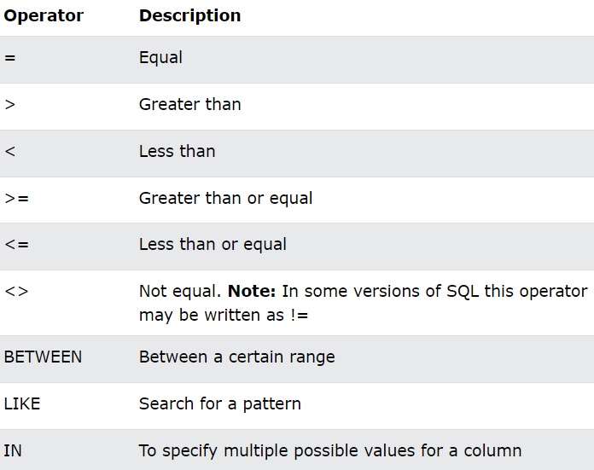
* A picture containing graphical user interface

  Description automatically generatedA picture containing polygon

  Description automatically generated

## AND, OR and NOT Operators

## filter records based on more than one condition

## AND

## if all the conditions separated by AND are TRUE.

## OR

## if any of the conditions separated by OR is TRUE

## NOT

## displays a record if the condition(s) is NOT TRUE

## ALIAS

* SELECT c.* FROM CITY c WHERE ID = 1661;

BASIC STRUCTURE

