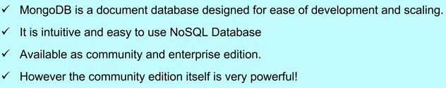

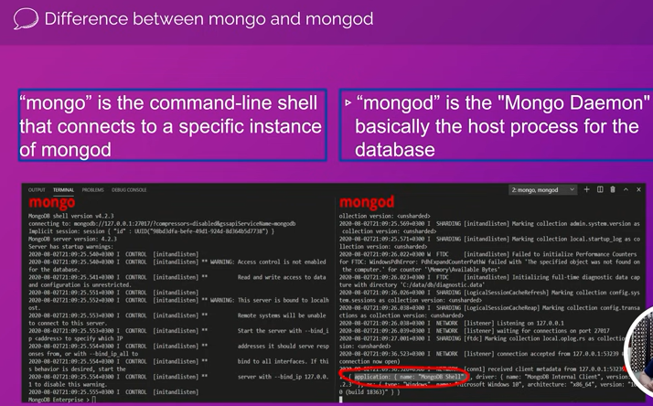



**Table🡪Collection ; rows 🡪 documents ; columns🡪fields**

Creating a database using MongoDB gui

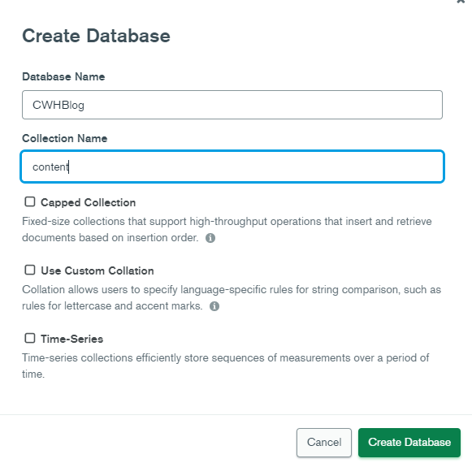

Collection Name 🡪 Table Name

Capped Collection🡪 Capped collections are fixed-size collections means when we create the collection, we must fix the maximum size of the collection(in bytes) and the maximum number of documents that it can store. After creation, if we try to add more than documents to their capacity, it overwrites the existing documents.

Use Custom Collation 🡪 When you want to use any such characters which may not come into default encoding

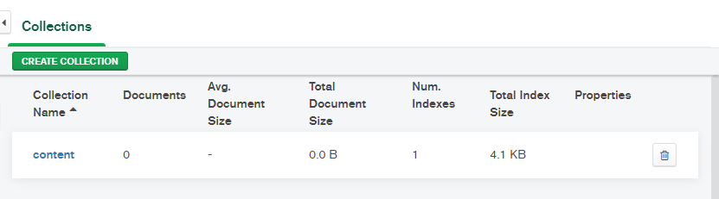

Create Collection will create a new table

Just Click on content(Table name) to start editing the table

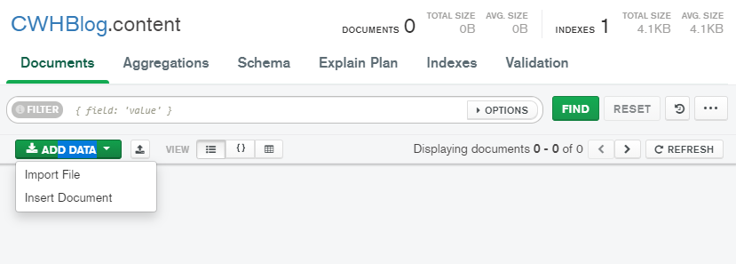

Add data 🡪 adding rows into table

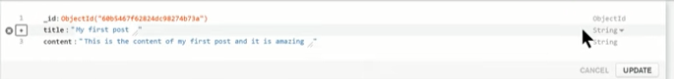

TO EDIT a Document a double click / on the right hand side top there will be a symbol(pen) to edit the document

Click on the plus sign to insert a new field