MONGODB

MongoDb intro database on cloud 🡪 <https://www.mongodb.com/basics/create-database-for-python-app?utm_campaign=python_inf_tim1&utm_source=youtube&utm_medium=influencers&utm_term=atlas>

MongoDb Cluster 🡪

<https://www.mongodb.com/basics/clusters#:~:text=A%20sharded%20cluster%20in%20MongoDB,data%20and%20high%20query%20rates>.

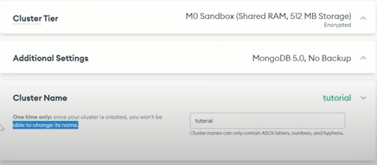

Cluster Tier 🡪 <https://www.mongodb.com/docs/atlas/manage-clusters/>

The cluster tier **dictates the memory, storage, and IOPS specification for each data-bearing server [1] in the cluster**.

Additional Settings 🡪 <https://www.mongodb.com/docs/atlas/cluster-additional-settings/#configure-backup-options-for-the-cluster>



Type 🡪 Replica Set – 3 nodes means we have 2 servers taking caring of