Introduction

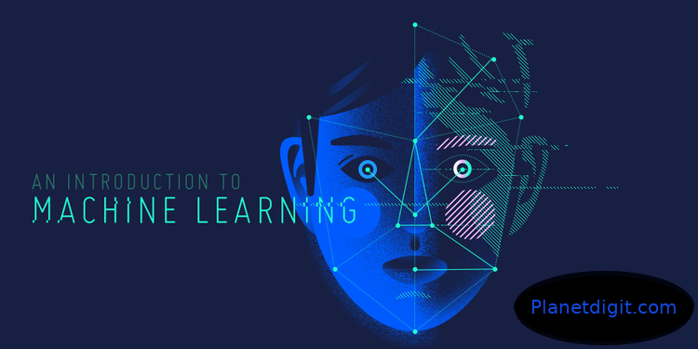
What is Machine Learning?
Machine learning is basically the study of computer algorithms that improve automatically through experience. It is an application/subset of artificial intelligence (AI) that provides systems the ability to automatically learn and improve from experience without being explicitly programmed.
How do you know that it’s going to rain? You have known this with experience in your life. You predict it while looking at the sky. That means your brain analyzes the behaviour of the sky from your past experience (privious data that is already present in your minds). That's what Machine Learning is. Thus it can be said that,
Machine Learning is the domain of computer science (and the sub-part of Artificial Intelligence) that uses statistical analysis/techniques to give computers the ability to think according to the previous data provided to it.

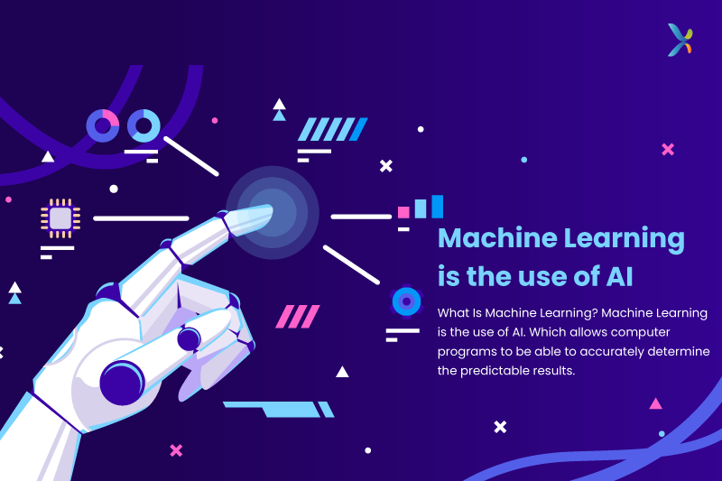
Machine learning is nothing new. The history, in fact, dates back over sixty years to when Alan Turing created the ‘Turing test’ to determine whether a computer had real intelligence.
In the past decade, machine learning has given us self-driving cars, practical speech recognition, effective web search, and a vastly improved understanding of the human genome. Machine learning is so pervasive today that you probably use it dozens of times a day without knowing it. It is undeniably one of the most influential and powerful technologies in today’s world. More importantly, we are far from seeing its full potential. There’s no doubt, it will continue to be making headlines for the foreseeable future. Many researchers also think it is the best way to make progress towards human-level.
Machine learning is basically a tool for converting information into knowledge. In the past decades, there has been an explosion of data. This mass of data is worthless unless we analyse and find the hidden patterns within it. Machine learning techniques are used to automatically find the valuable underlying patterns within complex data that we would otherwise struggle to discover. The hidden patterns and the knowledge about a problem can be used to predict the future events and perform all kinds of complex decision making.

Importance of:
Machine Learning
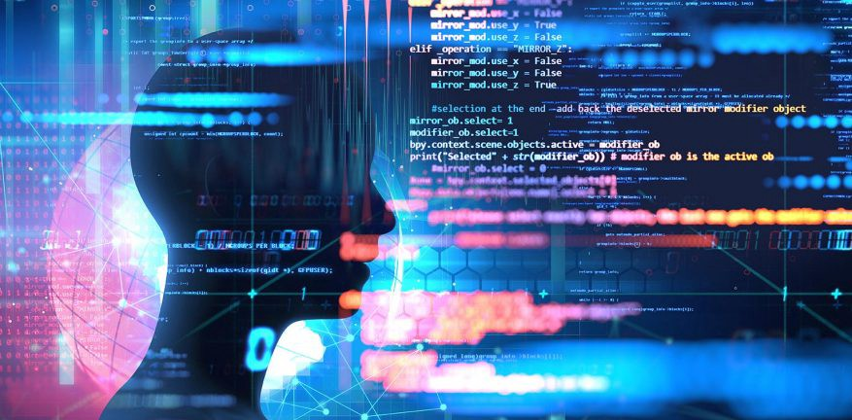

Machine learning is a field that combines artificial intelligence, computer programming, business and philosophy all in one.
But what is it? When your eyes take in information (let’s say, you are going out for a walk, and suddenly it started raining heavily. Your mind processes the data and makes a decision (open the umbrella or find a place to escape from it).
So, Machine learning is all about computers taking in huge amounts of data and solving for the best possible outcome.
Hence, Machine Learning is a way for humans to solve the problems without actually knowing how to solve them or why a particular approach works. Machines can try out every possibility and do it exceptionally fast. If one correct solution is to be chosen from millions of options, computers can simulate all million events and systematically determine the correct outcome.

