Introduction

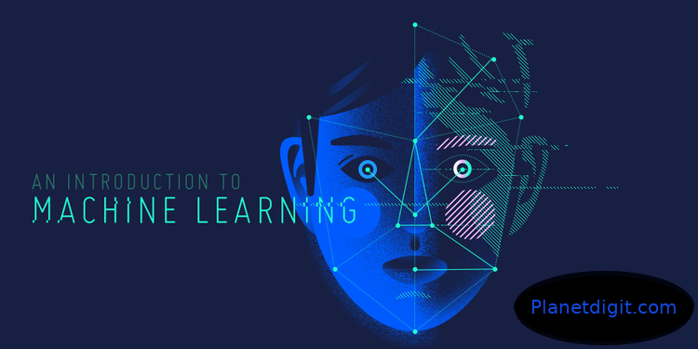
What is Machine Learning?
Machine learning is basically the study of computer algorithms that improve automatically through experience. It is an application/subset of artificial intelligence (AI) that provides systems the ability to automatically learn and improve from experience without being explicitly programmed.
In the past decade, machine learning has given us self-driving cars, practical speech recognition, effective web search, and a vastly improved understanding of the human genome. Machine learning is so pervasive today that you probably use it dozens of times a day without knowing it. It is undeniably one of the most influential and powerful technologies in today’s world. More importantly, we are far from seeing its full potential. There’s no doubt, it will continue to be making headlines for the foreseeable future. Many researchers also think it is the best way to make progress towards human-level.
Machine learning is basically a tool for converting information into knowledge. In the past decades, there has been an explosion of data. This mass of data is worthless unless we analyse and find the hidden patterns within it. Machine learning techniques are used to automatically find the valuable underlying patterns within complex data that we would otherwise struggle to discover. The hidden patterns and the knowledge about a problem can be used to predict the future events and perform all kinds of complex decision making.

