GREENOPS VERIFY | TEAM BRIEF
TEAM BRIEF / 01

One product. Two tested ways to reduce waste.
Keep GreenOps at the centre: audit cloud resources, forecast demand, compare cost and carbon, then approve and verify a bounded change.
Working title: GreenOps Verify. Add only one SpendProof-inspired feature: an AI Efficiency Lab that checks whether a support workflow can use fewer unnecessary calls or less irrelevant context without losing required behaviour. It shares the same evidence, approval and verification flow; it is not a separate subscription product.

The user and the promise
User: an engineering lead running an AI-enabled support service on GCP. Their question: “Which changes should we make this week to reduce waste while preserving our workload and support-policy requirements?” The output is an evidence-backed change proposal, trial results, a scoped approval and a verified result—not just advice.
Retain from GreenOps | Build as the new contribution
Cloud audit and recommendations | Cross-source evidence through Zetaris, with stable IDs and timestamps.
Forecasts and impact comparisons | Target-capacity checks, repeatable workload trials, explicit cost/carbon assumptions.
Execution and reporting | Approval enforced in code, fresh-state checks, read-back and recovery status.
Agent coordination | A critic sends failed plans back for revision; Meterless preserves tested outcomes.
Environmental purpose | Keep carbon estimates visible and scoped. Never convert AI token counts directly into CO2e.

The demonstration in plain English
A worker looks idle on average. The agent proposes shrinking it, but the critic finds a peak workload that will not fit and rejects that plan. The agent investigates a different cloud candidate. In the AI lab, aggressive context trimming misses a premium-return rule, so it too is rejected. A revised candidate is tested, approved in the sandbox and verified. After restart, Meterless recalls the rejected experiment; a new policy version triggers reevaluation.
No guaranteed savings, no zero-downtime claim, no fake sponsor integration. “No acceptable change found” is a valid outcome when the tests do not pass.

TEAM BRIEF / 02

Keep the stack small and the sponsors essential
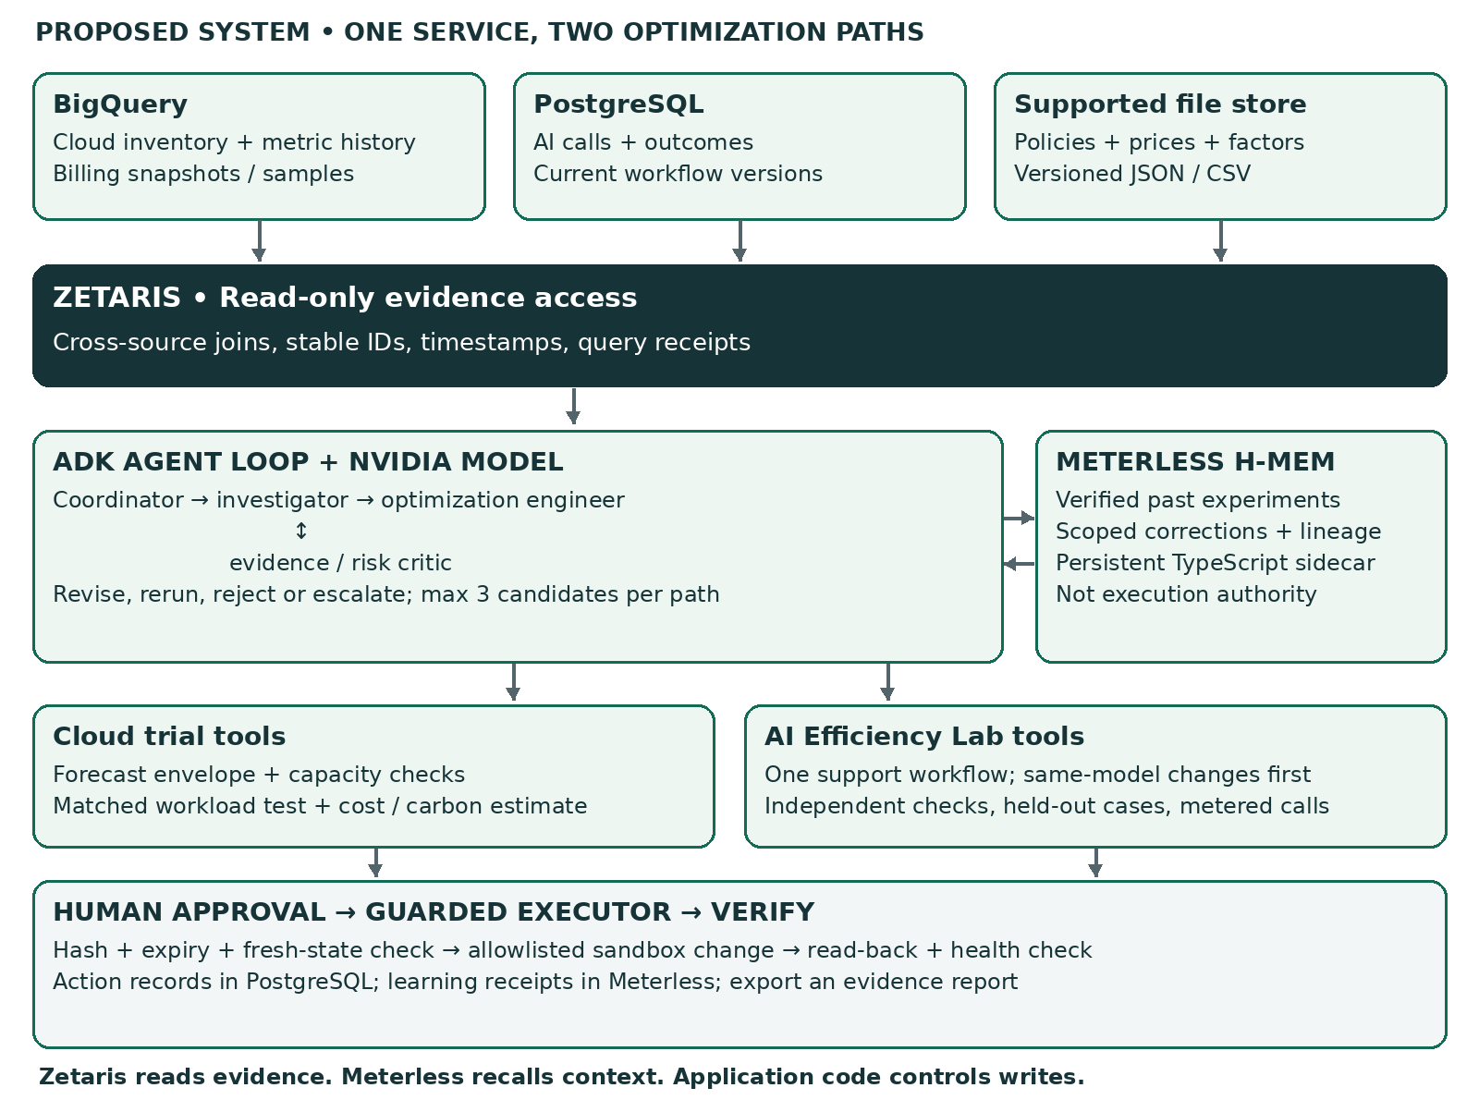
Component | Build decision
Python + Google ADK | Retain the base approach. Four meaningful roles: coordinator, investigator, optimizer and critic.
Streamlit + FastAPI | One interface with review queue, candidate comparison, evidence drawer and approve/verify controls.
Zetaris — required | Read-only investigation across BigQuery cloud records, PostgreSQL AI outcomes and a supported file source. At least two physical sources must actually work.
Meterless — required | TypeScript H-MEM reference behind a private sidecar. Persist rejected trials, verified corrections and their provenance. Action authority stays in PostgreSQL.
Cursor + NVIDIA | Use Cursor during development. Test a NVIDIA-hosted model through a supported adapter; pin the working dependency set.

The guide requires Zetaris, Meterless and Cursor, with NVIDIA wherever it contributes. H-MEM is a reference implementation/specification, not a billing or rollback service. Follow the supplied sponsor resources; do not invent vendor SDK calls. [H1 §8; M1–M2; Z1–Z3]

TEAM BRIEF / 03

Six days: build the proof before the polish
Planning assumption: three builders with web/API experience. For two builders, remove the second model, automatic slides and live cloud resize first.
Date / owner | Deliverable that must work
22 Oct | Integration + agent leads | Real Zetaris query; real Meterless memory survives restart; one model/tool call; a basic investigation.
23 Oct | Agent + trial leads | Cloud candidate, deterministic capacity/impact checks and a critic-driven revision or justified rejection.
24 Oct | Trial + integration leads | One AI workflow with actual traces, independent checks and development/held-out separation.
25 Oct | API + test leads | Human approval bound to plan/version; sandbox execution and read-back; stale and duplicate-action tests.
26 Oct | Whole team | Feature freeze; acceptance suite; clean-install test; deck and 1–4 minute video prepared.
27 Oct | Submission owner | Final links, provenance, credentials and limitations checked. Internal target 18:00 UTC; official guide deadline 23:45 UTC.

Day-one go/no-go gate
Do not spend two days polishing a disconnected frontend. First establish sponsor workspace access, connector reachability, model/tool compatibility and a persistent memory service. A remote Zetaris workspace cannot automatically reach a laptop database. Use an approved reachable sample source or request support immediately.

Minimum scope
GCP only; six small VM histories; one service; up to three candidate plans per path (six total); one sandbox action; one AI workflow. Prefer an owned disposable GCP trial when permissions, spend controls and compatibility are confirmed. Otherwise execute a real local worker/configuration change, clearly labelled as a local analogue—not a GCP resize.

Two questions to resolve before code reuse
No licence grant was found in the inspected GreenOps tree or README. Obtain permission covering reuse and redistribution before copying code or assets; attribution alone is not permission. Ask organizers whether a derivative of another team’s previously winning project is eligible and whether it belongs in Wildcard. Until clarified, independently implement the concept and plan for Track 02. [R1; L1; H1 §§4, 9]
The supplied guides and public page disagree on registration time and judging start. Use the earlier registration cutoff (22 Oct, 23:45 UTC), be demo-ready on 26 Oct, and confirm the controlling schedule on HackOS. Submission agrees: 27 Oct, 23:45 UTC / 28 Oct, 05:15 IST. [H1; E1]

TEAM BRIEF / 04

What the judges should see
Time | Show this, not a promise
0:00–0:25 | The problem: a cheaper change can break a cloud service or an AI answer. Identify the selected service and workload requirements.
0:25–0:55 | A real Zetaris-backed query and evidence receipt from separate sources.
0:55–1:35 | A rejected cloud candidate with its peak-capacity evidence, followed by a revised trial.
1:35–2:10 | The AI lab catches a missing policy exception and retests a revised configuration.
2:10–2:55 | Human approval, fresh-state check, scoped sandbox action and read-back/health verification.
2:55–3:30 | Restart and recall through Meterless; a changed policy makes old validation inapplicable.
3:30–3:55 | Actual test results, estimated carbon coverage, limitations and what was newly built.

The submission package
Provide the working repository and clean setup instructions, a 1–4 minute video, slide deck and an explanation of Zetaris, Meterless, Cursor and NVIDIA use. Declare original inspiration, permitted reused components, pre-event plans/data and the code built during the eligible window. The guide’s rubric is Impact 30, Technical 20, Innovation 15, Demo 15, Product/UX 10 and Sponsor Tech 10. [H1 §§9, 12]

Evidence to publish
Publish candidate decisions and failures, required-check results by case type, measured trial cost, cost per accepted task, latency, source freshness, memory-recall behaviour, stale-approval blocks and duplicate-action handling. Separate measured observations, projected costs and carbon estimates. A small synthetic evaluation does not prove production reliability.

Read the detailed companion documents
The 28-page Complete Blueprint explains the design and cites 28 sources/materials. The Developer Handoff contains module contracts, the implementation backlog, test cases and Cursor instructions. This Team Brief is an alignment document, not a claim that the product is already built.

Key source links
[LINK] Event page

[LINK] Original GreenOps repository

[LINK] Meterless H-MEM reference

[LINK] Zetaris connector documentation

