**Title: Proposal for a Chatbot-based College Management System**

**Applicants:**

* *Susan Subedi (Leader)*
* *Saksham Subedi (Asst. Leader)*
* *Sonam Gurung (Member)*
* *Prashant Sapkota (Member)*

**1. Introduction:**

The purpose of this proposal is to outline the implementation of a Chatbot-based College Management System. This system will leverage the capabilities of artificial intelligence and natural language processing to enhance communication, automate administrative tasks, and provide quick access to information for students, faculty, and staff.

**2. Objectives:**

The main objectives of the proposed Chatbot-based College Management System are as follows:

a. Improve Communication: Enable seamless communication between students, faculty, and staff by providing a user-friendly interface for inquiries, announcements, and general information.

b. Automate Administrative Tasks: Automate routine administrative tasks such as student registration, course enrollment, fee payments, and leave applications, reducing manual effort and streamlining processes.

c. Provide Information Access: Enable instant access to relevant information such as course schedules, examination timetables, campus events, library resources, and other important announcements.

d**.** Personalized Assistance: Offer personalized assistance to students regarding course selection, career guidance, and academic planning, thereby enhancing the overall student experience.

**3. Features and Functionality:**

a. Student Services:

- Course registration and enrollment

- Fee payment and financial aid information

- Academic calendar and class schedules

- Examination and assignment deadlines

- Access to grades and transcripts

- Library resources and book availability

- Student clubs and extracurricular activities information

b. Faculty Services:

- Course management and grading

- Attendance tracking

- Leave applications and approvals

- Access to student information

- Classroom and resource bookings

- Research and publication support

c. Staff Services:

- HR-related queries

- Employee attendance and leave management

- Facility and resource booking

- General administrative inquiries

- Internal communication and announcements

d. Personalized Assistance:

- Course recommendations and academic planning

- Career guidance and internship opportunities

- Frequently asked questions (FAQs) and knowledge base

- Virtual counseling and support services

**4. Technical Implementation:**

The Chatbot-based College Management System will be developed using state-of-the-art natural language processing (NLP) techniques and AI technologies. The following technical aspects will be considered during implementation:

a. Chatbot Framework: Select a suitable chatbot framework or platform, such as Dialogflow, Rasa, or IBM Watson, to build the conversational interface.

b. Integration: Integrate the chatbot system with existing college management systems, databases, and APIs to fetch real-time data and perform transactions securely.

c. User Interface: Develop a user-friendly interface accessible via web or mobile platforms, allowing users to interact with the chatbot seamlessly.

d. Security and Privacy: Implement robust security measures to protect sensitive student and faculty data, ensuring compliance with privacy regulations.

**5. Benefits:**

Implementing a Chat-Bot for the college management system offers several benefits:

* Improved accessibility: Users can access information and support through a user-friendly interface, anytime and anywhere.
* Enhanced efficiency: The automation of routine tasks and administrative processes reduces manual workload and increases productivity.
* Prompt responses: The Chat-Bot can provide immediate responses, reducing waiting times for users and improving overall satisfaction.
* Cost-effective: By automating tasks and reducing the need for human intervention, the Chat-Bot can optimize resource allocation and reduce operational costs.
* Scalability: The Chat-Bot can handle multiple user interactions simultaneously, making it scalable to meet the demands of a growing college community.

**6. Timeline and Milestones:**

Provide a detailed timeline outlining the key milestones for the development, testing, and deployment of the Chatbot-based College Management System. Consider allocating sufficient time for user feedback and iterative improvements.

Our Project will be started and completed at following months:

July -UI/UX design and frontend will be completed

August- Backend Development

September- Testing and Debugging

October- Project will be completed

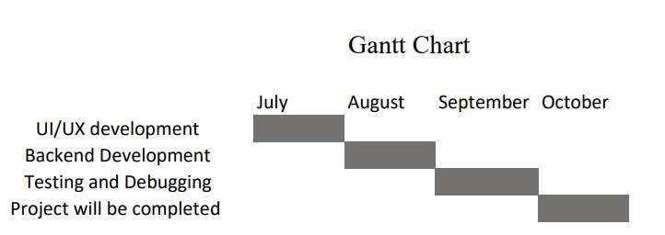

**7. Budget:**

Prepare a comprehensive budget estimate considering development costs, licensing fees (if applicable), infrastructure requirements, and ongoing maintenance and support expenses.

**8. Conclusion:**

The proposed Chatbot-based College Management System aims to enhance communication, automate administrative tasks, and provide quick access to information for students, faculty, and staff. By leveraging the power of artificial intelligence and natural language processing, the system will improve overall efficiency and productivity, leading to a better college experience for all stakeholders.

Implementing such a system will require careful planning, technical expertise, and collaboration between the college administration and the development team. However, the long-term benefits of improved communication, streamlined processes, and enhanced student support make this investment worthwhile for the institution.