**SHRI GOVINDRAM SEKSARIA INSTITUTE OF TECHNOLOGY AND SCIENCE**

**Department of Computer Engineering**

**B.Tech Computer Science**



**Internship Report**

**3rd year (2020-2024)**

**Submitted By:**

Saksham Wane

0801CS213D06



1

**INDEX**

|  |  |
| --- | --- |
| **Title** | **Page No.** |
| **INTERNSHIP CERTIFICATE** | 3 |
| **ORGANIZATION** | 4 |
| **INFORMATION** |  |
| **INTERNSHIP SUMMARY** | 5 |
| **INTERNSHIP DETAIL** | **6** |
| **REPORT** |  |
| **LEARNING OUTCOME OF** | **7** |
| **INTERNSHIP** |  |
|  |  |



2

**INTERNSHIP CERTIFICATE**



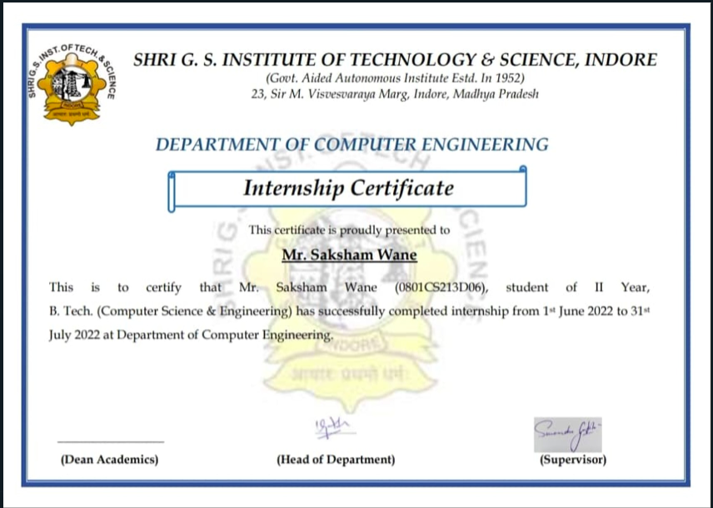

3

**ORGANIZATION INFORMATION**

|  |  |
| --- | --- |
| **Organization** | Shri G.S Institute of Technology and Science |
| **Address** | 23 Sir M. Visvesvaraya Marg, Indore, Madhya |
|  | Pradesh |
| **Title** | Computer Science Department |
| **Mode** | offline |
| **Stipend Received** | 0 |
| **Duration** | 2 months |
| **Time From - To** | 1 June 2022 – 31 July 2022 |

**Company Name:** Computer Science Department



4

**INTERNSHIP SUMMARY**

**Title:** Software Engineer Intern

**Duration:** 2 months

**Nature of Work:** Software Development

**Technologies Used:**

* Frontend – Swing
* Backend – Java



5

**INTERNSHIP DETAIL REPORT**

Project Title: Automation of Exam duty invigilation chart.

|  |  |  |  |
| --- | --- | --- | --- |
| **Month** |  | **Week** | **Task** |
|  |  |  |  |
| **June 2022** | • | **Week 1** | • Configuring tools and setup environment for |
|  |  |  | development. |
|  | • | **Week 2** | • Creating functions to accept and validate input files. |
|  |  |  |  |
|  | • | **Week 3** | • Creating business objects and other functionalities. |
|  |  |  |  |
|  | • | **Week 4** | • Converting business objects to business class. |
|  |  |  |  |
| **July 2022** | • | **Week 1** | • Designing algorithm and completing backend. |
|  |  |  |  |
|  | • | **Week 2** | • Designing and creating frontend. |
|  |  |  |  |
|  | • | **Week 3** | • Testing of the project. |
|  |  |  |  |
|  | • | **Week 4** | • Creating reports and user manual for the software. |
|  |  |  |  |



6

**LEARNING OUTCOME OF INTERNSHIP**

* Handling excel file using apache poi.
* Learning swing for frontend designing.
* Analysis in designing of algorithm.
* Learned Using Github (Version control system).
* Sticking to strict deadlines.
* Learned to work as a team.
* Develop communication, interpersonal and other critical skills.
* Develop work habits.



7