**Task: JMeter (Performance Testing Tool)**

**App-Url: https://blazedemo.com/**

**Task-Work: As of today, I have worked on JMeter Performance testing by applying threads (i.e.,100 of User in 5sec in single loop) on demo application.**

**And even by applying listener kind of reports generates as follows:**

**Kindly find attached screenshots for reference;**

**1.View Results Tress:**

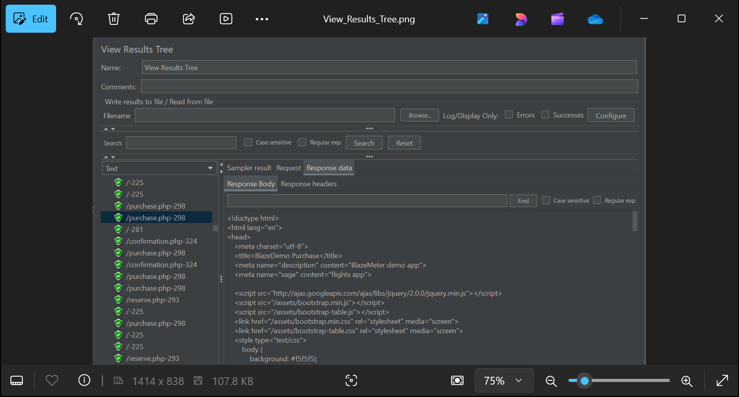

**2.Aggregate Test Report:**

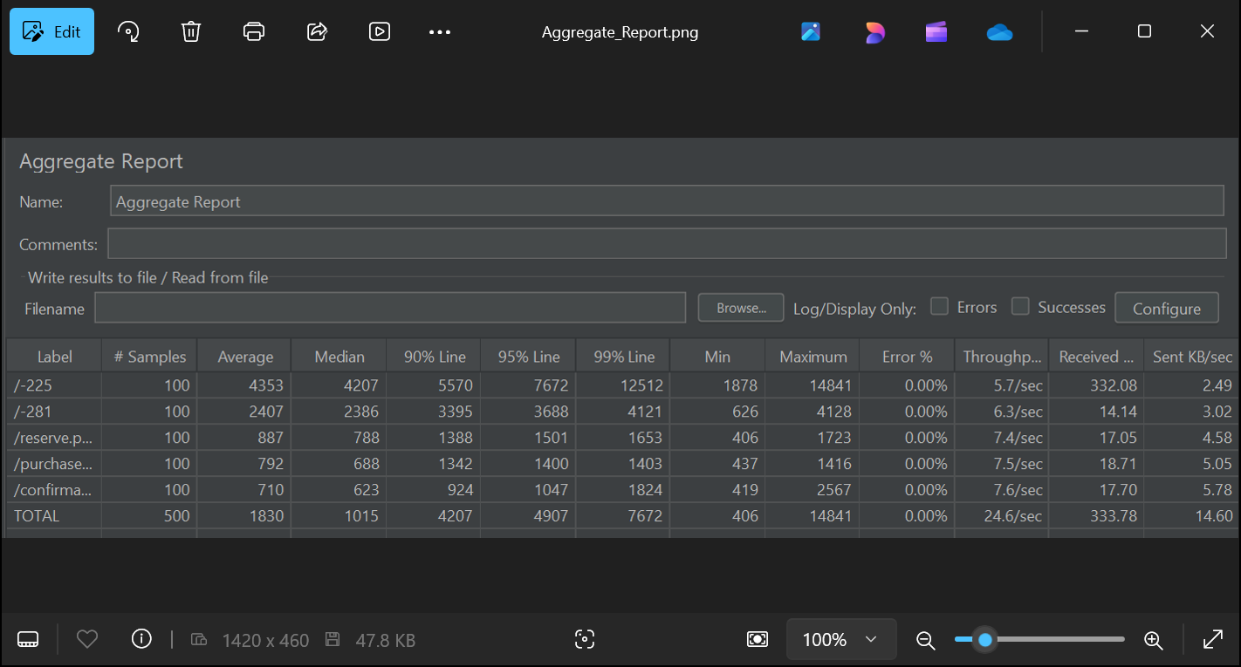

**3.Graph Report:**

