**Work: I have worked on multiple assertions and prepare result as well.**

**Url: https://the-internet.herokuapp.com/login**

**Issue: The kind of issue which I faced during assertions is like deleting HTTP Cookie Manager.**

**Resolve: I got to know that the application which is secure that we need to introduced with Cookie manager without cookie we can’t handle assertions.**

**Kindly find attached screenshot for the reference.**

**Code Assertion:** 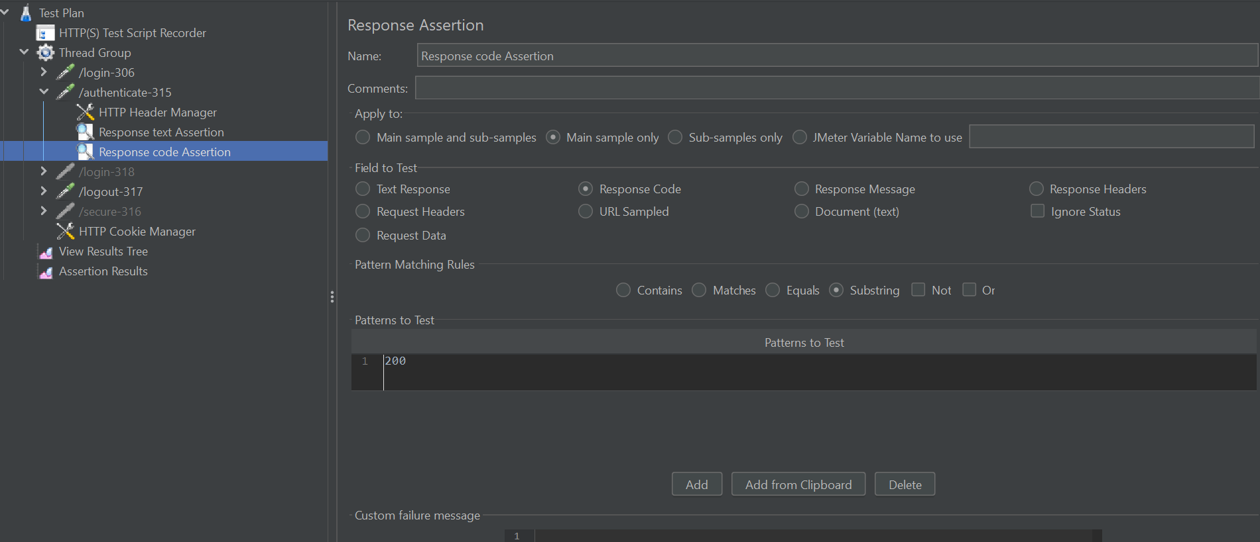

**Size Assertion:**

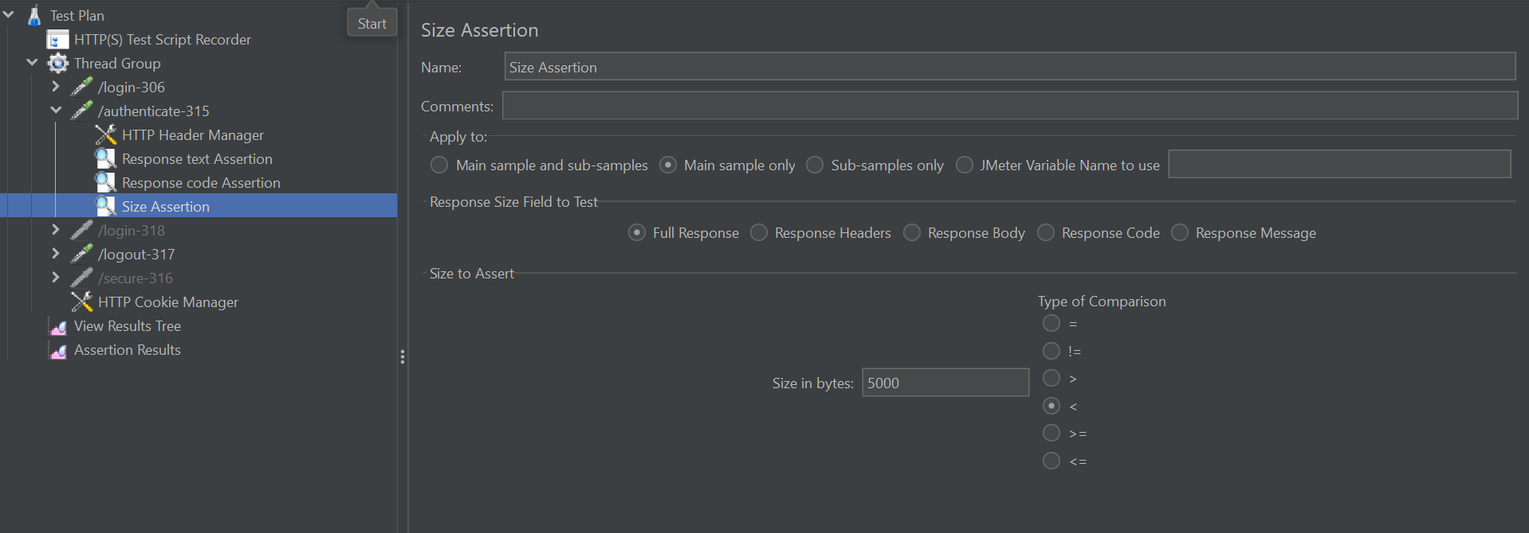

**Text Assertion:** 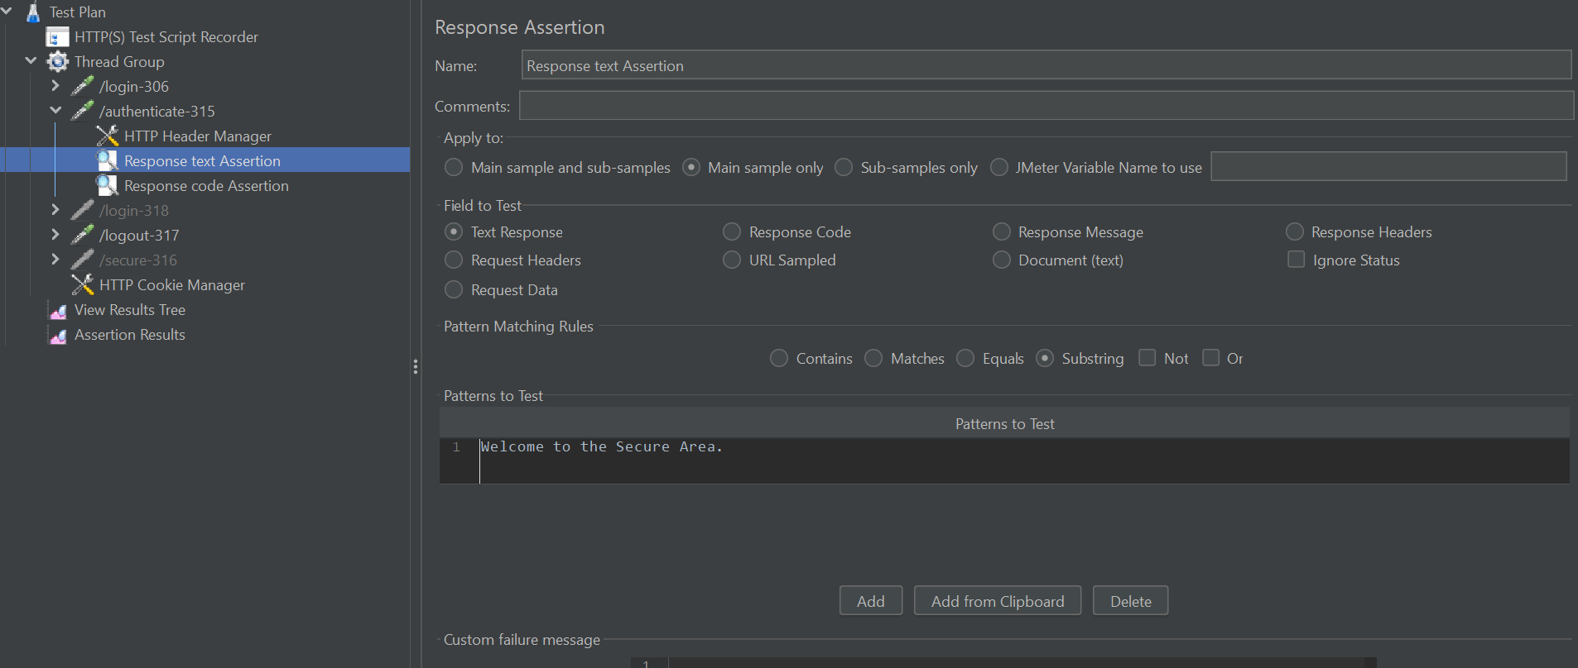

**Duration Assertion:**

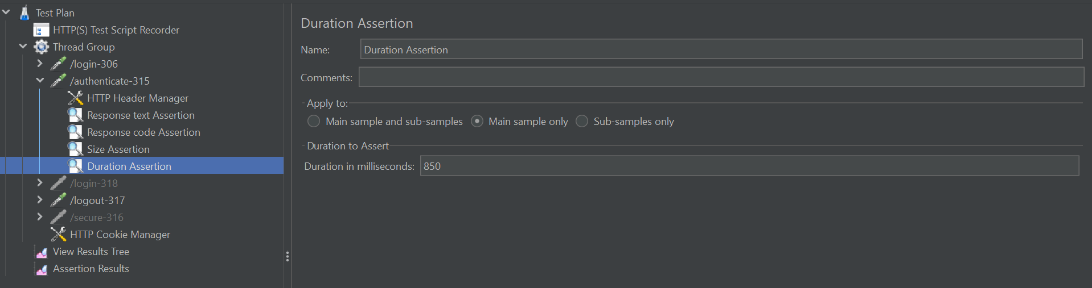

**Assertion Results:**

