**Task: JMeter Performance Testing Tool**

**Work:**

**I have worked on HTTP Cookie Manager and prepared View Results Tree Report.**

**Secure web application can be handled by cookie manager.**

**Kindly find attached View Results Tree Report screenshot before and after applying cookie manager.**

**Before Cookie Manager:**

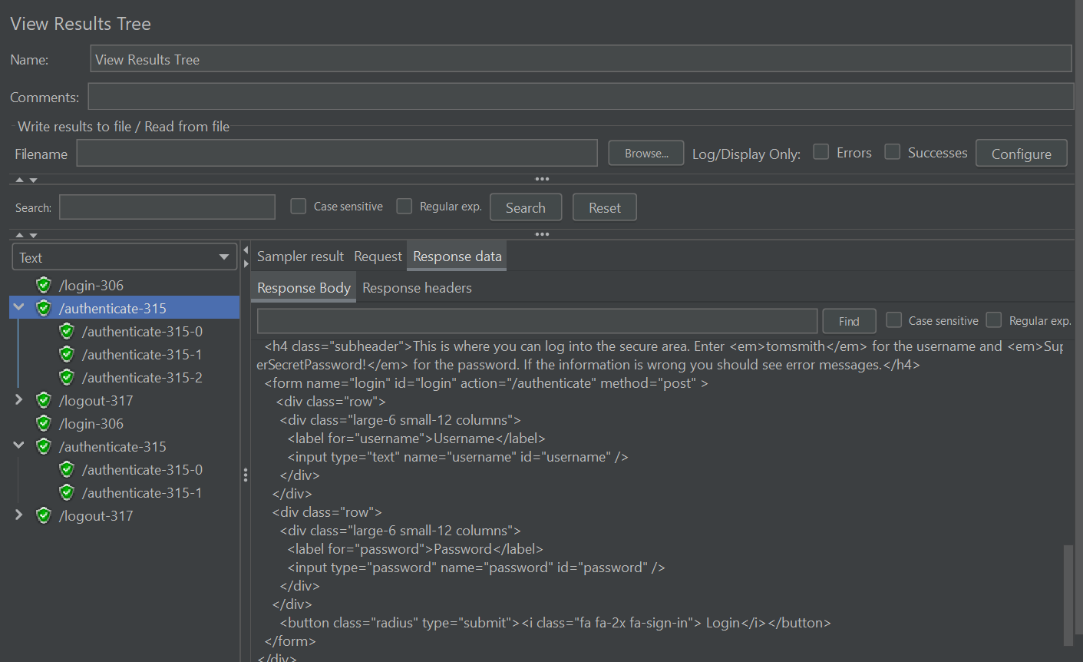

**After Cookie Manager:**

