#include<bits/stdc++.h>

using namespace std;

float fcfs_wt[10]={0}, fcfs_tat[10]={0},fcfs_awt=0,fcfs_atat=0;

float rr_wt[10]={0}, rr_tat[10]={0}, rr_awt=0, rr_atat=0;

float sjf_wt[10]={0}, sjf_tat[10]={0}, sjf_awt=0, sjf_atat=0;

float srtf_wt[10]={0}, srtf_tat[10]={0}, srtf_awt=0, srtf_atat=0;

struct process{

int at;

int id;

};

struct Comparetime {

bool operator()(process const& p1, process const& p2)

{

if(p1.at != p2.at){

return p1.at > p2.at;}

else{

return p1.id>p2.id;

}

}

};

void fcfs_compute(process p[], int bt[]){

int ct=0;

for(int i=0;i<10;i++){

if(p[i].at<=ct){

ct= ct + bt[p[i].id];

fcfs_tat[p[i].id] = ct - p[i].at;

fcfs_wt[p[i].id] = fcfs_tat[p[i].id] - bt[p[i].id];

}

}

}

void sjf_compute(process p[], int bt[]){

int left = 10, ct=0;

int vis[10]={0};

for(;left>0;){

int min=10000;

int flag;

for(int i=0;i<10;i++){

if(p[i].at <=ct && bt[p[i].id]<min && vis[p[i].id]==0){

min = bt[p[i].id];

flag=i;

}

}

ct+=min;

sjf_tat[p[flag].id]= ct - p[flag].at;

sjf_wt[p[flag].id]=sjf_tat[p[flag].id] - bt[p[flag].id];

vis[p[flag].id] = 1;

left--;

}

}

void srtf_compute(process p[], int bt[]){

int bt_temp[10];

for(int i=0;i<10;i++){

bt_temp[i]=bt[i];

}

int n=10;

int left =10;

int flag;

int MAX_INT=1000000, ct=0;

for(;left>0;){

int temp = MAX_INT;

for(int i=0;i<n;i++){

if(bt_temp[p[i].id]>0 && ct>=p[i].at && bt_temp[p[i].id]<temp )

{

flag = i;

temp=bt_temp[p[i].id];

}

}

ct++;

bt_temp[p[flag].id]-=1;

if(bt_temp[p[flag].id]==0){

left=left-1;

srtf_tat[p[flag].id]= ct - p[flag].at;

srtf_wt[p[flag].id] = srtf_tat[p[flag].id] - bt[p[flag].id];

}

}

}

void rr_compute(process p[], int bt[], int tq){

int n=10, quantum_time;

int ariv[n], burst[n], burst_temp[n], cpu_ft[n]={0}, coml[n];

int vis[n]={0};

for(int i=0; i<n;i++){

ariv[p[i].id]=p[i].at;

}

for(int i=0;i<n;i++){

burst[i]= bt[i];

burst_temp[i]=burst[i];

}

quantum_time=tq;

queue <int>q;

q.push(0);

int l=1, left=n, ct=0;

while(left!=0){

int temp = q.front();

q.pop();

if(ariv[temp]<=ct){

if(vis[temp]==0){cpu_ft[temp] = ct;vis[temp]=1;}

if(burst_temp[temp]<=quantum_time){

ct+= burst_temp[temp];

coml[temp]=ct;

left -=1;

while(l<n){

if(ct>=ariv[l]){

q.push(l);

l++;

}else{break;}

}

}else{

ct+=quantum_time;

burst_temp[temp]-=quantum_time;

while(l<n){

if(ct>=ariv[l]){

q.push(l);

l++;

}else{break;}

}

q.push(temp);

}

}else{

ct++;

}

}

for(int i=0;i<10;i++){

rr_tat[i]=coml[i] - ariv[i];

rr_wt[i]=coml[i] - ariv[i]- burst[i];

}

}

int main(){

process p[10];

int bt[]={10,12,8,11,3,15,16,12,7,5},tq;

int at[]={0,2,3,1,4,3,2,6,8,9};

priority_queue<process, vector<process>, Comparetime> Q;

for(int i=0;i<10;i++){

p[i].at= at[i];

p[i].id=i;

}

// for(int i=0;i<10;i++){

// cin>>bt[i];

// }

// cin>>tq;

tq=2;

for (int i = 0; i <10; ++i) {

Q.push(p[i]);

}

for(int i=0;i<10;i++){

p[i]=Q.top();

Q.pop();

}

fcfs_compute(p,bt);

sjf_compute(p,bt);

srtf_compute(p,bt);

rr_compute(p,bt, tq);

cout<<"Process ID:"<<" FCFS_WT"<<" FCFS_TAT"<<" SJF_WT"<<" SJF_TAT"<<" RR_WT"<<" RR_TAT"<<" SRTF_WT"<<" SRTF_TAT\n";

for(int i=0;i<10;i++){

cout<<i+1<<"\t\t"<<fcfs_wt[i]<<"\t"<<fcfs_tat[i]<<"\t"<<sjf_wt[i]<<"\t"<<sjf_tat[i]<<"\t"<<rr_wt[i]<<"\t"<<rr_tat[i]<<"\t"<<srtf_wt[i]<<"\t"<<srtf_tat[i]<<"\n";

}

float total_wtime[4]={0}, total_atime[4]={0};

for(int i=0;i<10;i++){

total_wtime[0]+=fcfs_wt[i];

total_atime[0]+=fcfs_tat[i];

total_wtime[1]+=sjf_wt[i];

total_atime[1]+=sjf_tat[i];

total_wtime[2]+=srtf_wt[i];

total_atime[2]+=srtf_tat[i];

total_wtime[3]+=rr_wt[i];

total_atime[3]+=rr_tat[i];

}

for(int i=0;i<4;i++){

total_atime[i]=total_atime[i]/10;

total_wtime[i]= total_wtime[i]/10;

}

fcfs_awt=total_wtime[0];

fcfs_atat=total_atime[0];

sjf_awt =total_wtime[1];

sjf_atat=total_atime[1];

rr_atat=total_atime[3];

rr_awt=total_wtime[3];

srtf_atat = total_atime[2];

srtf_awt = total_wtime[2];

cout<<"FCFS Average Weighting Time:"<<fcfs_awt<<"\t"<<"FCFS Average Turn around time:"<<fcfs_atat<<"\n";

cout<<"SFJ Average Weighting Time:"<<sjf_awt<<"\t"<<"SFJ Average Turn around time:"<<sjf_atat<<"\n";

cout<<"SRTF Average Weighting Time:"<<srtf_awt<<"\t"<<"SRTF Average Turn around time:"<<srtf_atat<<"\n";

cout<<"RR Average Weighting Time:"<<rr_awt<<"\t"<<"RR Average Turn around time:"<<rr_atat<<"\n";

}

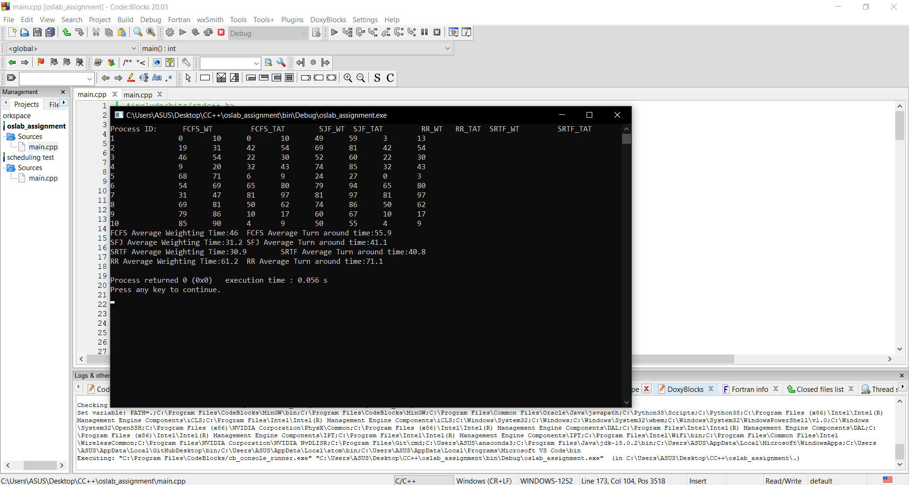

In my opinion SRTF is the best algorithm for this problem as it has the least average turnaround time and average waiting time.