MINI CASE STUDY
From 50% to 65% Alignment
How successive model and prompt iterations improved the reliability of qualitative tagging
“The same instructions and source material should produce the same result.”
The evaluation began by testing that assumption—and measuring where it broke down.
+15 pp | -43 pp | 880
repeat-run alignment | score concentration | modules in scale target

Executive summary
The project compared multiple OpenAI models for a demanding qualitative-tagging task: apply a fixed rubric to hundreds of research modules without drifting, over-interpreting, or collapsing into repetitive scores. The retained project notes show that the GPT-4 baseline produced about 50% variation across runs, while o3-mini-high reduced variation to about 35%. Expressed as derived alignment, repeatability improved from 50% to 65%—a 15-point gain.
DECISION Use o3-mini-high as the default high-volume tagging model, escalate ambiguous or high-stakes cases to full O3, use GPT-4.5 for creative stress-testing rather than primary scoring, and reserve O1 Pro for throughput-sensitive bulk passes.
Scope note: this is a reconstruction from project chat records and process notes—not a controlled external benchmark.

1. The evaluation problem
The team was classifying structured research modules across qualitative dimensions such as ambiguity type, framing move, stabilizer, false clarity, tension axis, organizational implication, and friction archetype. The output needed to be interpretable enough to preserve latent meaning, yet consistent enough to support clustering and archetype development.
Three practical failure modes drove the evaluation:
- Run-to-run variation: the same module received different tags or scores in fresh chats.
- Score flattening: the model reused a safe scoring template instead of distinguishing modules.
- Scale drift: performance could degrade as the batch grew from tens to hundreds of modules.

2. Models considered
Model | Role tested | Observed outcome | Selection
GPT-4 baseline  (recorded as 4.0/4o) | Initial production baseline | 50% observed variation; creative but prone to liberal interpretation | Not selected for repeatable tagging
GPT-4.5 | Nuance and common-sense check | Strong reframing; risk of speculative expansion; no retained alignment % | Secondary stress-test model
Full O3 | High-rigor rubric execution | Best qualitative fit for structured reasoning; slower | Escalation / adjudication model
o3-mini-high | Efficient reasoning model | 35% observed variation; 65% derived alignment | Primary tagging model
O1 Pro | Bulk throughput option | 500-module passes discussed; no retained accuracy % | Scale fallback, not nuanced adjudicator

3. How the evaluation was conducted
The evaluation evolved as a sequence of practical experiments. Each iteration kept the task recognizable while changing either the model, the prompt controls, or the batch design.
Iteration | Change | Test | Practical outcome
1 | Screen the model family | Compare GPT-4o, GPT-4.5, O1, and O3 against rubric fidelity, reasoning depth, and scale. | O3 identified as the highest-rigor evaluator.
2 | Run the rubric at batch scale | Score multiple modules with the same 17-criterion matrix. | All outputs initially collapsed to score 153.
3 | Harden the prompt | Add module resets, mandatory rubric language, duplicate-score audits, and stronger penalty rules. | Score concentration fell from 100% to 57%.
4 | Repeat across model variants | Compare output variation under GPT-4 baseline and o3-mini-high. | Derived alignment rose from 50% to 65%.
5 | Test operating scale | Compare o3-mini-high batches with O1 Pro’s 500–880 module throughput proposition. | Adopt a tiered model workflow rather than one universal model.

Metric definitions
Metric | Meaning
Observed variation | Share of outputs that changed across repeated runs, as recorded in the project notes.
Derived alignment | 100% minus observed variation. Used as a simple repeatability indicator.
Identical-score concentration | Share of a batch receiving the same final score (153). High concentration indicated score flattening, not quality.
Differentiation rate | 100% minus identical-score concentration. Used to show whether the rubric separated modules.

IMPORTANT Alignment and score concentration are different indicators. The first measures repeatability across runs; the second detects whether a scoring rubric is producing meaningful separation within a batch.

4. Results across iterations
Indicator | Iteration | Observed result | Converted metric | Change
Model repeatability | GPT-4 baseline | 50% variation | 50% derived alignment | Baseline
Model repeatability | o3-mini-high | 35% variation | 65% derived alignment | +15 pp
Rubric differentiation | Initial scoring run | 30/30 shared score 153 | 0% differentiated | Failure state
Rubric differentiation | After prompt hardening | 17/30 shared score 153 | 43.3% differentiated | +43.3 pp

5. What changed in the numbers
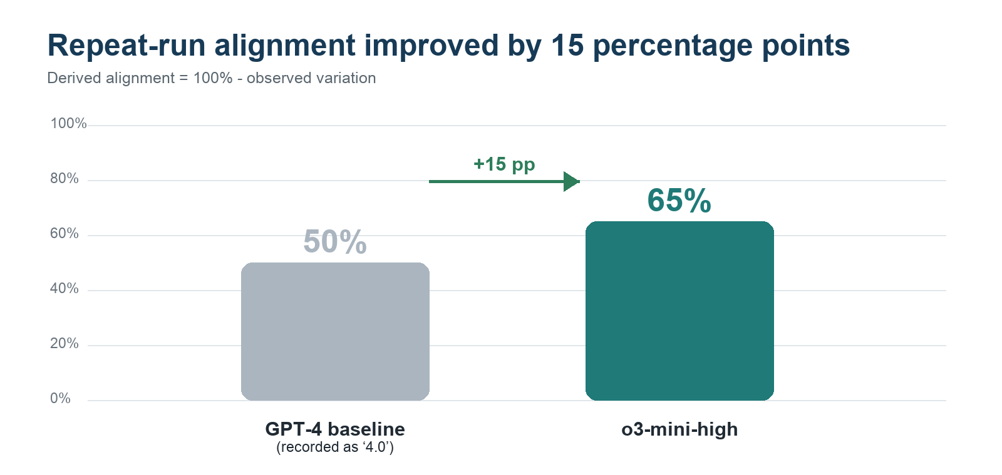
Figure 1. Only two model variants had retained percentage measurements. Alignment is derived from the recorded variation rates.
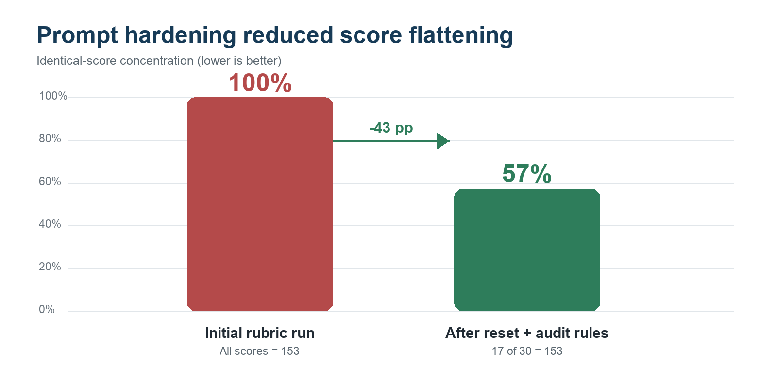
Figure 2. Prompt-level controls reduced—but did not eliminate—the model’s tendency to reuse the same score.

6. A concrete module-level example
Categorical Module 37 – C2-I1 was evaluated twice in fresh chat windows using the same rubric. The final scores were nearly identical, but the second run showed materially different reasoning behavior.
Criterion | Run 1 | Run 2 | What changed
Bias Visibility | 4 × 2 = 8 | 5 × 2 = 10 | Second run recognized stronger evidence.
Over-Generality Penalty | 1 × -2 = -2 | 3 × -2 = -6 | Second run applied a more meaningful penalty.
Cross-Level Noise | 4 × 2 = 8 | 5 × 2 = 10 | Interpretation changed despite identical source material.
Final score | 153 | 152 | Only a 1-point change, masking larger criterion-level movement.

INTERPRETATION A stable total score did not guarantee a stable evaluation. The diagnostic therefore expanded beyond final-score comparison to inspect criterion-level decisions, justification quality, and recurring score patterns.

7. Final model selection
The evaluation did not produce one universal winner. It produced a task-specific operating stack that balanced repeatability, reasoning depth, and throughput.
Workflow role | Selected model | Why
Default tagging | o3-mini-high | Best retained repeat-run result (65% derived alignment) with practical 30–50 module batches.
Ambiguous or high-stakes cases | Full O3 | Highest rubric fidelity and deeper structured reasoning; used where nuance matters more than speed.
Creative counterfactual testing | GPT-4.5 | Useful for reframing and challenging assumptions after reliable extraction—not for primary scoring.
Very large batch triage | O1 Pro | Potential 500-module throughput; requires sampling and escalation because no retained accuracy percentage was documented.
Retired baseline | GPT-4 baseline | Higher observed variation and repeated concern about imaginative interpretation of qualitative criteria.

BOTTOM LINE For repeatable qualitative tagging, o3-mini-high was the best measured production choice. Full O3 remained the quality backstop, while GPT-4.5 and O1 Pro were assigned narrower supporting roles.

8. What the team learned
- Model choice mattered, but prompt architecture also materially changed behavior.
- A single final score could conceal significant changes in criterion-level reasoning.
- Repeated-score concentration was a useful diagnostic for evaluator laziness or anchoring.
- Throughput claims needed to be separated from measured reliability.
- The final workflow benefited from routing work by task type instead of asking one model to do everything.

Evidence and limitations
This mini case study reconstructs the evaluation from retained ChatGPT thread exports and a later process summary. The original run-level dataset, sample sizes behind the 35% and 50% variation figures, and a direct percentage result for GPT-4.5, full O3, and O1 Pro were not retained in the reviewed files. Those models are therefore presented with qualitative outcomes only. The 50% and 65% alignment values are explicitly derived as the complement of recorded variation.

Source threads
Thread | Date | Evidence used
D³ process | 2025-05-05 | Recorded ~35% variation for o3-mini-high and ~50% for the GPT-4 baseline; noted comparative model analysis and tagging accuracy.
Categorical Module Evaluation Strategy | 2025-03-25 | Model shortlist; repeated score of 153; 17 of 30 modules at 153; Module 37 two-run comparison.
Research Synthesis 1 | 2025-03-17 | Defined O3 as precision model and GPT-4.5 as creative counterfactual model.
Reducing Output Variability | 2025-04-08 | Compared O1 Pro, O3, and o3-mini-high for interpretive variability, batching, and throughput.
GPT-4.5 vs GPT-4o Evaluation | 2025-04-13 | Documented concern that GPT-4o was too imaginative for qualitative tagging.
GPT Model Selection for Modality | 2025-04-02 | Compared GPT-4o and o3-mini-high on abstraction, contamination, and label variance.

Prepared from files in HBS/Chat Threads. Percentages should be treated as internal directional evidence, not general model benchmarks.

