1)Simple_Compound_Interest
#include <iostream>
using namespace std;

int main()
{
float P, R, T;
float SI, CI;
float amount = 1;

cout << "Enter Principal: ";
cin >> P;

cout << "Enter Rate: ";
cin >> R;

cout << "Enter Time: ";
cin >> T;

// Simple Interest
SI = (P * R * T) / 100;

// Calculate (1 + R/100)^T manually
float base = 1 + R / 100;

for(int i = 0; i < T; i++)
{
amount = amount * base;
}

CI = P * amount - P;

cout << "Simple Interest = " << SI << endl;
cout << "Compound Interest = " << CI << endl;

return 0;
}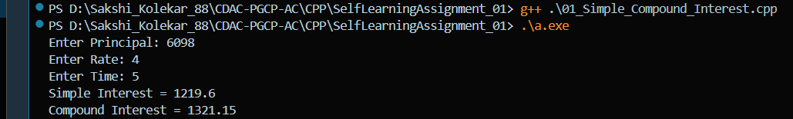

2)Transpose
#include <iostream>
using namespace std;

int main()
{
int a[10][10], t[10][10];
int r,c;

cout<<"Enter rows and columns: ";
cin>>r>>c;

cout<<"Enter matrix elements:\n";

for(int i=0;i<r;i++)
for(int j=0;j<c;j++)
cin>>a[i][j];

for(int i=0;i<r;i++)
for(int j=0;j<c;j++)
t[j][i]=a[i][j];

cout<<"Original Matrix\n";

for(int i=0;i<r;i++)
{
for(int j=0;j<c;j++)
cout<<a[i][j]<<" ";
cout<<endl;
}

cout<<"Transpose Matrix\n";

for(int i=0;i<c;i++)
{
for(int j=0;j<r;j++)
cout<<t[i][j]<<" ";
cout<<endl;
}

return 0;
}
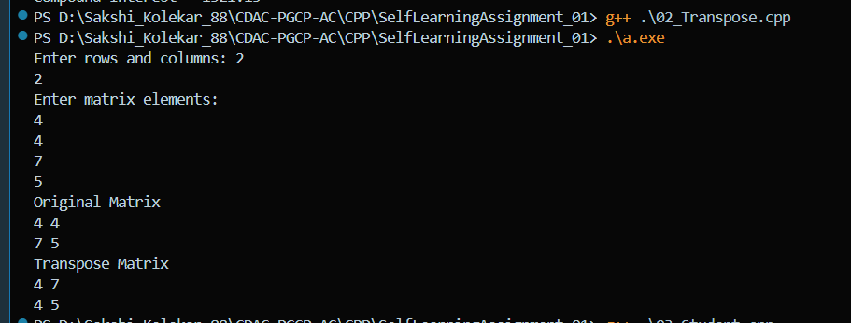

3)student
#include <iostream>
using namespace std;

class Student
{
private:
char name[50];
int m1,m2,m3;

public:
void accept()
{
cout<<"Enter Name: ";
cin>>name;

cout<<"Enter Marks 1: ";
cin>>m1;

cout<<"Enter Marks 2: ";
cin>>m2;

cout<<"Enter Marks 3: ";
cin>>m3;
}

void result()
{
if(m1>=50 && m2>=50 && m3>=50)
cout<<name<<" PASS\n";
else
cout<<name<<" FAIL\n";
}
};

int main()
{
int n;

cout<<"Enter number of students: ";
cin>>n;

Student s[50];

for(int i=0;i<n;i++)
s[i].accept();

for(int i=0;i<n;i++)
s[i].result();

return 0;
}
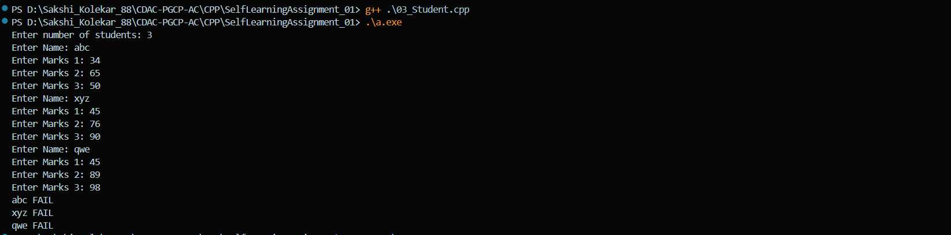

4)Average
#include <iostream>
using namespace std;

int main()
{
int marks[5];
int sum=0,count=0;

cout<<"Enter 5 marks\n";

for(int i=0;i<5;i++)
{
cin>>marks[i];
sum+=marks[i];

if(marks[i] < 65)
count++;
}

float avg = sum / 5.0;

cout<<"Average = "<<avg<<endl;
cout<<"Marks less than 65 = "<<count<<endl;

return 0;
}
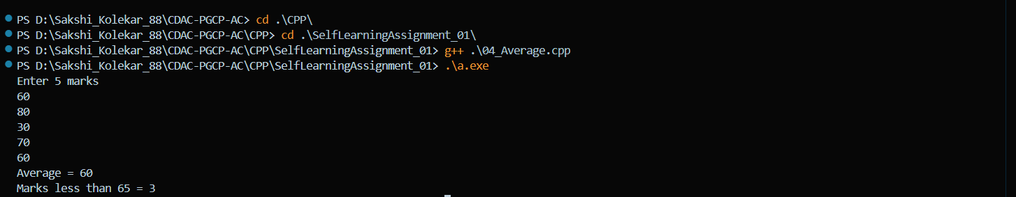

5)Matrix_Operation
#include <iostream>
using namespace std;

class Matrix
{
private:
int a[2][2];

public:
void accept()
{
for(int i=0;i<2;i++)
for(int j=0;j<2;j++)
cin>>a[i][j];
}

void display()
{
for(int i=0;i<2;i++)
{
for(int j=0;j<2;j++)
cout<<a[i][j]<<" ";
cout<<endl;
}
}

Matrix operator+(Matrix m)
{
Matrix temp;

for(int i=0;i<2;i++)
for(int j=0;j<2;j++)
temp.a[i][j] = a[i][j] + m.a[i][j];

return temp;
}

Matrix operator-(Matrix m)
{
Matrix temp;

for(int i=0;i<2;i++)
for(int j=0;j<2;j++)
temp.a[i][j] = a[i][j] - m.a[i][j];

return temp;
}

Matrix operator*(Matrix m)
{
Matrix temp;

for(int i=0;i<2;i++)
{
for(int j=0;j<2;j++)
{
temp.a[i][j]=0;

for(int k=0;k<2;k++)
temp.a[i][j]+=a[i][k]*m.a[k][j];
}
}

return temp;
}
};

int main()
{
Matrix m1,m2,m3;
int choice;

cout<<"Enter Matrix 1\n";
m1.accept();

cout<<"Enter Matrix 2\n";
m2.accept();

cout<<"1 Add\n2 Subtract\n3 Multiply\n";
cin>>choice;

if(choice==1)
m3 = m1 + m2;

else if(choice==2)
m3 = m1 - m2;

else
m3 = m1 * m2;

cout<<"Result Matrix\n";
m3.display();

return 0;
}
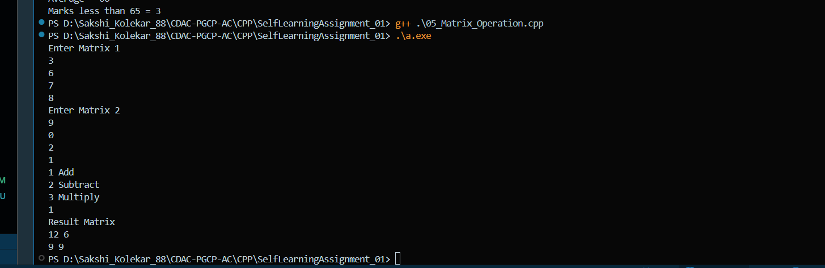
06)Donor
#include <iostream>
#include <cstring>
using namespace std;

class Donor
{
public:
int number;
char name[50];
int age;
char address[100];
char sex;
char blood[5];

void accept()
{
cout<<"Enter Donor Number: ";
cin>>number;

cout<<"Enter Name: ";
cin>>name;

cout<<"Enter Age: ";
cin>>age;

cout<<"Enter Address: ";
cin>>address;

cout<<"Enter Sex (M/F): ";
cin>>sex;

cout<<"Enter Blood Group: ";
cin>>blood;
}

void display()
{
cout<<number<<" "<<name<<" "<<address<<endl;
}
};

int main()
{
Donor d[50];
int n;

cout<<"Enter number of donors: ";
cin>>n;

for(int i=0;i<n;i++)
d[i].accept();

cout<<"Donors with Blood Group O+\n";

for(int i=0;i<n;i++)
if(strcmp(d[i].blood,"O+")==0)
d[i].display();

return 0;
}

7)Electricity
#include <iostream>
using namespace std;

int main()
{
char name[50];
int units;
float bill = 0;

cout<<"Enter User Name: ";
cin>>name;

cout<<"Enter Units Consumed: ";
cin>>units;

if(units <= 100)
{
bill = units * 5.5;
}
else if(units <= 300)
{
bill = (100 * 5.5) + (units - 100) * 7.25;
}
else
{
bill = (100 * 5.5) + (200 * 7.25) + (units - 300) * 8.75;
}

if(bill < 60)
bill = 60;

if(bill > 750)
bill = bill + (bill * 0.10);

cout<<"Name: "<<name<<endl;
cout<<"Total Bill = "<<bill<<endl;

return 0;
}
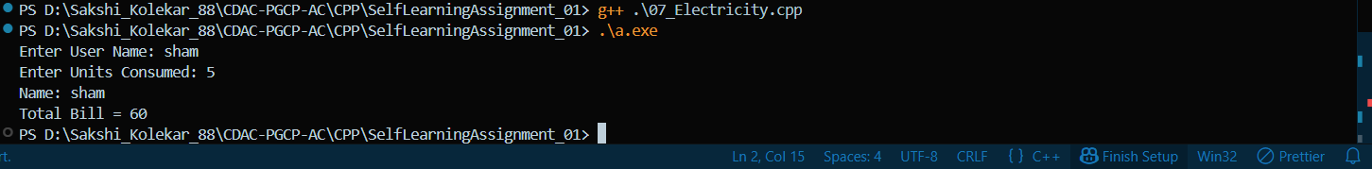
8)Operator
#include <iostream>
using namespace std;

int main()
{
float a, b, result;
char op;

cout<<"Enter operand 1: ";
cin>>a;

cout<<"Enter operand 2: ";
cin>>b;

cout<<"Enter operation (+,-,*,/): ";
cin>>op;

switch(op)
{
case '+':
result = a + b;
break;

case '-':
result = a - b;
break;

case '*':
result = a * b;
break;

case '/':
result = a / b;
break;

default:
cout<<"Invalid Operation";
return 0;
}

cout<<"Result = "<<result;

return 0;
}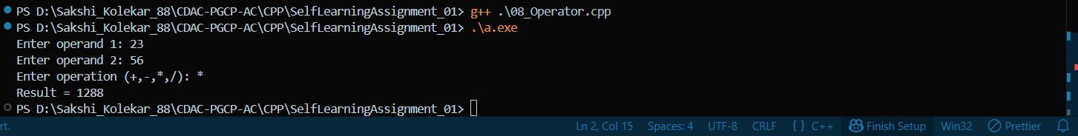

9)Time
#include <iostream>
using namespace std;

class Time
{
private:
int h,m,s;

public:

void accept()
{
cout<<"Enter Hours Minutes Seconds: ";
cin>>h>>m>>s;
}

void addHours(int x)
{
h = h + x;
}

void addMinutes(int x)
{
m = m + x;

if(m>=60)
{
h = h + m/60;
m = m % 60;
}
}

void addSeconds(int x)
{
s = s + x;

if(s>=60)
{
m = m + s/60;
s = s % 60;
}
}

void display()
{
cout<<"Time = "<<h<<":"<<m<<":"<<s<<endl;
}
};

int main()
{
Time t;
int choice,x;

t.accept();

cout<<"1 Add Hours\n2 Add Minutes\n3 Add Seconds\n";
cin>>choice;

cout<<"Enter value: ";
cin>>x;

if(choice==1)
t.addHours(x);

else if(choice==2)
t.addMinutes(x);

else
t.addSeconds(x);

t.display();

return 0;
}

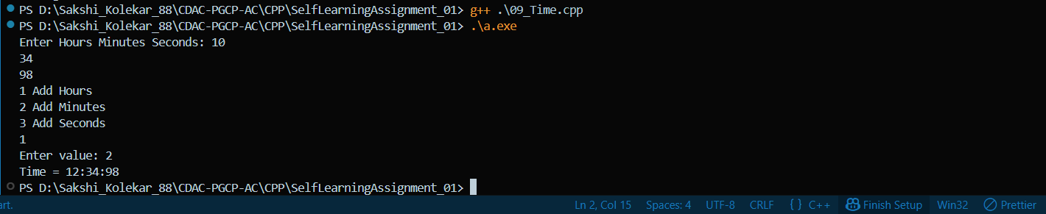
10)Number
#include <iostream>
using namespace std;

void oddEven(int n)
{
if(n%2==0)
cout<<"Even Number\n";
else
cout<<"Odd Number\n";
}

void posNeg(int n)
{
if(n>=0)
cout<<"Positive Number\n";
else
cout<<"Negative Number\n";
}

int main()
{
int num,choice;

cout<<"Enter Number: ";
cin>>num;

cout<<"1 Prime or not\n2 Odd or Even\n3 Positive or Negative\n4 Exit\n";

cin>>choice;

switch(choice)
{
case 2: oddEven(num); break;
case 3: posNeg(num); break;
case 4: break;
default: cout<<"Invalid choice";
}

return 0;
}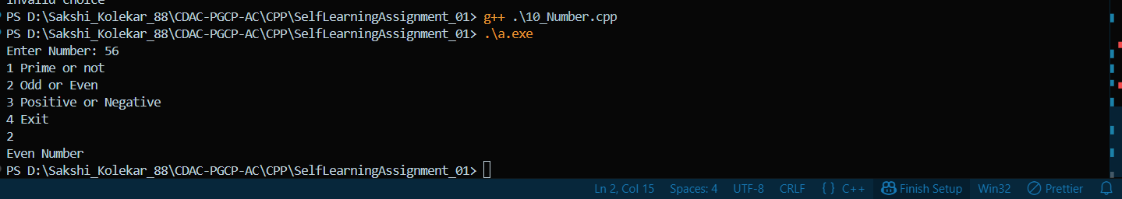

11)Reverse
#include <iostream>
using namespace std;

void reverse(char str[])
{
int i=0,len=0;

while(str[len]!='\0')
len++;

for(i=len-1;i>=0;i--)
cout<<str[i];
}

int main()
{
char str[100];

cout<<"Enter String: ";
cin>>str;

cout<<"Reverse = ";
reverse(str);

return 0;
}

12)CmpString
#include <iostream>
using namespace std;

int main()
{
char s1[50], s2[50];
int i=0;

cout<<"Enter String 1: ";
cin>>s1;

cout<<"Enter String 2: ";
cin>>s2;

while(s1[i]==s2[i] && s1[i]!='\0' && s2[i]!='\0')
i++;

if(s1[i]=='\0' && s2[i]=='\0')
cout<<"Strings are Equal";
else
cout<<"Strings are Different";

return 0;
}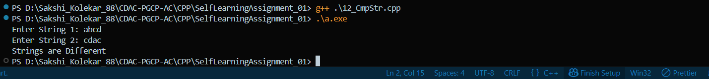

13)Vowel_Consonents
#include <iostream>
using namespace std;

int main()
{
char str[200];
int v=0,c=0,i=0;

cout<<"Enter text: ";
cin.getline(str,200);

while(str[i]!='\0')
{
if(str[i]=='a'||str[i]=='e'||str[i]=='i'||str[i]=='o'||str[i]=='u'||
str[i]=='A'||str[i]=='E'||str[i]=='I'||str[i]=='O'||str[i]=='U')
v++;

else if((str[i]>='a' && str[i]<='z') || (str[i]>='A' && str[i]<='Z'))
c++;

i++;
}

cout<<"Vowels = "<<v<<endl;
cout<<"Consonants = "<<c<<endl;

return 0;
}
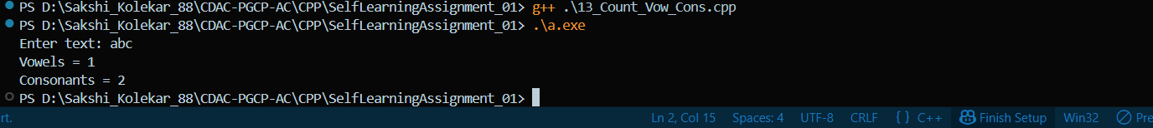

14)Stock
#include <iostream>
using namespace std;

class Stock
{
private:
int code;
int qty;
float price;

public:

void set(int c,int q,float p)
{
code=c;
qty=q;
price=p;
}

void purchase(int q)
{
qty = qty + q;
}

void sell(int q)
{
if(qty>=q)
qty = qty - q;
else
cout<<"Not enough stock\n";
}

void display()
{
cout<<"Item Code: "<<code<<endl;
cout<<"Quantity: "<<qty<<endl;
cout<<"Price: "<<price<<endl;
}
};

int main()
{
Stock s;

s.set(101,50,100);

s.purchase(20);
s.sell(10);

s.display();

return 0;
}
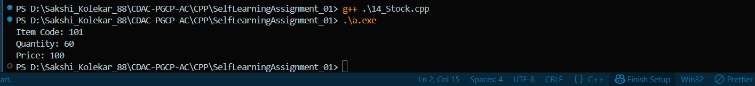

15)Power
#include <iostream>
using namespace std;

double power(double n,int p=2)
{
double result=1;

for(int i=0;i<p;i++)
result=result*n;

return result;
}

int main()
{
double num;
int p;

cout<<"Enter number: ";
cin>>num;

cout<<"Enter power: ";
cin>>p;

cout<<"Result = "<<power(num,p)<<endl;

return 0;
}

