1. Print Hello World

#include<iostream>
using namespace std;
int main(){
cout<<"Hello world";
return 0;
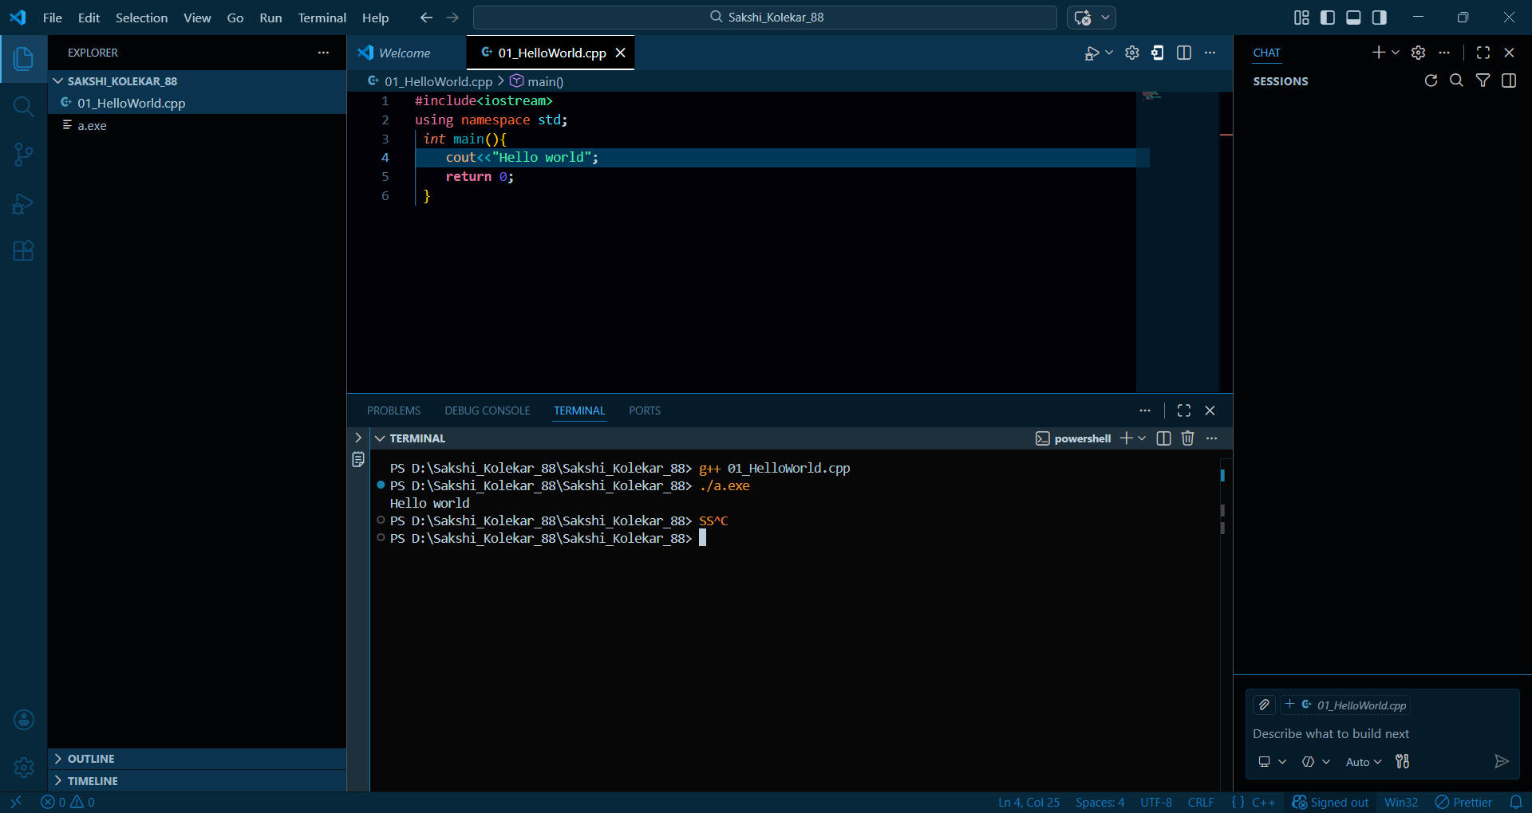
}

2. Add two numbers/binary numbers/characters
#include <iostream>
using namespace std;

int main() {
int a, b;
cout << "Enter two integers: ";
cin >> a >> b;
cout << "Sum = " << a + b << endl;

char c1, c2;
cout << "Enter two characters: ";
cin >> c1 >> c2;
cout << "Sum of ASCII values = " << int(c1) + int(c2) << endl;

return 0;
}
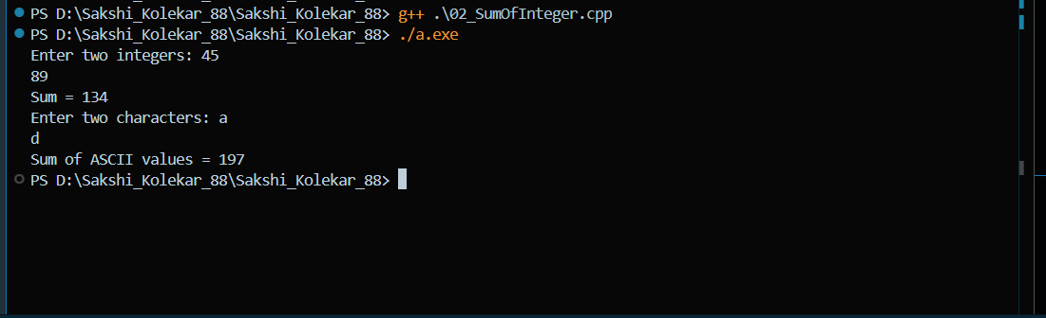

#include <iostream>
using namespace std;

//function for addition of twobinary numbers
int addBinary(int a, int b)
{
while (b != 0)
{
int carry = (unsigned)a & b; // carry
a = a ^ b; // sum without carry
b = carry << 1; // shift carry
}
return a;
}

int main()
{
int a, b;

cout << "Enter first number: ";
cin >> a;

cout << "Enter second number: ";
cin >> b;

int result = addBinary(a, b);

cout << "Sum = " << result << endl;

return 0;
}

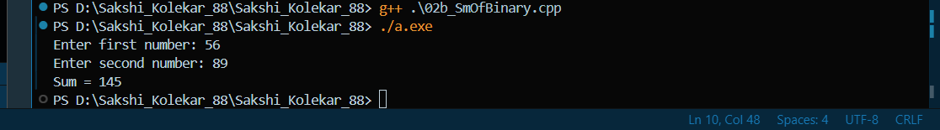

3. Calculate compound interest
#include <iostream>
using namespace std;
//program for calculating compound interest
int main() {
double P, R, T;

cout << "Enter Principal, Rate(%), Time(years): ";
cin >> P >> R >> T;

double rate = 1 + (R / 100);
double power = 1;

// Manually calculate (1 + R/100)^T
for (int i = 0; i < T; i++) {
power = power * rate;
}

double CI = P * power - P;

cout << "Compound Interest = " << CI << endl;

return 0;
}

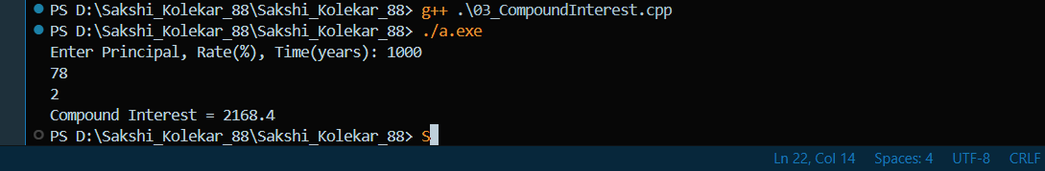

4. Calculate power of a number
#include <iostream>
using namespace std;
//power of number
int main() {
long long base, exp;
long long result = 1;

cout << "Enter base and exponent: ";
cin >> base >> exp;

for (int i = 0; i < exp; i++) {
result = result * base;
}

cout << "Power = " << result << endl;

return 0;
}
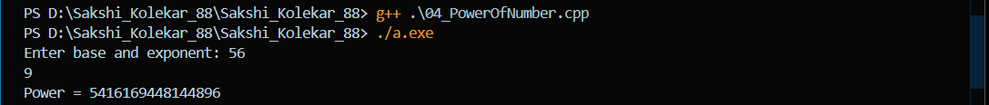
Function Assignments
5. Swap two numbers
#include <iostream>
using namespace std;
//swapping of two variables
void swapNumbers(int &x, int &y) {
x = x+y;
y = x-y;
x=x-y;
}

int main() {
int a, b;
cout << "Enter two numbers: ";
cin >> a >> b;
swapNumbers(a, b);
cout << "After swap: a=" << a << " b=" << b << endl;
return 0;
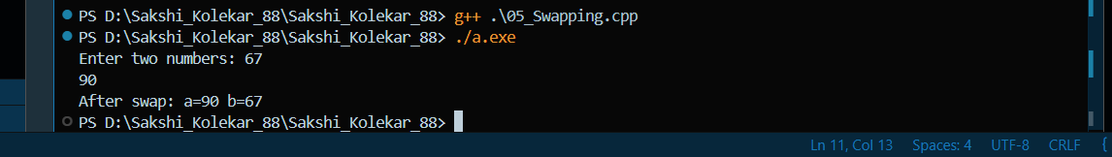
}

6. Calculate area of rectangle
#include <iostream>
using namespace std;
//function for calculating area
int areaRectangle(int l, int w) {
return l * w;
}

int main() {
int length, width;
cout << "Enter length and width: ";
cin>>length>>width;
cout << "Area = " << areaRectangle(length, width) << endl;
return 0;
}

7. Get 4 digit number from user, write a function to calculate sum of
digits of the 4-digit number:
• Using loop
#include <iostream>
using namespace std;
//sum of digits using loop
int sumDigitsLoop(int num) {
int sum = 0;
while(num > 0) {
sum += num % 10;
num /= 10;
}
return sum;
}

int main() {
int n;
cout << "Enter 4-digit number: ";
cin >> n;
cout << "Sum of digits (loop) = " << sumDigitsLoop(n) << endl;
return 0;
}

• Using recursion
#include <iostream>
using namespace std;
//recurssive function for sum of digits
int sumDigitsRec(int num) {
if(num == 0) return 0;
return (num % 10) + sumDigitsRec(num / 10);
}

int main() {
int n;
cout << "Enter 4-digit number: ";
cin >> n;
cout << "Sum of digits (recursion) = " << sumDigitsRec(n) << endl;
return 0;
}
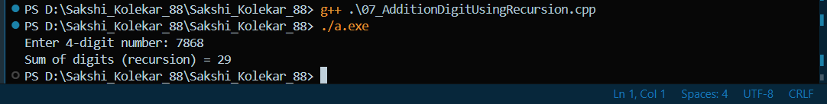

8. Write a recursive function to obtain n numbers of a Fibonacci series
0 1 1 2 3 5 8 13 21 34 55 89...
#include <iostream>
using namespace std;
//recurssive function for fibonacci series
int fibonacci(int n) {
if(n <= 1) return n;
return fibonacci(n-1) + fibonacci(n-2);
}

int main() {
int terms;
cout << "Enter number of terms: ";
cin >> terms;
for(int i = 0; i < terms; i++)
cout << fibonacci(i) << " ";
cout << endl;
return 0;
}

9. Write a function to find the binary equivalent of this number using
recursion.
#include <iostream>
using namespace std;

void toBinary(int n) {
if(n == 0) return;
toBinary(n / 2);
cout << n % 2;
}

int main() {
int num;
cout << "Enter a number: ";
cin >> num;
cout << "Binary equivalent: ";
if(num == 0) cout << 0;
else toBinary(num);
cout << endl;
return 0;
}
