17. Accept n numbers from users and store them in to array. Write a function to sort and
display sorted array.
i/p:[1,4,32,5]
o/p:[1,4,5,32]

#include <iostream>
using namespace std;
//function for sorting array
void sortArray(int arr[], int n) {
for (int i = 0; i < n-1; i++) {
for (int j = 0; j < n-i-1; j++) {
if (arr[j] > arr[j+1]) {
// swap
int temp = arr[j];
arr[j] = arr[j+1];
arr[j+1] = temp;
}
}
}
cout << "Sorted array: ";
for (int i = 0; i < n; i++) cout << arr[i] << " ";
cout << endl;
}

int main() {
int n;
cout << "Enter number of elements: ";
cin >> n;
int arr[n];
cout << "Enter elements: ";
for (int i = 0; i < n; i++) cin >> arr[i];
sortArray(arr, n);
return 0;
}

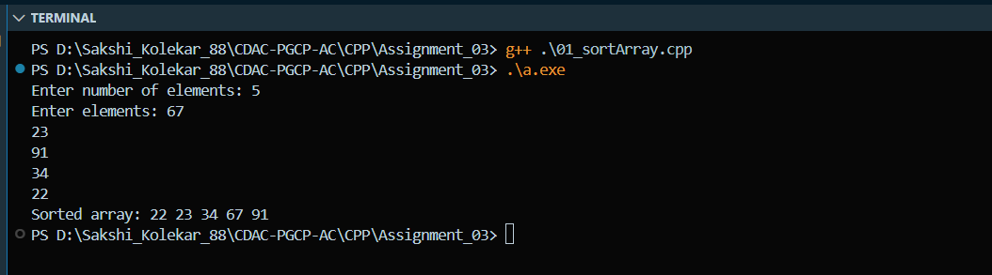

18. Accept n characters from user and search a character appears how many times in the array.
i/p:['a','b','c','d','a']
search 'a'
o/p: a count is 2

#include <iostream>
using namespace std;
//Function For Counting Number Of Character We Are Searching For
int countChar(char arr[], int n, char search) {
int count = 0;
for (int i = 0; i < n; i++) {
if (arr[i] == search) count++;
}
return count;
}

int main() {
int n;
cout << "Enter number of characters: ";
cin >> n;
char arr[n];
cout << "Enter characters: ";
for (int i = 0; i < n; i++) cin >> arr[i];
char search;
cout << "Enter character to search: ";
cin >> search;
cout << search << " count is " << countChar(arr, n, search) << endl;
return 0;
}
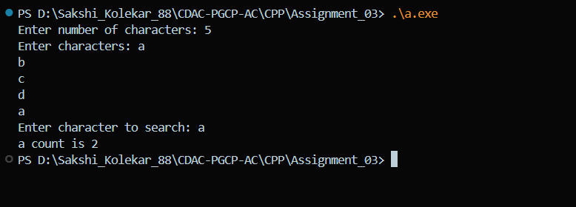
19. Accept n numbers from user and write a function to find out average and display average.
i/p:{10,20,30}
o/p:Average: 20

#include <iostream>
using namespace std;
//Function to find average of number
double findAverage(int arr[], int n) {
int sum = 0;
for (int i = 0; i < n; i++) sum += arr[i];
return (double)sum / n;
}

int main() {
int n;
cout << "Enter number of elements: ";
cin >> n;
int arr[n];
cout << "Enter elements: ";
for (int i = 0; i < n; i++) cin >> arr[i];
cout << "Average: " << findAverage(arr, n) << endl;
return 0;
}
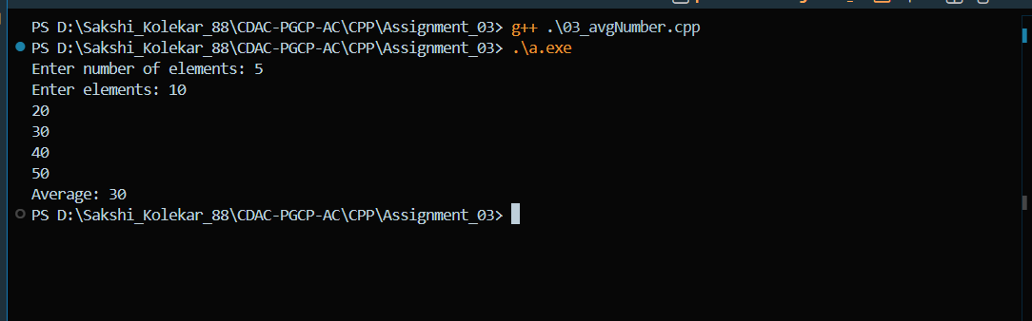

20. Accept n numbers from user and write a function to multiply each num-ber by 2 and display
result.
i/p: [10,20,30,40]
o/p:[20,40,60,40]

#include <iostream>
using namespace std;
//multiply given numbers array by 2
void multiplyByTwo(int arr[], int n) {
for (int i = 0; i < n; i++) arr[i] *= 2;
cout << "Result: ";
for (int i = 0; i < n; i++) cout << arr[i] << " ";
cout << endl;
}

int main() {
int n;
cout << "Enter number of elements: ";
cin >> n;
int arr[n];
cout << "Enter elements: ";
for (int i = 0; i < n; i++) cin >> arr[i];
multiplyByTwo(arr, n);
return 0;
}
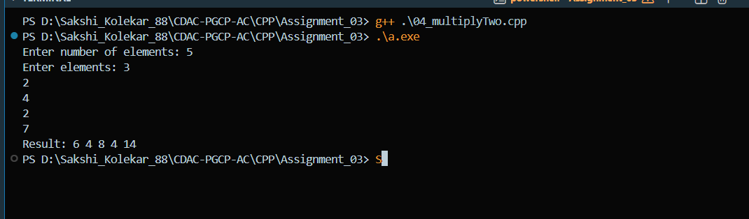

21. Accept n number from user and write functions for finding min, max, second max and
second min from these numbers
i/p: [10,20,30,40,5,7,10]
o/p:min:10
second min: 20
max:40
second max:30

#include <iostream>
using namespace std;
//function for finding max among number
void findMinMax(int arr[], int n) {
// First sort manually
for (int i = 0; i < n-1; i++) {
for (int j = 0; j < n-i-1; j++) {
if (arr[j] > arr[j+1]) {
int temp = arr[j];
arr[j] = arr[j+1];
arr[j+1] = temp;
}
}
}

cout << "Min: " << arr[0] << endl;
cout << "Second Min: " << arr[1] << endl;
cout << "Max: " << arr[n-1] << endl;
cout << "Second Max: " << arr[n-2] << endl;
}

int main() {
int n;
cout << "Enter number of elements: ";
cin >> n;
int arr[n];
cout << "Enter elements: ";
for (int i = 0; i < n; i++) cin >> arr[i];
findMinMax(arr, n);
return 0;
}

