NAME: Sakshi Shinde SAP ID: 86062300041

Roll No.: A064

**Practical 3: Identity and Access Management**

Search IAM after logging into your AWS account.

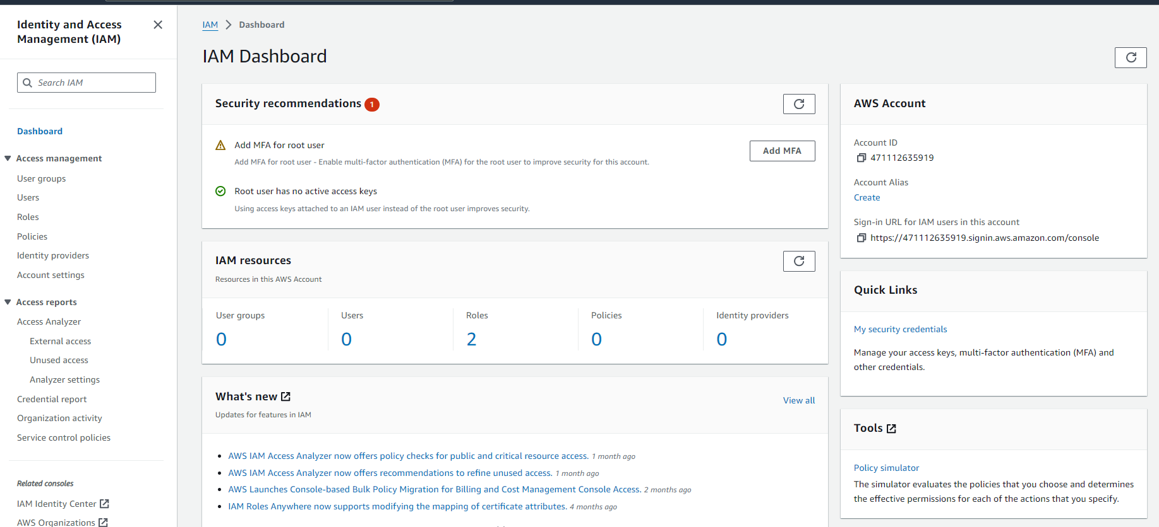

Select Users from left tab and create user

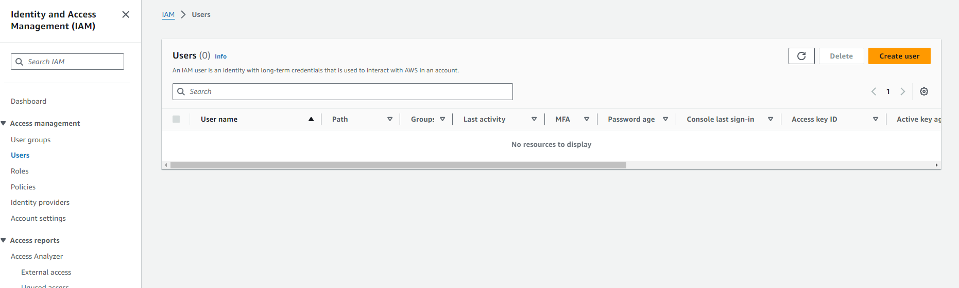

Enter user name

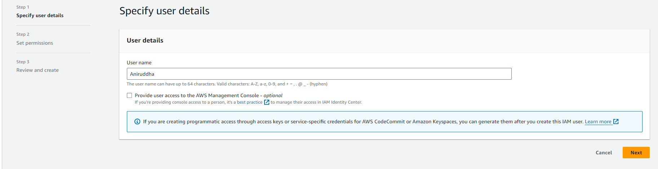

Update policies to attach policies directly

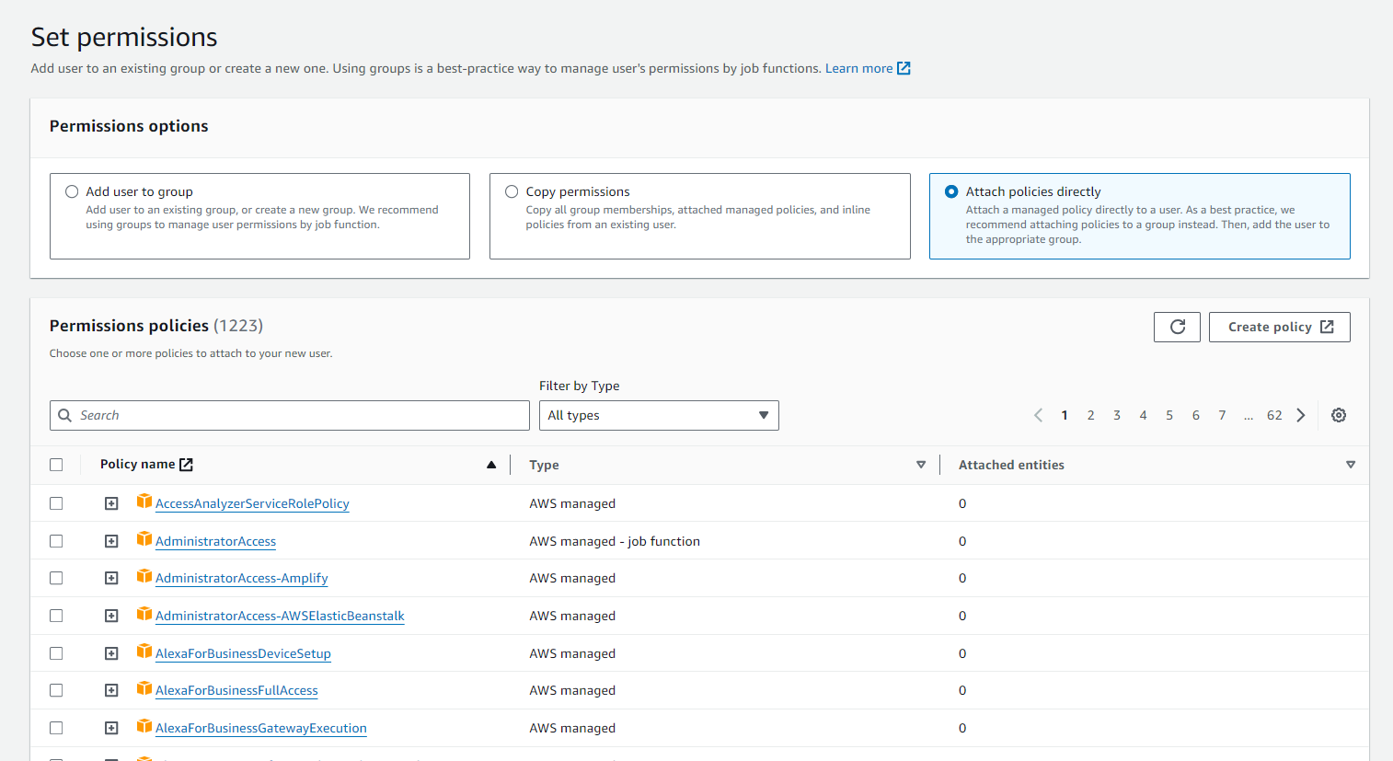

Enable console access by selecting security credential and select autogenerated password

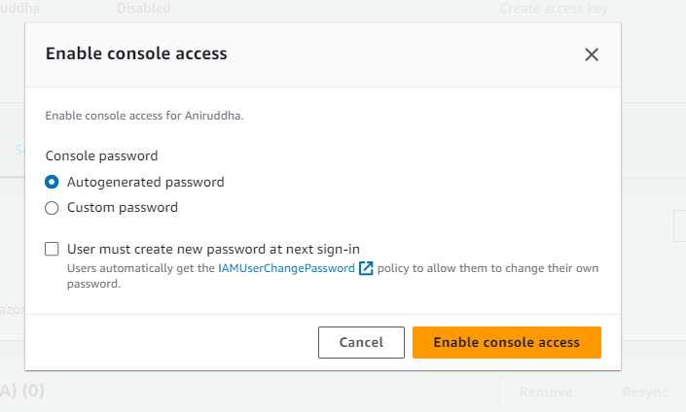

Copy the url for I AM user login: <https://471112635919.signin.aws.amazon.com/console>

Password: 8lY5]'[@

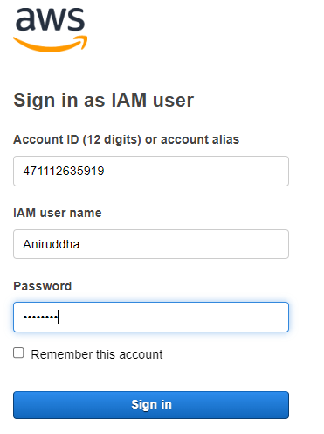

Sign in as IAM user by opening incognito tab and check if you have the access

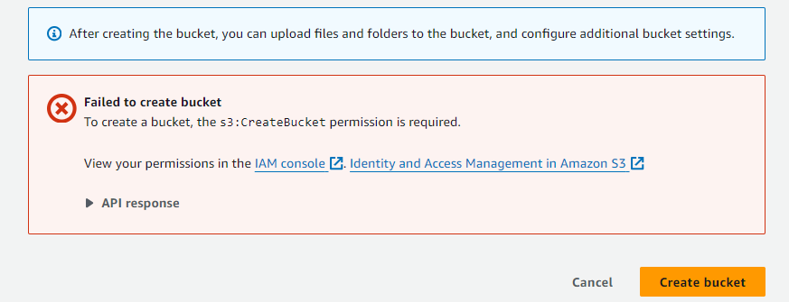

Attach policies to the IAM user

Select policy from the left tab and search for S3 services.

